A study of the company reveals that George Bigelow and Juanita Gomez have retired and left Susan Bannister as C.E.O. The company has four directors; they are:

|  |  |
| --- | --- |
| Kim Watson | Director Corporate Security |
| Alex Wong | Director Administrative Services |
| Rachel Smith | Director Research and Development |
| Juan Valdez | Director Production |

You were able to review the job descriptions and the company organizational chart. The organization of the company is summarized below:

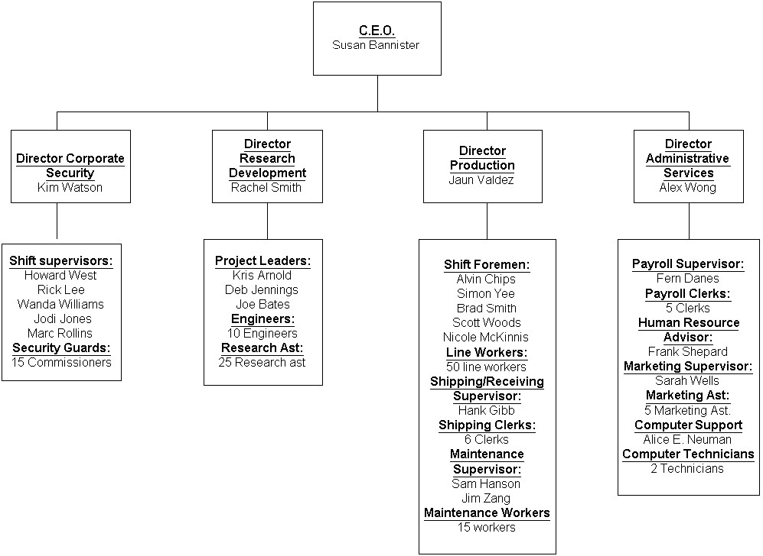

A brief job description of each position is:

|  |  |
| --- | --- |
| C.E.O.  Responsibilities are:   1. Handle public relations for the company. 2. Establish strategic direction of the company.     Director Corporate Security  Responsibilities are: | |
| 1. | Handle all security issues including a. Issuing security clearance   1. Assessing security risks 2. Establishing security plans |
| 2. | Coordinate evacuation procedures |
| 3.    Shift Supervisors  Responsibilities are: | Report to CEO |
| 1. | Monitor employee movement |
| 2. | Issue security badges |
| 3.    Security Guards  Responsibilities are: | Update security privileges |
| 1. | Investigate security breaches |
| 2. | Visually inspect predetermined locations on a regular schedule |
| 3. | Assist in evacuation |

Director Research and Development Responsibilities are:

* + 1. Coordinate research activities
    2. Report to CEO

Project Leaders Responsibilities are:

* + 1. Coordinate current projects
    2. Report progress to Director

Engineers

Responsibilities are:

* + 1. Design of new products
    2. Research

Research Assistant Responsibilities are:

1. Aid the engineers

Director Production Responsibilities are:

* + 1. Schedule runs production of current products
    2. Report to CEO

Shift Foreman Responsibilities are:

1. Supervise production shifts

Line Workers

Responsibilities are:

1. Work at assigned tasks on assembly line

Shipping/Receiving Supervisor Responsibilities are:

* + 1. Coordinate acquisition of need supplies for company operation and production
    2. Coordinate the shipping of finished goods to customers
    3. Report to Director of production

Shipping Clerk

Responsibilities are:

1. Handle day-to-day activities of shipping and receiving supplies and products.

Maintenance Supervisor Responsibilities are:

* + 1. Supervise maintenance workers
    2. Schedule maintenance

Maintenance Worker Responsibilities are:

1. Maintain equipment

Director Administrative Services Responsibilities are:

* + 1. Coordinate all administrative activities
    2. Reports to CEO

Payroll Supervisor Responsibilities are:

* + 1. Report to Director of Administrative Services
    2. Supervise all payroll activities

Payroll Clerks

Responsibilities are:

1. Handle all aspects of payroll.

Human Resources Advisor Responsibilities are:

* + 1. Report to Director of Administrative Services
    2. Hiring of personnel
    3. Employee benefits

Marketing Supervisor Responsibilities are:

* + 1. Report to Director of Administrative Services
    2. Coordinate
       1. Guest relations
       2. Public relations
       3. Interface with military

Marketing Assistances Responsibilities are:

* + 1. Report to Marketing Supervisor
    2. Perform functions in
       1. Guest relations
       2. Public relations
       3. Interface with military

Computer Support Supervisor Responsibilities are:

* + 1. Report to Director of Administrative Services
    2. Coordinate
       1. Network installation and maintenance
       2. Software out sourcing
       3. Help Desk functions

Computer Technicians Responsibilities are:

* + 1. Report to Computer Support Supervisor
    2. Perform functions in
       1. Network installation and maintenance
       2. Software out sourcing
       3. Help Desk functions

**Exercise II**

Using the organizational data provided:

1. Identify the stakeholders. Referring to the diagram “***Possible stakeholders in a bank ATM network” fig 2.3 (of text book)***, produce a similar diagram.

|  |  |  |
| --- | --- | --- |
| **Stakeholder affected** | **Possible consequence of system** | **Nature of effect on stakeholder** |
| C.E.O | Sole decision for strategic directions | Less need for meetings to design strategies or to make decisions |
| Director Corporate Security | No automation of security systems, scarcity of information | Increased awareness of employees', quality of work improves |
| Shift Supervisors | Currently unable to see where employees are in the system | Increased awareness of employees' location |
| Security Guards | Excessive investigations could lead to employees getting irritated. | Increased security integrity |
| Director Research and Development | Reporting to the CEO gives the CEO vital information. | Increased communication |
| Project Leaders | Requires access to many areas, unable to change access level, may have had access to everything | Increased security internally |
| Engineers | Designing the correct products, the correct way using the research they conducted. | Increased use and Productivity |
| Research Assistant | An average of 2 assistants per engineer could lead to excessive costs and diminishing returns | Increased productivity |
| Director Production | Sole decisions for production process could lead to narrow strategies | Less time deciding on strategy |
| Shift Foreman | Supervises production shifts | Increased awareness of employees’ location |
| Line Workers | Works in designated area | Increased security due to access level changes |
| Shipping/Receiving Supervisor | In charge of creating orders to receive more products if need. Along with giving reports to production director. | Assurance of Product flow along with communication. |
| Shipping Clerk | Makes sure products are shipped and received ultimately bringing in revenue and dishing out revenue. | Increased assurance of product flow. |
| Maintenance Supervisor | Works surveilling employees, and managing maintenance | Will have increased control of worker access level, and able to see employee location. |
| Maintenance Worker | Maintenance process must be done manually | Reduced chance for machine errors and maintenance error |
| Director Administrative Services | One person might not be enough to manage every administrative activity | Administrative activities are coherent and follow the same format, less arguments |
| Payroll Supervisor | Hours collected manually, unable to see exact employee hours | Increased accuracy of hours |
| Payroll Clerks | Hours collected manually, unable to see exact employee hours | Increased accuracy of hours |
| Human Resources Advisor | Incidents don’t have exact locations involved, could become he said she said scenario | Additional information now available for incidents. |
| Marketing Supervisor | Will have less access to company areas with new system. | Increased security |
| Marketing Assistances | Will have less access to company areas with new system. | Increased security |
| Computer Support Supervisor | Coordinating employees creates ease of life for them. Helping consumers with help support or outsourcing software. | Increased productivity in employees. Software is being outsourced, (increased profit). |
| Computer Technicians | Only 2 technicians to assist in maintenance might not be enough | Less costs on labor |

1. Identify people you might want to be involved in the development process.
   * Director of Production
   * Director of Corporate Security
   * Director Administrative Services
   * Human Resources
   * Computer Support Supervisor
2. Considering the development process in three general phases

* 1. Identify requirements.
     + **Secure!** - Security and Computer Support Supervisor
       - Site access
     + **Different access levels** – Director of Production, Director of Corporate Security, Director Administrative Services
       - Employee levels, where they’re working and should have access
     + **Location tracking** – Director of Corporate Security
       - Camera access
       - Door security access
     + **Integration with HR and Payroll** – Director Administrative Services, Human Resources
       - Employee ids, names, etc.
  2. Planning how to deliver what is required.
     + Areas that require special supervision
       - Director of Corporate Security
     + Gates which require enhanced security or pinpoint vital access locations – Director Administrative Services
* Identifying different individuals that will be restricted/allowed access to their respected areas.
  1. Delivering what is required.
     + Doors need to be secured properly
     + Cameras need to be installed
     + Integrate emergency exits that have separate security processes
* Doors will have access card scanners to take in the info of the individuals who enter and storing that info in a database.
* Properly integrated with other internal systems i.e., HR, Projects, payroll, etc.

Identify at what phase you would involve those people from question 2.

Indicate the type of information you would require from them at each phase.