**Requirements Document**

**Tiger Dam International Flood Control Inventory System**

**Group Members**

Dylano Van Der Meer, Joshua Law, Trung Hieu Tran, Daniel Wong, Rajdeep Sangha

**Client**

Trevor Wright

**Instructor**

Ali Moussa

Date

09-29-22

# **Table of Contents**

Table of Contents 3

**Preface** 5

**Purpose of Document** 5

**Documentation Standards** 5

**User Requirements** 5

**Business Overview and Objectives** 5

**Project Overview** 6

**Statement of the Problem** 6

**Project Scope** 6

**System Environment** 7

**Current System** 7

**System Requirements** 8

**Fact-Finding Methodology** 8

**Use Case Diagram** 8

**Scenario #1: receiving orders** 8

Figure 1 8

Figure 2 9

Figure 3 9

Figure 4 10

Figure 5 10

Figure 6 11

**Scenario #2: Acquiring new inventory items** 11

Figure 7 11

Figure 8 12

Figure 9 12

***Scenario #3: Accounting for inventory*** 13

Figure 10 13

Figure 11 13

Figure 12 14

Figure 13 15

**Non-Functional Requirements** 16

**System Interface Requirements** 16

**Maintainability and Administration Requirements** 16

**Usability Requirements** 16

Project Management 17

**Schedule** 17

**Team Configuration** 17

**Members:** 17

**Roles** 18

**Reporting relationships** 18

**Contact information(Emails):** 18

**Project Standards and Procedures** 18

Glossary 19

Index 20

# **Preface**

## **Purpose of Document**

The purpose of this document is to analyze and log the requirements of making an for the community flood assistance company called “Tiger Dam.” This document aims to document the team's approach to development. The information will include the functional/non-functional, admin, maintenance requirements along with a milestone schedule for the project. The document will also provide a use case diagram accompanied by a brief essential description of each scenario.

## **Documentation Standards**

* **Fonts:** We will be using “**Calibri light**” to make the documentation readable, simple, and professional, font size .11
* **Colors:** We will be using a monochromatic color scheme for this document to keep the text clean. Using proper bolding and italic etiquette to emphasize the importance of topics.

# **User Requirements**

## **Business Overview and Objectives**

* Tiger Dam International Flood Control is an emergency flood supply company who specializes in sending flood prevention supplies.
* Tiger Dam’s mission is to help communities negate massive floods damage; they strive to be as efficient as possible to assist communities
* Our mission with this company is to build them an inventory management system to better manage their warehouse inventory to process and manage inventory in an instance

# **Project Overview**

## **Statement of the Problem**

Tiger Dams International Flood Control is a company that provides flood control utilities. The current inventory management system is inefficient and out of date. The employees must use pen and paper to manually log inventory. These employees need as automated method that saves time, enabling them to fulfill and ship orders more efficiently. We aim to create an inventory management application that uses a database to store the inventory system that allows data manipulation by the employees.

## **Project Scope**

* + - Build an inventory system for users to update and keep track of inventory
  + System generates a simple and efficient interface
  + System generates insights on both inventories and orders
  + System processes CSV file as the order input
  + System stores and processes input orders
  + System allows access for multiple users
  + System allows export of orders and inventories
  + User has access to order history and associated inventory
  + User has access to update, change, or override orders.
  + User has access to fulfill orders fully or partially
  + User should be able to export data from the database into a csv file for further use
  + Client will often get CSV’s files with order information; the system should be able to read the file and upload the data to the database
  + Orders sometimes need to be changed even after the order is processed, the system must be dynamically mutated by the user

## **System Environment**

* The system will be a web-based system, the system will live offsite on the Company’s server or a personal server.
* The user will be able to access the system via any device that has access to the web application
  + Mobile devices
  + Computers
  + Laptops

## **Current System**

The current system being utilized by the client is an impartial system that relies on excel generated files that are used as orders. As for inventory, the client uses a method of written data that is used to check quantities. The Client then proceeds to fulfill the order based on the inventory available, if inventory is available and the order is fulfillable, the client generates a CSV style invoice and stored both the invoice and the order in his local domain, if the order is partially fulfillable, the client will contact the customer and generate needed changes to the order.

# **System Requirements**

## **Fact-Finding Methodology**

* We interviewed our client via a call.
* Our first approach was enabling our client take the stand and walk us through a typical day at the warehouse, as he described his day, we would take notes and think of problems and solutions he faces
* One of the questions we asked was, “would you want the system to be accessible from more than a local computer.” and “Would you benefit from being able to edit all aspects of the data/orders.”

## **Use Case Diagram**

### **Scenario #1: receiving orders**

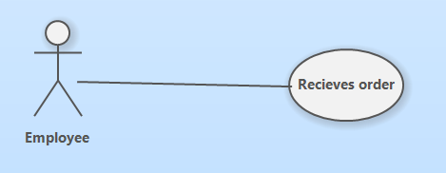

#### Figure 1

An employee receives an order for supplies. The data received contains item numbers, amount, pricing, and the date/time the order is required. All this information is contained in a CSV file.

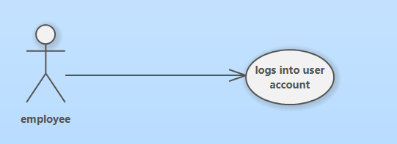

#### Figure 2

Employee logs into inventory management system via username and password. Inventory System contains the company’s current inventory organized by unique IDs for each item, pricing, category of item, and location within the warehouse.

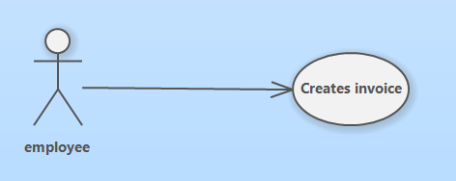

#### Figure 3

Employee inputs the CSV file from the order into the inventory management system. The system will then parse the information and create an invoice containing the supplies and pricing information for the order.

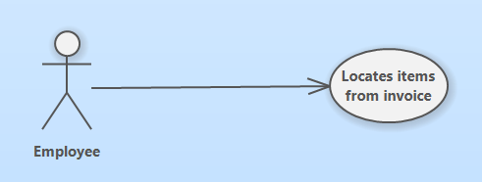

#### Figure 4

Once the invoice is completed the employee uses the inventory system to locate the items from the invoice. Items can be searched via search-bar. The search results will show the location of the item, and the number of items.

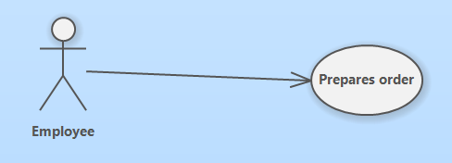

#### Figure 5

Employees then gather items listen on invoice, packages, then load items onto delivery vehicle.

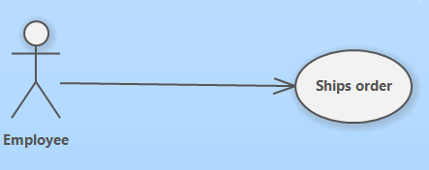

#### Figure 6

Once the order has been prepared the employee can now ship the order to destination.

### **Scenario #2: Acquiring new inventory items**

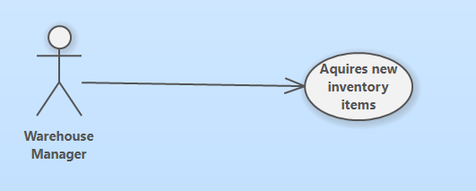

#### Figure 7

The warehouse manager receives new inventory items that are not currently contained in the systems database. These items do not have any unique ID’s, the only information is the name of the product.

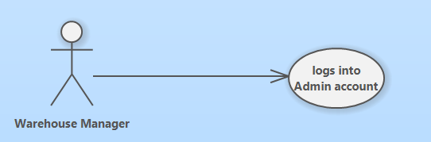

#### Figure 8

Employee logs into an admin account on the system with a specific username and password. This admin account has permission to add and remove items from the inventory system.

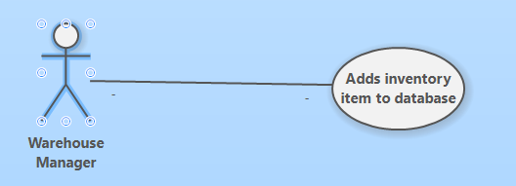

#### Figure 9

The manager then adds item information to inventory database and saves the changes using the item name, unique identifier, price, and location. If any mistakes occur the admin account has permission to edit items in database.

### ***Scenario #3: Accounting for inventory***

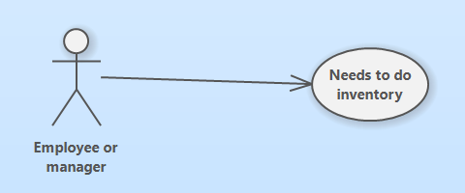

#### Figure 10

Employees need to perform an inventory check on the entire warehouse. The employee needs a complete breakdown of all the inventory items accompanied by the amount of each unique item.

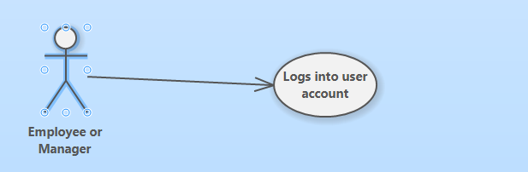

#### Figure 11

The employee then logs into a user account with username and password. An admin account is not necessary because no edits to the system inventory are being made.

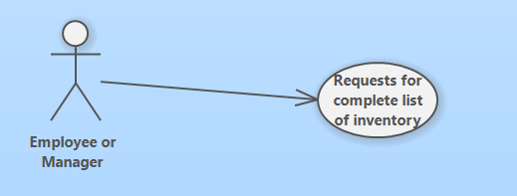

#### Figure 12

The employee then requests a system inventory check. This prompts the system to create a CSV file that contains the complete list of the inventory accompanied by the unique ID’s, number of items, and the location.

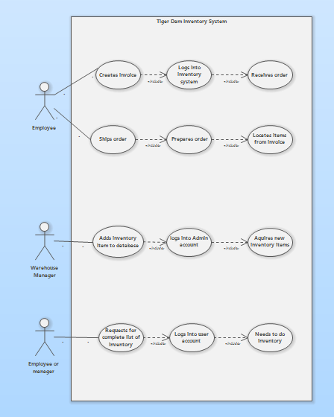

#### Figure 13

The employee then requests a system inventory check. This prompts the system to create a CSV file that contains the complete list of the inventory accompanied by the unique ID’s, number of items, and the location.

## **Non-Functional Requirements**

* **Security:** The system requires users to create accounts to access sensitive data. There are two accounts, “users,” and “Admin.” Users have permission to perform basic functions of the inventory system like create invoice, find inventory, Check pricing, and print inventory list. Admin accounts have permission to create other admin accounts, modify permissions in user accounts, add items to inventory, and any user permissions are also permitted.
* **Speed:** This will determine how fast the application responds. Will use stress testing to determine efficiency of application. Application should be functional on different devices

## **System Interface Requirements**

The inventory management systems will only interface with programs that manage CSV files like excel, and the CSV files themselves.

## **Maintainability and Administration Requirements**

**Maintainability:** We plan to update our system to incorporate different inventory items after our initial implementation. We will also perform regular system maintenance like backing up the database and bug fixes.

**Administration:** There will be two accounts for users on the system. The user account and admin account. The user account allows the employee to create invoices from existing orders and perform a total count of inventory. The admin account will have permissions to customize parts of the application such as adding or removing existing items to the inventory database and creating new admin accounts.

## **Usability Requirements**

The users of the application will have little to no experience with managing a database. The GUI will be intuitive and uncluttered reducing the confusion for inexperienced users. Avoiding fancy designs and using simple monochromatic color schemes with larger buttons and font signifying importance of functions. We also plan to provide an instruction manual to thoroughly cover the basics of the inventory management system.

# **Project Management**

## **Schedule**

|  |  |  |
| --- | --- | --- |
| **#** | **Milestone** | **phase** |
| 1 | Inquire about initial requirements | Assessment |
| 2 | Define Scope and goal of project | Definition |
| 3 | Work on prototype of frontend | Execution |
| 4 | Work on prototype of backend | Execution |
| 5 | Create working prototype of complete app (minor functionality) | Execution |
| 6 | Present complete prototype to client for approval | Assessment |
| 7 | Completion of database | Execution |
| 7 | Completion of backend | Execution |
| 8 | Completion of frontend | Execution |
| 10 | Connection of components successful | Execution |
| 11 | Debugging of complete product successfully |  |
| 12 | Documentation of final product finalized | Execution |
| 13 | Project completion | Warranty and Closure |

# 

## **Team Configuration**

### **Members:**

* Dylano Van Der Meer
* Joshua Law
* Trung Hieu Tran
* Daniel Wong
* Rajdeep Sangha

### **Roles**

* *Front-end developers*: Rajdeep, Daniel, Dylano
* *Back-end developers*: Joshua, Trung, Rajdeep
* *Scribes*: Daniel, Trung
* *Client liaison:* Joshua
* *Team leader:* Dylano

### **Reporting relationships**

* All members of the team will organize a meeting after completion of components or if an issue arises. We will also all report to the instructor Ali Moussa.

### **Contact** **information(Emails):**

* [Daniel.y.wong@edu.sait.ca](mailto:Daniel.y.wong@edu.sait.ca)
* [Rajdeepsangha166@gmail.com](mailto:Rajdeepsangha166@gmail.com)
* [*TrungHieu.Tran@edu.sait.ca*](mailto:TrungHieu.Tran@edu.sait.ca)
* [*Joshuasmlaw@gmail.com*](mailto:Joshuasmlaw@gmail.com) *or* [*Joshua.Law@edu.sait.ca*](mailto:Joshua.Law@edu.sait.ca)
* [*Dylanovandermeer@gmail.com*](mailto:Dylanovandermeer@gmail.com) *or* [*Dylano.vandermeer@edu.sait.ca*](mailto:Dylano.vandermeer@edu.sait.ca)

### **Project Standards and Procedures**

* **Communication:** Main method of communication will be Microsoft Teams. Each team member has provided their schedules to find the date and time for a consistent meeting.
* **Execution:** The team will do our best to complete most of the work during class time and save the meeting time for debriefs and extra planning.

# 

# **Glossary**

|  |  |  |
| --- | --- | --- |
|  | **Term** | **Definition** |
| 1 | Inventory System | A process used to track stock, supplies and sales through an application |
| 2 | System | A set of things working together to give an output |
| 3 | User Interface | The way a user and a computer/application interact |
| 4 | Comma Separated values (CSV) | Is a formatted excel sheet file |
| 5 | Discord | Discord is a communication app where users can voice, video and text chat with other users |

# **Index**

Maintainabiity and Administration Requirements

Maintainability 16

**Maintainability and Administration Requirements** 16

Administration 16

**Non-Functional Requirements** 16

Security 16

**Preface** 5

Documentation Standards 5

Purpose of Document 5

Project Management 17

Schedule 17

Team Configuration 18

**Project Overview** 6

Current System 7

Project Scope 6

Statement of the Problem 6

System Environment 7

Scenario #1\ receiving orders

Figure 2 9

Scenario #1: receiving orders

Figure 1 8

Figure 3 9

Figure 4 10

Figure 5 10

Figure 6 11

Scenario #2

\ Acquiring new inventory items

Figure 7 11

Figure 8 12

Figure 9 12

**Scenario #2: Acquiring new inventory items** 11

Scenario #3

\ Accounting for inventory

Figure 10 13

Figure 11 13

Figure 12 14

Figure 13 15

***Scenario #3: Accounting for inventory*** 13

**System Interface Requirements** 16

**System Requirements** 8

Fact-Finding Methodology 8

Use Case Diagram 8

Team Configuration

Contact information(Emails): 18

Members: 18

Project Standards and Procedures 18

Reporting relationships 18

Roles 18

**Usability Requirements** 17

Use Case Diagram

Scenario #1: receiving orders 8

**User Requirements** 5

Business Overview and Objectives 5