Barnes et al: Predator and Prey Bodysizes in Marine Food Webs

Felix Carter

27/10/2020

## Background Information

The abstract of this paper explains that we need information of the relationships between predator and prey size in order to understand how species and size classes interact within food webs. This data contains almost 35,000 records from a range of environments and locations, for a vast range of predator sizes - from 0.1 milligrams to 415 kilograms, and prey sizes from 75 picograms to over 4.5 kilograms. Information about the species such as location, scientific name, life stage and habitat description is also included.

## Importing the Data

Firstly, I had to download the text file containing the data from the Barnes et al study(the data can be found at <https://figshare.com/articles/dataset/Full_Archive/3529112>). Then I converted it to a .csv file in Excel. In this code, we import the library tidyverse to use its features (including ggplot) in the future. Then we import the data file into R and save it to the pred_prey_data dataframe.

library(tidyverse)

## -- Attaching packages ------------------------------------------------------- tidyverse 1.3.0 --

## v ggplot2 3.3.2 v purrr 0.3.4  
## v tibble 3.0.3 v dplyr 1.0.1  
## v tidyr 1.1.1 v stringr 1.4.0  
## v readr 1.3.1 v forcats 0.5.0

## -- Conflicts ---------------------------------------------------------- tidyverse_conflicts() --  
## x dplyr::filter() masks stats::filter()  
## x dplyr::lag() masks stats::lag()

pred_prey_data <- read.csv("Predator_and_prey_body_sizes_in_marine_food_webs_vsn4_csvcopy.csv")

## Starting to look at the data

Plotting masses of the prey masses shows the variation in the data.

plot(pred_prey_data$Prey.mass)

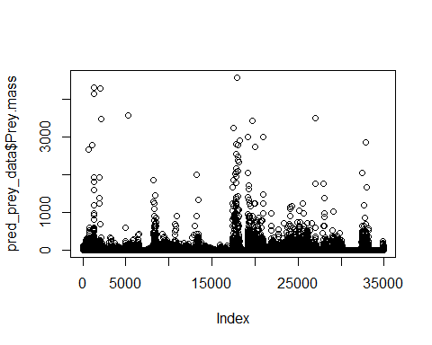

This graph shows that most of the data entries are under 1000 units for Prey.mass, however some of them are over 4000 units. We can view the units for this variable:

unique(pred_prey_data$Prey.mass.unit)

## [1] "g" "mg"

unique(pred_prey_data$Predator.mass.unit)

## [1] "g"

Which shows that for Prey Mass as in the graph above, some masses are measured in milligrams but some are measured in grams. Fortunately, for Predator Mass all units are in grams. Ideally we would like to get all measurements in the same unit (grams) for fair comparison in graphs. In the code below, we multiply any Prey Mass measurement that is in milligrams by 0.001 to convert it to grams. We then set the mass unit value to grams for these to “g” so this is accurate.

pred_prey_data$Prey.mass[pred_prey_data$Prey.mass.unit == "mg"] <- 0.001*pred_prey_data$Prey.mass[pred_prey_data$Prey.mass.unit == "mg"]  
pred_prey_data$Prey.mass.unit[pred_prey_data$Prey.mass.unit == "mg"] <- "g"

We can now see that all measurements for Prey mass are in grams:

unique(pred_prey_data$Prey.mass.unit) #shows now all in grams

## [1] "g"

We have now got data on predator/prey masses we can work with for comparisons.

## Predator and Prey Mass data

Now assign the data for Predator and Prey mass in grams to new data frames:

pred_mass_g <-pred_prey_data$Predator.mass #all in grams anyway  
prey_mass_g <-pred_prey_data$Prey.mass # now all converted to grams

We can view summaries of the data for Predator Mass and Prey Mass:

summary(pred_mass_g)

## Min. 1st Qu. Median Mean 3rd Qu. Max.   
## 0 172 1751 15292 6326 415600

plot(pred_mass_g)

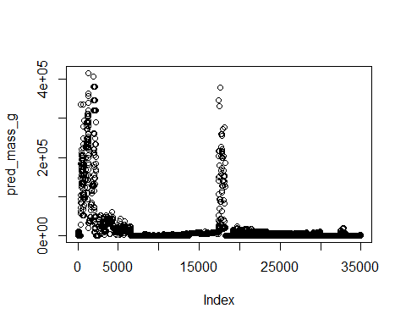

This shows that whilst the average predator has a mass of about 15,000g, there are some predators that have a mass of up to 415,600g.

Now if we wanted to compare the mass of a predator with the mass of its prey, we could do this using the ggplot function, which has more features than the inbuilt plot function:

pred_prey_data %>%  
 ggplot(aes(x= prey_mass_g, y= pred_mass_g)) +  
 geom_point()

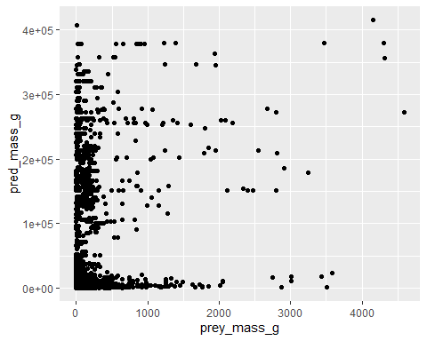

Its hard to draw conclusions from this graph because of the scale of the graph - most values are clustered towards the lower end of the mass scale. If we take the log of both sides, this should represent the data in a better way visually:

pred_prey_data %>%  
 ggplot(aes(x= log(prey_mass_g), y= log(pred_mass_g))) +  
 geom_point(shape=20) +  
 ggtitle("Log-Log Plot of Predator-Prey Masses") +  
 xlab("log(Prey Mass (g))") +  
 ylab("log(Predator Mass (g))")

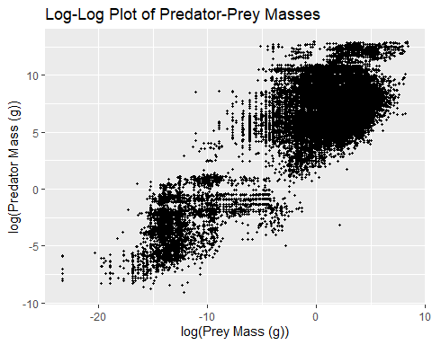

(Note we have added titles and labels to the graph, and made the scatterpoints smaller so they can be differentiated more easily). As we can see from this graph, there appears to be a correlation between the natural logarithm of predator mass and the natural logarithm of prey mass. This implies that the masses follow a power law relationship, i.e the function is of the form y=a*x^b.