Analysis
My current idea for this project is for it to provide a simple, retro-themed fighting game for one player. It will involve using different moves, each controlled by appropriate key bindings, to tackle various opponents with equal power. Opponents would be generated based on the player’s options with extra attributes such as reaction time to make it fair. Further scaling of the project would include a difficulty slider or even different rounds fighting enemies of greater and greater strength or speed. This would challenge the user, making the game fun and engaging to play.
My current knowledge of the games industry shows that similar games are underrepresented, despite their undisputed popularity amongst all audiences. Current examples include Street Fighter and Mortal Kombat. Other games with desirable features for this product are Gladio Mori, Half Sword and Watermelon Sandbox. Whilst two of these are 3d, I admire their menus, theming and core mechanics. This project has the goal of filling this niche in a scalable manor. This design could remove the problem of boredom from the user as they would have never truly beaten it.
The embarkment of this project excites me as I can appreciate the dedication and creativity in the games industry. By completing this relatively small project, I would be able to use it for developing my skills. An ideal development engine should be incredibly minimal, thus allowing me to use all of my skills organically, rather than having them built in. Additionally, it ought to be compatible across PC operating systems such as MacOS, Debian and NixOS. This would garner a wider player base and expand the clientele of the game.
For this project to be successful, it should allow a player to fight against a condition based bot. The player should have to balance various displayed attributes such as stamina and health whilst beating their opponent. Examples of the bot’s conditions may include the proximity of the player, the stamina of the player or the health of the bot.

Research
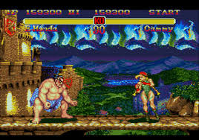
Qualities to Take Forwards | Qualities I Dislike
I think the menu of Half Sword sets up the theme of the game perfectly before the game is properly started. This is great because it clearly informs the player of the genre and style. | I think that in a minimal environment I would struggle to replicate this menu. It would be needlessly complicated and in depth than the game itself.
The combat in the game is incredibly realistic with conditionally actioning bots. I really like this because it greatly simplifies the concepts and code of the bots. This is good for my minimal IDE where training a full AI may not be possible. | Again, the combat is too detailed. It would be far too much to add realistic bruising and effects to a simple 2d fighter.

Qualities to Take Forwards | Qualities I Dislike
I like the clear UI displaying the health of each fighter, this makes it easy to quickly gauge the opponent’s strength mid-fight. Consequently, the game is easier to read, meaning that it could be more accessible to an external audience. This opens up streaming as a viable form of marketing. | I’m not a fan of the difficult colour scheme, making it difficult to interpret. This hinders the user’s ability to interpret the given information. Furthermore, it might harm the ability for visually challenged people to enjoy any content produced with it.
I like the pixelated graphics since they add to the character of the game. This makes the style seem authentic and more likeable from an audience or consumer. | But I think that mine should have greater clarity to blend in with similar and more modern games and feel closer to a remake. By doing this I could engage prior audiences of this media.

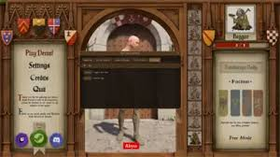
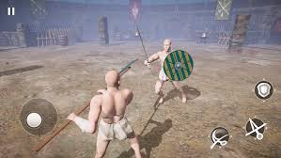

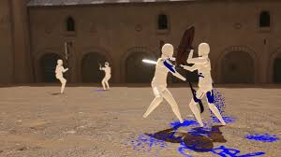

Qualities to Take Forwards | Qualities I Dislike
The simplified models for player and enemies would make development of my game much easier. It would also standardise player hitboxes and sizes. This would be ideal for my game because a faster development process would make for a longer amount spent on implementation of desired features, which is the core idea of this genre. | In my final product, I aim to properly sprite the characters. This would make it more engaging for the user as it would be easier to relate to. Games like Mario show that players are warmer to a game featuring humanoid characters and so mine should do similar.
The idea of multiple enemies is intriguing. It would veritably add depth to further difficulties in the game. By having multiple enemies onscreen concurrently, it would take longer for the player to win the fight. This addition could be an option for users wishing for a longer experience. | It would be difficult to have multiple enemies all in view, or without getting in the way. This could in turn make it slower or jankier to play, reducing the amount of time players are likely to spend playing it.

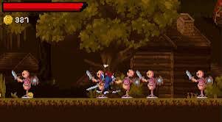

Qualities to Take Forwards | Qualities I Dislike
I am a big fan of the chevron above the player’s head. This would make the game easier to play by reducing the risk of confusion. Resultantly, consumers are able to pick up the game faster and invest more time in it. | I dislike the use of physical weapons. I am to make my game at least plausible, which the addition of blades would jeopardise. My characters will use hand to hand combat, making it seem much grittier and so appealing to teenage audiences.
The cohesion between the ground and background leads to a seemingly better designed product. This has been known to increase user acceptance rates and so I will aim to have the same. | The apparent monetary system displayed would not fit my game. Were I to implement it, there would not, at current state of planning, be many options of use. Thus I have decided that it is an unnecessary feature which causes conflict with the core mechanics of the game.
I think that the idea of multiple enemies can add a layer of complexity to the game, supported by the zoom of the camera. This added complexity can easily be a worthwhile extension to the game. | The camera has a wide zoom which would not fit the cosy aesthetic of my game. It would be harder to achieve the desired effect of my game.

Stakeholders
My stake holders would likely be teenagers interested in computer science, between 14 and 19. This is because my research and experience shows that this demographic is the most likely to be engaged with similar media. Furthermore, this group tend to be socially active in both real life and online. This level of communication can be capitalised on for easier marketing. Subsequently, I will survey this demographic in order to determine features and implementations which may be successful and desirable in this game.
I believe that my player base will be making greatest use of this product in their free time after education hours. As such, I will aim to make each experience succinct in order to support a user’s requirement of homework. Longer games can feel like a greater commitment to play and so are not as popular during this targeted time window.
I aim to include my stake holders in this process in order to maintain a high fidelity to the desired concept and functionality.

