Analysis
My current idea for this project is for it to provide a simple, retro-themed fighting game for one player. It will involve using different moves, each controlled by appropriate key bindings, to tackle various opponents with equal power. Opponents would be generated based on the player’s options with extra attributes such as reaction time to make it fair. Further scaling of the project would include a difficulty slider or even different rounds fighting enemies of greater and greater strength or speed. This would challenge the user, making the game fun and engaging to play.
My current knowledge of the games industry shows that similar games are underrepresented, despite their undisputed popularity amongst all audiences. Current examples include Street Fighter and Mortal Kombat. Other games with desirable features for this product are Gladio Mori, Half Sword and Watermelon Sandbox. Whilst two of these are 3d, I admire their menus, theming and core mechanics. This project has the goal of filling this niche in a scalable manor. This design could remove the problem of boredom from the user as they would have never truly beaten it.
The embarkment of this project excites me as I can appreciate the dedication and creativity in the games industry. By completing this relatively small project, I would be able to use it for developing my skills. An ideal development engine should be incredibly minimal, thus allowing me to use all of my skills organically, rather than having them built in. Additionally, it ought to be compatible across PC operating systems such as MacOS, Debian and NixOS. This would garner a wider player base and expand the clientele of the game.
For this project to be successful, it should allow a player to fight against a condition based bot. The player should have to balance various displayed attributes such as stamina and health whilst beating their opponent. Examples of the bot’s conditions may include the proximity of the player, the stamina of the player or the health of the bot.

Research
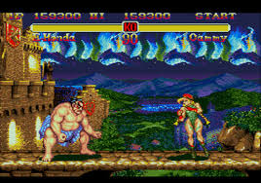
Qualities to Take Forwards | Qualities I Dislike
I think the menu of Half Sword sets up the theme of the game perfectly before the game is properly started. This is great because it clearly informs the player of the genre and style. | I think that in a minimal environment I would struggle to replicate this menu. It would be needlessly complicated and in depth than the game itself.
The combat in the game is incredibly realistic with conditionally actioning bots. I really like this because it greatly simplifies the concepts and code of the bots. This is good for my minimal IDE where training a full AI may not be possible. | Again, the combat is too detailed. It would be far too much to add realistic bruising and effects to a simple 2d fighter.

Qualities to Take Forwards | Qualities I Dislike
I like the clear UI displaying the health of each fighter, this makes it easy to quickly gauge the opponent’s strength mid-fight. Consequently, the game is easier to read, meaning that it could be more accessible to an external audience. This opens up streaming as a viable form of marketing. | I’m not a fan of the difficult colour scheme, making it difficult to interpret. This hinders the user’s ability to interpret the given information. Furthermore, it might harm the ability for visually challenged people to enjoy any content produced with it.
I like the pixelated graphics since they add to the character of the game. This makes the style seem authentic and more likeable from an audience or consumer. | But I think that mine should have greater clarity to blend in with similar and more modern games and feel closer to a remake. By doing this I could engage prior audiences of this media.

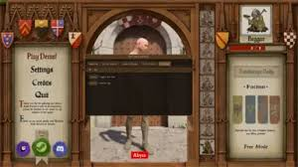
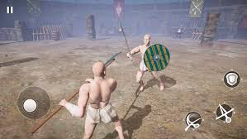

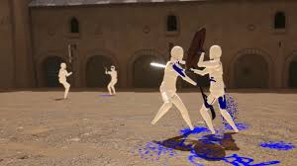

Qualities to Take Forwards | Qualities I Dislike
The simplified models for player and enemies would make development of my game much easier. It would also standardise player hitboxes and sizes. This would be ideal for my game because a faster development process would make for a longer amount spent on implementation of desired features, which is the core idea of this genre. | In my final product, I aim to properly sprite the characters. This would make it more engaging for the user as it would be easier to relate to. Games like Mario show that players are warmer to a game featuring humanoid characters and so mine should do similar.
The idea of multiple enemies is intriguing. It would veritably add depth to further difficulties in the game. By having multiple enemies onscreen concurrently, it would take longer for the player to win the fight. This addition could be an option for users wishing for a longer experience. | It would be difficult to have multiple enemies all in view, or without getting in the way. This could in turn make it slower or jankier to play, reducing the amount of time players are likely to spend playing it.

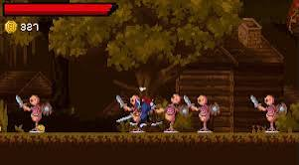

Qualities to Take Forwards | Qualities I Dislike
I am a big fan of the chevron above the player’s head. This would make the game easier to play by reducing the risk of confusion. Resultantly, consumers are able to pick up the game faster and invest more time in it. | I dislike the use of physical weapons. I am to make my game at least plausible, which the addition of blades would jeopardise. My characters will use hand to hand combat, making it seem much grittier and so appealing to teenage audiences.
The cohesion between the ground and background leads to a seemingly better designed product. This has been known to increase user acceptance rates and so I will aim to have the same. | The apparent monetary system displayed would not fit my game. Were I to implement it, there would not, at current state of planning, be many options of use. Thus I have decided that it is an unnecessary feature which causes conflict with the core mechanics of the game.
I think that the idea of multiple enemies can add a layer of complexity to the game, supported by the zoom of the camera. This added complexity can easily be a worthwhile extension to the game. | The camera has a wide zoom which would not fit the cosy aesthetic of my game. It would be harder to achieve the desired effect of my game.

Stakeholders
My stake holders would likely be teenagers interested in computer science, between 14 and 19. This is because my research and experience shows that this demographic is the most likely to be engaged with similar media. Furthermore, this group tend to be socially active in both real life and online. This level of communication can be capitalised on for easier marketing. Subsequently, I will survey this demographic in order to determine features and implementations which may be successful and desirable in this game.
I believe that my player base will be making greatest use of this product in their free time after education hours. As such, I will aim to make each experience succinct in order to support a user’s requirement of homework. Longer games can feel like a greater commitment to play and so are not as popular during this targeted time window.
I aim to include my stake holders in this process in order to maintain a high fidelity to the desired concept and functionality.

My Form Is Linked Below:
Bar Fight Consumer Research – Fill in form

Consumer Research Findings
On a scale from 1->10, how much would you desire two or more moves?
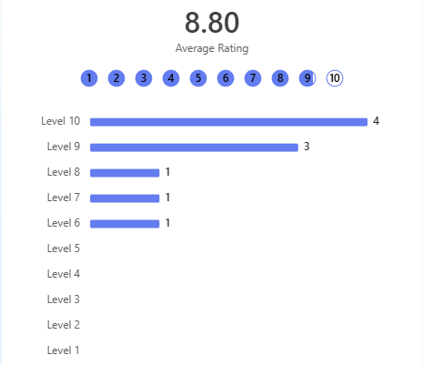
This shows a high demand for the ability to use multiple different attacks. I am grateful for this result since this feature was one which I envisaged in the game, making it fully engaging. Following this result, I shall make this a priority. I can see how this would largely impact the game and make it more exciting to play.

On a scale from 1->10, how much would you desire enemies varying in size and strength?
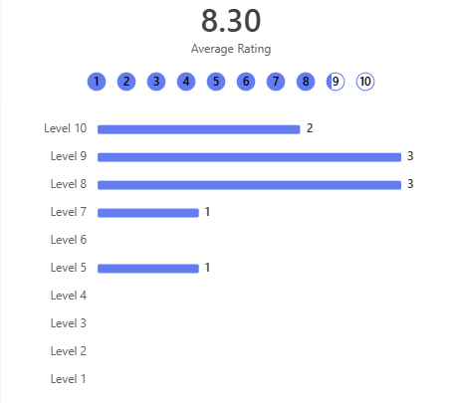
As one of the highest rated ideas, this would be a priority for the game. It would make the whole environment feel more alive, with a perceived challenge that could be easily implemented.

On a scale from 1->10, how much would you desire fighting two or more enemies simultaneously?
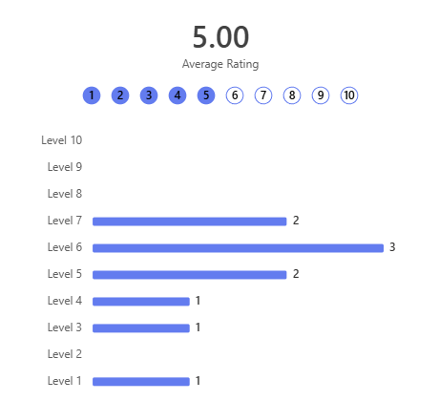
This shows a fortunate lack of demand for fighting multiple enemies. I can gauge from this that it is far from an the essential feature, and consequentially I shall not list it as a requirement for this game.

On a scale from 1->10, how much would you desire combo moves?
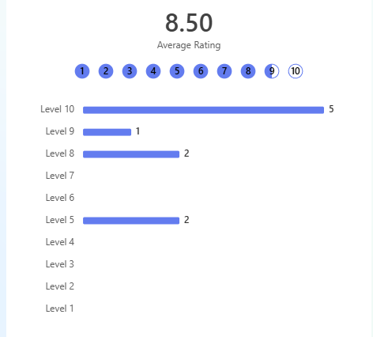
This is one of the most demanded implementations for the game. It would add a necessary skill curve to the game and in turn make it more engaging for both new and advanced players.

- On a scale from 1->10, how much would you desire character customisation?
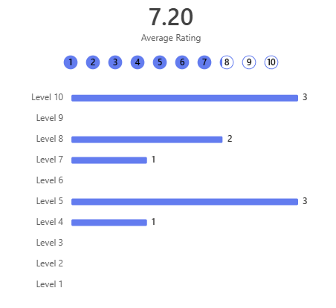
As an averagely rated feature, it would not be a priority to implement, but it is worth consideration. The concept of customisation could lead to the addition of more features such as a customisation shop, which is intriguing. Yet it may extend beyond the scope of the project.

On a scale from 1->10, how much would you desire exponential knockback?
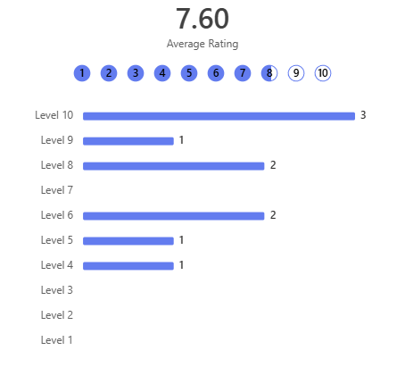
Due to the rating of this feature, and my own personal willingness to implement it, this is likely to make it into the game. It would both make attacks feel more meaningful, whilst also acting as a safety net were the player caught in range of the enemy.

On a scale from 1->10, how much would you desire the use of environmental props?
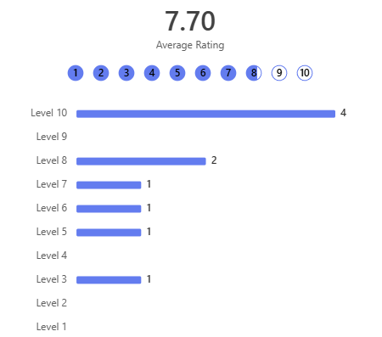
As a relatively highly requested addition, this would be very nice to add. It would mesh the background and environment with the player and enemy, creating a worthy cohesion. This would also give the game a unique selling point and further separate it from competition.

On a scale from 1->10, how much would you desire enemies with varying reaction times?
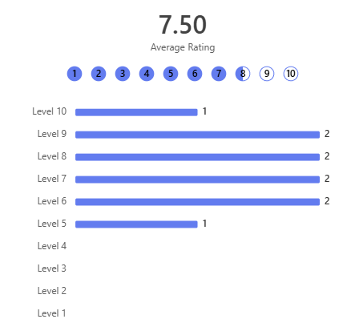
As another vehemently requested feature, this would be an interesting addition to the game, making it feel more challenging and having better scaling. This number could be tweaked also so that the further the player can progress in the game, the harder the enemies become to face.

Subsequent Requirements
 | Feature |  | Sub Features | Explanation | Justification | Importance
1 | Combo Moves | A | Varying Attacks With Primary Attack Button | On pressing the given attack button in rapid succession, the first displayed attack would differ to the second/third, which would have a different level of power. | This would encourage longer engagements which could be challengingly risky. This would add a level of difficulty to engage the player. Finally, it is a greatly requested feature and would please stakeholders with its addition. | 7/10  (Desirable)
 |  | B | Multiple Inputs for One Attack | Upon entering multiple inputs sequentially, a different attack is shown with different attributes for knockback, damage, etc. | This adds an element of skill to the game, where more advanced players can use different abilities. This increases the complexity of the game and thus encourages the player to spend more time playing it. | 5/10  (If Possible)
 | This falls further into desirable content, rather than necessary. Whilst it would surely increase a required skill level of the game, I can see how it might be hard to implement. | C | X | X | X | X
2 | Enemies of Varying Sizes and Strengths | A | Random Size | Uses random numbers to scale the displayed enemy within a range fitting of the difficulty. | This shows variance between the enemies and gives the illusion of a larger game. Furthermore, it makes the player anticipate a longer or more difficult fight, engaging them further. Finally, it is a heavily requested feature and would please stakeholders. | 8/10  (Desirable)
 |  | B | Random Strength | Uses random numbers to modify the damage done by the enemies’ attacks within a range fitting of the difficulty. | This shows variance between the enemies and gives the illusion of a larger game. The random value of the strength could be increased with difficulty, making it more challenging as appropriate. | 9/10  (Essential)
 | This addition to the game had a vehement popularity from my stakeholders. Furthermore, I am sure that its implementation would coincide pleasantly with other possible features. Hence I shall list this as a required feature. | C | Random Reaction Time | Uses random numbers to set the relative reaction time of the enemy for certain conditions. | This would add a further value to change with difficulty. Enemies could react to conditions such as player proximity with ease, thus making it harder to safely attack the enemy. | 8/10  (Essential)
3 | Multiple Different Moves | A | Basic Punch | A simple punch with a small range. This would form the basis of the fighting game. | As the most rudimentary element of any fighting game, this would make it indelibly simple for any new players, whilst also allowing better skilled people to play. | 10/10  (Essential)
 |  | B | Kick | A short kick with greater range and damage than the punch. | This might add ideas of decision to the game. It would allow the player to take a gamble and deal more damage, with a greater risk of reciprocating fire or loss of stamina. | 9/10  (Essential)
 | The basis of this concept has had an overwhelming level of support from my surveyed target audience. This undoubtably places this in a necessary position. | C | Headbutt | An incredibly short range attack with the highest damage. | The player could use this to punish the enemy, giving an easy solution to close quarters combat. This would then reduce the possibility of a near impossible games for certain difficulties and thus increase user retention rates. | 7/10  (Desirable)
4 | A Consistent HUD (Heads Up Display) | A | Health Bar | A visible bar above the player’s head, designed to indicate a fighter’s hit points. | In all of the games which I investigated for this project, this item was prevalent. The reason being that it is an essential indicator of the leading fighter and the proximity to a loss. My use of this would see the traditional red block fill, making use of the user’s precognition of its meaning. I feel free to do this due to my target audience having a prior experience of similarly categorised games. | 10/10  (Essential)
 |  | B | Stamina Bar | A simple element similar to the health bar, used to show the current level of stamina possessed by the relevant fighter. Positioned below the health bar. | This element would act incredibly like the above. This would show the stamina attribute of the fighter as an orange block fill. As so, it would decrease after the player or enemy made a move, thus showing both the player’s capability to advance, or the enemies weakness. By including this as a displayed element, it improves the ease of use for the player. This would differ slightly to the health bar in light of the nature of stamina to be recovered, both in similar media and real life. Hence, mine shall use a formula to determine the rate at which the bar should be filled over a given period. The result would be a smoother looking increase in stamina as opposed to a direct spike. | 9/10  (Essential)
 | This element would be essential to display current attributes such as player health and stamina. | C | Attack reset time | A short and semi-permanent addition, appearing after the player has completed an action with a delay. |  | 4/10  (If Possible)
5 | Menu Screen | A | A start button | A simple menu item which starts the game on being clicked. | In all three games which I analysed for my market research, a start button was consistent. This feature is useful because it allows the player to instantiate a new game if and when they desire. Furthermore, this permits a period of which a student playing this game can wait before playing again, for example if they are printing out an essay they might load the game when they plan to start printing, but only actually begin it once the document has started to print. | 10/10  (Essential)
 |  | B | A difficulty slider | A simple slider produced by having an object follow the mouse when it is in a set region and clicks. Different points on the possible path of this actor would correspond to different ranges for enemy attributes such as damage. | Whilst my survey has not accounted for this idea, I find that nearly all similar games have this feature. Additionally, it would veritably support other favoured features such as enemies with variable reaction times. Hence, I have decided to take agency on this matter and make this a necessary feature in my game. This would be helpful for students playing the game because it would allow them to control the level of focus required to enjoy the game. Often after a long day, students can struggle to engage with prolonged and intense brain function. | 8/10  (Desirable)
 | A menu screen would be crucial for a typical functionality of the game. Due to the fast paced nature of the game, a menu to break it up would feel helpful. It would also be a necessary platform for elements such a play button. | C | X | X | X | X
6 | Movement | A | Movement from left to right | This would enable the player to move their character from left to right with certain inputs. The game would likely use WASD format, as is conventional in this category. | My game would require the ability for the player to move around. This forms the basis for almost all similar games, including all of which I researched prior. I did not include this idea in my survey, due to it being typical. | 10/10  (Necessary)
 |  | B
 |  | C

Success Criteria
 | Explanation | Justification | Measurability
2B | Randomly generated levels of strength for an enemy fighter. | This is relatively achievable and capable of making the game more realistic and exciting. | It is also measurable, since it is binary in whether it is or isn’t implemented.
3A | The ability for the fighter to punch or be punched by the enemy. | This is an incredibly basic mechanic, involved in almost all market competitors. It would allow the very basis of a fighting game. | It is also measurable, since it is binary in whether it is or isn’t implemented.
3B | The power for the fighter to kick their enemy with greater range and damage to the punch. | This would add a variance to the fighting, with certain moves being best applied under differing circumstances. Furthermore, its implementation would be held back only by a changing of the attributes of it. | It is also measurable, since it is binary in whether it is or isn’t implemented.
3C | The allowance of the player to strike their enemy with a headbutt, the attack having greater power and shorter ranges to its peers. | The consequence of this would be the emergence of strategies such as closing distance between user and enemy. This directly adds risk management as a skill to the game, permitting the choice between playstyles. | It is also measurable, since it is binary in whether it is or isn’t implemented.
5A | A simple menu screen item being a start button, with the power to start the game upon being clicked. | This allows the user to take agency over the starting of the game. The alternative would force the user to focus immediately after launching the game, where the fight would start as soon as it opens. This would be incredibly difficult and hence shall be thwarted. | It is also measurable, since it is binary in whether it is or isn’t implemented.
4A | A health bar to hover over the player or enemies’ head and display their remaining health. | This addition to the HUD would allow easy tracking of health metrics, allowing the player to easily gauge the risk of the next exchange. | It is also measurable, since it is binary in whether it is or isn’t implemented.
4B | A stamina bar to monitor and show the stamina of the player. | The feature would allow the player to keep track of their stamina. This is useful because this metric decreases on attacks. By keeping it visible, the player can time their attacks and engagements. | It is also measurable, since it is binary in whether it is or isn’t implemented.

Possible Limitations
 | Description | Justification
xA

