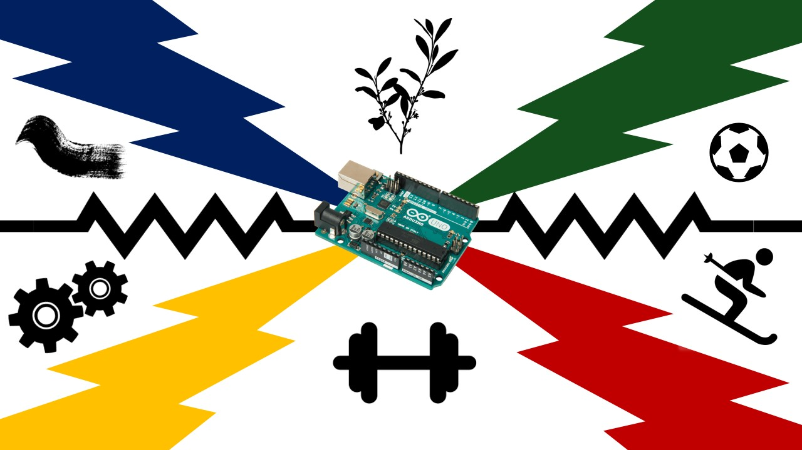

The flag we've crafted is a symbol of unity among us. Everyone has inserted a symbol which indicates as a reminder that, even though we have different backgrounds, we’ve all gathered in one place to create a strong and impactful force. The colors on the flag are a combination of those from the South African and United States flags, and they're not just there for decoration – they hold a deeper meaning. These colors tell a story about how, despite living in different countries, we share common qualities and characteristics. It's like we're all part of a big team, each bringing something special to the table. The flag is a visual representation of this shared bond, a powerful message that says, "Look at us – despite our differences, we're connected by something greater." In essence, our flag is a testament to the beauty that emerges when people from diverse backgrounds come together. It's a celebration of the strengths we share and a recognition that, despite our geographical distances, we're more alike than meets the eye. So, when you see our flag waving proudly, remember that it stands for unity in the face of diversity.

Ryan – Growing up in Colorado I loved skiing from a young age. Skiing has always been a huge factor in my life, and it is something that I cannot imagine living without. I am on the Penn State ski club, and it has been a huge part of my life throughout college.

Chay – I included the dumbbell as I enjoy the gym and any other sort of physical activities. Exercise has always been important to me to stay active and clear my head.

Armend – I included a plant because I really like outdoors and nature. I spend a lot of time outside, going on hikes, etc. And so, I felt that it was a good way to represent me.

Michael – I like cars and am on Penn State’s race team. I didn’t want to be too stereotypical about it though and make my symbol an engine or a wheel, for example, so I decided on transmission gears. Gears are also a good symbol for teamwork, since they’re only useful in a gear train made of multiple parts! A single gear cannot transmit power on its own, just like a project is not successful without the contributions of all its members.

Felix – I have a deep passion for soccer, and to symbolize my love for the sport, I've included a soccer ball in the design of the flag. It's a personal touch that represents a significant part of who I am because I grew up in a family that loves the sport.

Taryn - A paint brush stroke describes my personality on a deeper level. Although I enjoy painting, I’m also a very creative person. As the paint brush moves it indicates my ability to adapt to different situations and move with an open mind. With painting there’s so many layers of paint that are added onto one another, this indicates that there are so many aspects to me.