See discussions, stats, and author profiles for this publication at: [https://www.researchgate.net/publication/317336647](https://www.researchgate.net/publication/317336647_Automated_Detection_of_Coronary_Artery_Disease_Using_Different_Durations_of_ECG_Segments_with_Convolutional_Neural_Network?enrichId=rgreq-03d3befafa9a46e7d47f8b0b4f640e2b-XXX&enrichSource=Y292ZXJQYWdlOzMxNzMzNjY0NztBUzo1NDM3MzY4NzI4MDAyNTZAMTUwNjY0ODM4MDMwNA%3D%3D&el=1_x_2&_esc=publicationCoverPdf)

[Automated Detection of Coronary Artery Disease Using Different Durations of ECG Segments with Convolutional Neural Network](https://www.researchgate.net/publication/317336647_Automated_Detection_of_Coronary_Artery_Disease_Using_Different_Durations_of_ECG_Segments_with_Convolutional_Neural_Network?enrichId=rgreq-03d3befafa9a46e7d47f8b0b4f640e2b-XXX&enrichSource=Y292ZXJQYWdlOzMxNzMzNjY0NztBUzo1NDM3MzY4NzI4MDAyNTZAMTUwNjY0ODM4MDMwNA%3D%3D&el=1_x_3&_esc=publicationCoverPdf)

**Article** *in* Knowledge-Based Systems · June 2017

DOI: 10.1016/j.knosys.2017.06.003

CITATIONS READS

187 4,198

[Muhammad Adam](https://www.researchgate.net/profile/Muhammad-Adam-2?enrichId=rgreq-03d3befafa9a46e7d47f8b0b4f640e2b-XXX&enrichSource=Y292ZXJQYWdlOzMxNzMzNjY0NztBUzo1NDM3MzY4NzI4MDAyNTZAMTUwNjY0ODM4MDMwNA%3D%3D&el=1_x_5&_esc=publicationCoverPdf)

**6**

**authors**

, including:



U Rajendra Achary

[a](https://www.researchgate.net/profile/U-Rajendra-Acharya?enrichId=rgreq-03d3befafa9a46e7d47f8b0b4f640e2b-XXX&enrichSource=Y292ZXJQYWdlOzMxNzMzNjY0NztBUzo1NDM3MzY4NzI4MDAyNTZAMTUwNjY0ODM4MDMwNA%3D%3D&el=1_x_5&_esc=publicationCoverPdf)

Ngee Ann, Singapore University of Social Science,

Singapore; University of Malaya

…

**744**

PUBLICATIONS

**33,773**

CITATIONS

[E](https://www.researchgate.net/profile/U-Rajendra-Acharya?enrichId=rgreq-03d3befafa9a46e7d47f8b0b4f640e2b-XXX&enrichSource=Y292ZXJQYWdlOzMxNzMzNjY0NztBUzo1NDM3MzY4NzI4MDAyNTZAMTUwNjY0ODM4MDMwNA%3D%3D&el=1_x_7&_esc=publicationCoverPdf)

SEE PROFIL



[h](https://www.researchgate.net/profile/Shu-Lih-Oh?enrichId=rgreq-03d3befafa9a46e7d47f8b0b4f640e2b-XXX&enrichSource=Y292ZXJQYWdlOzMxNzMzNjY0NztBUzo1NDM3MzY4NzI4MDAyNTZAMTUwNjY0ODM4MDMwNA%3D%3D&el=1_x_5&_esc=publicationCoverPdf)

Shu Lih O

Ngee Ann Polytechni

[c](https://www.researchgate.net/institution/Ngee_Ann_Polytechnic?enrichId=rgreq-03d3befafa9a46e7d47f8b0b4f640e2b-XXX&enrichSource=Y292ZXJQYWdlOzMxNzMzNjY0NztBUzo1NDM3MzY4NzI4MDAyNTZAMTUwNjY0ODM4MDMwNA%3D%3D&el=1_x_6&_esc=publicationCoverPdf)

**63**

PUBLICATIONS

**4,475**

CITATIONS

[E](https://www.researchgate.net/profile/Shu-Lih-Oh?enrichId=rgreq-03d3befafa9a46e7d47f8b0b4f640e2b-XXX&enrichSource=Y292ZXJQYWdlOzMxNzMzNjY0NztBUzo1NDM3MzY4NzI4MDAyNTZAMTUwNjY0ODM4MDMwNA%3D%3D&el=1_x_7&_esc=publicationCoverPdf)

SEE PROFIL



Ngee Ann Polytechni

[c](https://www.researchgate.net/institution/Ngee_Ann_Polytechnic?enrichId=rgreq-03d3befafa9a46e7d47f8b0b4f640e2b-XXX&enrichSource=Y292ZXJQYWdlOzMxNzMzNjY0NztBUzo1NDM3MzY4NzI4MDAyNTZAMTUwNjY0ODM4MDMwNA%3D%3D&el=1_x_6&_esc=publicationCoverPdf)

**29**

PUBLICATIONS

**2,355**

CITATIONS

[E](https://www.researchgate.net/profile/Muhammad-Adam-2?enrichId=rgreq-03d3befafa9a46e7d47f8b0b4f640e2b-XXX&enrichSource=Y292ZXJQYWdlOzMxNzMzNjY0NztBUzo1NDM3MzY4NzI4MDAyNTZAMTUwNjY0ODM4MDMwNA%3D%3D&el=1_x_7&_esc=publicationCoverPdf)

SEE PROFIL

**Some of the authors of this publication are also working on these related projects:**

Retinal Image Classification (CAMERA) [View project](https://www.researchgate.net/project/Retinal-Image-Classification-CAMERA?enrichId=rgreq-03d3befafa9a46e7d47f8b0b4f640e2b-XXX&enrichSource=Y292ZXJQYWdlOzMxNzMzNjY0NztBUzo1NDM3MzY4NzI4MDAyNTZAMTUwNjY0ODM4MDMwNA%3D%3D&el=1_x_9&_esc=publicationCoverPdf)



COVID-19 Detection and Forecasting using Deep Learning Techniques [View project](https://www.researchgate.net/project/COVID-19-Detection-and-Forecasting-using-Deep-Learning-Techniques?enrichId=rgreq-03d3befafa9a46e7d47f8b0b4f640e2b-XXX&enrichSource=Y292ZXJQYWdlOzMxNzMzNjY0NztBUzo1NDM3MzY4NzI4MDAyNTZAMTUwNjY0ODM4MDMwNA%3D%3D&el=1_x_9&_esc=publicationCoverPdf)

All content following this page was uploaded by [Shu Lih Oh](https://www.researchgate.net/profile/Shu-Lih-Oh?enrichId=rgreq-03d3befafa9a46e7d47f8b0b4f640e2b-XXX&enrichSource=Y292ZXJQYWdlOzMxNzMzNjY0NztBUzo1NDM3MzY4NzI4MDAyNTZAMTUwNjY0ODM4MDMwNA%3D%3D&el=1_x_10&_esc=publicationCoverPdf) on 29 September 2017.

The user has requested enhancement of the downloaded file.

**Automated Detection of Coronary Artery Disease**

**Using Different Durations of ECG Segments with Convolutional Neural Network 用卷积神经网络自动检测冠心病借助不同持续时间的心电图片段**

# U. Rajendra Acharyaa,b,c*,Hamido Fujitad, Oh Shu Liha, Muhammad Adama, Jen Hong Tana,Chua Kuang Chuaa

1. Department of Electronics and Computer Engineering, Ngee Ann Polytechnic,

Singapore

1. Department of Biomedical Engineering, School of Science and Technology, SUSS

University, Singapore

1. Department of Biomedical Engineering, Faculty of Engineering, University of

Malaya, Malaysia

1. Iwate Prefectural University (IPU), Faculty of Software and Information Science, Iwate

020-0693, Japan

*Postal Address: Iwate Prefectural University (IPU), Faculty of Software and Information Science, Iwate 020-0693, Japan

Telephone: +65-6460-6135; Email Address: aru@np.edu.sg

# ABSTRACT

Coronary artery disease (CAD) is caused due by the blockage of inner walls of coronary arteries by plaque. 冠状动脉疾病（CAD）是由冠状动脉内壁堵塞引起的This constriction reduces the blood flow to the heart muscles resulting in myocardial infarction (MI). 这种缩小将降低流动到心肌血液量导致心肌梗塞（MI）。 The electrocardiogram (ECG) is commonly used to screen the cardiac health. 心电图（ECG）通常用于筛选心脏健康。The ECG signals are nonstationary and nonlinear in nature whereby the transient disease indicators may appear randomly on the time scale. ECG信号是非稳定的，在自然界中是非线性的，由此瞬态疾病指标可能会在时间尺度随机出现。Therefore, the procedure to diagnose the abnormal beat is arduous, time consuming and prone to human errors. 因此，诊断异常节拍的程序是艰巨，耗时，人类容易出错的。 The automated diagnosis system overcomes these problems. 自动诊断系统克服了这些问题。In this study, convolutional neural network (CNN)

structures comprising of *four* convolutional layers, *four* max pooling layers and *three* fully connected layers are proposed for the diagnosis of CAD using *two* and *five* seconds durations of ECG signal segments.在该研究中，提出了包括四个卷积层，四个最大池层和三个全连接层的卷积神经网络（CNN）结构，使用持续时间2和5秒的ECG信号段来诊断CAD。 Deep CNN is able to differentiate between normal and abnormal ECG with an accuracy of 94.95%, sensitivity of 93.72%, and specificity of 95.18% for Net 1 (two seconds) and accuracy of 95.11%, sensitivity of 91.13% and specificity of 95.88% for Net 2 (5 seconds).深度CNN能够区分正常和异常的心电图Net1（两秒钟）的精度为94.95％，敏感性为93.72％，特异性为95.18％，Net 2 (5s)精度为95.11％，敏感性为91.13％，特异性为95.88％。 The proposed system can help the clinicians in their accurate and reliable decision making of CAD using ECG

signals. 使用ECG信号的建议系统在临床上可以帮助医生对CAD准确、可靠的诊断。

***Keywords***: CAD, ECG, CNN, feature, heart, training, testing.

# INTRODUCTION

Cardiovascular disease (CVD) is one of the main non-communicable diseases (NCDs) worldwide. 心血管疾病（CVD）是全球主要的非传染病疾病之一。The NCDs have resulted in more deaths as compared to other diseases combined [46]. 与其他疾病合并的疾病相比，NCD导致了更多的死亡。Out of the 56 million deaths reported globally in 2012, 38 million are due to NCDs. 在2012年全球报告的5600万人死亡中，3800万是由于NCDS。In fact, nearly half (approximated 17.5 million) of the NCDs death is due to CVDs.事实上，非传染病疾病死亡的近一半（近似的1750万）是由于心血管疾病。 Among this, almost 7.4 million deaths are due to coronary artery disease (CAD) [37]. 其中，近740万人死亡是由于冠状动脉疾病（CAD）。The CVD deaths with aging are predicted to increase to 22.2 million in 2030 [36]. 具有CVD死亡预计将增加到2030年的2220万[36]。Also, the CVDs are accountable for the increase in healthcare spending and serious lifetime disability [42]. 此外，CVDS对医疗保健支出增加和严重寿命减少负责。In 2010, CVDs have resulted in US$863 billion spending for direct healthcare and worldwide productivity losses. This figure is projected to reach to US$20 trillion by 2030 [12]. 2010年，CVDS导致8630亿美元用于直接医疗保健和全球生产力损失。该数字预计到2030年达到20万亿美元

In general, the inflammation of the arterial wall due to multi factorial injuries will result in coronary arteriosclerosis (or plaques build up), which is the primary cause of CAD. 通常，由于多因素损伤导致动脉壁的炎症将导致冠状动脉粥样硬化（或斑块积聚），这是CAD的主要原因。As the disease progresses, atherosclerotic deposit starts to develop in the lumen of the coronary arteries. Consequently, these depositions cause the inner surface of coronary arteries and the lumen to become irregular and narrow. 随着疾病的进展，动脉粥样硬化沉积物开始在冠状动脉的内腔中发展。因此，这些沉积导致冠状动脉的内表面和内腔变得不规则和窄。Hence, it reduces the perfusion of the blood to the myocardium [14,15,45]. Over time, the atherosclerotic deposits may rupture and subsequently coagulate the blood, which can lead to fatal heart attack. 因此，它减少了血液灌注到心肌[14,15,45]。随着时间的推移，动脉粥样硬化沉积物可能破裂并随后凝结血液，这会导致致命的心脏病发作。In 2013, it is reported that 370213 Americans die due to CAD, which is about 1 in every 7 people in the United States [6]. In contrast, an estimated 74000 people died in 2013 due to CAD in the United Kingdom, which is almost half (45%) of the CVDs deaths [43,44]. 2013年，据悉，370213名美国人因CAD而死亡，美国在美国每7人中约有1个[6]。相比之下，在2013年，估计英国74000人由于CAD死亡，占据近一半（45％）的CVDS。

Typically, arteriosclerosis is developed in the vessel walls of the coronary arteries. The individual coronary artery is essential for delivering the oxygen-rich blood to the myocardium [11]. 通常，动脉硬化是在冠状动脉的血管壁中发展的。单独的冠状动脉对于将富氧血液输送到心肌是必不可少的[11]。For a normal artery, the vessel wall is comprised of *three* layers, namely intima, media and adventitia. The intima is the inner layer which is made up of endothelial cells. The media is the middle layer comprised of smooth muscle cells. Lastly, the adventitia is the outer layer composed of mostly collagen fibers. 对于正常动脉，血管壁由三层，即内膜，介质和外形组成。内部层是由内皮细胞组成的内层。介质是由平滑肌细胞组成的中间层。最后，外形是由大多数胶原纤维组成的外层。The arteriosclerosis begins with circulating inflammatory white blood cells (WBCs), cholesterol and hemodynamic forces. Then, the leukocytes and low density lipoprotein (LDL) cholesterol will attach and penetrate to the region of the vascular wall where the viscosity and turbulent flow is high.动脉硬化开始于循环炎性白细胞（WBC），胆固醇和血液动力学力。然后，白细胞和低密度脂蛋白（LDL）胆固醇将附着并渗透到血管壁的区域，其中粘度和湍流流量高。 Concurrently, the oxidized LDL cholesterol releases and transforms the macrophages into foam cells, which mainly promotes the formation of fatty deposits. In addition, the oxidized LDL cholesterol encourage the monocytes and smooth muscle cells to migrate to the intima layer where the smooth muscle cells differentiate to produce fibrous encapsulation of the arteriosclerotic plaque. 同时，氧化的LDL胆固醇释放并将巨噬细胞转化为泡沫细胞，其主要促进脂肪沉积物的形成。此外，氧化的LDL胆固醇促进单核细胞和平滑肌细胞，以迁移到平滑肌细胞分化以产生动脉粥样硬化斑块的纤维包封的内膜层。The arteriosclerotic plaque is mainly comprised of the dead and smooth muscle cells. The fibrous encapsulate region of the intima layer progressively grow thicker as smooth muscle cells continue to deposit collagen fibers. Consequently, narrowing the artery lumen which restricts the blood perfusion to the heart muscles.动脉粥样硬化斑块主要由死的平滑肌细胞组成。随着平滑肌细胞继续沉积胶原纤维，Intima层的纤维包封区域逐渐增长较厚。因此，缩小动脉内腔，限制血液灌注到心脏肌肉。 Overall, CAD represents the culmination of the injured vascular wall, triggered inflammatory response, accumulating cholesterol and captured cells as illustrated in Figure 1 [11]. 总体而言，CAD代表了受损血管壁的峰值，触发炎症反应，积累胆固醇和捕获细胞，如图1所示。The degree of stability of atherosclerotic plaque and its clinical manifestation depends on the cellular composition. For a stable plaque, the fibrous encapsulation layer is thick and the presence of smooth muscle cells are in abundance at its core. 动脉粥样硬化斑块的稳定性及其临床表现取决于细胞组合物。对于稳定的斑块，纤维包封层厚，并且平滑肌细胞的大量存在其核心处。Conversely, an unstable plaque has a thinner fibrous encapsulation layer and comprised of mostly fat-rich macrophages at its core. Also, this soft and unstable plaque can easily get ruptured and may cause blood clotting. Thus, blocking the blood perfusion may lead to myocardial infarction (or heart attack) 相反，不稳定的斑块具有较薄的纤维封装层，并且在其核心上由富含脂肪的巨噬细胞组成。此外，这种柔软和不稳定的斑块可能很容易破裂，可能导致血液凝固。因此，阻断血液灌注可能导致心肌梗塞（或心脏病发作）

[11].

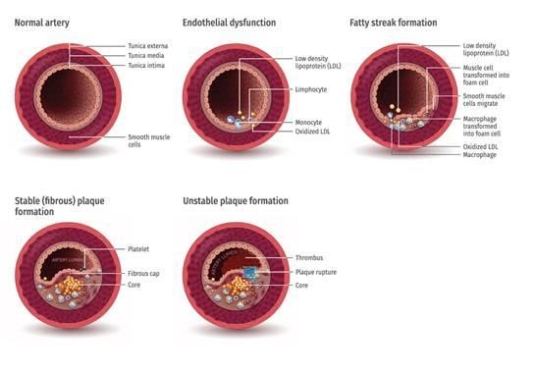

**Figure 1: The pathology of coronary artery disease (CAD). 冠状动脉疾病（CAD）的病理学。normal artery：正常动脉 endothelial dysfunction:内皮功能障碍 fatty streak formation：脂肪条纹形成 stable(fibrous) plaque formation:稳定（纤维状）斑块形成 unstable plaque formation:不稳定板块形成**

Hence, an early clinical diagnosis is needed to better assist the CAD patients. The clinical vital information on the functioning of the heart is reflected in the ECG signals. The minute changes in the morphology of the ECG beat indicates a cardiac abnormality.因此，需要早期临床诊断来更好地帮助CAD患者。关于心脏功能的临床生命信息反映在ECG信号中。心电图节拍形态的微小变化表明心脏异常。 Long QT interval and abnormally high T waves imply acute myocardial infarction (MI), but depressed and elevated ST segments indicate sub endocardial and extensive myocardial ischemia respectively [7]. 长QT间隔和异常高的T波暗示急性心肌梗死（MI），但下降和升高的ST段分别表明子心内膜和广泛的心肌缺血[7]。Nevertheless, manually examining the voluminous ECG signals for disease-related morphological changes are tedious and may lead to errors in reading the ECG signals. Also, these disease indicators may appear irregularly in the ECG timescale. 然而，手动检查疾病相关形态变化的大量ECG信号是乏味的，并且可能导致读取心电图信号的错误。此外，这些疾病指标可能在ECG时间尺度中不规则地出现。Hence, computer aided diagnosis system can be an effective and reliable tool to overcome these inadequacies of manual examination of diseases using ECG signals. 因此，计算机辅助诊断系统可以是一种有效且可靠的工具，以克服使用ECG信号对疾病进行手动检查的这些不足。

Over the last decade, several algorithms for automated characterization of CAD have been widely developed.在过去十年中，已广泛开发了用于CAD的自动表征的几种算法。 These algorithms are implemented using various advanced signal processing methods, such as linear [32,27,31] and nonlinear [32,27,31,8,9,5], wavelet transform [20,38,47,26,30] algorithms coupled with artificial intelligence techniques [34,35]. 这些算法使用各种先进的信号处理方法实现，例如线性[32,27,31]和非线性[32,27,31,8,9,5]，小波变换[20,38,47,26,30]算法与人工智能技术结合[34,35]。Acharya et al. [1] proposed an automated detection system for CAD and MI using *three* decomposition techniques, namely discrete cosine transform (DCT), empirical mode decomposition (EMD) and discrete wavelet transform (DWT). ACHAREA等 [1]提出了一种用于CAD和MI的自动检测系统，使用三种分解技术，即离散余弦变换（DCT），经验模式分解（EMD）和离散小波变换（DWT）。The proposed system achieved maximum classification accuracy of 98.5%, sensitivity of 99.7% and specificity of 98.5% using only *seven* features extracted from DCT coefficients. 所提出的系统实现最大分类精度为98.5％，灵敏度为99.7％，特异性为98.5％，只有来自DCT系数提取的七个特征。 The summary of studies conducted on the automated characterization of CAD using ECG and HRV signals is shown in Table1. 使用ECG和HRV信号在CAD自动表征上进行的研究摘要如表1所示。 These studies are mainly focused on feature extraction and classification processes. The performance of the classifier greatly depends on the distinctive characteristics of the extracted features. 这些研究主要集中在特征提取和分类过程中。分类器的性能大大取决于提取特征的独特特征。Hence, features extraction process is most crucial in characterizing the ECG signals. Furthermore, feature extraction process, normalization, denoising, segmentation, dimension reduction, features selection, and involve a series of *trial and error* manipulation prior to acquiring distinctively significant features for optimal classification results. 因此，特征提取过程在表征ECG信号时是最重要的。此外，特征提取过程，归一化，去噪，分割，尺寸减少，特征选择，并涉及在获取最佳分类结果的明显显着特征之前，涉及一系列试验。This process is time consuming and labor intensive as it involves finding and selection of important features. In addition, the computational complexity of the whole process may significantly increase with huge diverse ECG signals which may alleviate its application as a heart screening toolkit. 这个过程是耗时和劳动密集，因为它涉及找到和选择重要特征。此外，整个过程的计算复杂性可以随着巨大的多样化ECG信号而显着增加，这可以减少其作为心脏筛选工具包的应用。

There are several signal processing techniques that can be used to extract distinctive information from the ECG signals [4]. Still, the real challenge lies in carefully choosing the appropriate technique and testing the developed model. 有几种信号处理技术可用于从ECG信号提取独特信息[4]。尽管如此，真正的挑战仍在仔细选择适当的技术和测试开发的模型。The signal processing techniques are generally categorized as linear and nonlinear. The linear group is further divided into time and frequency domain measures [19]. The nonlinear techniques used are based on the theory of chaos [18]. 信号处理技术通常被分类为线性和非线性。线性组进一步分为时间和频域测量[19]。使用的非线性技术基于混沌理论[18]。The time domain measures are vulnerable to outliers and artifacts, which has an impact on the specificity and sensitivity [3]. In addition, time domain measures may not be particularly reliable in differentiating distinct ECG signals with similar *means* and standard deviations. 时域措施容易受到异常值和人为的影响，这对特异性和灵敏度产生了影响[3]（论文讲了不同姿势对心率有影响）。另外，在将具有类似均值和标准差的不同的ECG信号区分不同的情况下，时间域措施可能不特别可靠。The frequency domain measures assume that signal is periodic and stationary. However, this assumption is invalid for ECG signals. In order to overcome these problems, nonlinear methods can be used [3]. 频域测量假定该信号是周期性和静止的。但是，这种假设对于ECG信号无效。为了克服这些问题，可以使用非线性方法[3]

The automated characterization of heart abnormalities using ECG signal is a challenging task. The system classification performance may significantly vary among patients due to artifacts and even unbalanced classes of ECG signals. 使用ECG信号的心脏异常自动表征是一个具有挑战性的任务。由于人为影响以及不平衡类别的ECG信号，系统分类性能可能显着变化。Furthermore, notable variations can be observed in morphological and time domain characteristics of ECG signals for different patients during various physical and temporal conditions [24]. 此外，可以在各种物理和时间条件下的不同患者的ECG信号的形态学和时域特征中观察到显着变化[24]。Nevertheless, these methodologies performed well only while using training

data also for testing (ten-fold cross validation), but not in clinical practice (see Table 1). In real life, ECG signals are different for various classes and factors like age, sex, condition of like diabetes, blood pressure, mental states and life style affecting the

signal [33,15]. 尽管如此，这些方法仅在使用训练数据的同时进行测试（十倍交叉验证），但不在临床实践中（见表1）。在现实生活中，ECG信号对于各种阶级和因素不同，例如糖尿病，患糖尿病，血压，精神状态和影响信号的生活方式的各种类别和因素[33,15]。

Therefore, to overcome the limitations present in the methods presented in Table 1, this study proposes the deep learning-based approach for the diagnosis of CAD using ECG signals. 因此，为了克服表1中呈现的方法中存在的限制，本研究提出了使用ECG信号诊断CAD的深度学习方法。In this work, we have used *eleven* layered CNN comprising of convolution layers, subsampling layers and fully connected layers, which are like multilayer perceptron (MLP).在这项工作中，我们使用了11个层叠的CNN，包括卷积层，子采样层和完全连接的层，这就像多层感知机（MLP）。 The CNNs have performed remarkably well for image analysis and classification [25,29]. Hence, they are likely to detect hidden signatures from the physiological signals without any preprocessing, feature extraction and selection steps. 对于图像分析和分类，CNN具有显着良好的表现[25,29]。因此，它们可能会从没有任何预处理，特征提取和选择步骤的情况下检测生理信号的隐藏信息。

**Table 1: Summary of studies conducted on the automated characterization of CAD using ECG and HRV signals. 使用ECG和HRV（心率变异性）信号对CAD自动表征进行的研究摘要。**

|  |  |  |
| --- | --- | --- |
|  | **HRV 心率变异性signals** |  |
| **Reference (Year)** | **Methodology** | **Performance** |
| Lee et al  [32], 2007 | **Linear Features:**   * Frequency domain频域• Time domain **时域**   **Nonlinear Features:**   * Poincare plot潘凯图• Approximate entropy **近似熵**   **Classifiers:**   * Support vector machine (SVM) * Classification based on multiple association rules (CMAR) **基于多关联规则的分类** * Naïve Bayesian (NB) * C4.5 (Decision tress) | Acc = 90% |
| Kim et al  [27], 2007 | **Linear Features:**   * Frequency domain• Time domain   **Nonlinear Features:**   * Poincare plots * Fractal scaling measures **分形尺度** * Complexity estimations **复杂性估计** * **Classifiers: 分类器：** * Multiple discriminant analysis (MDA) **多组判别分析** | Acc = 72.5 ~  84.6% |
| Lee et al  [31], 2008 | **Linear Features:**   * Frequency domain• Time domain   **Nonlinear Features:**   * Poincare plot * Hurst exponent赫斯特指数 * Detrended fluctuation analysis去趋势波动分析 * Approximate entropy   **Classifiers:**   * Support vector machine (SVM) * Classification based on multiple association rules (CMAR) **多组判别分析** * Classification based on predictive association rules (CPAR) **基于预测关联规则的分类** * Multiple discriminant analysis (MDA) **多组判别分析** * Naïve Bayesian (NB) **朴素贝叶斯** | Acc = 85 ~ 90% |

|  |  |  |
| --- | --- | --- |
|  | • C4.5 (Decision tress) |  |
| Giri et al  [20], 2013 | **Wavelet transform: 小波变换**   * Discrete wavelet transform (DWT) 离散小波变换**Dimensionality reduction techniques: 降维技术** * Principle component analysis (PCA) 主成分分析 * Independent component analysis (ICA)独立成分分析 * • Linear discriminant analysis (LDA) 线性判别分析 * **Classifiers:** * Support vector machine (SVM) * Gaussian mixture model (GMM) 高斯混合模型 * K-Nearest Neighbors (KNN) * Probabilistic neural network (PNN) 概率神经网络 | Acc = 96.8%  Sen = 100%  Spec = 93.7% |
| Patidar et  al [38],  2015 | **Features:**   * Tunable Q wavelet transform (TQWT) based decomposition 基于可调Q小波变换（TQWT）的分解 * Correntropy based nonlinear features computed from sub-band of TQWT based decompositions 基于TQWT分解子带计算的相关熵非线性特征**Classifier:** * Least Squares Support Vector Machine (LS-SVM)最小二乘支持向量机 | Acc = 99.7%  Sen = 99.6%  Spec = 99.8% |
| Sood et al  [41], 2016 | **Features:**   * Empirical mode decomposition (EMD)经验模态分解 * Second-order difference plot area **二阶差分绘图面积** * Analytical signal representation area **分析信号表示区** * Amplitude-modulation bandwidth  **调幅带宽** * Frequency modulation bandwidth **调频带宽** * Fourier-Bessel expansion-based mean frequency **基于Fourier-Bessel展开的平均频率**   **Classifier**   * Statistical analysis using p-value and Krusal-Wallis利用p值和Krusal-Wallis进行统计分析 | AM and FM bandwidth and FBE-based features are reported to be better at picking up subtle details as compared to ASR and SODP  area features 与ASR和SODP相比，AM和FM带宽以及基于FBE的特性更能捕捉到细微的细节区域特征 |
|  | **ECG signals** |  |
| **Reference (Year)** | **Methodology** | **Performance** |
| Schreck et al [39],  1988 | **Features:**   * Biopotential coordinate transformation (BCT) 生物电位坐标变换 * **Classification:** * Blinded test 盲法试验 * Fisher’s exact test 费系尔精确检验 | **Men:**  Sen = 84.3% Spec = 81.8% **Women:**  Sen = 76.2%  Spec = 80% |
| Lehtinen et al [34],  1998 | **Features:**  • Artificial neural network **人工神经网络分类Classification:** | ROC = 91.5% |

|  |  |  |
| --- | --- | --- |
| • Receiver operating characteristics (ROC) analysis 观测者操作特性曲线分析 | |  |
| Lewenstein  et al [35], 2001 | **Features:**  • Radial basis function (RBF) neural networks 径向基函数（RBF）神经网络 | Average Spec and Sen  97% |
| Arafat et al  [8], 2005 | **Features:**   * Fuzzy uncertainty 模糊不确定性 * Probabilistic uncertainty 概率不确定性 * Combined uncertainty 组合不确定性 | 80% correct classification percentage  (CCP) |
| Babaoglu  et al [9],  2010 | **Features:**   * Principle component analysis (PCA) **Classifier:** * Support vector machine (SVM) | Acc = 79.2% |
| Babaoglu  et al [10],  2010 | **Features selection:**   * Binary particle swarm 二进制粒子群 * Genetic algorithm **遗传算法** * **Classifier:** * Support vector machine | Acc = 81.7% |
| Yin et al  [47], 2011 | **Features:**   * Denoise 去噪 * Wavelet decomposition 小波分解 * R-wave peaks detection R波峰值检测 * ST segment detection ST段检测 | Acc = 80% |
| Kaveh et al  [26], 2013 | **Features:**   * Discrete wavelet transform (DWT) • 小波变换 * Principle component analysis (PCA) **Classifier:** * Support vector machine (SVM) | Acc = 88% |
| Acharya et al [5], 2017 | **Features:**   * Bispectrum **双谱** * Cumulant **累积量**   **Classifiers:**   * K-Nearest Neighbors (KNN) * Decision Tree (DT) | **BispectrumKNN:**  Acc = 98.2%  Sen = 94.8%  Spec = 99.3% |
| Kumar et  al [30],  2017 | **Features:**   * Flexible Analytic Wavelet Transform(FAWT)  **灵活的解析小波变换** * • Cross Information Potential (CIP) **交叉信息潜力** * **Classifiers:** * Least Squares Support Vector Machine (LS-SVM) | Acc = 99.6% |
|  | **2 seconds and 5 seconds of ECG segments** |  |
|  | **Methodology** | **Performance** |
| **In this study** | **Convolutional Neural Networks (CNNs) (11 layers):**   * Four convolutional layers * Four max pooling layers * Three fully connected layers | **Net A:**  Acc = 95%  Sen = 93.7% Spec = 95.2%  **Net B:**  Acc = 95.1%  Sen = 91.1%  Spec = 95.9% |

**\* Acc = accuracy, PPV = positive predictive value, Sen = sensitivity, Spec = specificity.**

# METHODOLOGY 方法

# Material Used 使用的数据

The normal and CAD ECG signals were retrieved from the Physionet databases, namely Fantasia (for Normal) and St.-Petersburg Institute of Cardiology Technics 12lead arrhythmia (for CAD) [22]. 从物理体数据库检索正常和CAD ECG信号，即幻想曲（对于正常）和圣彼得堡的心脏病学技术12导联心律失常（CAD）[22]。In this work, we have taken the ECG signals (lead II) from 40 normal (20 males and 20 females) and 7 CAD (1 male and 6 females) subjects. The overview of the number of segmented ECG signals (2 and 5 seconds) used is shown in Table 2. 在这项工作中，我们从40名正常（20名男性和20名女性）和7名CAD（1男性和6名女性）受试者中获取了ECG信号（表II）。表2中示出了使用分段的ECG信号（2和5秒）的数量概述。In this study, a total of 95300 and 38120 segmented ECG signals were used for Net 1 (2 seconds) and Net 2 (5 seconds) respectively. 在本研究中，共有95300和38120分段的ECG信号分别用于Net 1（2秒）和Net 2（5秒）。

**Table 2: Total number of segmented ECG signals used (2 and 5 seconds).**

|  |  |  |
| --- | --- | --- |
| **Type** | **Number of 2 seconds segments (Net 1)** | **Number of 5 seconds segments (Net 2)** |
| Normal | 15300 | 6120 |
| CAD | 80000 | 32000 |
| **Total** | **95300** | **38120** |

# Pre-processing 预处理

The ECG signals from the Fantasia database (for Normal) and St.-Petersburg Institute of Cardiology Technics 12-lead arrhythmia database (for CAD) were sampled at 250 Hz and 257 Hz respectively. 来自Fantasia数据库（正常）和圣彼得堡心脏病学技术12-导联心律失常数据库（CAD）的ECG信号分别以250Hz和257 Hz进行采样。The ECG signals from Fantasia database (for Normal) were up-sampled to 257 Hz to establish uniformity and standardization of both databases. 来自Fantasia数据库（正常）的ECG信号被上采样到257 Hz，以建立两个数据库的均匀性和标准化。Subsequently, discrete wavelet transform (DWT) was applied on the ECG signals using Daubechies 6 (db6) mother wavelet to remove the noise and baseline wander [40]. 随后，在ECG信号上应用离散小波变换（DWT）使用Daubechies 6（DB6）母小波，以去除噪声和基线漂移[40]。

# ECG signal segmentation 心电图信号分段

Next, the pre-processed normal and CAD ECG signals are segmented into two

separate groups Net 1 and Net 2 for *two* and *five* seconds time intervals respectively without any detection of R peaks of the ECG waves. 接下来，将预处理的正常和CAD ECG信号分段分为Net 1和NET 2两组，分别为2和5秒的时间间隔，而不检测ECG波的R峰值。The *five* and *two* second ECG segment consists of 1285 and 514 samples respectively. In addition, Z score normalization technique is implemented to normalize the individual ECG segments. 五秒和两秒的心电图片段分别由1285和514个样本组成。此外，实现了Z score归一化技术以归一化各个ECG段。This is to overcome the problem of amplitude scaling and to remove the offset effect prior to feeding the segmented ECG signals to the 1 dimensional (1D) CNN for training and testing. The typical plot of the *two* and *five* second ECG signals are shown in Figure 2 and Figure 3 respectively. 这是为了克服幅度缩放的问题，并在将分段的ECG信号馈送到1维（1D）CNN之前，去除偏移效果以进行训练和测试。两秒和五秒ECG信号的典型图分别如图2和图3所示。

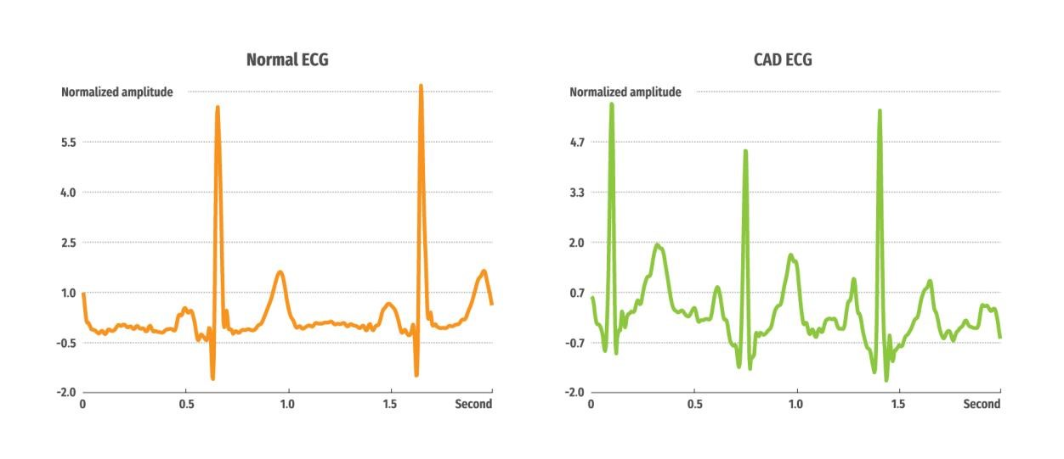

**Figure 2: Typical sketch of 2 second ECG signals (Net 1).**

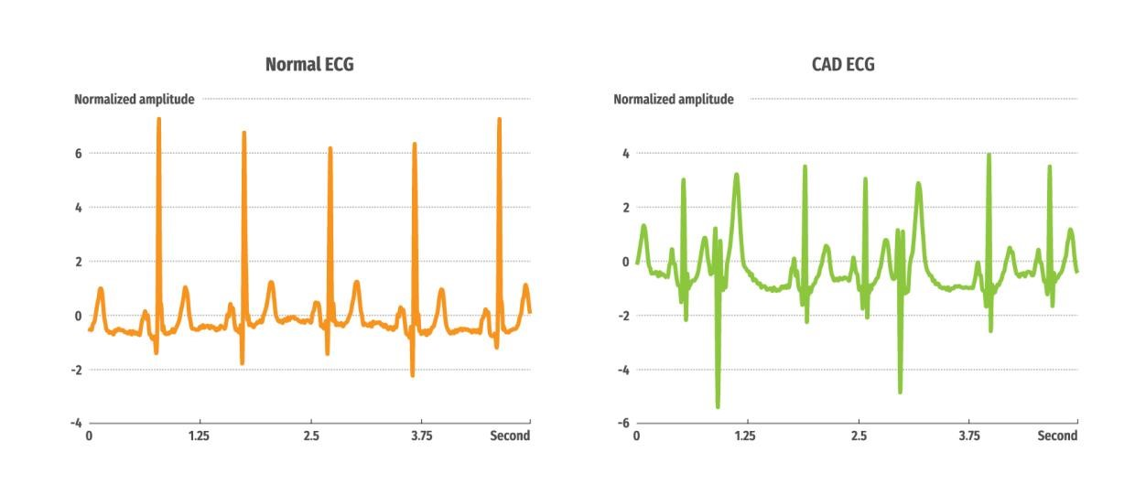

**Figure 3: Typical sketch of 5 second ECG signals (Net 2).**

# Convolutional Neural Networks (CNNs) 卷积神经网络

The convolutional neural networks (CNNs) technique is made up of *two* components. The first component is the feature identifier where the features from the input data are automatically learned. The second component is a fully connected multi-layer perceptron (MLP) which carry out classification based on the initially learned features [48]. 卷积神经网络（CNNS）技术由两个组件组成。第一组件是自动学习输入数据的特征表示器。第二组件是一个完全连接的多层感知机（MLP），其基于最初学习的特征进行分类[48]。Further, the feature identifier component comprises of convolutional and pooling layers. In the convolutional layer, the activation (or feature) map from the previous layer is convolved using convolutional filter (or kernel) which is added with a bias and subsequently fed to the activation function to generate an activation map for the next layer.此外，特征表示器组件包括卷积和池化层。在卷积层中，来自前一层的激活（或特征）图被使用卷积滤波器（或内核）卷积，该卷积滤波器（或内核）被添加偏置并随后馈送到激活函数以生成下一层的激活图。 Meanwhile, the pooling layer (or subsampling layer) causes the activation maps to be reduced but, increases the invariance to distortion in the inputs. The convolutional and pooling layers are positioned to accomplish high level feature

extraction. Also, a simple classifier, such as softmax, can be used in the last part of the CNNs. 同时，池化层（或下采样层）使激活图减少，但是，增加了输入中的失真的不变性。卷积和池化层作用是完成高级特征提取。此外，可以在CNN的最后一部分中使用诸如Softmax的简单分类器。

Let 𝒙𝟎𝒊 **= (x1, x2…, xn)** be the data input vector, where *n* is the total number of samples

in the ECG segment [48]. 让𝒙𝟎𝒊 **= (x1, x2…, xn)是数据输入向量，这里n是ECG片段的总样本数。**Next, the convolutional layer output is computed as follows 接下来，卷积层输出计算如下

𝒄𝒍𝒊,𝒌 = 𝝈(𝒃𝒌 + ∑𝑵𝒏=𝟏 𝒘𝒌𝒏 𝒙𝟎𝒌𝒊+𝒏−𝟏)

(1)

where *l* is the layer index, sigma is the activation function producing nonlinearity, b is the bias for the kth activation map, N is the size of the filter, 𝑤𝑛𝑘is the weight for the nth

filter index and kth activation map.这里l是层的索引，σ是非线性激活函数，b是第k个特征的偏置。Also, max pooling can be used to compute the maximum value in an input. The activation map in a layer is the pool using the following computation, 此外，最大池化可用于计算输入中的最大值。图层中的激活映射是使用以下计算的池化，



(2) Where T is the window size of the pooling and S is the pooling stride. Thus, the activation map from layer to layer forward propagation is computed using the

equation (1) and (2). 其中t是池的窗口大小，s是池步长。因此，使用等式（1）和（2）来计算来自层到层向前传播的激活图。This includes initializing the weights and calculating the error cost minimization by using stochastic gradient descent on the ECG beats. After obtaining the predicted output, the loss function is used to calculate the prediction error. 这包括通过在心电图节拍上使用随机梯度下降来初始化权重并计算错误成本最小化。在获得预测的输出后，损失函数用于计算预测误差。Then, back propagation is implemented to adjust the weights and the eror is predicted by calculating the slope of the convolutional weights. The process of forward and back propagation is continuously executed till the required number of epochs or other stopping criteria is met [48]. 然后，实现了反向传播以调整权重，通过计算卷积权重的斜率来预测错误。在满足所需数量的批次或其他停止标准之前，连续执行前向和反向传播的过程[48]

# Structure

In this study, two 1-dimensional (1D) CNNs structures (Net 1 and Net 2) comprising of *four* convolutional layers, *four* max pooling layers and *three* fully connected layers are proposed. 在该研究中，提出了包括四个卷积层，四个最大池层和三个全连接层的两个1立维（1D）CNNS结构（net 1和net 2）。The pooling layer comes directly after the convolutional layer. Also, the striding of the filter over the input is set at 1 and 2 for convolutional and max pooling layers respectively. 汇集层在卷积层之后直接出现。而且，卷积和最大池池层的输入上的过滤器步长分别设定为1和2。For Net 1 (2 second duration), the kernel size for all the max pooling layers are set at 2. In contrast, the kernel size for the alternating convolutional layers starting from layer 1 are set at 27, 15, 4 and 3 respectively. 对于net 1（2秒持续时间），所有最大池层的内核大小被设置为2。相反，从层1开始的交替卷积层的核尺寸分别设置为27,15,4和3。For Net 2 (5 second duration), the kernel size for all the max pooling layers are set at 2. The kernel size for the alternating convolutional layers starting from layer 1 are set at 26, 15, 3 and 4 respectively. 对于net 2（5秒持续时间），所有最大池层的内核大小设置为2。从层1开始的交替卷积层的核尺寸分别设置为26,15,3和4。Lastly, the neurons in layer 8 for both Net 1 and Net 2 are completely connected to 30, 10 and 2 neurons of layer 9, 10 and 11 respectively. 最后，net 1和net 2在8层中的神经元全连接到层9,10和11分别是30,10和2神经元。For layer 1, 3, 5, 7, 9 and 10, leaky rectifier linear unit (LeakyRelu) [23] is implemented as an activation function and Xavier initialization [21] for the weights. 对于层1, 3, 5, 7, 9, 10分别用LeakyRelu作为激活函数，权重使用Xavier初始化。Also, softmax function is used as a classifier in the last layer. The proposed structures of CNN (Net 1 and Net 2) is illustrated in Figure 4 and Figure 5 respectively. The structural details of the *two* networks are provided in Table 3 and Table 4. 此外，SoftMax函数用作最后一层中的分类器。 CNN（NET 1和NET 2）的所提出的结构分别在图4和图5中示出。两个网络的结构细节在表3和表4中提供。

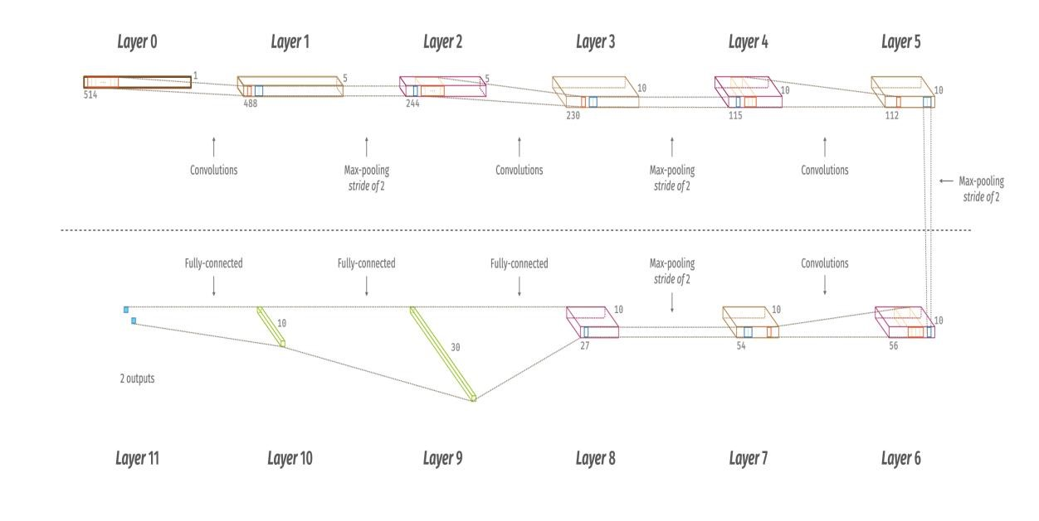

**Figure 4: The proposed CNN structure of Net 1.**

**Table 3: The detailed overview of Net 1 structure.**

|  |  |  |  |  |
| --- | --- | --- | --- | --- |
| **Layers** | **Type** | **No. of neurons**  **(output layer)** | **Kernel size for each output feature map** | **Stride** |
| 0-1 | Convolution | 488 x 5 | 27 | 1 |
| 1-2 | Max-pooling | 244x 5 | 2 | 2 |
| 2-3 | Convolution | 230 x 10 | 15 | 1 |
| 3-4 | Max-pooling | 115 x 10 | 2 | 2 |
| 4-5 | Convolution | 112 x 10 | 4 | 1 |
| 5-6 | Max-pooling | 56 x 10 | 2 | 2 |
| 6-7 | Convolution | 54x 10 | 3 | 1 |
| 7-8 | Max-pooling | 27 x 10 | 2 | 2 |
| 8-9 | Fully-connected | 30 | - | - |
| 9-10 | Fully-connected | 10 | - | - |
| 10-11 | Fully-connected | 2 | - | - |

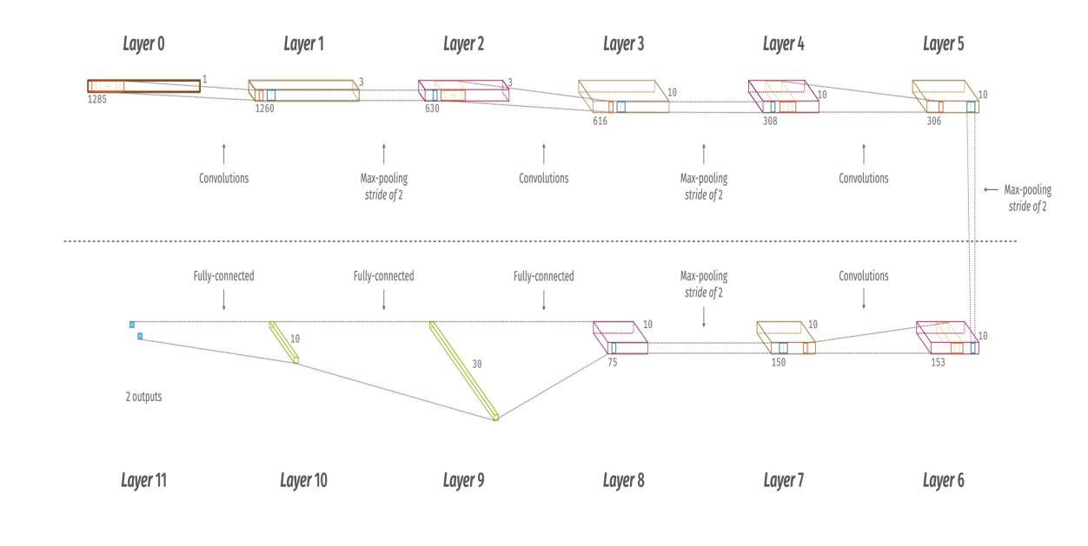

**Figure 5: The proposed CNN structure of Net 2.**

**Table 4: The detailed overview of Net A structure.**

|  |  |  |  |  |
| --- | --- | --- | --- | --- |
| **Layers** | **Type** | **No. of neurons**  **(output layer)** | **Kernel size for each output feature map** | **Stride** |
| 0-1 | Convolution | 1260 x 3 | 26 | 1 |
| 1-2 | Max-pooling | 630 x 3 | 2 | 2 |
| 2-3 | Convolution | 616 x 10 | 15 | 1 |
| 3-4 | Max-pooling | 308 x 10 | 2 | 2 |
| 4-5 | Convolution | 306 x 10 | 3 | 1 |
| 5-6 | Max-pooling | 153 x 10 | 2 | 2 |
| 6-7 | Convolution | 150 x 10 | 4 | 1 |
| 7-8 | Max-pooling | 75x 10 | 2 | 2 |
| 8-9 | Fully-connected | 30 | - | - |
| 9-10 | Fully-connected | 10 | - | - |
| 10-11 | Fully-connected | 2 | - | - |

# Training 训练

For stochastic learning, back propagation [13] with batch size of 10 samples is

employed. Accordingly, the weights are updated using the following equation (3), **对于随机学习，采用批量大小为10个样品的反向传播[13]。因此，使用以下等式（3）更新权重，**

(3)

where w is the weight, *l* is the layer number, m is the learning rate, λ is the

regularization parameter, s is the total training samples, x is the batch size and c is the cost function. Also, the biases are updated according to equation (4), **其中w是权重，l是层索引，m是学习率， lambda是正则化参数， s是训练样本数，x是批大小，c是损失函数。偏置根据以下公式更新**



(4) For this study, parameters such as regularization, learning rate and momentum are used to train the CNN structure. These parameters are set at 0.2, 0.003 and 0.7

respectively. 对于本研究，使用诸如正则化，学习率和动量的参数来训练CNN结构。这些参数分别设定为0.2,0.003和0.7。

# Testing

For every completed round of training epoch, the CNN model undergoes

computational testing whereby 30% of the total training set (90%) are used for validation. In total, twenty epochs are iteratively run for both training and testing procedures. The distribution of ECG segments used for training and testing is

illustrated in Figure 6. 对于每个完整的训练时期，CNN模型经历了计算测试，其中总训练集（90％）的30％用于验证。总共有二十个批次迭代地运行培训和测试程序。用于训练和测试的ECG段的分布在图6中示出。

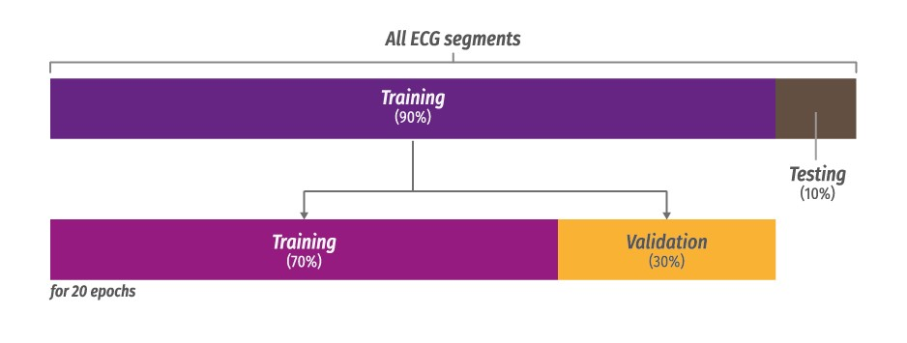

**Figure 6: An illustration of ECG segment distributions for training and testing sets. 训练和测试集的ECG段分布的例证。**

# k-fold cross validation k折交叉验证

The ten-fold cross validation technique [17] is implemented on both Net 1 (95300 ECG segments) and Net 2 (38102 ECG segments) by splitting the data in to *ten* parts. Of these, *nine* parts are used to train and the remaining ECG segments are for testing. 十倍交叉验证技术[17]通过将数据分成10个部分来在net 1（95300CEG段）和NET 2（38102CECG段）上实现。其中，九个部分用于培训，剩余的ECG段用于测试。The process is iterated *ten* times by shifting the testing part. Simultaneously, classification performance (accuracy, specificity and sensitivity) is computed for every fold and the overall performance is obtained by taking the average of the *ten* folds. 这个过程迭代了十次，通过交换测试部分，同时分类性能（精度，特异性和灵敏度）通过计算十次的平均值得到。

# RESULTS 结果

The experiment is conducted on a workstation with two Intel Xeon 2.40 GHz (E5620) processor and 24 GB RAM specification. Net 1 and Net 2 availed 3472.842 seconds and 1649.483 seconds respectively to complete an epoch. 该实验是在具有两个英特尔Xeon 2.40 GHz（E5620）处理器和24 GB RAM的工作站上进行的。 NET 1和NET 2可分别使用3472.842秒和1649.483秒，以完成一个迭代。

The confusion matrix of the results for Net 1 is presented in Table 5. It can be noted from the table that, sensitivity of 95.18% and specificity of 93.72% is obtained for the input of 2 seconds of ECG segment. In this work, 6.28% of the CAD ECG

segments are wrongly identified as normal. Net 1的结果的混淆矩阵列于表5中。可以从表中注意到，获得95.18％的灵敏度，93.72％的特异性对于2秒的ECG段的输入。在这项工作中，6.28％的CAD ECG段被错误地确定正常。

**Table 5: Confusion matrix for Net 1.**

|  |  |  |  |  |  |  |
| --- | --- | --- | --- | --- | --- | --- |
| **Original/**  **Predicted** | **Normal** | **CAD** | **Acc (%)** | **PPV (%)** | **Sen (%)** | **Spec (%)** |
| **Normal** | 76146 | 3854 | 94.95 | 98.75 | 95.18 | 93.72 |
| **CAD** | 961 | 14339 | 94.95 | 78.82 | 93.72 | 95.18 |

* **Acc = accuracy, PPV = positive predictive value, Sen = sensitivity, Spec = specificity.**

Table 6 shows the results obtained using 5 seconds of ECG duration. It can be noted from the table that, sensitivity of 95.88% and specificity of 91.13% is obtained. Also,

out of the 6120 CAD ECG segments, 8.87% are incorrectly identified as normal. 表6显示了使用5秒的ECG持续时间获得的结果。可以从表中注意到，获得95.88％的灵敏度和91.13％的特异性。此外，在6120个CAD ECG段中，8.87％不正确地确定正常。

**Table 6: Net 2 confusion matrix obtained using 10-fold cross validation.**

|  |  |  |  |  |  |  |
| --- | --- | --- | --- | --- | --- | --- |
| **Original/**  **Predicted** | **Normal** | **CAD** | **Acc (%)** | **PPV (%)** | **Sen (%)** | **Spec (%)** |
| **Normal** | 30680 | 1320 | 95.11 | 98.26 | 95.88 | 91.13 |
| **CAD** | 543 | 5577 | 95.11 | 80.86 | 91.13 | 95.88 |

* **Acc = accuracy, PPV = positive predictive value, Sen = sensitivity, Spec = specificity.**

Lastly, the overall classification performance for Net 1 and Net 2 is shown in Table 7. For Net 1, 94.95% accuracy, 93.72% sensitivity and 95.18% specificity is yielded. On the other hand, Net 2 achieved an accuracy of 95.11%, sensitivity of 91.13%, and

specificity of 95.88%. 最后，net 1和net 2的整体分类性能如表7所示。对于net 1,94.95％的精度，93.72％的敏感性和95.18％的特异性。另一方面，net 2达到了95.11％的精度，灵敏度为91.13％，特异性为95.88％。

**Table 7: The overall classification performance for Net 1 (2 seconds) and Net 2 (5 seconds).**

|  |  |  |  |  |  |  |  |  |
| --- | --- | --- | --- | --- | --- | --- | --- | --- |
| **Segment length** | **TP** | **TN** | **FP** | **FN** | **Acc (%)** | **PPV (%)** | **Sen (%)** | **Spec (%)** |
| **2**  **seconds** | 14339 | 76146 | 3854 | 961 | 94.95 | 78.82 | 93.72 | 95.18 |
| **5**  **seconds** | 5577 | 30680 | 1320 | 543 | 95.11 | 80.86 | 91.13 | 95.88 |

**\*TP = true positive, TN = true negative, FP = false positive, FN = false negative.**

**Acc = accuracy, PPV = positive predictive value, Sen = sensitivity, Spec = specificity.**

# DISCUSSION

The proposed deep learning structures (Net 1 and Net 2) for ECG signal characterization is motivated by its application to image analysis and classification [25,29]. Several studies have initiated the implementation of CNN for the automated characterization of abnormal ECG signals. 对于ECG信号表征的建议深度学习结构（NET 1和NET 2）通过其应用于图像分析和分类来激励[25,29]。几项研究已启动CNN的实施，以实现异常ECG信号的自动表征。Kiranyaz et al. [28] developed a patient specific ECG monitoring and categorizing system using *three* layer CNN structure. Their system used only R wave and detected ventricular and supraventricular ectopic beats with 99.00% and 97.60% accuracies respectively. Kiranyaz等人使用三层CNN结构开发了患者特定的ECG监测和分类系统。它们的系统仅使用R波，检测到的室性和室上性异位搏动，分别具有99.00％和97.60％的精度。Zubair et al. [48] trained a *three* layer CNN structure using derived R peak ECG beat patterns and yielded 92.7% accuracy in detecting the *five* ECG classes. Zubair等人。 [48]使用衍生的R峰值ECG模式训练了三层CNN结构，并在检测五个ECG类方面产生92.7％的精度。Acharya et al. [2] developed an *eleven* layer CNN structure to characterize the *four* ECG classes using *two* and *five* seconds of ECG signals. They reported 92.50% accuracy, 98.09% sensitivity and 93.13% for the *two* seconds of ECG signals. ACHAREA等。 [2]开发了十一层CNN结构，以使用两秒和五秒的ECG信号来表征四个ECG类。它们的精度为92.50％，灵敏度为98.09％，2秒的ECG信号的灵敏度和93.13％。Also, their system obtained 94.90% accuracy, 99.13% sensitivity and 81.44% specificity for *five* seconds of ECG signals. In this study, alternative convolution and pooling layers are employed to derive robust deep features from the segmented ECG signals. 此外，其系统的精度为94.90％，灵敏度为99.13％，5秒的ECG信号的特异性为99.13％和81.44％。在本研究中，采用卷积和池化层来从分段的ECG信号推导强大的深度特征。Next, the features are linked to the fully connected layers for the ECG signal characterization. Our system negates the need for feature extraction, pre-processing, and classification stages. Thus, making the proposed system is suitable for real time monitoring of cardiac abnormalities. 接下来，该特征与全连接层链接到ECG信号表征。我们的系统否定了特征提取，预处理和分类阶段的需求。因此，使提出的系统适用于对心脏异常的实时监测。

Based on the results yielded in Table 5, Table 6 and Table 7, it can be argued that the algorithm implemented is significantly robust, reliable and efficient in deriving deep features and characterizing the input ECG signal. 基于表5，表6和表7所产生的结果，可以认为所实现的算法在引导深度特征和表征输入的ECG信号中具有显着稳健，可靠和高效的。Moreover, the extraction and selection of the features and classification are combined into a single structure. Evidently, the performance of the CNNs structure have been validated with Net 1 and Net 2. The classification performance results of Net 1 (2 seconds) and Net 2 (5 seconds) are comparably superior as shown in Table 1. 此外，将特征和分类的提取和选择组合成单个结构。显然，CNNS结构的性能已经用NET 1和NET 2验证。net 1（2秒）和net 2（5秒）的分类性能结果相当优于表1。

In addition, the class of artificial neural networks formed by CNNs have shifting and scaling invariance properties. The model relies on the learn convolution kernels to reliably represent the data. Thus, R peak detection is not performed as the segmented ECG signals are not affected by time scaling or shifting. The R peak

detection is implemented in most of the works listed in Table 1. 此外，CNN形成的人工神经网络的类具有转换和缩放不变性属性。该模型依赖于学习卷积内核以可靠地代表数据。因此，由于分段的ECG信号不受时间缩放或移位的影响，不执行R峰值检测。在表1中列出的大多数作品中实现了R峰值检测。

The computational cost of the proposed system for the ECG signals characterization is relatively low. The algorithm is implemented in a computer with specifications of two Intel Xeon 2.40 GHz (E5620) processor and 24 GB RAM. 所提出的ECG信号表征系统的计算成本相对较低。该算法在具有两个英特尔Xeon 2.40 GHz（E5620）处理器和24 GB RAM的计算机上的计算机中实现。Moreover, the proposed system only needs 1-Dimensional convolutions (multiplications and additions), hence implementation is economical and requires simple hardware. Therefore, the trained dedicated CNN can be used to characterize patient’s long ECG signals efficiently and accurately. Also, Net 1 and Net 2 require

3472.842 seconds and 1649.483 seconds to complete an epoch. 此外，所提出的系统仅需要1维卷积（乘法和加法），因此实现是经济的，需要简单的硬件。因此，训练有素的专用CNN可用于有效且准确地表征患者的长ECG信号。此外，NET 1和NET 2要求3472.842秒和1649.483秒完成一个epoch。

The main advantages of our proposed system are summarized below: 我们所提出的系统的主要优势总结如下：

1. The proposed CNNs structure is robust to shifting and scaling invariance. 所提出的CNNS结构是稳健的转换和缩放不变性。
2. QRS detection is not required. 不需要QRS检测。
3. Feature extraction, selection and classification procedures are combined in a single CNN structure. 特征提取，选择和分类程序在单个CNN结构中组合。
4. Ten-fold cross validation ensures that, the results are reliable and robust. 十倍的交叉验证可确保结果可靠且稳健。
5. The proposed system does not require extensive computational machinery. Thus,

it is considerably easy to operate and cost effective. 本文的系统不需要广泛的计算机械。因此，操作和成本效益相当容易。

The drawbacks of our proposed system are as follows: 我们提出的系统的缺点如下：

1. The CNN requires lot of time (few hours) to train. CNN需要大量的时间（几个小时）来训练。
2. The training process requires huge database. 训练过程需要大量数据。
3. The length of the ECG signals for training and testing must be fixed, which

depends on the structure of the CNN. 必须固定用于训练和测试的ECG信号的长度，这取决于CNN的结构。

# CONCLUSION

The CAD is the leading cause of heart attack. Therefore, a reliable and efficient automated diagnosis system is needed for an early detection of CAD. In this study, CNNs structures (Net 1 and Net 2) comprising of *four* convolutional layers, *four* max pooling layers and *three* fully connected layers are developed to detect *two* classes (normal and CAD). CAD是心脏病发作的主要原因。因此，需要可靠和有效的自动诊断系统来早期检测CAD。在该研究中，开发了包括四个卷积层，四个最大池层和三个全连接层的CNNS结构（网1和网2）以检测两个类（正常和CAD）。In total, 95300 ECG segments of Net 1 (2 seconds) and 38120 ECG segments of Net 2 (5 seconds) are used. The proposed system yielded 94.95% accuracy, 93.72% sensitivity and 95.18% specificity for Net 1 and 95.11% accuracy, 91.13% sensitivity and 95.88% specificity for Net 2. 总共有95300个ECG段的 net 1（2秒）和38120个ECG段的net 2（5秒）。所提出的系统的精度为94.95％，灵敏度为93.72％，特异性为95.18％net 1和95.11％的精度，91.13％的敏感性和95.88％的特异性对于net 2。Our developed system can assist the clinicians to accurately diagnose CAD. Our method is simple to use, affordable and can be used for cardiac screening in developing nations. In future work, authors will be exploring possibility of improving the CNN structure with huge database. 我们的系统可以帮助临床医生准确诊断CAD。我们的方法很容易使用，价格实惠，可用于发展中国家的心脏筛选。在未来的工作中，作者将探索使用巨大数据库改进CNN结构的可能性。 Also, this work can be extended for the early diagnosis of CAD, different stages of myocardial infarction (MI) and congestive heart failure (CHF) using ECG signals. This will help the clinicians to provide proper medication and save life. 此外，可以扩展该作品，以便使用ECG信号进行CAD的早期诊断，心肌梗死（MI）和充血性心力衰竭（CHF）的早期诊断。这将有助于临床医生提供适当的药物和拯救生命。

# REFERENCES

1. Acharya UR, Fujita H, Adam M, Lih OS, Sudarshan VK, Hong TJ, Koh JEW, Hagiwara Y, Chua CK, Poo CK, San TR. Automated characterization and classification of coronary artery disease and myocardial infarction by decomposition of ECG signals: A comparative study. Information Sciences, 377:

17-29, 2017.

1. Acharya UR, Fujita H, Lih OS, Hagiwara Y, Tan JH, Adam M. Automated detection of arrhythmias using different intervals of tachycardia ECG segments with

convolutional neural network. Information sciences, 405: 81-90, 2017.

1. Acharya UR, Kannathal N, Hua LM, Yi LM. Study of heart rate variability signals at sitting and lying postures. Journal of Bodywork and Movement Therapies, 9: 134-141, 2005.
2. Acharya UR, Faust O, Sree V, Swapna G, Martis RJ, Kadri NA, Suri JS. Linear and nonlinear analysis of normal and CAD-affected heart rate signals. Computer Methods and Programs in Biomedicine, 113(1):55-68, 2014.
3. Acharya UR, Sudarshan VK, Koh JEW, Martis RJ, Tan JH, Oh SL, Muhammad A, Hagiwara Y, Mookiah MRK, Chua KP, Chua CK, Tan RS. Application of higherorder spectra for the characterization of coronary artery disease using

electrocardiogram signals. Biomedical Signal Processing and Control, 31(2017), 31-

34.

1. American Heart Association, AHA. Heart disease and stroke statistics – 2016 Update, A report from the American Heart Association (AHA). Circulation, pp. e2-211, 2016.
2. Arafat S, Dohrmann M, Skubic M. Classification of coronary artery disease stress ECGs using uncertainty modeling. 1-4244-0020-1, IEEE, 2005.
3. Arafat S, Dohrmann M, Skubic M. Classification of coronary artery disease stress ECGs using uncertainty modeling. 1-4244-0020-1, IEEE, 2005.
4. Babaoglu I, Findik O, Bayrak M. Effects of principle component analysis on assessment of coronary artery diseases using support vector machine. Elsevier, Expert Systems with Applications, 37:2182-2185, 2010.
5. Babaoglu I, Findik O, Ulker E. A comparison of feature selection models utilizing

binary particle swarm optimization and genetic algorithm in determining coronary artery disease using support vector machine. Elsevier, Expert Systems with Applications, 37: 3177-3183, 2010.

1. Bhatia SK. Chapter 2: Coronary artery disease. Biomaterials for clinical

applications, pp. 23-49. Springer, 2010. ISBN: 978-1-4419-6919-4.

1. Bloom De, Cafiero ET, Jane-Llopis E, et al. The global economic burden of

noncommunicable diseases. Geneva, Switzerland: World Economic Forum, 2013.

1. Bouvrie J. Notes on convolutional neural network, 2007.
2. Buja LM, McAllister Jr HA. Coronary artery disease: pathological anatomy and pathogenesis. In: Willerson JT, Cohn JN, Wellens HJJ, Holmes Jr DR, editors.

Cardiovascular medicine, 3rd ed. London: Springer, pp. 593-610, 2007.

1. Buja LM, Willerson JT. The role of coronary artery lesions in ischemic heart disease: insights from recent clinicopathologic, coronary arteriographic, and experimental

studies. Hum Pathol., 18:451-61, 1987.

1. de Chazal P, Reilly RB. A patient-adapting heartbeat classifier using ECG morphology and heartbeat interval features. IEEE Trans. Biomed. Eng., vol. 53, no. 12, pp. 2534-2543, 2006.
2. Duda RO, Hart PE, Stork DG. Pattern classification 2nd edition. New York, John Wiley and Sons, 2001.
3. Eckmann JP, Rueller D. Ergodic theory of chaos and strange attractors. Review of

Modern Physics, 57(3), part 1, pp. 617-656, 1985.

1. Faust O, Acharya R, Krishnan US, Min L. Analysis of cardiac signals using spatial

filling index and time-frequency domain. Biomed. Eng. Online 3(1), (2004), 1-30.

1. Giri D, Acharya UR, Martis RJ, Sree SV, Lim TC, Ahamed TVI, Suri JS. Automated diagnosis of coronary artery disease affected patients using LDA, PCA, ICA and

discrete wavelet transform. Knowledge-based systems, 37:274-282, 2013.

1. Glorot X, Bengio Y. Understanding the difficulty of training deep feedforward

neural networks. Aistats, 2010.

1. Goldberger AL, Amaral LAN, Glass L, Hausdorff JM, Ivanov PCh, Mark RG, Mietus JE, Moody GB, Peng C-K, Stanley HE. PhysioBank, PhysioToolkit, and PhysioNet: Components of a New Research Resource for Complex Physiologic

Signals. Circulation 101(23): e215-e220, 2000.

1. He K, Zhang X, Ren S, Sun J. Developing deep into rectifiers: Surpassing human-

level performance on image net classification, 1026-1034, 2015.

1. Hoekema R et al. Geometrical aspects of the interindividual variability of multilead ECG recordings. IEEE Trans. Biomed. Eng., vol. 48, no. 5, pp. 551-559, 2001.
2. Howard AG. Some improvements on deep convolutional neural network based

image classification. In: arXiv: 1312.5402, 2013.

1. Kaveh A, Chung W. Automated classification of coronary atherosclerosis using

single lead ECG. IEEE Conference on Wireless Sensors, Kuching, Sarawak, 2013.

1. Kim WS, Jin SH, Park YK, Choi HM. A study on development pf multi-parameter measure of heart rate variability diagnosing cardiovascular disease. IFMBE Proceedings, 14:3480-3483, 2007.
2. Kiranyaz S, Ince T, Gabbouj M. Real time patient specific ECG classification by 1D convolutional neural network. IEEE Transaction on Biomedical Engineering, 63(3): 664-675, 2016.
3. Krizhevsky A, Sutskever I, Hinton GE. Imagenet classification with deep convolutional neural networks. In: Advances in neural information processing

systems, pp. 1097-1105, 2012.

1. Kumar N, Pachori RB, Acharya UR. Characterization of coronary artery disease using flexible analytic wavelet transform applied on ECG signals. Biomedical Signal Processing and Control, 31(2017), 301-308.
2. Lee HG, Noh KY, Ryu KH. A data mining approach for coronary heart disease prediction using HRV features and carotid arterial wall thickness. IEEE, International Conference on Biomedical Engineering and Informatics, 2008.
3. Lee HG, Noh KY, Ryu KH. Mining biosignal data: coronary artery disease diagnosis using linear and nonlinear features of HRV. Springer-Verlag Berlin Heidelberg, pp. 218-228, 2007.
4. Lee SC. Using translation-invariant neural network to diagnose heart arrhythmia.

In Proc. IEEE Cnf. Neural Inf. Process. Syst., pp. 2025-2026, 1989.

1. Lehtinen R, Holst H, Turjanmaa V, Edenbrandt L, Pahlm O, Malmivuo J. Artificial neural network for exercise electrocardiographic detection of coronary artery disease. 2nd International Conference on Bioelectromagnetism, Melbourne Australia, February 1998.
2. Lewenstein K. Radial basis function neural network approach for the diagnosis of coronary artery disease based on the standard electrocardiogram exercise test.

Medical and Biological Engineering &Computing,39: 1-6, 2001.

1. Mathers CD, Loncar D. Projections of global mortality and burden of disease 2002-

2030. PloS Med., 3(11): e422, 2006. doi: 10.1371/journal.pmed.0030442.

1. Mendis S, et al. Global Status Report on non-communicable diseases 2014. World Health Organization, 2014.
2. Patidar S, Pachori RB, Acharya UR. Automated diagnosis of coronary artery disease using Tunable-Q wavelet transform applied on heart rate signals.

Knowledge-Based Systems, 82:1-10, 2015.

1. Schreck DM, Ng L, Schreck BS, Bosco SF, Allegra JR, Zacharias D, Wortzel JV. Detection of coronary artery disease from the normal resting ECG using nonlinear

mathematical transformation. Annals of Emergency Medicine, 17: 132-134, 1988.

1. Singh BN, Tiwari A. Optimal selection of wavelet basis function applied to ECG

signal denoising. Digital Signal Processing 16(3): 275-287, 2006.

1. Sood S, Kumar M, Pachori RM, Acharya UR. Application of empirical mode decomposition-based features for analysis of normal and CAD heart rate signals. Journal of Mechanics in Medicine and Biology 16(1), 2016.
2. Tarride JE. Lim M, DesMeules M, et al. A review of the cost of cardiovascular

disease. Can J Cardiol., 25: e195-202, 2009.

1. Townsend N, Wickramasinghe K, Bhatnagar P, Smolina K, Nicholas M, Leal J, Luengo-Fernandez R, Rayner M. Coronary heart disease statistics, a compendium

of health statistics 2012 edition. British Heart Foundation: London, 2012.

1. Townsend N, Williams J, Bhatnagar P, Wickramasinghe K, Rayner M.

Cardiovascular disease statistics, British Heart Foundation: London, 2014.

1. Willer JT, Hillis LD, Buja LM. Ischemic heart disease clinical and

pathophysiological aspects. New York: Raven, 1982.

1. World Health Organization. Global Health Estimates: Deaths by Cause, Age, Sex

and Country, 2000-2012. Geneva, WHO, 2014.

1. Yin L, Chen Y, Ji W. A novel method of diagnosing coronary heart disease by analyzing ECG signals combined with motion activity. IEEE International workshop on machine learning for signal processing, Beijing, China, September 18-21, 2011.
2. Zubair M, Kim J, Yoon C. An automated ECG beat classification system using convolutional neural networks. 6th International conference on IT convergence and

security (ICITCS), pp. 1-5, 2016, ISBN: 978-1-5090-3766-7.

[View publication stats](https://www.researchgate.net/publication/317336647)