2022-2023人教PEP小学英语三年级上册期末测试卷

题号 | 一 | 二 | 三 | 四 | 五 | 六 | 七 | 八 | 九 | 十 | 总分
得分
Listening Part 听力部分（共五大题，计50分）
一、听录音，选出你所听到的单词或字母。将正确答案的字母序号填入题前括号内，每小题读两遍。（共10小题，计10分）
( ) 1. A. ruler B. rice C. red
( ) 2. A. W B. Q C. H
( ) 3. A. yellow B. green C. brown
( ) 4. A. ear B. eraser C. egg
( ) 5. A. bread B. head C. hand
( ) 6. A. cake B. cat C. white
( ) 7. A. four B. six C. three
( ) 8. A. fish B. five C. face
( ) 9. A. dog B. duck C. bag
( ) 10. A. nine B. nose C. mouth
- 听录音，选出与你所听内容相符的图片。将正确答案的字母序号填入题前括号内，每小题读两遍。（共5小题，计10分）

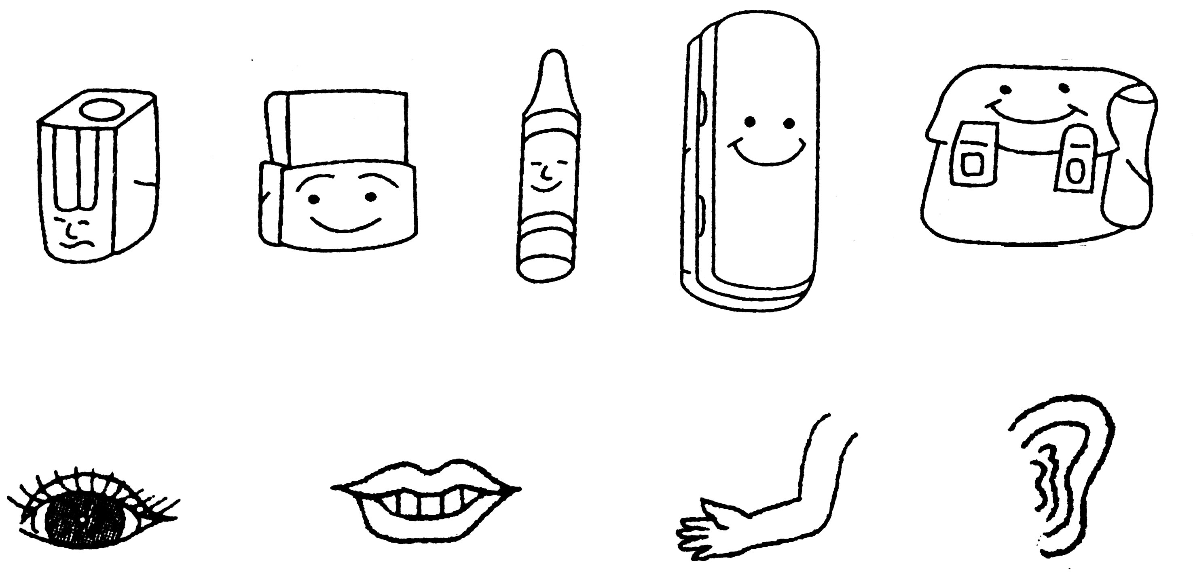
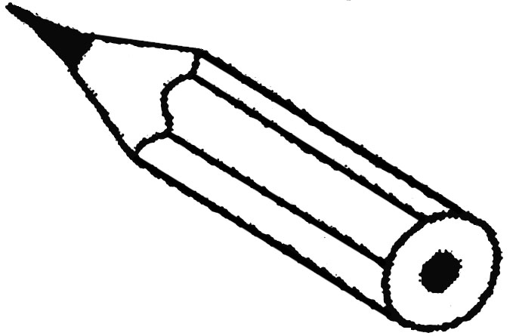
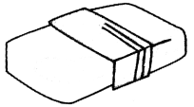
( ) 1. A. B. C.
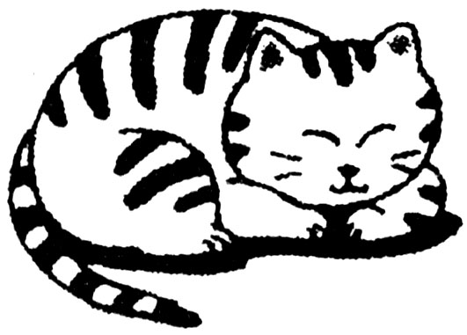
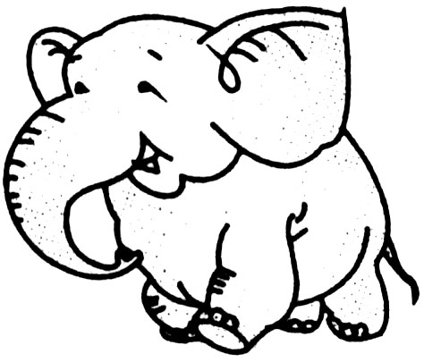
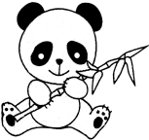
( ) 2. A. B. C.
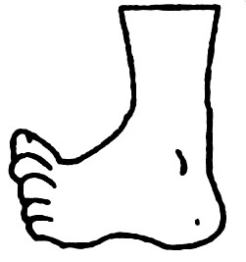
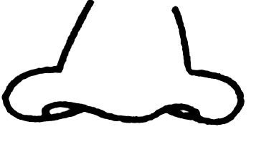
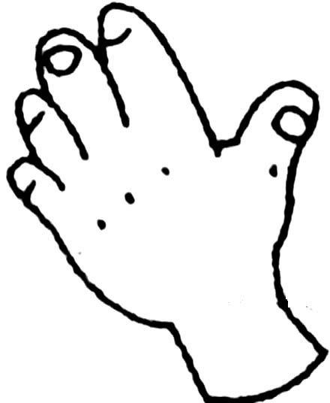
( ) 3. A. B. C.

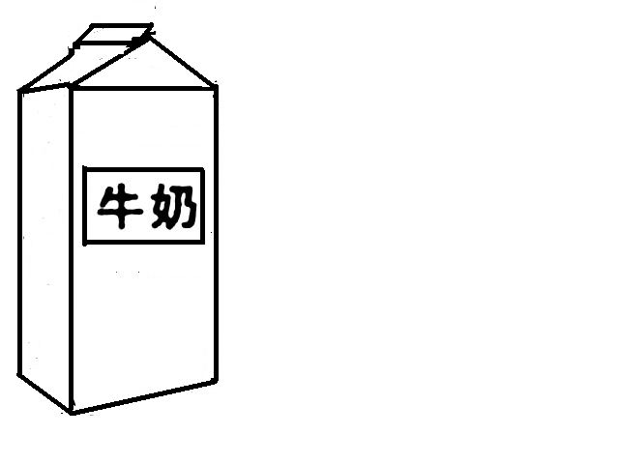
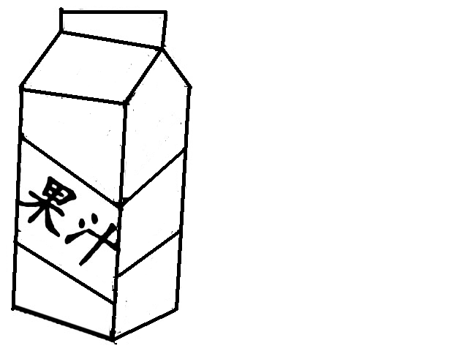
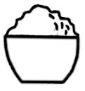
( ) 4. A. B. C.
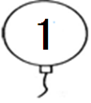
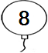
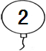
( ) 5. A. B. C.

三、听录音，选出你所听到的句子。将正确答案的字母序号填入题前括号内，每小题读两遍。（共5小题，计10分）
( ) 1. A. It’s a panda. B. It’s a tiger.
( ) 2. A. I see white. B. I see blue.
( ) 3. A. Can I have some water, please? B. Can I have some milk, please?
( ) 4. A. I have a pencil. B. I have a pen.
( ) 5. A. I’m ten years old. B. I’m six years old.
四、听录音，选出合适的选项，补全句子。将正确答案的字母序号填入题前括号内，每小题读两遍。（共5小题，计10分）
( ) 1. Lucy is years old.
A. two B. four C. five
( ) 2. Have some .
A. bread B. cake C. rice
( ) 3. It’s a .
A. pencil box B. book C. bag
( ) 4. This is my .
A. arm B. leg C. eye
( ) 5. The bird is .
A. red B. orange C. black
五、听录音，选出你所听到的句子的应答语。将正确答案的字母序号填入题前括号内，每小题读两遍。（共5小题，计10分）
( ) 1. A. Good morning, Bill. B. Good afternoon, Bill.
( ) 2. A. Goodbye, Miss Green. B. I’m fine, thank you.
( ) 3. A. It’s a pig. B. It’s yellow.
( ) 4. A. Here you are. B. You’re welcome.
( ) 5. A. One. B. This one, please.
Writing Part 笔试部分（共五大题，计50分）
六、用手写体写出所给字母的左邻右舍。（共5小题，计10分）

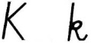
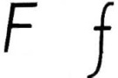
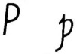
1. 2. 3.

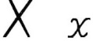
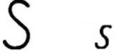
4. 5.

七、选出与划线部分单词属于同类的词。将正确答案的字母序号填入题前括号内。
（共5小题，计10分）
( ) 1. The bag is black.
A. ruler B. blue C. four
( ) 2. This is my head.
A. mouth B. school C. funny
( ) 3. It’s a monkey.
A. mum B. bear C. no
( ) 4. I’d like some cake.
A. plate B. orange C. egg
( ) 5. Lily is seven years old.
A. six B. brother C. white
八、单项选择。将正确答案的字母序号填入题前括号内。（共5小题，计10分）
( ) 1. — are you?
—I’m four years old.
A. How many B. How C. How old
( ) 2. —Let’s make a puppet!
—________
A. Wow! B. Great ! C. Cool!
( ) 3. — is your name?
—I’m Sarah.
A. What B. Who C. How
( ) 4. Look me!
A. at B. to C. in
( ) 5. I have eraser.
A. a B. an C. /
九、看一看，选一选。将正确答案的字母序号填入题前括号内。 （共5小题，计10分）
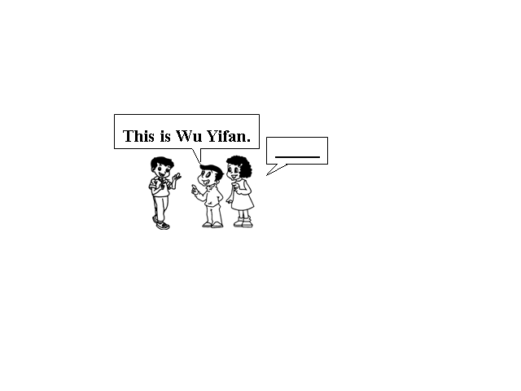
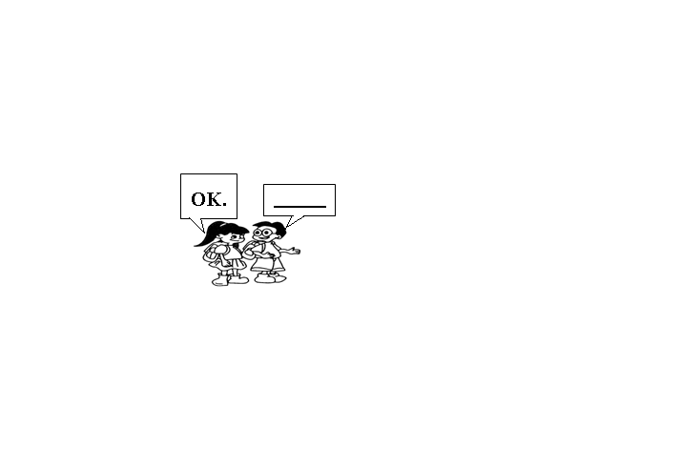
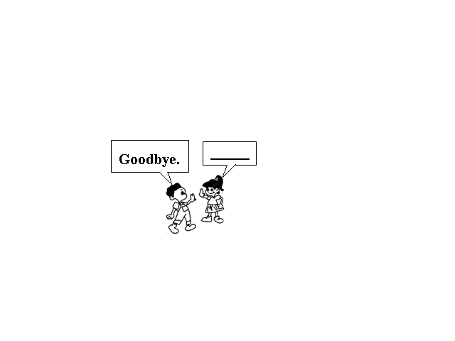
( ) 1. ( ) 2. ( ) 3.
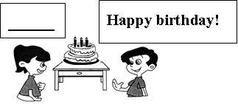
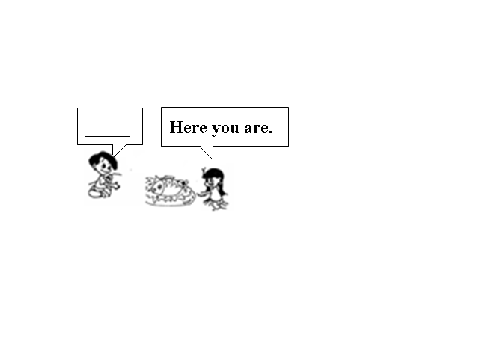

( ) 4. ( ) 5.
A. Let’s go to school! B. Thank you. C. Bye.
D. Can I have some fish, please? E. Nice to meet you.

十、阅读短文，判断下面句子的正（T）误（F）。将正确答案填入题前括号内。
（共5小题，计10分）

Sam and his friends (他的朋友) are at a snack bar (小吃店). Sam would like some rice and fish. Lily would like some bread and water. Lucy would like some cake and juice. Bob would like some cake and milk. Linda would like some fish and water.

( ) 1. Sam and his friends are in a zoo.

( ) 2. Sam would like some fish and rice.

( ) 3. Lily would like some juice and cake.

( ) 4. Bob would like some cake and milk.
( ) 5. Linda would like an egg and some water.

听力材料

一、听录音，选出你所听到的单词或字母。将正确答案的字母序号填入题前括号内，每小题读两遍。(每遍之间停顿5秒)
1. ruler 2. H 3. yellow 4. eraser 5. hand
6. cat 7. three 8. fish 9. dog 10. nose
二、听录音，选出与你所听内容相符的图片。将正确答案的字母序号填入题前括号内，每小题读两遍。 (每遍之间停顿6秒)
1. crayon 2. elephant 3. foot 4. juice 5. eight
三、听录音，选出你所听到的句子。将正确答案的字母序号填入题前括号内，每小题读两遍。(每遍之间停顿6秒)
1. It’s a tiger.
2. I see blue.
3. Can I have some water, please?
4. I have a pen.
5. I’m ten years old.
四、听录音，选出合适的选项，补全句子。将正确答案的字母序号填入题前括号内，每小题读两遍。(每遍之间停顿6秒)
1. Lucy is five years old.
2. Have some rice.
3. It’s a book.
4. This is my arm.
5. The bird is black.
五、听录音，选出你所听到的句子的应答语。将正确答案的字母序号填入题前括号内，每小题读两遍。(每遍之间停顿8秒)
1. Good afternoon, Linda.
2. How are you?
3. What’s that?
4. Thank you.
5. How many plates?

参考答案
一、1-5: ACABC 6-10: BCAAB
二、1-5: CBAAB
三、1-5: BBABA
四、1-5: CCBAC
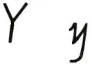
五、1-5: BBABA
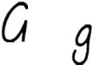
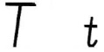
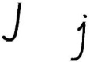
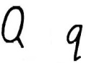
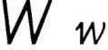
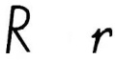
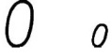
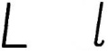
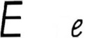
六、1. , 2. , 3. , 4. , 5. ,
七、1-5: BABCA
八、1-5: CBAAB
九、1-5: EACDB
十、1-5: FTFTF

