2023-2024学年人教PEP版五年级英语下册期末测试卷
考试范围：全册；考试时间：60分钟；
班级： 姓名： 成绩：
听力部分
一．听句子，选出与句子内容有关的信息。(5分)
( ) 1. A．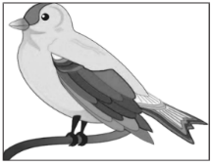 B．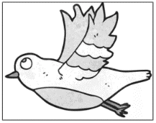 C． 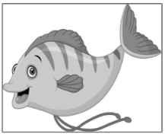
( ) 2. A．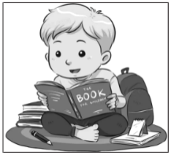 B．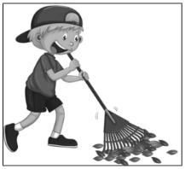 C． 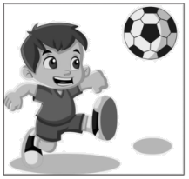
( ) 3. A．pink B．pick C． think
( ) 4. A．mash B．match C． maths
( ) 5. A．clean B．clever C． cloud
二．听录音。选择你所听到的句子。(10分)
( )1. A．Who is drawing pictures in the bedroom?
B．Who is taking pictures in the dining room?
( )2. A．The two birds are swimming in the lake.
B．The two birds are flying in the sky.
( )3. A．Whose books are these?
B．Whose book is this?
( )4. A．It's time to go to school.
B．It's time to go to park.
( )5. A．We are climbing mountains.
B．They are climbing trees.
三．听录音，判断正误。根据所听内容，判断图片与所听内容是否相符，相符的写“T”，不相符的写“F”。(5分)
1. 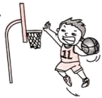 ( ) 2.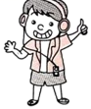( ) 3. 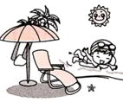 ( )
4. 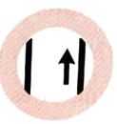 ( ) 5. 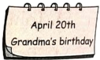 ( )
四．听录音，选择正确的答语。每个句子读两遍。(10分)
( ) 1. A．I often cook dinner. B．I’m cooking dinner.
( ) 2. A．I often go shopping. B．I’m listening to music.
( ) 3. A．It’s on Sept.10th. B．It’s on Mar.12th.
( ) 4. A．It’s Zhang Peng’s. B．Yes, it is.
( ) 5. A．No, it isn’t. B．OK. Take turns!
笔试部分
五、读一读，选出划线部分读音不同的一项。(5分)
( ) 1．A．what B．where C．whose
( ) 2．A．please B．people C．plate
( ) 3．A．China B．lunch C．school
( ) 4．A．thin B．that C．thank
( ) 5．A．drink B．think C．long
六、选出每组中不属于同类的选项。(5分)
( ) 1．A．Monday B．March C．June
( ) 2．A．their B．her C．ours
( ) 3．A．mouth B．third C．fourth
( ) 4．A．autumn B．October C．summer
( ) 5．A．drinking B．listening C．morning
七、单项选择。(10分)
( ) 1．—Are they ________ football now? —No, they often ________ on the weekend.
A．play; play B．playing; plays C．playing; play
( ) 2．It is ________ dog. The dog is ________.
A．she; her B．her; hers C．hers; her
( ) 3．—__________ are you shopping today? —My mum worked last night. So I’m shopping today.
A．How B．Why C．Where
( ) 4．We’ll ________ to the Great Wall.
A．go B．goes C．going
( ) 5．My mum ________ cooking. I ________ reading. They ________ singing now.
A．is; is; are B．am; is; are C．is; am; are
八、用所给单词的适当形式填空。(10分)
1．I often clean (I) room on the weekend.
2．There (be) two tigers at the zoo.
3．China’s National Day is on October (one).
4．I often take a (dance) class on Sundays.
5．Can we (use) your crayons?
九、选出与句意相符的图片。(10分)
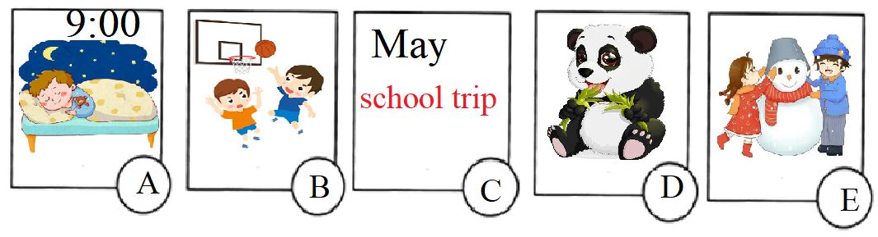
1．—What do you often do after school? ( )
—I often play basketball with my friend.
2．—When do you go to bed? ( )
—Usually at 9 o’clock.
3．—Which season do you like best? ( )
—Winter. I can make a snowman.
4．—Is the school trip in May? ( )
—Yes, it is.
5．—What’s the panda doing? ( )
—It’s eating bamboo.
十、将熊大和熊二的对话补充完整。 (10分)

Xiongda: Xionger 1 .
Xionger: I am in the kitchen.
Xiongda: 2
Xionger: I’m eating honey(蜂蜜).
Xiongda: 3
Xionger: Yes, they’re in the bedroom.
Xiongda: Oh, here they are. Listen! 4
Xionger: He is cutting trees.
Xiongda: 5
Xionger: OK! Let’s go.
A．What is Guangtouqiang doing?
B．Where are you?
C．Let’s go and stop him.
D．Do you see my shoes?
E．What are you doing?
十一、阅读下面的公告，选择正确答案。(10分)

City Museum Opening Hours: Tue.—Sun.  9:00a.m.—4:00p.m.  Attention:  No flash!  Don’t touch Ticket: For adults—10 RMB  For children—Free | City Library Opening Hours: Mon.—Sun.  8:30a.m.—4:30p.m.  Attention:  Queue up!  Be quiet!  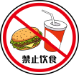No drinks or food!

1．You can go to ________ on Monday. ( )
A．City Museum B．City Library
2．It’s Sunday today. It’s 8:45 a.m. now. I’m ________. ( )
A．reading books B．visiting historical relics(参观历史文物)
3．You can’t take pictures(拍照) in the ________. ( )
A．museum B．library
4．“Queue up!”的意思与“________”相近. ( )
A．Stop! B．Take turns!
5．公告中的黑体字“Free”是什么意思? ________. ( )
A．免费的 B．自由的
十二、书面表达(10分)
随着夏季的到来，傍晚时分人们的业余活动也丰富起来。用现在进行时描述一下Sarah一家人正在做什么？可适当发挥想象，写一篇不少于5句话的小作文。
要求：书写工整，时态准确，无语法和标点错误。

Father | Mother | I | Grandma | Grandpa and my brother
  reading a book | 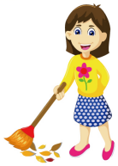  cleaning the room | 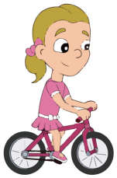  riding a bike | 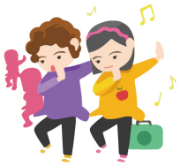  dancing | 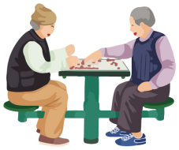  playing chess
Hello! I’m Sarah. ______________________________________________
_________________________________________________________________
_________________________________________________________________
_________________________________________________________________

参考答案：
一． C A A C B
二． A B A A B
三． F T T T F
四． B A B A B
五、CBCBC
六、ACABC
七、CBBAC
八、1．my2．are3．1st/first4．dancing5．use
九、BAECD
十、BEDAC
十一、BAABA
十二．范文：
Hello! I’m Sarah. My family are busy now. Look, my father is reading a book. My mother is cleaning the room. My grandma is dancing with her friends. My grandpa and my brother are playing chess. What about me? I am riding a bike in the park.

