重庆市2025年初中学业水平暨高中招生考试英语试题
（全卷共九个大题 满分: 150分 考试时间: 120分钟）
注意事项:
1. 试题的答案书写在答题卡上, 不得在试题卷上直接作答。
2. 作答前认真阅读答题卡上的注意事项。
3. 考试结束, 由监考人员将试题卷和答题卡一并收回。
第Ⅰ卷（共100分）
I. 听力测试。（共 35 分）
第一节（每小题1分, 共6分）
听一遍。根据你所听到的句子, 从A、B、C三个选项中选出最恰当的答语, 并把答题卡上对应题目的答案标号涂黑。
1. 【此处可播放相关音频，请去附件查看】

A. Good morning. B. Good afternoon. C. Good luck.
2. 【此处可播放相关音频，请去附件查看】

A. Well done. B. I hope so. C. Sorry, I won’t.
3. 【此处可播放相关音频，请去附件查看】

A. With pleasure. B. Never mind. C. Enjoy yourself.
4. 【此处可播放相关音频，请去附件查看】

A Here you are. B. Glad to hear that. C. It doesn’t matter.
5. 【此处可播放相关音频，请去附件查看】

A. Don’t mention it. B. Sounds great! C. Be careful!
6. 【此处可播放相关音频，请去附件查看】

A. Take it easy. B. Thank you. C. Have fun.
第二节（每小题1.5分, 共9分）
听一遍。根据你所听到的对话和问题, 从A、B、C三个选项中选出正确答案, 并把答题卡上对应题目的答案标号涂黑。
7. 【此处可播放相关音频，请去附件查看】

A. /'dʒɜːni/. B. /dʒei/. C. /dʒʌdʒ/.
8. 【此处可播放相关音频，请去附件查看】

A. Blue. B. Red. C. Yellow.
9. 【此处可播放相关音频，请去附件查看】

A. To the park. B. To the bank. C. To the library.
10. 【此处可播放相关音频，请去附件查看】

A. Lucy. B. Lily. C. Mary.
11. 【此处可播放相关音频，请去附件查看】

A. Thin. B. Short. C. Tall.
12. 【此处可播放相关音频，请去附件查看】
.
A. 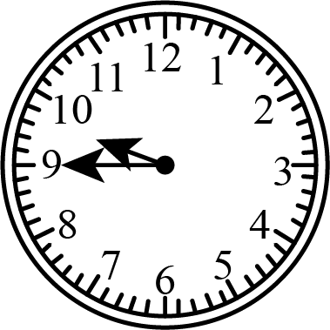 B. 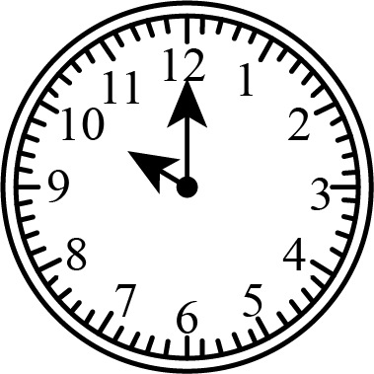 C. 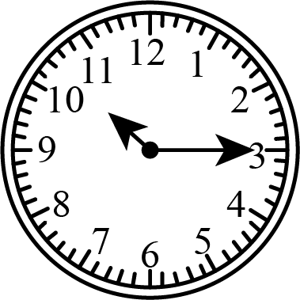
第三节（每小题1.5分, 共6分）
听两遍。根据你所听到的长对话, 从A、B、C三个选项中选出正确答案, 并把答题卡上对应题目的答案标号涂黑。
听材料，回答问题。【此处可播放相关音频，请去附件查看】

13. What is Li Hua doing now?
A. Reading a report. B. Watching TV. C. Writing a letter.
14. How do they both feel?
A. Happy. B. Surprised. C. Proud.
听材料, 回答问题。【此处可播放相关音频，请去附件查看】

15. Where is Emma now?
A. In the restaurant. B. In the kitchen. C. In the dining hall.
16. Why is Mark laughing?
A. Because Emma got vegetable pieces on her face.
B. Because Emma told a funny story about cooking.
C. Because Emma forgot to bring her own wallet.
第四节（每小题1.5分, 共6分）
听两遍。根据你所听到的短文内容，从A、B、C 三个选项中选出正确答案，并把答题卡上对应题目的答案标号涂黑。【此处可播放相关音频，请去附件查看】

17. How often will the students have a volleyball match?
A. Every day. B. Twice a week. C. Once a month.
18. How far does everyone need to swim in the test?
A. 50 meters. B. 100 meters. C. 200 meters.
19. What will the students have in June?
A. A sports meet. B. A parent meeting. C. A kung fu show.
20. What does the speaker expect the students to be like?
A. Safe and fit. B. Safe and fast. C. Fit and fast.
第五节（每小题 2分, 共8分）
听两遍。根据你所听到的演讲内容，在横线处补全笔记。每空1词，并把答案填写在答题卡上对应的位置。【此处可播放相关音频，请去附件查看】

Make People Want to Listen
21. People ________ ________ to listen.
22. Some bad habits:
√…
√speaking ill…
√speaking ________ ________
23. Some suggestions:
√be an ________ person
√keep...words
√wish...well
√speak...proper...
24. The speaker thinks these suggestions can help us have better conversations, so we will have a ________ ________ with people around us.
II. 语法选择。（每小题1分, 共10分）
根据短文内容, 从A、B、C三个选项中选出一个语法正确的答案, 并把答题卡上对应题目的答案标号涂黑。
Li Liang has always been interested in science since childhood. He’s good ____25____ solving problems in daily life. It is ____26____ dream to make people’s lives better.
One night when he was 11, he ____27____ the news on TV with his parents. He heard that there were harmful chemicals (化学物质) left in the vegetables people ate in a village nearby. Parents and ____28____ were worried about their food safety. He couldn’t sleep that night ____29____ he kept thinking about the kids of his age who didn’t have safe vegetables. He decided ____30____ something to help. He spent over a year in researching and testing. Finally, a tool ____31____ by him. It could show results fast, so people would know ____32____ the food was safe.
Now, as ____33____ college student, he gives public talks and holds science workshops (工作坊) to share his research methods. Through his ____34____ work, more and more students are following in his footsteps.
25. A. at B. to C. for
26. A. he B. his C. him
27. A. watch B. watches C. watched
28. A. kid B. kids C. kids’
29. A. or B. but C. because
30. A. to do B. doing C. do
31. A. invented B. is invented C. was invented
32. A. what B. whether C. which
33. A. a B. an C. the
34. A. hard B. harder C. hardly
III. 完形填空。（每小题 1.5分, 共15分）
根据短文内容, 从A、B、C、D四个选项中选出一个能填入相应空格的最佳答案, 并把答题卡上对应题目的答案标号涂黑。
The sunlight came through the windows, bringing in the hot summer air. I saw a long line of people at the medicine pickup counter (取药处). I took a deep breath to cool ____35____ down.
I joined the line to ____36____ for my turn. The weight of my coming baby made it ____37____ for me to stand straight, and my legs felt heavy. I raised my head and saw there were still quite a few people ahead. Some were playing with their phones and some were talking quietly. The line moved so ____38____ .
I began to feel weaker in my ____39____ . I couldn’t stand for long. “Should I ask the one at the front for help? What if he ____40____ ? He’s been waiting for a long time, too. Will the other people agree?” I thought to myself, “But I …” My forehead was starting to sweat (冒汗).
I knew I couldn’t wait. I walked up to the ____41____ person in the line and asked in a low voice, “Excuse me, could I go first? I am not feeling so well.”
The young man looked at me in surprise ____42____ he saw my belly (肚子). He agreed. Almost no one noticed what happened. I thought he would remain behind me. Instead, he moved straight to the end.
The second person ____43____ her phone. She looked at me and looked back at the young man. Then she moved to the back, too. Then the third one, then the fourth…until the young man came right ____44____ me.
I felt a gentle wind blowing across my face, and the summer heat was gone with the wind.
35 A. myself B. yourself C. himself D. herself
36. A. fight B. wait C. call D. ask
37. A. easy B. possible C. difficult D. important
38. A. carefully B. successfully C. quickly D. slowly
39. A. stomach B. legs C. arms D. head
40. A. agrees B. smiles C. refuses D. cries
41. A. first B. second C. third D. fourth
42. A. if B. unless C. until D. though
43. A. looked out at B. looked up from C. looked down on D. looked around for
44. A. far from B. before C. across from D. behind
IV. 阅读理解。（每小题2分, 共30分）
阅读下列材料, 从A、B、C、D四个选项中选出最佳答案, 并把答题卡上对应题目的答案标号涂黑。
A
When someone’s heart suddenly stops, we can use an AED to save him or her. It can be found in public places and it is easy to use. Turn it on and follow the voice instructions. Here are some key steps.
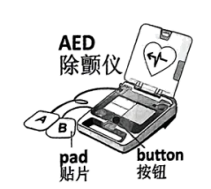
1. Place one pad onto the upper-right chest（胸膛）. Place the other onto the lower-left chest.
2. Connect the pads to the AED.
3. Don’t touch the patient! Wait for the result of the examination.
4. Press the button when a shock is advised.
5. Give CPR（心肺复苏）if needed.
Remember: It’s best to treat the patient within the “Golden 4 Minutes”! Time matters! If an AED is not around, send someone to get one and give CPR while waiting. Don’t forget to call 120.
45. When is an AED used?
A. When someone’s heart suddenly stops. B. When someone has a headache.
C. When someone’s back suddenly hurts. D. When someone has a toothache.
46. Where should the pads be placed on the patient?
A. 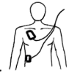 B. 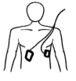 C. 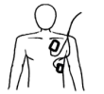 D. 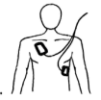
47. What’s the golden time to use an ABD?
A. The first 4 minutes. B. The first 5 minutes.
C. The first 6 minutes. D. The first 7 minutes.
B
Tea has long been a popular drink in China. Chinese people love different kinds of tea. Among them, black tea and white tea from Fujian, green tea from Zhejiang and Anhui, and dark tea from Yunnan are some of the favorites.
In the Song Dynasty (960—1279), tea culture reached new heights. The beauty of the Song tea came alive through “dian cha”. Powdered (粉状的) tea was whisked (搅打) with water into soft “clouds”. White tea was often used to make the “clouds” as white as the moonlight. Tea artists used clean water to draw pictures on them with a teaspoon. The way of serving dian cha became a living art. It later influenced Japanese tea culture. Today, more young people are learning and passing it on.
Yunnan’s dark tea, especially Pu’er, got famous because of the Ancient Tea Horse Road. And it won popularity around the world. In 1976, Frenchman Fred Kempler found a new kind of Pu’er from Yunnan in a Hong Kong shop. In the same year, he visited Yunnan, bought nearly two tons, and began to sell “Yunnan Tuocha” in Europe. Since 1986, Yunnan’s Pu’er tuocha has got many prizes at food expos (博览会) in France, America and other countries. Today you can see an old Australian lady holding a cup of tea of sun-dried Pu’er, though she still enjoys her English-style black tea with milk and sugar. Tea is a bridge of friendship among nations and peoples.
Tea is enjoyed timelessly from ancient to modern times. Each cup of dian cha, white as the moonlight, turned tea into art, and art into eternity (永恒). Tea is also loved globally from the east to the west. Each cup of Pu’er, with the smell of sunshine, turns tea into friendship, and friendship into a shared future.
48. What kind of tea was often used for dian cha according to the passage?
A. Black tea. B. Green tea. C. Dark tea. D. White tea.
49. When did Fred Kempler begin to sell “Yunnan Tuocha” in Europe?
A. In 1986. B. In 1976. C. In 1279. D. In 960.
50. Which sentence uses “globally” with the same meaning as the underlined word?
globally /'gləʊbəli/ adv. ①全球地②全面地③总体而言，整体地
A. Globally, our class did well in the English test.
B. The Olympic Games bring people together globally.
C. The story is globally interesting though some parts are slow.
D. This math question needs you to consider the numbers globally.
51. What is the best title for the passage?
A. More Than a Drink B. Tea Trade in China
C. Art in a Tea Cup D. Journey of Yunnan Tea
C
(Mr. Wormwood sells stolen cars and tries to get more money by cheating others. Matilda, a book lover, hates that.)
Scene One
One morning, just when Mr. Wormwood was setting off to cheat others again, Matilda walked into his room quietly to get the hat he wore each day to work. She was too short and had to get it with a walking-stick.
Holding the hat in one hand and a bottle of superglue in the other, Matilda put some glue very carefully all round the inside rim (边) of the hat. Then she carefully put the hat back.
Scene Two
That evening, when Mr. Wormwood got home, he cried, “I can’t take my hat off and I have to keep it all day!”
“Don’t be silly,” his wife said. “Come here. I’ll take it off for you.”
“Ow-w-w! Don’t do that! Let go! You’ve nearly killed me!” he shouted.
“What’s the matter?” Matilda was standing at the door with a book in her hand.
Mr. Wormwood looked at her doubtfully, but said nothing.
“It must be superglue. Haven’t I told you not to touch the dirty thing?” Mrs. Wormwood said.
“I haven’t touched it!” Mr. Wormwood shouted. He turned and looked again at Matilda, who looked back at him with large innocent (无辜的) brown eyes.
Scene Three
Mr. Wormwood had to keep his hat on all through dinner. Later, he discovered that the worst thing about having the hat was not to take a shower in it, but to sleep in it. “I expect it will be loose (松动) by the morning and then it’ll be taken off easily,” Mrs. Wormwood said.
Scene Four
But the hat wasn’t loose by the morning. So Mrs. Wormwood cut the thing off his head, bit by bit, first the top and then the rim.
At breakfast Matilda said to Mr. Wormwood, “You must try to get those bits off your head. They look like little brown insects. And people will think you’ve got lice (虱子).”
“Be quiet!” Mr. Wormwood shouted. “Just keep your mouth shut!”
All in all, it is a most satisfying exercise. But don’t get your hopes up that it has taught the cheater a good lesson.
(Matilda borrows her friend’s parrot (鹦鹉) and…)
52. What did Matilda put inside Mr. Wormwood’s hat?
A. Some hair. B. Some superglue.
C. A book. D. A stick.
53. According to Scene Two, which word best describes Matilda?
A. Creative. B. Friendly. C. Shy. D. Calm.
54. What can we infer from the text?
A. The couple loved each other very much.
B. Mrs. Wormwood really enjoyed cutting hair.
C. Matilda would continue to punish the cheater.
D. Mr. Wormwood wouldn’t cheat others any more.
55. 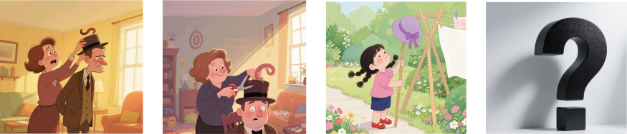
Each picture above matches one scene. Which scene is missing?
A. Scene One. B. Scene Two.
C. Scene Three. D. Scene Four.
D
“Wow! Look at that! Isn’t it a real fish?” The bionic (仿生) fish, named “Jinlin”, was swimming lively like a real one. It was developed by researchers at Shanghai Ocean University. This invention isn’t just for fun—it shows how humans copy nature to solve problems. That is a science called bionics.
Over millions of years, animals and plants have developed smart ways to survive. For example, kingfishers are experts at moving fast between air and water with very little noise. Through their study, scientists discovered that the birds’ long beaks (喙) enabled this ability. Then they used the knowledge to change the front of the high-speed train. This change cut down noise level, increased speed by 10% and greatly saved energy. This combination (结合) of biology and engineering is the key to success in bionics. And it has set the stage for the rise of other new technologies.
Driven by robotics and AI, bionics has grown rapidly. The AI-powered bionic fish “Jinlin” can be used for environmental protection and deep sea exploration. In medicine, bionic arms can work similarly to real arms. Sensors allow the user to “feel” touch and pressure. Motors help the bionic arms make movements, like human muscles (肌肉). With AI, the bionic arms are able to “learn” new tasks and become smarter over time. These inventions are examples to show how bionics bridges biology and new technologies to solve humans’ problems.
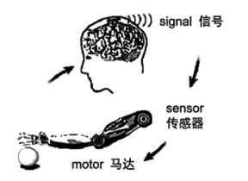
Although so much progress has been made, bionics faces challenges. Nature’s designs are hard to copy perfectly. As for bionic arms, one key area of development is Brain-Computer Interface (脑机接口). More work on direct communication between the brain and bionic arms is required to control movements as naturally as real arms. Researchers are also working on creating new materials and structures which can sense and repair themselves.
While there’s still a long way to go, the future of bionics is full of possibilities. Stay hungry. Stay foolish. Maybe you’ll be the next one to change the world!
56. Why does the writer mention “Jinlin” at the beginning of the passage?
A. To suggest some new ideas. B. To lead into the topic of bionics.
C. To explain the habits of fish. D. To show the importance of bionics.
57. What can we learn from Paragraph 3?
A. Robotics and AI have developed fast because of bionics.
B. The bionic fish “Jinlin” is used for medical purposes.
C. Motors allow the bionic arms to make movements.
D. Sensors help bionic arms learn new tasks over time.
58. According to Paragraph 4, how would scientists make bionic arms more like real ones?
① By connecting motors with smart phones.
② By developing new materials and structures.
③ By improving Brain-Computer Interface.
④ By changing the shape and look of bionic arms.
A. ①② B. ②③ C. ①④ D. ③④
59. Which of the following shows the use of bionics?
A. Drawing a picture of birds by watching real birds.
B. Building a house with natural materials like wood.
C. Designing a camera by copying some insects’ eyes.
D. Learning to dance by studying monkeys’ movements.
V. 口语应用。（每小题2分, 共10分）
阅读下面对话，从7个选项中选择5个恰当的句子完成此对话，并把答题卡上对应题目的答案标号涂黑。
A: Hi, I’m Chris. Nice to meet you!
B: Oh, hi, I’m Amy. ___60___
A: So, Amy. Why are you interested in joining our group?
B: Well, I want to do something for our environment.
A: ___61___ We are all trying to live a low-carbon (低碳) life.
B: A low-carbon life? What is that?
A: It’s a green lifestyle. ___62___ We still buy daily things like food and drinks. But we try not to buy new clothes or shoes.
B: Wow! ___63___
A: Well, we eat less meat and we prefer more local food.
B: I can do that. And I often take a bus to school.
A: That’s great. Then welcome to join us.
B: ___64___ Thanks.
A I’d love to.
B. Let’s eat together.
C. It’s great to see you, too.
D. We start with less shopping.
E. Can you lend me a bike?
F. Anything else?
G This group is just right for you.
第Ⅱ卷（共50分）
VI. 任务型阅读。（65-66小题, 每小题 2分; 67-68小题, 每小题3分; 共10分）
阅读下文并回答问题。
Dear friends,
Last month, we started the “Nature and Me” activity. What did you see and do during your time with nature? And how did you feel? Please share your stories.
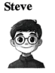
8:15 p. m. 31 May
I disliked hiking in the past, but now I enjoy it. My father and I had a hiking trip on MacLehose Trail in Hong Kong. The journey was harder than I expected. My legs started burning after just 30 minutes. But as we climbed higher, the amazing views—green hills, golden beaches, and endless ocean—seemed under my feet. There’s an old Chinese saying, “When you climb to the top, all other mountains seem small.” That’s exactly how I felt. Every drop of sweat counts!

8: 17 p. m. 31 May
“I feel free and peaceful.” This was my answer to my friend when she asked me how I felt after an afternoon walk. As we walked through the park, I noticed all those fallen leaves with different shapes and colors lying on the ground. I picked some up and made them into a picture.
You know what they say, “The best thing in life is free.” That’s so true. By walking, I got good exercise. By collecting these little treasures, I started paying attention to all the small things around me that I used to miss. It was like an escape (逃离) from what was troubling me.
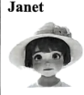
12 minutes ago
During the holiday, my family and I went to Crystal Waterfall. It was amazing! I stood near the falls, hearing the rush of water and feeling the cool mist (水雾). The sound of the water was actually super relaxing. It felt like all my tiredness and worries were being washed away.
Back home, I even downloaded the recordings of waterfalls online. They can help me sleep better!

65. Does Steve like hiking now?
_______________________________________________________________________________________________
66. What did Lan pick up during the afternoon walk?
_______________________________________________________________________________________________
67. What have the three people learned in common from their trips?
_______________________________________________________________________________________________
68. What do you think of their experiences and why? Choose one to reply. (about 30 words)
_______________________________________________________________________________________________
VII.完成句子。（69-72小题,每空1分;73小题2分;共10分）
根据所给提示, 完成句子。69-72小题, 每空一词, 含缩略词, 73 小题请将完整的句子写在答题卡上对应的位置。
69. Gina is talking to her friend on the phone.（改为否定句）
Gina ________ ________ to her friend on the phone.
70. Andy paid 30 yuan for his new book.（对划线部分提问）
________ ________ did Andy pay for his new book?
71. Sorry, you are not old enough to drive.（改为同义句）
Sorry, you are ________ young ________ drive.
72. 面对困难, 我们应该永不放弃。（完成译句）
We should never ________ ________ in the face of difficulties.
73. to be, want, a writer, I, in the future（连词成句）
_____________________________________________________________________________.
VIII. 概要补全。（75和77小题, 每小题2分; 74和76小题, 每小题3分; 共10分）
阅读文章，用恰当的短语或句子补全概要。补全部分总词数不超过30词，不能照抄原文连续超过 3个词。
When you make a mistake or say something wrong, it’s easy to be hard on yourself. Then stress is caused. Feelings of anger, disappointment and sadness come along. That’s why such stress needs to be dealt with.
Max, a 14-year-old boy, used to be very competitive and always felt stressed. Now he is learning to give himself care and kindness. When he doesn’t win or get the top marks, he talks to himself, “It’s OK not to be perfect.” He knows he always does his best and that is enough.
What Max does is called self-compassion (自我和解). With self-compassion, you treat yourself kindly like a friend. It allows you to forgive (原谅) yourself when you mess up or fail. After feelings of guilt (愧疚) go away, you get more relaxed and you can think more clearly. This way self-compassion makes you move forward. Many studies have shown it is of great help.
However, some disagree. They argue that self-compassion leads people to be less active. But Breines and Chen’s study had a different result. They gave students a difficult word test. The students were given the chance to study for a second test. They found those who were compassionate toward their failure spent more time preparing.
Experts suggest that you should write a letter to yourself, describing the situation that causes your pain and accepting how you feel. Or you can do something you like to make yourself feel at peace. Suzy Reading, a psychologist (心理学家), suggests using a “gentle touch” like placing one both hands on your heart, so you will feel safe and loved.
Being hard on yourself causes stress. However, ____74____. Se-compassion means being kind to yourself. With its help, you will have more relaxation and a clearer mind so that ____75____. Some think differently, but a study shows that ____76____. To practice self-compassion, some ____77____ are suggested by experts.

IX. 书面表达。（满分20分）
78. 某权威英语阅读网站发布报告：从小学到高中毕业，如每天坚持阅读 15分钟，学生的累积阅读量可达680万词；不足15分钟，则只有约150万词。你校英语社团在全校每天阅读时间不足15分钟的学生中进行原因调查后（结果见下图），针对最突出的原因，以“Everyone can have time to read”为主题发起征文。请你简述调查结果，提出行之有效的建议（1—2条）参与投稿。
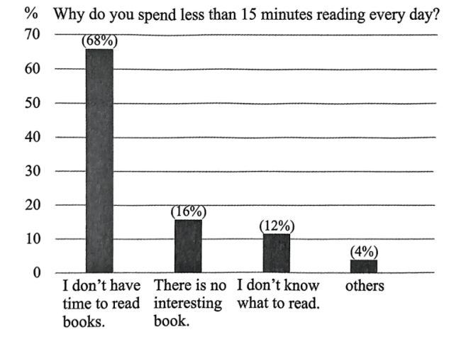
要求
1. 80—120词，开头已给出，不计入总词数；
2. 文中不能出现自己姓名和所在学校的名称。
参考信息
spare moments (碎片化时间) (during lunch breaks, while waiting, before bed...)
use/ create an AI reading agent (智能体) (make plans, remind sb. to read, manage time well...)
less screen time (less time on the phone...)
be a better learner (focus well, learn better in less time...)
…
According to the survey, 16% show little interest in reading.
_______________________________________________________________________________________________________________________________________________________________________________________________________________________________________________________________________________________________________________________________________________________________________________________

