深圳沪教牛津版2024-2025学年六年级英语下学期期末提分卷
学校:___________姓名：___________班级：___________考号：___________
一、听力题（每小题2分 共40分）
1．听录音，按顺序选出与录音内容相符的图片。
A． B． C．  D．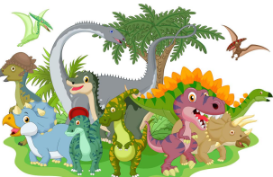 E. 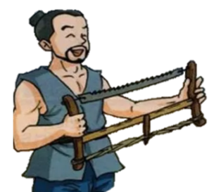
1）. ( ) 2）. ( ) 3）. ( ) 4）. ( ) 5）. ( )
2．听短文，判断下列句子与所听内容是(T)否(F)相符。
( ) 1）. Lisa and Tony are sister and brother.
( ) 2）. Tony likes swimming.
( ) 3）. Tony would like to have a big playground near his home.
( ) 4）. Lisa would like to have a big library and a shopping mall.
( ) 5）. Lisa and Tony are talking about the changes in the future.
3．听录音，根据对话内容，选择最佳答案。
( ) 1）. Which sign is on the wall?
-  B．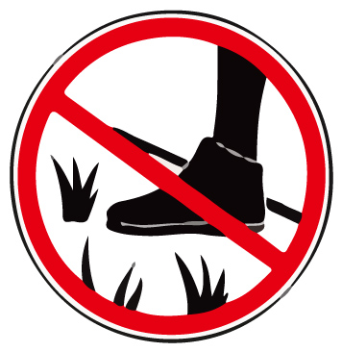 C． 
( ) 2）. What do people do at the Mid-Autumn Festival?
-  B． C． 
( ) 3）. What does Sam sometimes do at the weekend?
-  B．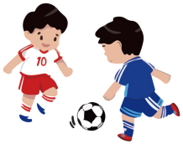 C． 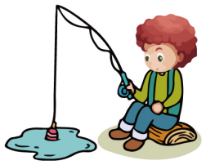
( ) 4）. What does Peter want to be?
A．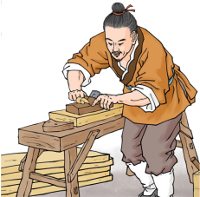 B． C． 
( )5）. What festival is coming?
A． B． C． 
4．听录音，选择恰当的问句或答句，将编号写在题前的括号内。
( ) 1）. A．Is there a big playground in your school?
B．How many computer rooms are there in your school?
C． Where is the reading room in your school?
( ) 2）. A．What should you do before going to bed?
B．What should you do before swimming?
C． What should you do before meals?
( ) 3）. A．What does your grandpa use to get crops in now?
B．What did your uncle use to write his books in the past?
C． What did your mother use to wash clothes in the past?
( ) 4）. A．Yes, I’d like to. B．Yes, I’d like some cola. C． I’d like some salad.
( ) 5）. A．We have five. B．I like PE lessons. C． On Monday and Friday.
二、选择题（共10分）
5．In the Spring Festival, children can ____________. ( )
A．go trick-or-theating B．decorate a tree C．get lucky money
6．The Olympic symbol is five rings in five colours: blue, black, red, yellow and ___________. ( )
A．orange B．green C．purple
7．When we see this sign ___________, we shouldn’t make noise there. ( )
A． B．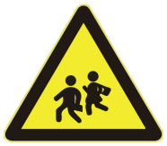 C．
8．My favourite artist is Qi Baishi. His paintings are usually in ___________. ( )
A．black and white B．black and brown C．brown and white
9．Sunflowers is a painting by Vincent van Gogh. It’s ___________. ( )
A．a sketch B．a Chinese ink painting C．an oil painting
10．—______ socks are these? ( )
—They’re ______.
A．Whose; my B．Who; mine C．Whose; mine
11．There ______ a lot of tall buildings in Shenzhen forty years ago. ( )
A．are B．wasn’t C．weren’t
12．Lily likes playing ______ chess, and her brother likes playing ______ violin. ( )
A．the; the B．/; / C．/; the
13．“Take care of ______!” Tom’s mum said to him. ( )
A．himself B．yourself C．herself
14．Everyone should ______ in the library. ( )
A．quiet B．keeps quiet C．keep quiet
三、填空题（共10分）
15．—How much do you ?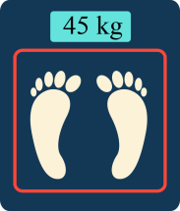
—Forty-five kilograms.
16．My mother bought a brush and some for me. 
17．Give me a pair of , please. I need to cut the paper. 
18．Today is Linda’s birthday. She makes a at the party. 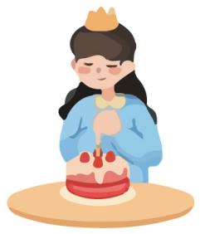
19．Ben is good at taking pictures. He wants to a be a in the future. 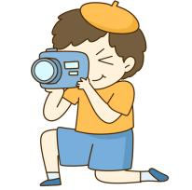
20．—What did Tom do yesterday? 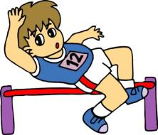
—He did the in the playground.
21．Father Christmas was (A．in / B．on) his way to give presents to children.
22．People like to enjoy shows in Pingshan T at the weekend.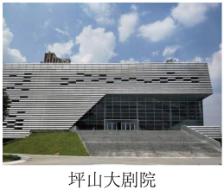
23．In the future, schools will be even in s . 
24．Luban made a s . People are still using this tool today. 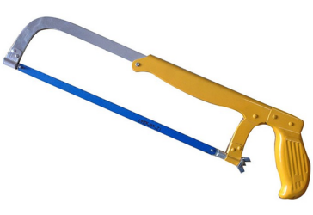
四、补全对话（共10分）
选择方框中恰当的句子补全对话，将其编号填在相应的横线上。
Tony: What a mess! What are you doing, Coco?
Coco: 25 His birthday is coming. He likes crafts.
Tony: 26 I can help you.
Coco: I just cut out some cardboard. It takes me long time. 27
Tony: Then we can use the cardboard to make small tables.
Coco: Good idea! We can reuse the chopsticks, too.
Tony: Sounds great. 28
Coco: We can use them to make the fence. 29
Tony: We also need some tape and glue, too. Then we can stick all the things in the model house.
A．Do you like the model house?
B．How can we reuse them?
C．I’m making a model house for Peter.
D．What else do we need?
E．What can we do then?
F．I like crafts, too.
五、完形填空（共10分）
从短文后每小题的三个选项中选出能填入相应空白处的最佳选项。
Annie lives in New York. She is 30 and tall. She is 170 cm tall and weighs 45 kg. She is a famous 31 in the US. Many people like her paintings. Annie likes 32 very much, she usually spends the whole day painting at home. You can see brushes and paints everywhere in her house. Annie also likes watching plays. She often goes to the 33 to watch plays on weekends. Annie is happy, because she really enjoys her 34 .
30．A．thin B．fat C．strong
31．A．artist B．paints C．doctor
32．A．singing B．dancing C．painting
33．A．supermarket B．theatre C．hospital
34．A．tape B．leaf C．life
六、阅读理解（共10分）
阅读短文，根据短文内容选择正确答案。
A man made a nice talking machine. It could weigh people’s weight.
The first one who used the machine was a Japanese woman. She stood on the machine. The machine thought for a few seconds to decide which language to speak. “Good morning, Madam,” it said in Japanese. “Your weight is 55 kilograms. That’s three kilograms more. If you eat more fruit and vegetables, you will be all right soon. Please have a nice day.”
The second one to use the machine was a Chinese girl. She stood on the machine and waited to hear her weight. “Good morning, Miss,” the machine said in Chinese. “Your weight is 45 kilograms. It’s all right for your age. Keep eating what you eat every day. Please have a nice day.”
The third one to use the machine was a very fat American woman. She thought for a long time to stand on the machine. The machine spoke quickly in English. “Good morning. But can one of you get off first?”
35．What was the machine used to? ( )
A．To weigh and talk to people. B．To tell people what they should drink.
C．To speak all kinds of languages.
36．What language did the machine use to speak to the first person? ( )
A．Chinese. B．Japanese. C．English.
37．According to the machine, to make the Japanese woman look all right, how much should she weigh? ( )
A．52 kilograms. B．55 kilograms. C．58 kilograms.
38．What did the machine say to the Chinese girl? ( )
A．She should eat more. B．She should eat less. C．She kept herself healthy.
39．What does the machine want to tell the American woman? ( )
A．She liked thinking. B．She was too heavy. C．She was healthy.
七、书面表达（共10分）
40．请你根据思维导图提示，以Changes in Shenzhen为题写一篇深圳城市变化的短文。要求：语句通顺，书写规范，卷面整洁，60个单词左右。

low houses | in the past | Changes in Shenzhen | now | many tall buildings
not many trees |  |  |  | many trees and flowers
not many people |  |  |  | a lot of people
… |  |  |  | …
… |  |  |  | …
__________________________________________________________________________________________________________________________________________________________________________________________________________________________________________________________________________________________________________________________________________________________________________________________________________________________________________________________________________________________

试卷解析
一、听力题（每小题2分 共40分）
1．听录音，按顺序选出与录音内容相符的图片。
A． B． C．  D． E. 
1. ( ) 2. ( ) 3. ( ) 4. ( ) 5. ( )
【答案】 B C D E A
【解析】略
2．听短文，判断下列句子与所听内容是(T)否(F)相符。
( ) 1）. Lisa and Tony are sister and brother.
( ) 2）. Tony likes swimming.
( ) 3）. Tony would like to have a big playground near his home.
( ) 4）. Lisa would like to have a big library and a shopping mall.
( ) 5）. Lisa and Tony are talking about the changes in the future.
【答案】 F T F T T
【详解】听力材料：
Lisa and Tony are good friends. One day, Lisa asks Tony, “Tony, what changes would you like to see in our town in the future?” Tony likes swimming. So he says, “I’d like to have a big swimming pool near my home. What about you, Lisa?” Lisa says, “I’d like to have a big library in our town. So I can read all kinds of books. I also would like to have a shopping mall.”
3．听录音，根据对话内容，选择最佳答案。
( ) 1）. Which sign is on the wall?
A． B． C． ( ) 2）. What do people do at the Mid-Autumn Festival?
A． B． C． ( ) 3）. What does Sam sometimes do at the weekend?
A． B． C． ( ) 4）. What does Peter want to be?
A． B． C． ( ) 5）. What festival is coming?
A． B． C． 
【答案】 A B A C B
【详解】1. —Wow! This flower shop is big and beautiful. Edie, let’s go and have a look.
—I’m afraid not. Kitty, the sign on this wall means “No pets.” My cat cannot go inside.
2. —Look! The moon is so round.
—Yes that’s because today is the Mid-Autumn Festival.
—What do people do at the Mid-Autumn Festival?
—People often eat moon cakes and watch the moon with their family.
3. —Hi! Sam you look so strong. I think you like doing exercise.
—Of course. I often play football after school.
—How about weekends?
—I sometimes go swimming and sometimes play basketball with my friend.
4. —Do you like art, Peter?
—Yes. I’m good at oil paintings. I want to be an artist like your father.
—What about you, Jill?
—I want to be a craftsman like Lu Ban.
5. —Did you go shopping yesterday dad.
—Yes, Lisa. It’s Christmas tomorrow I bought some presents for you.
—Thank you, dad. Do we have Christmas trees?
—Of course.
4．听录音，选择恰当的问句或答句，将编号写在题前的括号内。
( ) 1）. A．Is there a big playground in your school?
B．How many computer rooms are there in your school?
C． Where is the reading room in your school?
( ) 2）. A．What should you do before going to bed?
B．What should you do before swimming?
C． What should you do before meals?
( ) 3）. A．What does your grandpa use to get crops in now?
B．What did your uncle use to write his books in the past?
C． What did your mother use to wash clothes in the past?
( ) 4）. A．Yes, I’d like to. B．Yes, I’d like some cola. C． I’d like some salad.
( ) 5）. A．We have five. B．I like PE lessons. C． On Monday and Friday.
【答案】 C B B B A
【详解】1. It’s on the third floor of this building.
2. We should do warm up exercises.
3. He wrote his book with paper and a pen.
4. Would you like something to drink, Joe?
5. How many PE lessons do you have every week?
二、选择题（共10分）
5．In the Spring Festival, children can ____________. ( )
A．go trick-or-theating B．decorate a tree C．get lucky money
【答案】C
【详解】句意：在春节，孩子们可以___________。本题考查动词短语，A去玩不给糖就捣蛋的游戏，B装饰一棵树，C得压岁钱，AC属于国外节日做的事，孩子们在春节可以得压岁钱，故选C。
6．The Olympic symbol is five rings in five colours: blue, black, red, yellow and ___________. ( )
A．orange B．green C．purple
【答案】B
【详解】句意：奥林匹克标志是五种颜色的五环:蓝、黑、红、黄和________。本题考查形容词辨析，A橙色的，B绿色的，C紫色的。奥运五环的颜色分别是：蓝、黑、红、黄和绿。故选B。
7．When we see this sign ___________, we shouldn’t make noise there. ( )
A． B． C．
【答案】C
【详解】句意：当我们看到这个标志_______，我们不应该在那里制造噪音。本题考查标志，A勿踏草坪，B留心孩子，C保持安静，根据题干可知应该保持安静，故选C。
8．My favourite artist is Qi Baishi. His paintings are usually in ___________. ( )
A．black and white B．black and brown C．brown and white
【答案】A
【详解】句意：我最喜欢的艺术家是齐白石。他的画通常是__________。本题考查形容词辨析，A黑白相间的，B黑棕相间的，C棕白相间的，齐白石的画以黑白相间为主，故选A。
9．Sunflowers is a painting by Vincent van Gogh. It’s ___________. ( )
A．a sketch B．a Chinese ink painting C．an oil painting
【答案】C
【详解】句意：向日葵是文森特·梵高的一幅画。它是______。本题考查名词辨析和名词词组，A素描，B中国水墨画，C油画，根据常识可以，梵高的向日葵是一副油画，故选C。
10．—______ socks are these? ( )
—They’re ______.
A．Whose; my B．Who; mine C．Whose; mine
【答案】C
【详解】句意：—这些是谁的袜子？—它们是我的。本题考查疑问词和名词性物主代词。whose谁的，who谁，根据句意可知问句问谁的，排除B；my我的，形容词性物主代词，mine我的，名词性物主代词，横线后没有名词，用名词性物主代词，排除A。故选C。
11．There ______ a lot of tall buildings in Shenzhen forty years ago. ( )
A．are B．wasn’t C．weren’t
【答案】C
【详解】句意：四十年前，深圳的高楼大厦并不多。本题考查时态辨析和there be句型。forty years ago四十年前，是一般过去时的标志词，横线后是名词复数，be用are，are的过去式是were，故选C。
12．Lily likes playing ______ chess, and her brother likes playing ______ violin. ( )
A．the; the B．/; / C．/; the
【答案】C
【详解】句意：莉莉喜欢下棋，他哥哥喜欢拉小提琴。本题考查动词短语和冠词。play chess下棋，棋类前不加任何限定词；play the violin拉小提琴，乐器前加定冠词the。故选C。
13．“Take care of ______!” Tom’s mum said to him. ( )
A．himself B．yourself C．herself
【答案】B
【详解】句意：“保重！”汤姆的妈妈对他说。本题考查代词辨析。A他自己，B你自己，C她自己，选项B符合句意，故选B。
14．Everyone should ______ in the library. ( )
A．quiet B．keeps quiet C．keep quiet
【答案】C
【详解】句意：图书馆的每个人都应该保持安静。本题考查动词的形式。should后跟动词原形，keep是动词原形，quiet安静的，是形容词，故选C。

三、填空题（共10分）
15．—How much do you ?
—Forty-five kilograms.
【答案】weigh
【详解】句意：—你多重？—45公斤。本题考查动词的形式。根据句意及图片，可知单词为weigh重，助动词do后跟动词原形，故答案为weigh。
16．My mother bought a brush and some for me. 
【答案】paints
【详解】句意：我妈妈给我买了一把刷子和一些颜料。本题考查可数名词及其单复数。根据句意及图片，可知单词为paint颜料，可数名词，前面有some修饰，paint用复数paints，故答案为paints。
17．Give me a pair of , please. I need to cut the paper. 
【答案】scissors
【详解】句意：请给我一把剪刀。我需要剪纸。本题考查可数名词及其单复数。根据图片可知单词为scissors剪刀，常用复数，故答案为scissors。
18．Today is Linda’s birthday. She makes a at the party. 
【答案】wish
【详解】句意：今天是琳达的生日。她在聚会上许愿。本题考查动词短语。根据句意及图片，可知短语为make a wish许个愿，故答案为wish。
19．Ben is good at taking pictures. He wants to a be a in the future. 
【答案】photographer
【详解】句意：本擅长拍照。他未来想成为一名______。根据句意及图片，可知单词为photographer摄影师，前面有a修饰，用单数，故答案为photographer。
20．—What did Tom do yesterday? 
—He did the in the playground.
【答案】high jump
【详解】句意：—汤姆昨天做了什么？—他在操场上____。本题考查动词短语。根据图片和句意可知横线处应填high jump跳高，故答案为high jump。
21．Father Christmas was (A．in / B．on) his way to give presents to children.
【答案】B
【详解】句意：圣诞老人正在给孩子们送礼物的路上。本题考查介词的固定搭配，on one’s way to意思是某人在去……的路上，故答案为B。
22．People like to enjoy shows in Pingshan T at the weekend.
【答案】Theater/heater
【详解】句意：在周末人们喜欢在坪山大剧院欣赏演出。本题考查名词词组。图片所示是Pingshan Theater坪山大剧院，根据首字母和图片，可知是Theater剧院，故答案为Theater。
23．In the future, schools will be even in s . 
【答案】space/pace
【详解】句意：在未来，学校甚至会在______。本题考查介词的固定搭配，根据首字母及图片提示，可推测未来学校会在太空里，in space在太空，故答案为space。
24．Luban made a s . People are still using this tool today. 
【答案】saw/aw
【详解】句意：鲁班做了一把锯子。今天人们仍然在使用这个工具。本题考查可数名词及其单复数。根据句意，图片及首字母，可知单词为saw锯，前面有a修饰，用单数，故答案为saw。

四、补全对话（共10分）
选择方框中恰当的句子补全对话，将其编号填在相应的横线上。
Tony: What a mess! What are you doing, Coco?
Coco: 25 His birthday is coming. He likes crafts.
Tony: 26 I can help you.
Coco: I just cut out some cardboard. It takes me long time. 27
Tony: Then we can use the cardboard to make small tables.
Coco: Good idea! We can reuse the chopsticks, too.
Tony: Sounds great. 28
Coco: We can use them to make the fence. 29
Tony: We also need some tape and glue, too. Then we can stick all the things in the model house.
A．Do you like the model house?
B．How can we reuse them?
C．I’m making a model house for Peter.
D．What else do we need?
E．What can we do then?
F．I like crafts, too.

【答案】25．C 26．F 27．E 28．B 29．D
【导语】本文主要写了Tony和Coco正在做手工。
25．上句问：你正在做什么，Coco？可知这句回答正在做的事情，C选项“我在给彼得做一个模型房子。”符合语境，故选C。
26．上句说：他喜欢手工艺。结合选项，可知F选项“我也喜欢手工艺。”符合语境，故选F。
27．下句说：然后我们可以用纸板做小桌子。可知这句询问然后做什么，E选项“然后我们可以做什么？”符合语境，故选E。
28．下句说：我们可以用它们来做栅栏。可知这句询问怎样再利用，B选项“我们如何再利用它们？”符合语境，故选B。
29．下句说：我们还需要一些胶带和胶水。可知这句询问还需要什么，D选项“我们还需要什么？”符合语境，故选D。

五、完形填空（共10分）
完形填空（共10分）。
从短文后每小题的三个选项中选出能填入相应空白处的最佳选项。
Annie lives in New York. She is 30 and tall. She is 170 cm tall and weighs 45 kg. She is a famous 31 in the US. Many people like her paintings. Annie likes 32 very much, she usually spends the whole day painting at home. You can see brushes and paints everywhere in her house. Annie also likes watching plays. She often goes to the 33 to watch plays on weekends. Annie is happy, because she really enjoys her 34 .
30．A．thin B．fat C．strong
31．A．artist B．paints C．doctor
32．A．singing B．dancing C．painting
33．A．supermarket B．theatre C．hospital
34．A．tape B．leaf C．life

【答案】30．A 31．A 32．C 33．B 34．C
【导语】本文主要讲述的是安妮的生活。
30．句意：她又瘦又高。A瘦的，B胖的，C强壮的，根据句子“She is 170 cm tall and weighs 45 kg.”，可知她很瘦，故选A。
31．句意：在美国她是一名著名的____。A艺术家，B画画，C医生，根据句子“Many people like her paintings.”，可知她是一名艺术家，故选A。
32．句意：安妮非常喜欢_____，她通常一整天都在家画画。A唱歌，B跳舞，C画画，根据句意可知此处指画画，故选C。
33．句意：她经常在周末去____看戏剧。A超市，B剧院，C医院，根据常识可知是去剧院看戏剧，故选B。
34．句意：安妮很开心，因为她真的很喜欢她的_____。A磁带，B叶子，C生活，根据句意可知此处指生活，故选C。

六、阅读理解（共10分）
阅读短文，根据短文内容选择正确答案。
A man made a nice talking machine. It could weigh people’s weight.
The first one who used the machine was a Japanese woman. She stood on the machine. The machine thought for a few seconds to decide which language to speak. “Good morning, Madam,” it said in Japanese. “Your weight is 55 kilograms. That’s three kilograms more. If you eat more fruit and vegetables, you will be all right soon. Please have a nice day.”
The second one to use the machine was a Chinese girl. She stood on the machine and waited to hear her weight. “Good morning, Miss,” the machine said in Chinese. “Your weight is 45 kilograms. It’s all right for your age. Keep eating what you eat every day. Please have a nice day.”
The third one to use the machine was a very fat American woman. She thought for a long time to stand on the machine. The machine spoke quickly in English. “Good morning. But can one of you get off first?”
35．What was the machine used to? ( )
A．To weigh and talk to people. B．To tell people what they should drink.
C．To speak all kinds of languages.
36．What language did the machine use to speak to the first person? ( )
A．Chinese. B．Japanese. C．English.
37．According to the machine, to make the Japanese woman look all right, how much should she weigh? ( )
A．52 kilograms. B．55 kilograms. C．58 kilograms.
38．What did the machine say to the Chinese girl? ( )
A．She should eat more. B．She should eat less. C．She kept herself healthy.
39．What does the machine want to tell the American woman? ( )
A．She liked thinking. B．She was too heavy. C．She was healthy.

【答案】35．A 36．B 37．A 38．C 39．B
【导语】本文主要介绍了一个会说话能称重的机器。
35．句意：这台机器过去是干什么用的？A称重并与人交谈。B告诉人们应该喝什么。C会说各种语言。根据文中句子“A man made a nice talking machine. It could weigh people’s weight.”可知这台及其被用来称重和与人交谈，故选A。
36．句意：机器用什么语言和第一个人说话？A中文，B日语，C英语。根据文中句子“‘Good morning, Madam,’ it said in Japanese.”可知机器用日语和第一个人说话，故选B。
37．句意：根据机器显示，要让这个日本女人看起来没事，她应该多重？A 52千克，B 55千克，C 58千克。根据文中句子“Your weight is 55 kilograms. That’s three kilograms more.”可知这个日本女孩要看起来好，应该是52千克，故选A。
38．句意：机器对中国女孩说了什么？A她应该多吃点。B她应该少吃点。C她保持健康。根据文中句子“It’s all right for your age. Keep eating what you eat every day.”可知机器让她保持健康，故选C。
39．句意：机器想告诉美国女人什么？A她喜欢思考。B她太重了。C她很健康。根据文中句子“Good morning. But can one of you get off first?”可知机器告诉她要一个人可以先下来，所以想告诉她太重了，故选B。

七、书面表达（共10分）
40．书面表达（共10分）。
请你根据思维导图提示，以Changes in Shenzhen为题写一篇深圳城市变化的短文。要求：语句通顺，书写规范，卷面整洁，60个单词左右。
low houses | in the past | Changes in Shenzhen | now | many tall buildings
not many trees |  |  |  | many trees and flowers
not many people |  |  |  | a lot of people
… |  |  |  | …
… |  |  |  | …
_______________________________________________________________________________
_______________________________________________________________________________
_______________________________________________________________________________
_______________________________________________________________________________
_______________________________________________________________________________
_______________________________________________________________________________

【答案】例文：
Changes in Shenzhen
In the past, Shenzhen was a small village. There were some low houses. There weren’t many trees. There weren’t many people. There weren’t many cars. The air was fresh and clean.
Now, Shenzhen is a beautiful and modern city. There are many tall buildings. There are also many trees and flowers. There are a lot of people. There are many cars. The air is not fresh and clean.
【详解】1. 题干解读：该题目要求根据思维导图提示，以Changes in Shenzhen为题写一篇深圳城市变化的短文。注意文章为一般过去式时态和一般现在时态并要符合句子数量要求。
2. 参考词汇和句型：
参考单词：changes变化，in the past在过去，low houses低矮的房子，many tall buildings许多高楼
参考句型：There were…；There weren’t…；There are…

