模擬結果

609415229 鍾承志

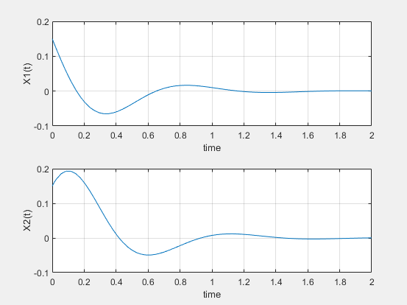

the response for the initial condition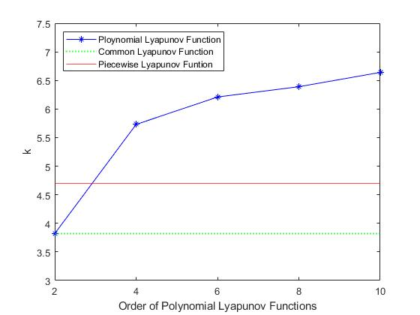

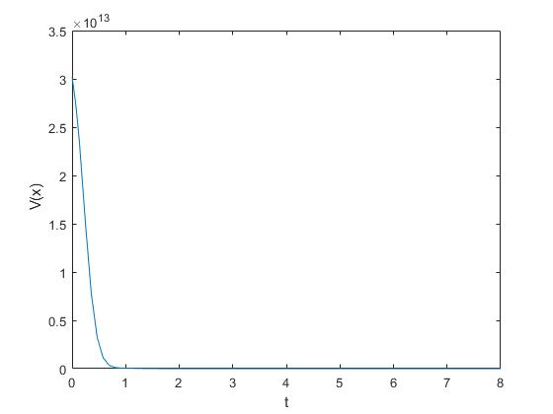Time transient of tenth-order polynomial Lyapunov function (kmax = 6.64).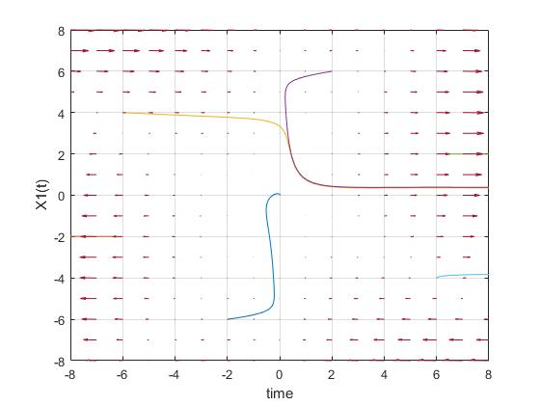 Behaviors in x1 –x2 plane.

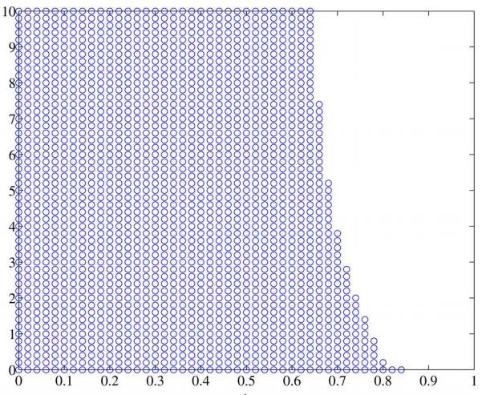

Feasible area of LMI design conditions (36)–(38) for T–S fuzzy model (57).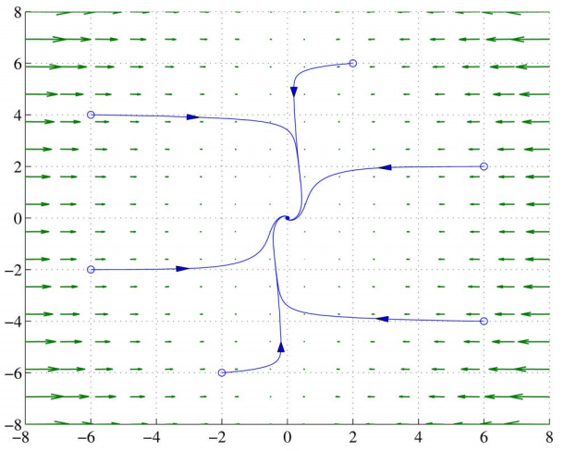 Behaviors in x1 –x2 plane (with feedback).