动态网关搭建完成后，启动eureka注册中心和springcloud2.0-zuul-apigateway-configserver服务，访问<http://localhost:8888/service-zuul-dev.yml> 读取配置文件中的路由转发信息：

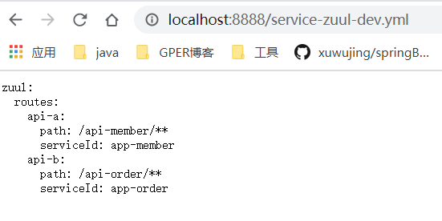

通过zuul网关访问member服务：

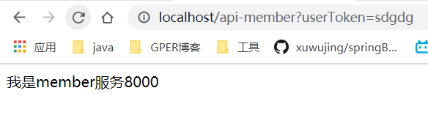

动态网关和SpringCloudConfig的关系如下：

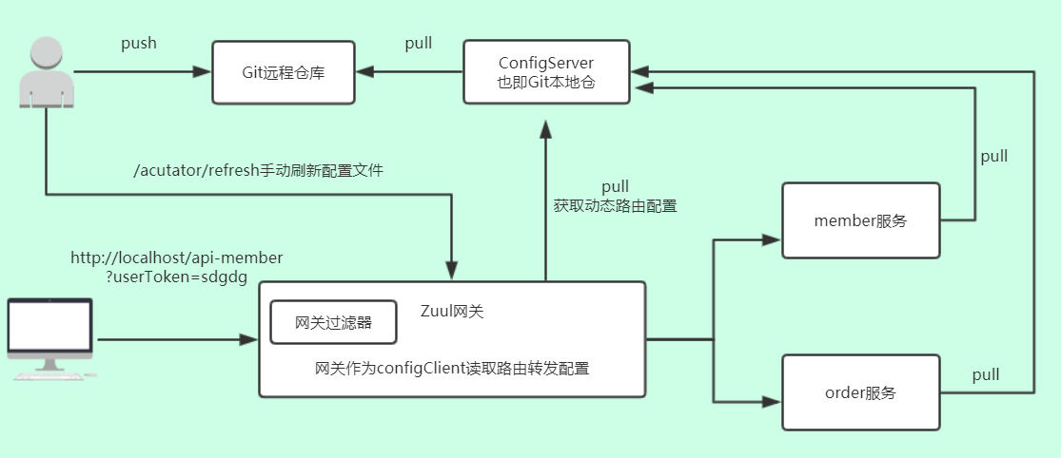

假如此时我在git上面再添加一个pay支付服务的路由转发规则：

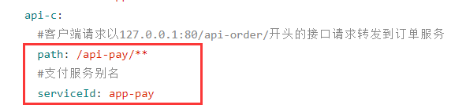

并创建一个pay服务：

Pom:

|  |
| --- |
| <project xmlns=*"http://maven.apache.org/POM/4.0.0"*  xmlns:xsi=*"http://www.w3.org/2001/XMLSchema-instance"*  xsi:schemaLocation=*"http://maven.apache.org/POM/4.0.0 http://maven.apache.org/xsd/maven-4.0.0.xsd"*>  <modelVersion>4.0.0</modelVersion>  <groupId>com.lchtest</groupId>  <artifactId>springcloud2.0-pay</artifactId>  <version>0.0.1-SNAPSHOT</version>  <parent>  <groupId>org.springframework.boot</groupId>  <artifactId>spring-boot-starter-parent</artifactId>  <version>2.0.3.RELEASE</version>  </parent>  <!-- 管理依赖 -->  <dependencyManagement>  <dependencies>  <dependency>  <groupId>org.springframework.cloud</groupId>  <artifactId>spring-cloud-dependencies</artifactId>  <version>Finchley.RELEASE</version>  <type>pom</type>  <scope>import</scope>  </dependency>  </dependencies>  </dependencyManagement>  <dependencies>  <!-- SpringBoot整合Web组件 -->  <dependency>  <groupId>org.springframework.boot</groupId>  <artifactId>spring-boot-starter-web</artifactId>  </dependency>  <!-- SpringBoot整合eureka客户端 -->  <dependency>  <groupId>org.springframework.cloud</groupId>  <artifactId>spring-cloud-starter-netflix-eureka-client</artifactId>  </dependency>  </dependencies>  </project> |

配置：

|  |
| --- |
| server:  port: 8006  spring:  application:  name: app-pay  eureka:  client:  service-url:  defaultZone: http://localhost:8100/eureka  #把自己注册到注册中心  register-with-eureka: **true**  # 从eureka上获取注册服务列表  fetch-registry: **true** |

主类：

|  |
| --- |
| **package** com.lchtest;  **import** org.springframework.beans.factory.annotation.Value;  **import** org.springframework.boot.SpringApplication;  **import** org.springframework.boot.autoconfigure.SpringBootApplication;  **import** org.springframework.cloud.netflix.eureka.EnableEurekaClient;  **import** org.springframework.web.bind.annotation.GetMapping;  **import** org.springframework.web.bind.annotation.RestController;  @SpringBootApplication  @EnableEurekaClient  @RestController  **public** **class** AppPay {    **public** **static** **void** main(String[] args) {  SpringApplication.*run*(AppPay.**class**, args);  }    @Value("${server.port}")  **private** String serverPort;    @GetMapping("/")  **public** String index() {  **return** "Pay service port=" + serverPort;  }  } |

启动pay服务，直接去访问网关<http://localhost/api-pay?userToken=sss>

会报404错误，因为网关获取到的配置还是旧的，通过网关服务器调用/actuator/refresh接口手动刷新网关服务的配置文件：

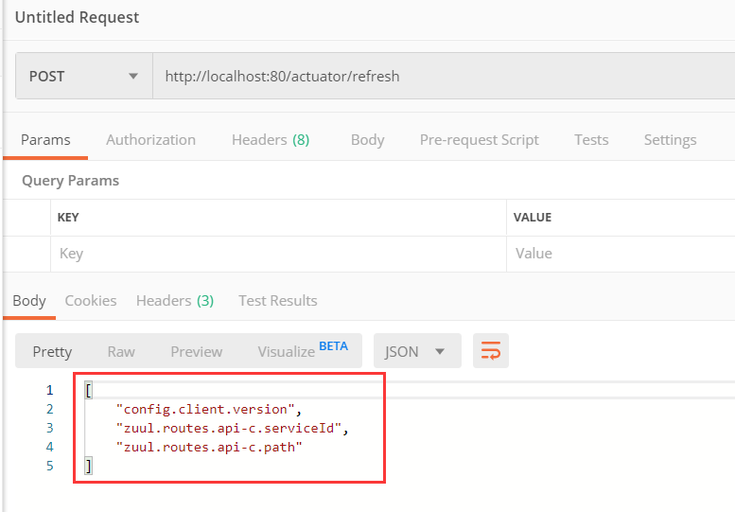

再次访问<http://localhost/api-pay?userToken=sss>

