# How to wire the Cognex CC24 IO Card to the SurfaceFX Ring Light Using a Strobe Controller

Wiring the Light, IO Card and Strobe Controller together must be done in the following steps:

* Connect the light to the strobe controller
* Connect the IO Card to the strobe controller
* Connect the Strobe Controller and the IO card to their power sources

## Connecting the Light to the Strobe Controller

The following diagram should illustrate the pins on the light’s connector and their function:

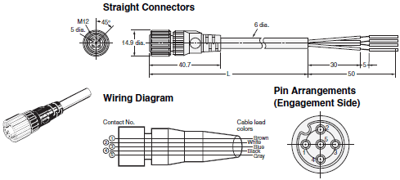

① Common + LED1 - and LED2 - and LED3 - and LED4 – from the Strobe Controller

② Light Block 1 (Top) LED1 + from the Strobe Controller

③ Light Block 2(Left) LED2 + from the Strobe Controller

④ Light Block 3(Bottom) LED3 + from the Strobe Controller

⑤ Light Block 4(Top) LED4 + from the Strobe Controller

Here is a diagram of the LED Outputs on the Strobe Controller

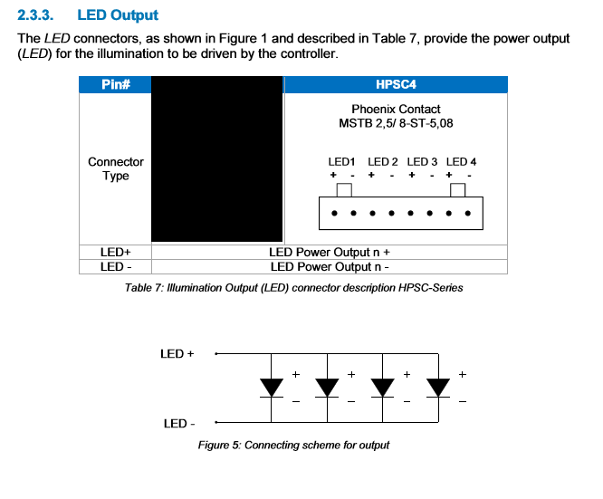

## Connecting the IO Card to the Strobe Controller

The following excerpt from the comm card manual shows all the pins on the comm card and which terminal on the Strobe Controller they’re supposed to connect to.

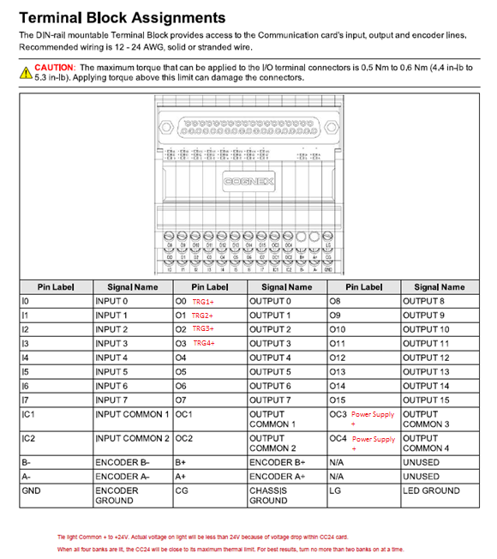

Here is a diagram of the Trigger Inputs for the Strobe Controller:

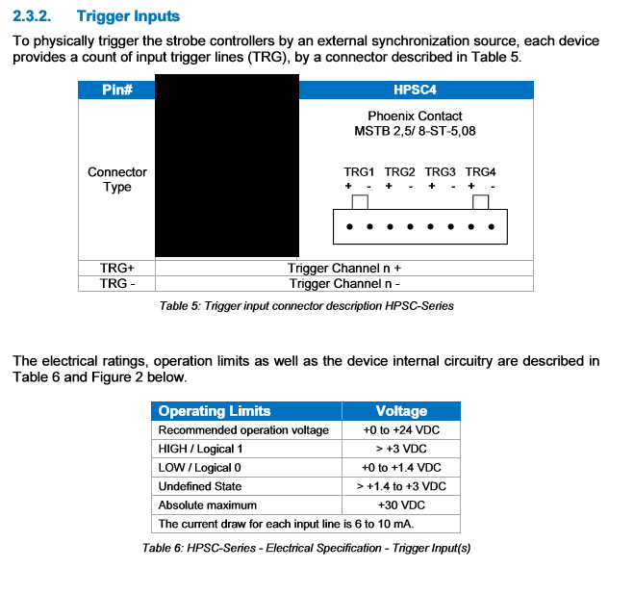

This excerpt details some information about the outputs of the CC24 for reference.

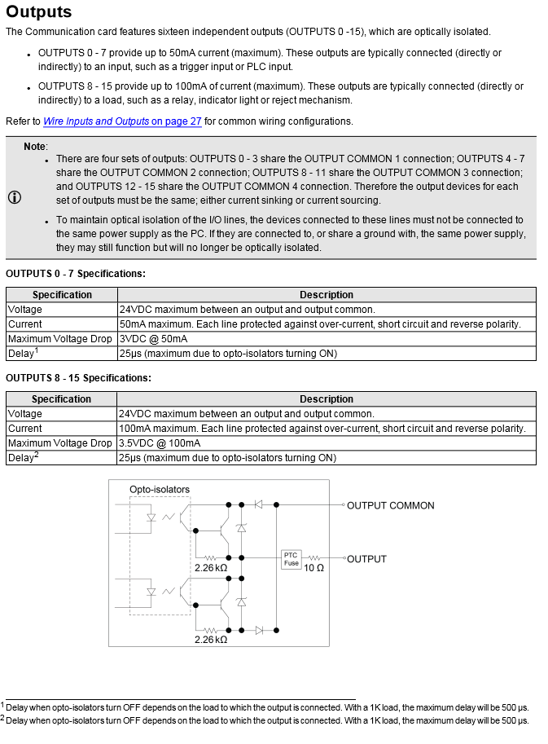

## Connecting a Power Source

Both the Strobe Controller and the IO card need to be connected to their own 24v power source.

For the Strobe Controller this power source should specifically be 12V-24V DC, 6.5A