For the purpose of this assignment I am using Postgres as database mangement system.
Create Database for the library system

Now we create the relations needed for our system with the specified constrains specified in the previews assignment.

Create Book relation with its constrains.
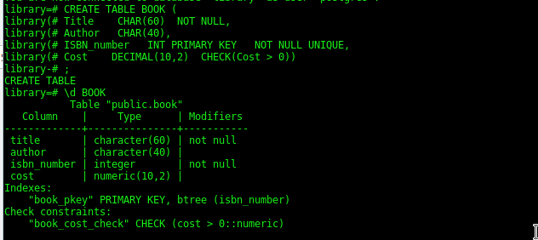

Create borrower relation and its constrains.

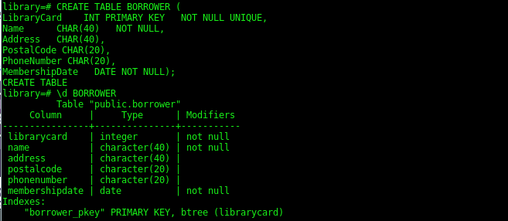

Create BookCopy relation with its constrains.
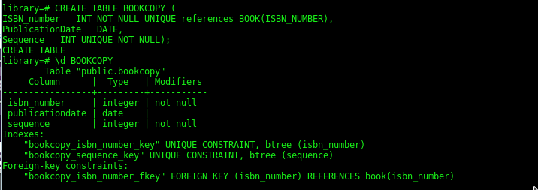
Create Librarian relation with the required constrains.

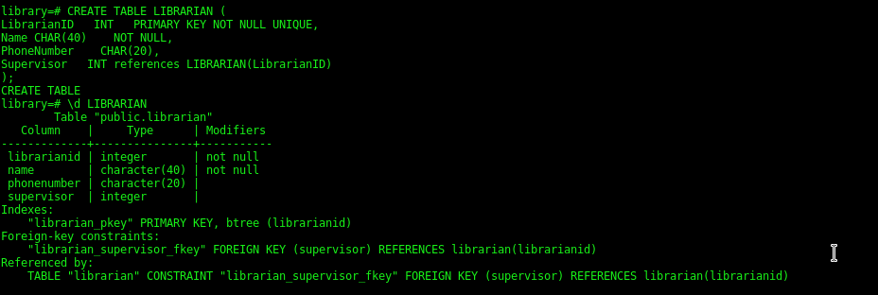
Create BookLended relation with all constrains.

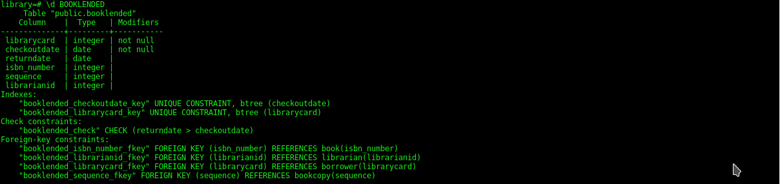
The resulting schema for our library system is completed.
