The SQL language provides additional flexibility when manipulating data in out database schema. The join operation allows the programmer to retrieve data from more than one relation with a single select operation. The join option, when retrieving data available in two different relation base on a criterion gives us the option to specify how narrow we want the result to be with the sql Inner Join and Outer Join statements. The inner Joijn tp be considered the most widely used type of Join in sql and it can be subdicided in three cathegories, Equi-join, Natural join and Cross join.
The possible joins can be described in the following image, where you can passed the columns you want to join in the select_list.
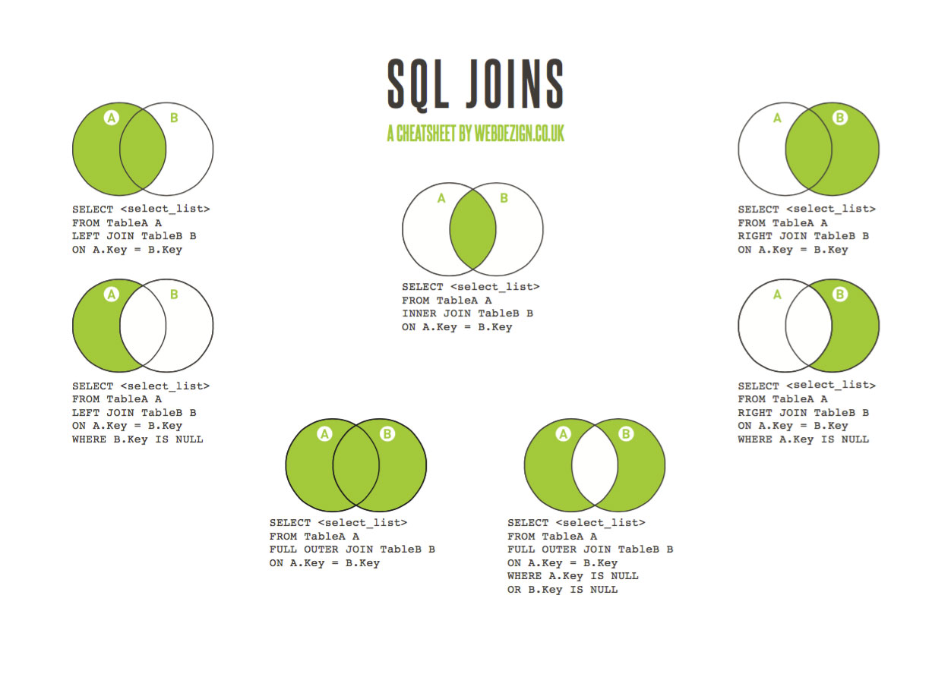

In the previous image we can see the syntax when querying data using joins

Examples of possible joins Using the relations Customer and Order ON CustomerID.

Inner Join Examples

SELECT Orders.OrderID, Customers.CustomerName
FROM Orders
INNER JOIN Customers ON Orders.CustomerID = Customers.CustomerID;
(w3schools, "SQL Joins", 2018)
The previous example of inner Join retrieves all the matching entries on customer id in both tables. The examples provided can be constructed in the section try yourself in the world wide consortium schools.

Left Join or Left outer Join
This Join will return all the values from the left table and any matching entry from the right table, additionally any non matching entry in the right table will be NULL.

Using the same tables we will create the query using Left Join in the same fields.

SELECT *
FROM Orders
LEFT JOIN Customers
ON Orders.Customer.ID=Customer.CustomerID;

Right Join
This Join will return all the values from the right table and any matching entry from the left table, additionally any non matching entry in the left table will be NULL.

Choose the correct JOIN clause to select all the records from the Customers table plus all the matches in the Orders table.
My solution
SELECT *
FROM Orders
RIGHT JOIN Customers
ON Orders.CustomerID=Customer.CustomerID

Full outer Join
This selection will return any matching values in either of the target tables
SELECT *
FROM Customers
FULL OUTER JOIN Orders ON Customers.CustomerID=Orders.CustomerID
//Optionally we can add how we want to sort the resulting values with
ORDER BY Customer.CustomerID;(w3schools, "SQL Joins", 2018)

Reference list
-SQL Joins. (n.d.). Retrieved from https://www.w3schools.com/sql/sql_join.asp

