IMAT3451_1819_520 Final Year Project

Student name: Ming-Hei Lui (Felix)

Student number: P15245731

Supervisor: Conor Fahy

Date: 05/04/2019

Word count:

**Abstract: 200-300**

(what this paper take about )

**Analysis of Requriements** **(Activity Type)**

**Review of literature 2000 each 200**

**Unity (game) engine**

**2.5games VS 3D**

-2.5D and 3D can use the 2D or 3D platform to make a game. According to unity3D (N/A) [1] “Some 2D games use 3D geometry for the environment and characters but restrict the gameplay to 2 dimensions”. Also, there have many ways to show 2.5D games, the one is orthographic 3D such as using the birds-eye view to the play like overcooked and Warcraft III: Reign of Chaos. The orthographic 3D games always using in the resource allocation and strategic. The other one is using the 2D gameplay with the 3D graphics. It makes the play in 3D mode but 2D gameplay like Crash Bandicoot and LIMBO. Also, both games are 3D modelling for the character.

[1]<https://unity3d.com/difference-between-2d-and-3d-games>

-2.5D is use the parallax mapping to look like 3D model.

<https://en.wikipedia.org/wiki/Video_game_graphics#Top-down_perspective> (cannot use)

-3D game uses more rescues to run, the platform need to high efficacy to run.

- The different between 2D and 3D platform, 3D platform to make 2.5D games will more real than the 2D platform, shadow, charter move, lighting.

<https://docs.unity3d.com/Manual/2Dor3D.html>

**2Dplatform (top down games)**

-The 2D platform game is using 2 dimensions gameplay, there have many 2D gameplay like side-scrolling game and top down view. In the 90’s have many games is use the side-scrolling game and top down view to playing. Because the platform has restricted cannot make the 3D game in this time. However, the game developer still makes the famous game in their technology. Such as Grand Theft Auto (GTA) and Metal Gear 2: Solid Snake. Now a day this game have improved many different version and story. RPG XXX

**PC platform**, the PC easy to get > PC gamer increase > PC market 上升 > PC games quality

<https://www.statista.com/chart/4527/game-developers-platform-preferences/>

**RPG**

-What is RPG.

RPG is Role-playing game. The player assumes the roles of characters in the virtual world. The player will control the one main character or more to do some quests. In the game world

<https://www.techopedia.com/definition/27052/role-playing-game-rpg>

-Benefit of RPG

<https://lifehacker.com/the-surprising-benefits-of-role-playing-games-and-how-1684582789>

**Unity VS Unreal**

Unity and Unreal are cross-platform game engine like Android, Windows and PlayStation.

-the big different in Unity and Unreal is the main programming language are C# and JavaScript to build the game. But Unreal are C++,

<https://www.androidauthority.com/unity-vs-unreal-engine-android-game-development-842045/>

-Unity and Unreal have different charging method to keep the company running. Unreal are free to use and create games but Unreal will charging the developer income in the game like buy the game or microtransaction, basis on Unreal engine (2014) “Anyone can ship a commercial product with UE4 by paying 5% of gross revenue resulting from sales to users.”. Unity have one free and three pay models.

<https://www.unrealengine.com/en-US/blog/welcome-to-unreal-engine-4>

-Unity and Unreal have different the graphics display. The Unreal is more suitable for the highly graphical and realism.

<https://medium.com/@thinkwik/cryengine-vs-unreal-vs-unity-select-the-best-game-engine-eaca64c60e3e>

<https://www.pluralsight.com/blog/film-games/unreal-engine-4-vs-unity-game-engine-best>

<https://blog.liveedu.tv/unity-vs-unreal/>

**UI design**

In the UI design, different art style design can combine to the games and make the player more immersion in the games. Also, the UI style is important to the game such as

Dishonored about the Science fiction it is using like rocking UI and Diablo 2 have the ancient UI in the game. UI can make the player to see the same style in the game, determine game era. XXX

“Having an UI’s art style that is consistent with your art direction matters a lot to improve the immersion.”

<https://medium.com/ironequal/the-only-advice-you-will-need-to-make-a-great-game-ui-ux-74a0db8de642>

In addition, good UI design make the player easy the getting about the information. Also, the UI do not too many spaces to display inventory.

Base on ieeexplore (2015), the UI designer put the UI in the different place affect the player experience and commitment to the character.

<https://ieeexplore.ieee.org/abstract/document/7377211/figures#figures>

**Level design**

Level design is one of the main conditions to make the game more challenging and interesting. According to Gillian Smith (2018) “Levels are the space where a player explores the rules and mechan-ics of a game”.

-Level can using the experience or skill to overcome the problem, it can increase the player problem solving skills. The game level can interactive with the player or character.

-level design is the guide to the player how to player the game. Also, the game story can be explained in the level design and different scenes.

-each level can upgrade the character or give the new ability to keep the player playing the game.

Gillian Smith (2018) [1]<https://www.researchgate.net/publication/229039146_A_framework_for_analysis_of_2D_platformer_levels>

<http://www.gamasutra.com/blogs/DanTaylor/20131006/197209/Ten_Principles_of_Good_Level_Design_Part_2.php>

**Target age**

The target age is important for the games because different ages will have different understandings and problem-solving skill. Also, the content of the game has ratings for target age such as ESRB (Entertainment Software Rating Board) and PEGI (Pan European Game Information). According to ESRB (N/A), “Content Descriptors indicate content that may have triggered a particular rating and/or may be of interest or concern”. It shows the content depends on the rating board to set the content such as Animated Blood and fantasy violence.

<https://www.esrb.org/ratings/ratings_guide.aspx>

The average age of gamers is youth, the target age set to 20-30 years can effective to have more people play and know about the games. According to Liza Brown (2018), the highest of games players by age between 21-35 have 35%. The second has 28% of game players between 36-50 years ago. The third is the 10-20 years teenagers have 22% is the games players. It can see 21-50 age of gamer over half of the age has 63%. Hence, this age of the player can afford to buy games or microtransaction (income job). Moreover, this group of gamers are played the video games more than the teenagers.

<https://www.bigfishgames.com/blog/2017-video-game-trends-and-statistics-whos-playing-what-and-why/>

<https://filmora.wondershare.com/infographic/video-game-trends-and-stats.html> <https://dmarket.com/blog/gaming-trends-2018/>

Design consideration (link back to lit review)

**Implementation**

**Introduction**: 1500

This project is using the unity to create an RPG game about the tank to save the world. The player can control the tank the

Story board

Game play

Game idea

Main body (about design the game) 3000

Cranmer follow the player tank

Why choose unity, C#

Main player design (240)

Frist, the player design the

(Player float chat)

Control (240)

In the player control part, this game is in PC platform will using keyboard key and mouse to control the main character. The character can use WASD to move and mouse left chick to shoot the bullet.

The player tank will follow the mouse cursor to aim because the mouse is shoot front sight for the player tank. Also, the cursor was designed the grey crosshair to default mouse cursor. It can make the player shoot more realistic. Furthermore, if the grey crosshair detect the enemy will call the function OnMouseEnter(), it will change the grey crosshair to red crosshair can much easy to aim the enemy object.

(Image for control)

Skill (240)

Shop (240)

Potion (240)

Coin (240)

In the game, the player can see the coin and get it. The coin system can cooperate to Shop

(Why need coin) In the game design, resource management is the one of the main RPG game elements. It can make the player to control the resource the player gets in the game. The coin system in this project can be save to another scene, it mean

Enemy

In the game, Enemy was develop to three different type of the enemy first one is the black tank enemy, the second is the red tank and the last one is Boss enemy. Each enemy have their special shooting style, it make the game more variety and the player will get more challenge. All enemy tank will shooting the bullet after a while will shooting again. The black enemy tank is the simple tank, it only shoot one bullet to the player. Next, the red enemy tank shooting style like a short gun, it have six fire point to shoot the bullet on the same time but different direction. The last Boss enemy tank designed have more HP, bigger and four fire point shooting to the same direction because it can make more hard to get kill and increase the level difficultly. Also it have the attack pattern in the Boss tank, it shoot the four bullet then two middle turret will shooting.

  

(The image for the enemy *3)

Explosion is the animation for the enemy, when the enemy health = 0 then show the explosion animation on the enemy die position. The animation can make improve the player experience. Unity is can make the five-explosion image to make a one animation for the game object. Each image of the animation time line takes 0:07 then move on to other image. This animation set show 1 second, it will loop the explosion animation unit less than 1 second.



(Explosion image)

AI

The enemy was design AI, it to focus on the player tank and attack. Also, the enemy tank will detect the player tank position and rotate the fire point face to the player tank. The AI was set the fire range for the enemy tank. If the player tank in the fire range, it will keep aim the player to shoot and stop move.

(AI diagram)

Collation system (save playerpfes ) (240)

Audio (240)

In the Audio part, in the online have many resources of the sound effects and some background music. Unity can support the common formats each as .mp3 and .wav can easy to add in the unity. In the game have four sound effects and one background music using the .wav formats. Audio can make a game more fun and vibrant. This game background music is making by beepbox.co. This website is the online tool can easy to crate the original songs of the user. Also in the website have many other user uploaded their original songs. Therefore, I crate write the own background music for this game. In the start game, the song will run and keep loop unit the game is quit.

On the other head, the sound effects are created by the online website tool call bfxr.net. It almost like the beepbox.co because those websites are for the game audio. But bfxr.net are make the sound effects for the computer games. Furthermore, The Sound effects can make the player more realistic in the game world. This website can make Coin, shoot and jump sound effects. Also, can synth the sound to make multiple changes for sound effects. It makes the sound effects for enemy and player shooting, the player gets hit and pick up the coin in the game. It adds those sound effects in the unity and in the coding make the trigger to run those audios.

Serene (200)

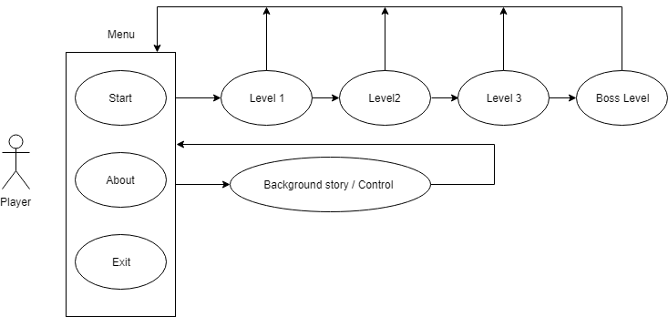

1. Game menu
2. Level 1
3. Level 2
4. Level 3
5. Boss Level

Linear RPG (線性RPG)

UI design (200)

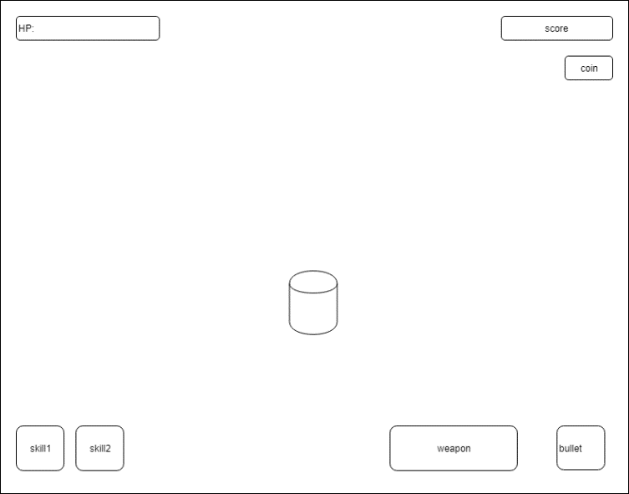

1. Menu
2. Skill
3. HP

(image UI)

Level design (240)

Map road

Tree

Potion

Trophy

Save data PlayerPrefs () (load.cs)

RPG games saving is the important part of the game. It can keep the player processes of the game and take a record for some achievement to make the player keep playing the game. because in the unity scene is cannot share the data to another different scene. In unity has many ways to save the player data, RPG games have many data need to be save in the games such as player health, coin, source and skills. Unity usually use JSON and PlayerPrefs method save the data in to unity. In this game for the project, it chooses the PlayerPrefs to save the player data in the unity. Using PlayerPrefs in the coding because of it much easier than use JSON method. In this game playerPrefs will save data such as the player Health, Source and skill. It saves the data because the game need those save to continue the game. In the game, the player go to the next level will save the health, source, player Level, coin and skill was upgraded. If the player quit and restate the game those data will be set to the default values.

2560

Future development:

Story board

The art cannot make player to empathy story

**Testing**

**User Evaluation:**

User feedback

**Conclusions**: 1500

Self-reflection

(why not have mini map )

**Project Management**

Gantt chart:

Project details:

**Reference**