**Table** **:** Descriptive Statistics Swedish Case Study

|  | **Control Group** | | | | | **Treatment Group** | | | | |
| --- | --- | --- | --- | --- | --- | --- | --- | --- | --- | --- |
| **Variable** | **N** | **Mean** | **SD** | **Min** | **Max** | **N** | **Mean** | **SD** | **Min** | **Max** |
| Trust in the Police | 703 | 7 | 1.8 | 0 | 10 | 414 | 7 | 1.9 | 0 | 10 |
| Obligation to Obey | 703 | 7 | 2 | 0 | 10 | 414 | 6.9 | 2.1 | 0 | 10 |
| Moral Alignment with Police | 703 | 3.8 | 0.53 | 1 | 5 | 414 | 3.8 | 0.62 | 1 | 5 |
| Lawfulness | 703 | 7.8 | 1.8 | 0 | 10 | 414 | 7.7 | 1.9 | 1 | 10 |
| Procedural Fairness | 703 | 2.9 | 0.44 | 1 | 4 | 414 | 2.9 | 0.46 | 1 | 4 |
| Effectiveness | 703 | 5.2 | 1.8 | 0 | 10 | 414 | 5.3 | 1.9 | 0 | 10 |
| Age (Years) | 703 | 50 | 19 | 15 | 91 | 414 | 46 | 16 | 16 | 88 |
| Gender | 703 | 0.48 | 0.5 | 0 | 1 | 414 | 0.49 | 0.5 | 0 | 1 |
| Education (Years) | 703 | 13 | 3.6 | 0 | 30 | 414 | 13 | 3.5 | 0 | 27 |
| Household Income (Decile) | 703 | 6.3 | 3 | 1 | 10 | 414 | 6.3 | 2.9 | 1 | 10 |
| SD = Standard deviation. | | | | | | | | | | |

**Table** **:** Descriptive Statistics Russian Case Study

|  | **Control Group** | | | | | **Treatment Group** | | | | |
| --- | --- | --- | --- | --- | --- | --- | --- | --- | --- | --- |
| **Variable** | **N** | **Mean** | **SD** | **Min** | **Max** | **N** | **Mean** | **SD** | **Min** | **Max** |
| Trust in the Police | 377 | 3.9 | 2.9 | 0 | 10 | 904 | 3.3 | 2.7 | 0 | 10 |
| Obligation to Obey | 377 | 4.2 | 2.8 | 0 | 10 | 904 | 3.7 | 2.5 | 0 | 10 |
| Moral Alignment with Police | 377 | 2.9 | 0.91 | 1 | 5 | 904 | 2.9 | 0.89 | 1 | 5 |
| Lawfulness | 377 | 3.5 | 2.4 | 0 | 10 | 904 | 3.9 | 2.1 | 0 | 10 |
| Procedural Fairness | 377 | 2.3 | 0.69 | 1 | 4.3 | 904 | 3.3 | 2.3 | 0 | 10 |
| Effectiveness | 377 | 4.4 | 2.1 | 0 | 10 | 904 | 2.2 | 0.65 | 1 | 4 |
| Age (Years) | 377 | 46 | 19 | 15 | 88 | 904 | 44 | 18 | 15 | 94 |
| Gender | 377 | 0.61 | 0.49 | 0 | 1 | 904 | 0.55 | 0.5 | 0 | 1 |
| Education (Years) | 377 | 13 | 3.1 | 2 | 22 | 904 | 13 | 2.9 | 2 | 23 |
| Household Income (Decile) | 377 | 4.7 | 2.5 | 1 | 10 | 904 | 5.9 | 3 | 1 | 10 |
| SD = Standard deviation. | | | | | | | | | | |

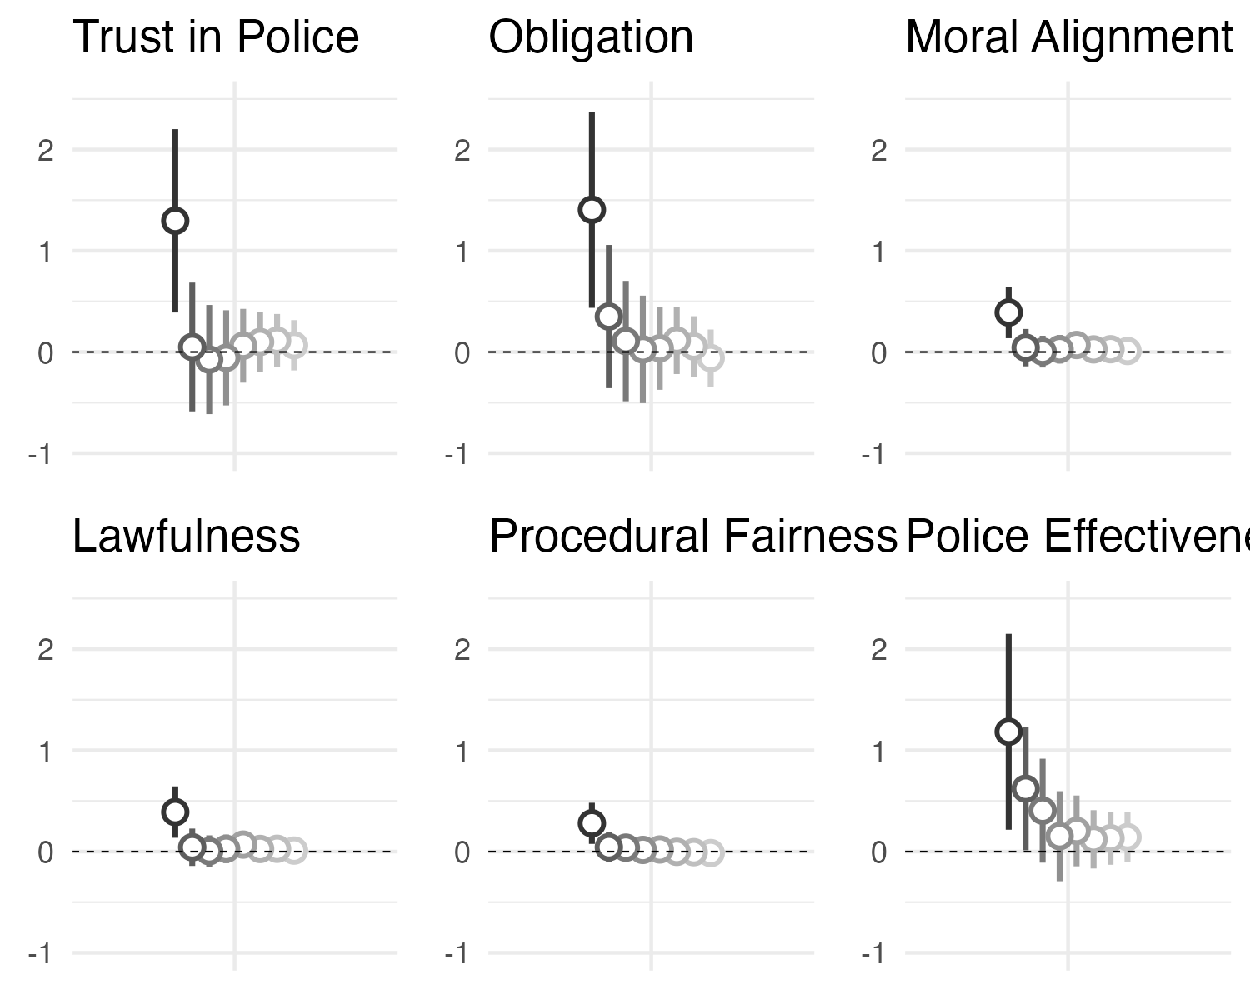

**Figure** **:** Average Treatment Effect Stockholm Bombing 2010

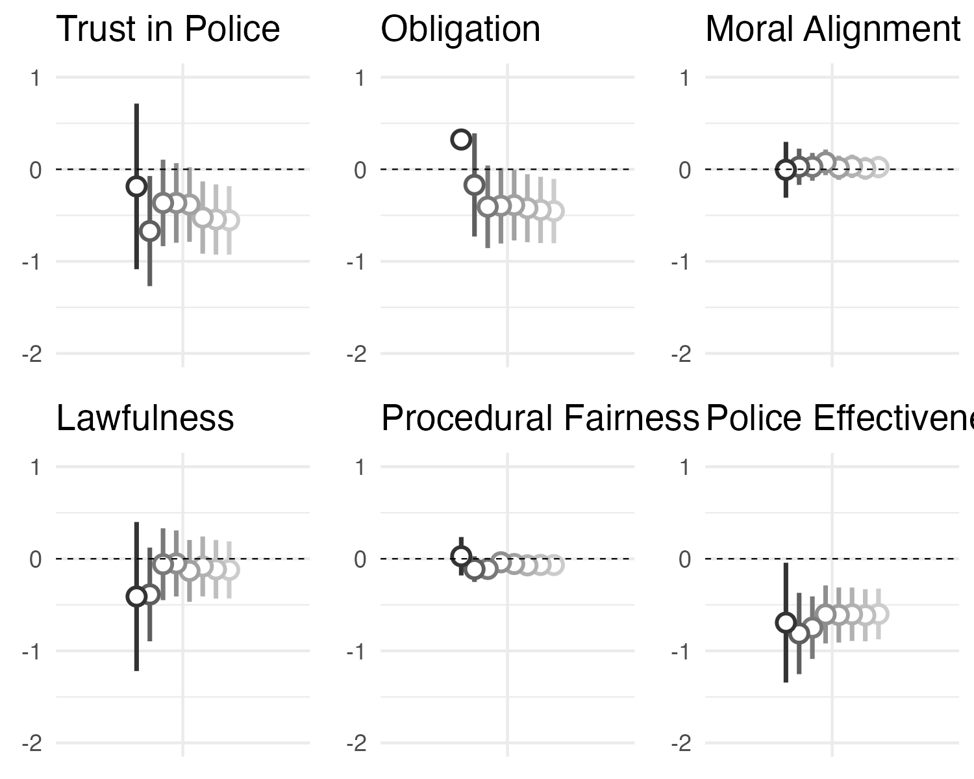

**Figure** **:** Average Treatment Effect Domodedovo Airport Bombing 2011

# Appendix

**Table** **:** Stockholm Bombing 1 to 4 week indow

|  |  |  |  |  |  |  |
| --- | --- | --- | --- | --- | --- | --- |
|  | **Trust** | **Obligation** | **Moral  Alignment** | **Lawfulness** | **Procedural Fairness** | **Police  Effectiveness** |
| **1 Week Window** | |  |  |  |  |  |
| (Intercept) | 6.447 *** | 6.376 *** | 3.667 *** | 7.681 *** | 2.787 *** | 4.702 *** |
|  | (0.297) | (0.318) | (0.083) | (0.268) | (0.067) | (0.318) |
| Treatment | 1.296 ** | 1.405 ** | 0.390 ** | 0.605 | 0.279 ** | 1.184 * |
|  | (0.455) | (0.487) | (0.128) | (0.410) | (0.102) | (0.486) |
| N | 82 | 82 | 82 | 82 | 82 | 82 |
| R2 | 0.092 | 0.094 | 0.105 | 0.027 | 0.086 | 0.069 |
| **2 Week Window** | |  |  |  |  |  |
| (Intercept) | 6.845 *** | 6.796 *** | 3.793 *** | 7.806 *** | 2.845 *** | 4.922 *** |
|  | (0.178) | (0.198) | (0.052) | (0.166) | (0.042) | (0.171) |
| Treatment | 0.050 | 0.350 | 0.043 | -0.122 | 0.044 | 0.621 * |
|  | (0.322) | (0.358) | (0.094) | (0.299) | (0.075) | (0.308) |
| N | 186 | 186 | 186 | 186 | 186 | 186 |
| R2 | 0.000 | 0.005 | 0.001 | 0.001 | 0.002 | 0.022 |
| **3 Week Window** | |  |  |  |  |  |
| (Intercept) | 6.910 *** | 7.016 *** | 3.837 *** | 7.794 *** | 2.857 *** | 5.058 *** |
|  | (0.132) | (0.145) | (0.038) | (0.126) | (0.032) | (0.125) |
| Treatment | -0.074 | 0.108 | 0.004 | -0.062 | 0.039 | 0.404 |
|  | (0.274) | (0.302) | (0.080) | (0.262) | (0.066) | (0.261) |
| N | 290 | 290 | 290 | 290 | 290 | 290 |
| R2 | 0.000 | 0.000 | 0.000 | 0.000 | 0.001 | 0.008 |
| **4 Week Window** | |  |  |  |  |  |
| (Intercept) | 6.967 *** | 6.948 *** | 3.838 *** | 7.738 *** | 2.871 *** | 5.212 *** |
|  | (0.101) | (0.114) | (0.030) | (0.098) | (0.024) | (0.095) |
| Treatment | -0.057 | 0.026 | 0.027 | 0.080 | 0.017 | 0.152 |
|  | (0.239) | (0.270) | (0.072) | (0.233) | (0.056) | (0.226) |
| N | 436 | 436 | 436 | 436 | 436 | 436 |
| R2 | 0.000 | 0.000 | 0.000 | 0.000 | 0.000 | 0.001 |
| Note: Standard errors in parentheses. Unstandardized coefficients are given. | | | | | | |
| *** p < 0.001; ** p < 0.01; * p < 0. | | | | | | |

**Table** **:** Stockholm Bombing 5 to 8 week window

|  |  |  |  |  |  |  |
| --- | --- | --- | --- | --- | --- | --- |
|  | **Trust** | **Obligation** | **Moral  Alignment** | **Lawfulness** | **Procedural Fairness** | **Police  Effectiveness** |
| **5 Week Window** | |  |  |  |  |  |
| (Intercept) | 7.026 *** | 6.947 *** | 3.830 *** | 7.714 *** | 2.878 *** | 5.256 *** |
|  | (0.085) | (0.096) | (0.025) | (0.084) | (0.020) | (0.082) |
| Treatment | 0.062 | 0.037 | 0.069 | 0.190 | 0.021 | 0.204 |
|  | (0.186) | (0.209) | (0.055) | (0.183) | (0.043) | (0.178) |
| N | 595 | 595 | 595 | 595 | 595 | 595 |
| R2 | 0.000 | 0.000 | 0.003 | 0.002 | 0.000 | 0.002 |
| **6 Week Window** | |  |  |  |  |  |
| (Intercept) | 7.000 *** | 6.990 *** | 3.830 *** | 7.725 *** | 2.875 *** | 5.230 *** |
|  | (0.076) | (0.086) | (0.022) | (0.074) | (0.019) | (0.074) |
| Treatment | 0.099 | 0.114 | 0.026 | 0.112 | -0.002 | 0.121 |
|  | (0.150) | (0.169) | (0.044) | (0.146) | (0.037) | (0.147) |
| N | 784 | 784 | 784 | 784 | 784 | 784 |
| R2 | 0.001 | 0.001 | 0.000 | 0.001 | 0.000 | 0.001 |
| **7 Week Window** | |  |  |  |  |  |
| (Intercept) | 6.975 *** | 6.969 *** | 3.819 *** | 7.754 *** | 2.869 *** | 5.217 *** |
|  | (0.072) | (0.081) | (0.021) | (0.069) | (0.018) | (0.071) |
| Treatment | 0.113 | 0.055 | 0.028 | 0.058 | -0.005 | 0.132 |
|  | (0.134) | (0.152) | (0.040) | (0.129) | (0.033) | (0.133) |
| N | 911 | 911 | 911 | 911 | 911 | 911 |
| **R2** | **0.001** | **0.000** | **0.001** | **0.000** | **0.000** | **0.001** |
| **8 Week Window** | |  |  |  |  |  |
| (Intercept) | 6.967 *** | 6.978 *** | 3.817 *** | 7.759 *** | 2.870 *** | 5.219 *** |
|  | (0.070) | (0.079) | (0.021) | (0.068) | (0.017) | (0.070) |
| Treatment | 0.067 | -0.060 | 0.010 | 0.002 | -0.014 | 0.143 |
|  | (0.127) | (0.144) | (0.038) | (0.123) | (0.031) | (0.126) |
| N | 990 | 990 | 990 | 990 | 990 | 990 |
| R2 | 0.000 | 0.000 | 0.000 | 0.000 | 0.000 | 0.001 |
| Note: Standard errors in parentheses. Unstandardized coefficients are given. | | | | | | |
| *** p < 0.001; ** p < 0.01; * p < 0. | | | | | | |

**Table** **:** Domodedovo Airport Bombing 1 to 4 week window

|  |  |  |  |  |  |  |
| --- | --- | --- | --- | --- | --- | --- |
|  | **Trust** | **Obligation** | **Moral  Alignment** | **Lawfulness** | **Procedural Fairness** | **Police  Effectiveness** |
| **1 Week Window** | |  |  |  |  |  |
| (Intercept) | 4.062 *** | 3.812 *** | 3.026 *** | 3.953 *** | 2.339 *** | 4.422 *** |
|  | (0.340) | (0.321) | (0.115) | (0.306) | (0.079) | (0.246) |
| Treatment | -0.186 | 0.323 | -0.005 | -0.410 | 0.028 | -0.693 * |
|  | (0.455) | (0.429) | (0.153) | (0.409) | (0.106) | (0.329) |
| N | 145 | 145 | 145 | 145 | 145 | 145 |
| R2 | 0.001 | 0.004 | 0.000 | 0.007 | 0.000 | 0.030 |
| **2 Week Window** | |  |  |  |  |  |
| (Intercept) | 4.404 *** | 4.184 *** | 3.009 *** | 4.005 *** | 2.417 *** | 4.617 *** |
|  | (0.209) | (0.196) | (0.069) | (0.178) | (0.049) | (0.155) |
| Treatment | -0.671 * | -0.170 | 0.027 | -0.387 | -0.112 | -0.811 *** |
|  | (0.304) | (0.285) | (0.100) | (0.259) | (0.071) | (0.224) |
| N | 348 | 348 | 348 | 348 | 348 | 348 |
| R2 | 0.014 | 0.001 | 0.000 | 0.006 | 0.007 | 0.036 |
| **3 Week Window** | |  |  |  |  |  |
| (Intercept) | 3.979 *** | 4.321 *** | 2.952 *** | 3.571 *** | 2.356 *** | 4.529 *** |
|  | (0.159) | (0.152) | (0.051) | (0.132) | (0.037) | (0.115) |
| Treatment | -0.365 | -0.407 | 0.027 | -0.059 | -0.110 | -0.748 *** |
|  | (0.239) | (0.228) | (0.077) | (0.199) | (0.056) | (0.173) |
| N | 597 | 597 | 597 | 597 | 597 | 597 |
| R2 | 0.004 | 0.005 | 0.000 | 0.000 | 0.006 | 0.031 |
| **4 Week Window** | |  |  |  |  |  |
| (Intercept) | 3.858 *** | 4.271 *** | 2.920 *** | 3.497 *** | 2.320 *** | 4.410 *** |
|  | (0.151) | (0.144) | (0.049) | (0.126) | (0.036) | (0.110) |
| Treatment | -0.366 | -0.396 | 0.075 | -0.050 | -0.038 | -0.604 *** |
|  | (0.220) | (0.209) | (0.071) | (0.183) | (0.052) | (0.160) |
| N | 695 | 695 | 695 | 695 | 695 | 695 |
| R2 | 0.004 | 0.005 | 0.002 | 0.000 | 0.001 | 0.020 |
| Note: Standard errors in parentheses. Unstandardized coefficients are given. | | | | | | |
| *** p < 0.001; ** p < 0.01; * p < 0. | | | | | | |

**Table** **:** Domodedovo Bombing 5 to 8 week window

|  |  |  |  |  |  |  |
| --- | --- | --- | --- | --- | --- | --- |
|  | **Trust** | **Obligation** | **Moral  Alignment** | **Lawfulness** | **Procedural Fairness** | **Police  Effectiveness** |
| **5 Week Window** | |  |  |  |  |  |
| (Intercept) | 3.875 *** | 4.242 *** | 2.925 *** | 3.501 *** | 2.317 *** | 4.403 *** |
|  | (0.148) | (0.140) | (0.048) | (0.123) | (0.035) | (0.109) |
| Treatment | -0.383 | -0.389 * | 0.016 | -0.131 | -0.057 | -0.611 *** |
|  | (0.206) | (0.196) | (0.067) | (0.171) | (0.049) | (0.152) |
| N | 777 | 777 | 777 | 777 | 777 | 777 |
| R2 | 0.004 | 0.005 | 0.000 | 0.001 | 0.002 | 0.020 |
| **6 Week Window** | |  |  |  |  |  |
| (Intercept) | 3.875 *** | 4.242 *** | 2.925 *** | 3.501 *** | 2.317 *** | 4.403 *** |
|  | (0.147) | (0.139) | (0.048) | (0.122) | (0.035) | (0.109) |
| Treatment | -0.524 ** | -0.423 * | 0.032 | -0.083 | -0.071 | -0.602 *** |
|  | (0.200) | (0.188) | (0.065) | (0.166) | (0.047) | (0.148) |
| N | 824 | 824 | 824 | 824 | 824 | 824 |
| R2 | 0.008 | 0.006 | 0.000 | 0.000 | 0.003 | 0.020 |
| **7 Week Window** | |  |  |  |  |  |
| (Intercept) | 3.875 *** | 4.242 *** | 2.925 *** | 3.501 *** | 2.317 *** | 4.403 *** |
|  | (0.146) | (0.138) | (0.047) | (0.122) | (0.035) | (0.108) |
| Treatment | -0.545 ** | -0.441 * | 0.010 | -0.115 | -0.067 | -0.614 *** |
|  | (0.194) | (0.183) | (0.063) | (0.162) | (0.046) | (0.144) |
| N | 871 | 871 | 871 | 871 | 871 | 871 |
| R2 | 0.009 | 0.007 | 0.000 | 0.001 | 0.002 | 0.020 |
| **8 Week Window** | |  |  |  |  |  |
| (Intercept) | 3.875 *** | 4.242 *** | 2.925 *** | 3.501 *** | 2.317 *** | 4.403 *** |
|  | (0.145) | (0.136) | (0.047) | (0.121) | (0.035) | (0.108) |
| Treatment | -0.554 ** | -0.454 * | 0.024 | -0.121 | -0.068 | -0.599 *** |
|  | (0.189) | (0.178) | (0.062) | (0.158) | (0.045) | (0.140) |
| N | 913 | 913 | 913 | 913 | 913 | 913 |
| R2 | 0.009 | 0.007 | 0.000 | 0.001 | 0.002 | 0.020 |
| Note: Standard errors in parentheses. Unstandardized coefficients are given. | | | | | | |
| *** p < 0.001; ** p < 0.01; * p < 0. | | | | | | |

## Robustness Assumption Tests

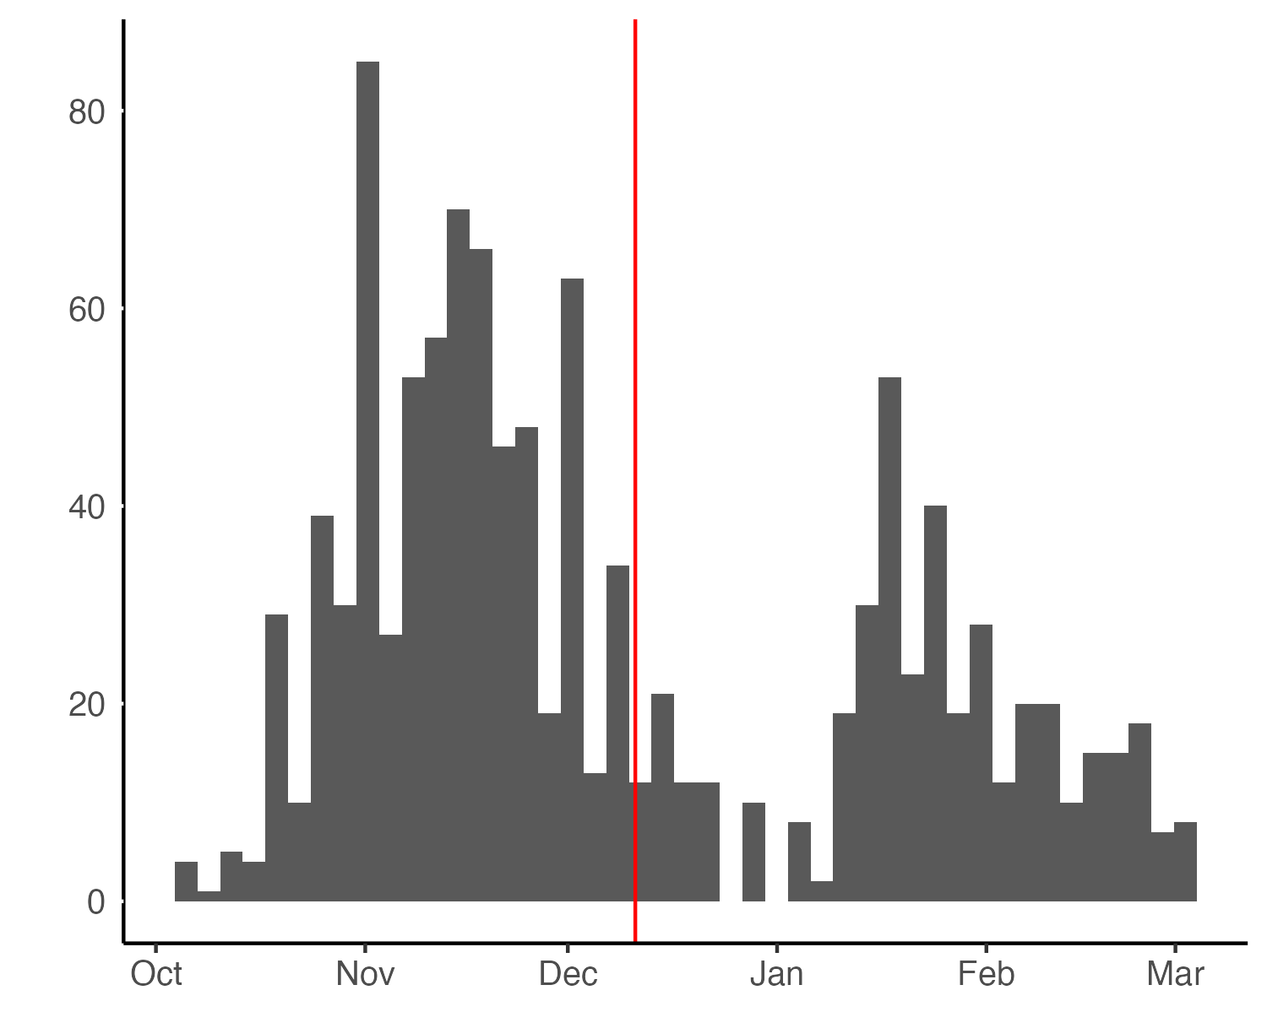

**Figure** **:** Daily number of Interviews in Swedish fieldwork

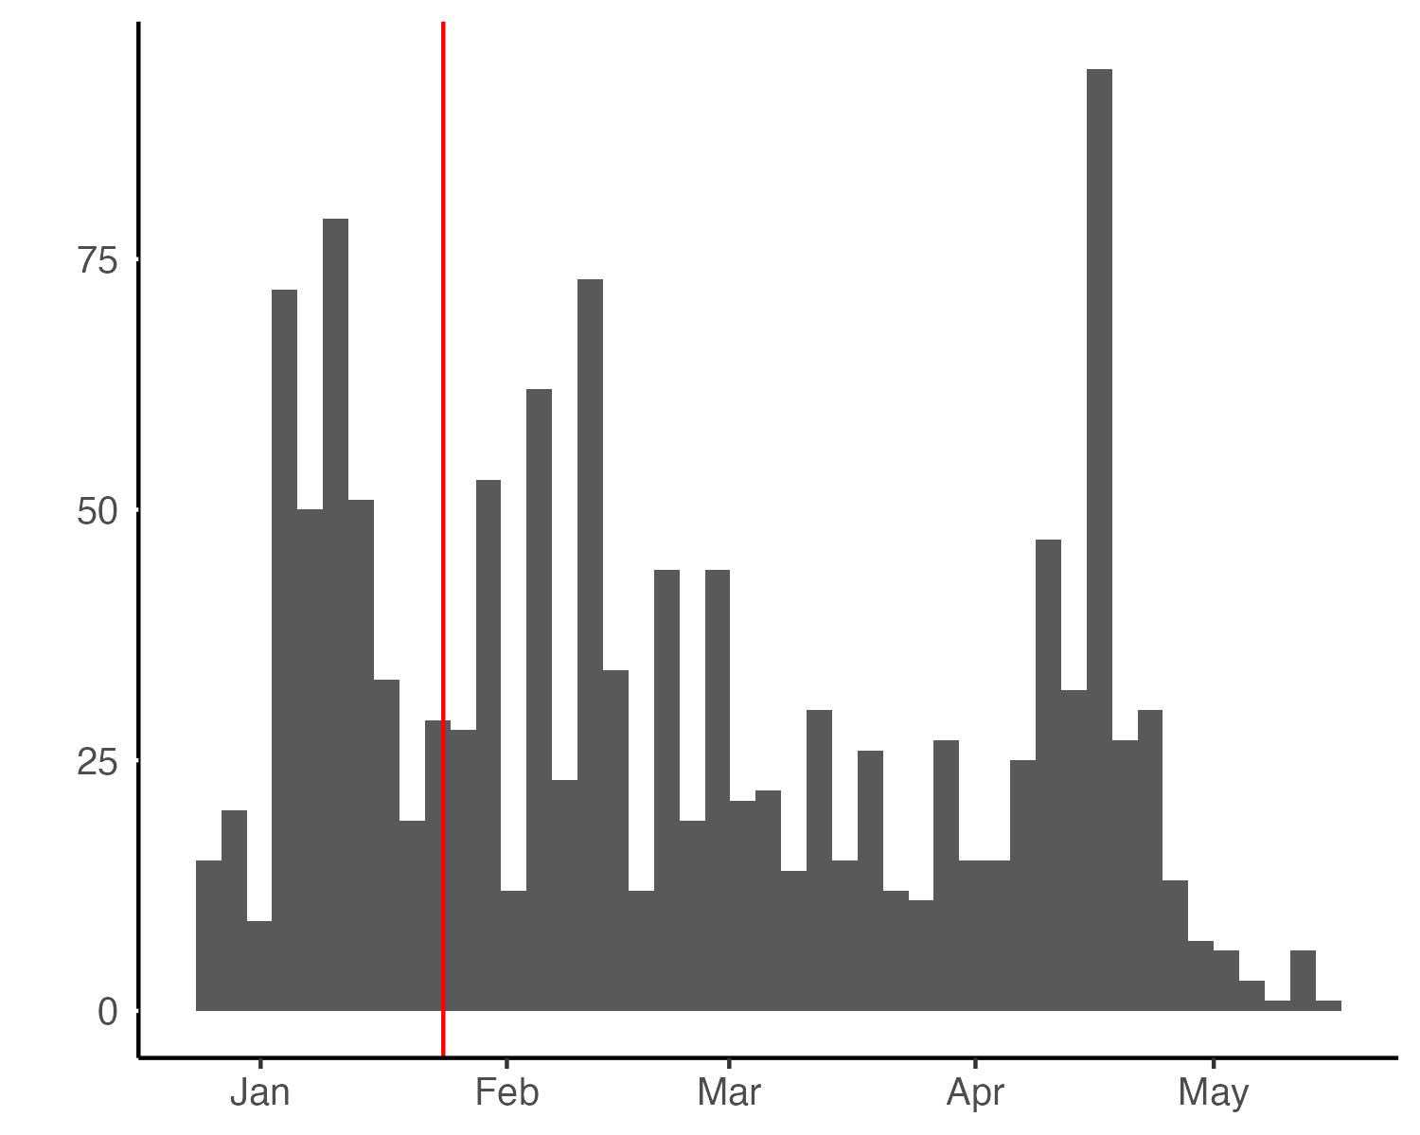

**Figure** **:** Daily number of Interviews in Russian fieldwork

**Table** **:** Non-responses to Survey Items

|  | **Swedish Sample** | | | **Russian Sample** | | |
| --- | --- | --- | --- | --- | --- | --- |
| **Item** | **Control** | **Treatment** | **Difference** | **Control** | **Treatment** | **Difference** |
| 'Duty to: back decisions made by police, even if disagree' | 3.3 | 3.9 | -0.6 | 17.1 | 15.0 | 2.1 |
| 'Duty to: back decisions made by police, even when you don't understand | 2.5 | 2.2 | 0.3 | 16.7 | 18.8 | -2.1 |
| 'Duty to: do what police say even if treated badly' | 3.0 | 2.2 | 0.8 | 13.4 | 10.6 | 2.8 |
| 'How much do you trust the police' | 0.7 | 1.1 | -0.4 | 16.3 | 17.5 | -1.2 |
| 'How often do Police explain their decisions and actions when asked' | 10.2 | 10.2 | 0.0 | 7.0 | 7.3 | -0.3 |
| 'How often do Police make fair imparcial decisions' | 5.9 | 5.2 | 0.7 | 6.8 | 7.3 | -0.5 |
| 'How often do Police treat people with respect' | 3.7 | 2.2 | 1.5 | 7.8 | 7.3 | 0.5 |
| 'how often would you say that police take bribes?' | 7.7 | 6.7 | 1.0 | 8.9 | 6.6 | 2.3 |
| 'How successful police are at preventing crimes in country' | 4.0 | 3.1 | 0.9 | 5.9 | 8.0 | -2.1 |
| 'I generally support how the police act' | 2.1 | 1.5 | 0.6 | 5.6 | 7.5 | -1.9 |
| 'Police have the same sense of right and wrong as me' | 1.3 | 2.6 | -1.3 | 6.3 | 6.4 | -0.1 |
| 'Police stand up for values that are important to people like me' | 2.3 | 2.0 | 0.3 | 4.3 | 4.4 | -0.1 |
| Note: Numbers indicate the percenteges of missing answers for each survey item. | | | | | | |

**Table** **:** Binary logistic regression with treatment as dependent variable

|  |  |  |
| --- | --- | --- |
|  | **Swedish Sample** | **Russian Sample** |
| (Intercept) | 0.419 *** | 0.670 *** |
|  | (0.078) | (0.078) |
| Age | -0.003 ** | -0.001 |
|  | (0.001) | (0.001) |
| Gender | -0.002 | -0.023 |
|  | (0.029) | (0.026) |
| Education | 0.010 * | -0.005 |
|  | (0.004) | (0.005) |
| Household Income | -0.008 | 0.027 *** |
|  | (0.005) | (0.005) |
| N | 1117 | 1281 |
| *** p < 0.001; ** p < 0.01; * p < 0.05 Note. Coeffitients are Log Odds, Standard errors in parentheses. Two-tailed tests | | |

**Table** **:**  Stockolm Bombing Average Treatment Effect with Covariate Adjustment

|  |  |  |  |  |  |  |
| --- | --- | --- | --- | --- | --- | --- |
|  | **Trust** | **Obligation** | **Moral  Alignment** | **Lawfulness** | **Procedural  Fairness** | **Police   Effectiveness** |
| **1 Week Window** | |  |  |  |  |  |
| (Intercept) | 6.632 *** | 5.316 *** | 3.219 *** | 6.283 *** | 3.103 *** | 4.810 *** |
|  | (1.114) | (1.175) | (0.307) | (0.938) | (0.247) | (1.207) |
| Treatment | 1.267 ** | 1.274 * | 0.336 * | 0.420 | 0.277 ** | 1.210 * |
|  | (0.470) | (0.496) | (0.129) | (0.396) | (0.104) | (0.509) |
| N | 82 | 82 | 82 | 82 | 82 | 82 |
| R2 | 0.119 | 0.144 | 0.162 | 0.174 | 0.131 | 0.071 |
| **2 Week Window** | |  |  |  |  |  |
| (Intercept) | 6.179 *** | 5.055 *** | 3.202 *** | 6.912 *** | 2.802 *** | 4.675 *** |
|  | (0.778) | (0.852) | (0.221) | (0.704) | (0.182) | (0.756) |
| Treatment | 0.159 | 0.392 | 0.064 | -0.115 | 0.065 | 0.621 |
|  | (0.325) | (0.356) | (0.092) | (0.294) | (0.076) | (0.315) |
| N | 186 | 186 | 186 | 186 | 186 | 186 |
| R2 | 0.035 | 0.067 | 0.078 | 0.084 | 0.029 | 0.025 |
| **3 Week Window** | |  |  |  |  |  |
| (Intercept) | 6.431 *** | 5.563 *** | 3.402 *** | 6.831 *** | 2.618 *** | 5.474 *** |
|  | (0.609) | (0.664) | (0.172) | (0.574) | (0.147) | (0.583) |
| Treatment | 0.002 | 0.139 | 0.016 | -0.036 | 0.052 | 0.400 |
|  | (0.277) | (0.302) | (0.078) | (0.261) | (0.067) | (0.265) |
| N | 290 | 290 | 290 | 290 | 290 | 290 |
| R2 | | 0.041 | 0.081 | 0.049 | 0.023 | 0.015 |
| **4 Week Window** |  |  |  |  |  |  |
| (Intercept) | 6.338 *** | 5.453 *** | 3.349 *** | 6.747 *** | 2.741 *** | 5.600 *** |
|  | (0.489) | (0.546) | (0.143) | (0.472) | (0.116) | (0.464) |
| Treatment | -0.011 | 0.006 | 0.032 | 0.088 | 0.023 | 0.139 |
|  | (0.241) | (0.269) | (0.071) | (0.232) | (0.057) | (0.228) |
| N | 436 | 436 | 436 | 436 | 436 | 436 |
| R2 | 0.013 | 0.035 | 0.059 | 0.036 | 0.012 | 0.009 |
| Note: Estimates controlling for age, gender, education and household income. Standard errors in parentheses. Unstandardized coefficients are given. | | | | | | |
| *** p < 0.001; ** p < 0.01; * p < 0. | | | | | | |

**Table** **:** Domolevov Bombing Average Treatment Effect with Covariate Adjustment

|  |  |  |  |  |  |  |
| --- | --- | --- | --- | --- | --- | --- |
|  | **Trust** | **Obligation** | **Moral  Alignment** | **Lawfulness** | **Procedural  Fairness** | **Police  Effectiveness** |
| **1 Week Window** | |  |  |  |  |  |
| (Intercept) | 5.932 *** | 2.384 | 2.963 *** | 3.911 ** | 2.566 *** | 5.174 *** |
|  | (1.415) | (1.329) | (0.473) | (1.271) | (0.321) | (1.017) |
| Treatment | -0.185 | 0.438 | 0.040 | -0.345 | 0.042 | -0.746 * |
|  | (0.461) | (0.433) | (0.154) | (0.414) | (0.105) | (0.331) |
| N | 145 | 145 | 145 | 145 | 145 | 145 |
| R2 | 0.025 | 0.035 | 0.039 | 0.033 | 0.063 | 0.064 |
| **2 Week Window** | |  |  |  |  |  |
| (Intercept) | 6.285 *** | 3.484 *** | 3.238 *** | 4.552 *** | 2.668 *** | 6.170 *** |
|  | (0.917) | (0.854) | (0.304) | (0.780) | (0.213) | (0.670) |
| Treatment | -0.698 * | -0.205 | 0.020 | -0.412 | -0.121 | -0.841 *** |
|  | (0.303) | (0.282) | (0.100) | (0.258) | (0.070) | (0.221) |
| N | 348 | 348 | 348 | 348 | 348 | 348 |
| R2 | 0.038 | 0.038 | 0.014 | 0.031 | 0.036 | 0.079 |
| **3 Week Window** | |  |  |  |  |  |
| (Intercept) | 5.386 *** | 3.216 *** | 2.953 *** | 3.632 *** | 2.639 *** | 6.051 *** |
|  | (0.733) | (0.690) | (0.237) | (0.609) | (0.172) | (0.526) |
| Treatment | -0.360 | -0.396 | 0.030 | -0.043 | -0.108 | -0.760 *** |
|  | (0.239) | (0.225) | (0.077) | (0.198) | (0.056) | (0.171) |
| N | 597 | 597 | 597 | 597 | 597 | 597 |
| R2 | | 0.051 | 0.009 | 0.018 | 0.033 | 0.061 |
| **4 Week Window** |  |  |  |  |  |  |
| (Intercept) | 5.260 *** | 3.577 *** | 2.983 *** | 3.855 *** | 2.559 *** | 6.075 *** |
|  | (0.668) | (0.626) | (0.216) | (0.553) | (0.156) | (0.483) |
| Treatment | -0.348 | -0.364 | 0.080 | -0.023 | -0.032 | -0.609 *** |
|  | (0.220) | (0.206) | (0.071) | (0.182) | (0.051) | (0.159) |
| N | 695 | 695 | 695 | 695 | 695 | 695 |
| R2 | 0.019 | 0.044 | 0.007 | 0.019 | 0.022 | 0.048 |
| Note: Estimates controlling for age, gender, education and household income. Standard errors in parentheses. Unstandardized coefficients are given. | | | | | | |
| *** p < 0.001; ** p < 0.01; * p < 0. | | | | | | |

**Table** **:** Domolevov Bombing Average Treatment Effect with Covariate Adjustment 5-8

|  |  |  |  |  |  |  |
| --- | --- | --- | --- | --- | --- | --- |
|  | **Trust** | **Obligation** | **Moral  Alignment** | **Lawfulness** | **Procedural  Fairness** | **Police  Effectiveness** |
| **5 Week Window** | |  |  |  |  |  |
| (Intercept) | 5.071 *** | 3.392 *** | 3.013 *** | 3.597 *** | 2.521 *** | 6.086 *** |
|  | (0.631) | (0.589) | (0.205) | (0.522) | (0.148) | (0.462) |
| Treatment | -0.371 | -0.341 | 0.024 | -0.095 | -0.048 | -0.611 *** |
|  | (0.206) | (0.193) | (0.067) | (0.171) | (0.049) | (0.151) |
| N | 777 | 777 | 777 | 777 | 777 | 777 |
| R2 | 0.017 | 0.046 | 0.007 | 0.018 | 0.022 | 0.045 |
| **6 Week Window** | |  |  |  |  |  |
| (Intercept) | 5.008 *** | 3.481 *** | 3.134 *** | 3.682 *** | 2.520 *** | 6.217 *** |
|  | (0.604) | (0.560) | (0.196) | (0.500) | (0.142) | (0.443) |
| Treatment | -0.505 * | -0.349 | 0.039 | -0.040 | -0.061 | -0.610 *** |
|  | (0.200) | (0.186) | (0.065) | (0.166) | (0.047) | (0.147) |
| N | 824 | 824 | 824 | 824 | 824 | 824 |
| R2 | 0.020 | 0.046 | 0.007 | 0.016 | 0.024 | 0.049 |
| **7 Week Window** | |  |  |  |  |  |
| (Intercept) | 5.036 *** | 3.558 *** | 3.138 *** | 3.706 *** | 2.512 *** | 6.156 *** |
|  | (0.586) | (0.546) | (0.191) | (0.489) | (0.139) | (0.431) |
| Treatment | -0.528 ** | -0.351 | 0.021 | -0.062 | -0.055 | -0.613 *** |
|  | (0.195) | (0.182) | (0.063) | (0.163) | (0.046) | (0.144) |
| N | 871 | 871 | 871 | 871 | 871 | 871 |
| R2 | | 0.046 | 0.007 | 0.014 | 0.024 | 0.047 |
| **8 Week Window** |  |  |  |  |  |  |
| (Intercept) | 4.923 *** | 3.569 *** | 3.131 *** | 3.613 *** | 2.473 *** | 6.182 *** |
|  | (0.571) | (0.529) | (0.186) | (0.476) | (0.136) | (0.420) |
| Treatment | -0.533 ** | -0.357 * | 0.036 | -0.062 | -0.056 | -0.597 *** |
|  | (0.191) | (0.177) | (0.062) | (0.159) | (0.046) | (0.141) |
| N | 913 | 913 | 913 | 913 | 913 | 913 |
| R2 | 0.021 | 0.045 | 0.007 | 0.013 | 0.023 | 0.045 |
| Note: Estimates controlling for age, gender, education and household income. Standard errors in parentheses. Unstandardized coefficients are given. | | | | | | |
| *** p < 0.001; ** p < 0.01; * p < 0. | | | | | | |

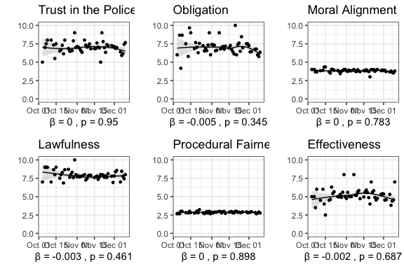

**Figure** **:** Pre-Existing Time Trends in Sweden depicted with locally weighted regression lines (LOESS)

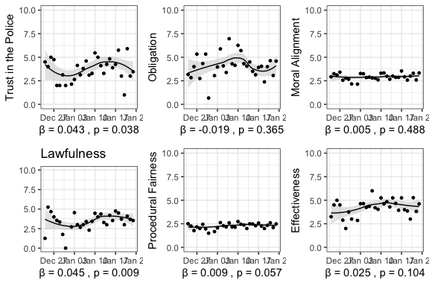

**Figure** **:** Pre-Existing Time Trends in Russia depicted with locally weighted regression lines (LOESS)

**Table** **:** Placebo Treatment Sweden

|  |  |  |  |  |  |  |
| --- | --- | --- | --- | --- | --- | --- |
|  | **Trust** | **Obligation** | **Moral Alignment** | **Lawfulness** | **Procedural Fairness** | **Police Effectiveness** |
| (Intercept) | 6.971 *** | 7.019 *** | 3.801 *** | 7.805 *** | 2.869 *** | 5.198 *** |
|  | (0.098) | (0.110) | (0.029) | (0.096) | (0.024) | (0.098) |
| Placebo | 0.005 | -0.071 | 0.036 | -0.057 | 0.001 | 0.033 |
|  | (0.139) | (0.157) | (0.041) | (0.137) | (0.034) | (0.140) |
| N | 678 | 678 | 678 | 678 | 678 | 678 |
| R2 | 0.000 | 0.000 | 0.001 | 0.000 | 0.000 | 0.000 |
| *** p < 0.001; ** p < 0.01; * p < 0.05 Note. | | | | | | |

**Table** **:** Placebo Treatment Russia

|  |  |  |  |  |  |  |
| --- | --- | --- | --- | --- | --- | --- |
|  | **Trust** | **Obligation** | **Moral Alignment** | **Lawfulness** | **Procedural Fairness** | **Police Effectiveness** |
| (Intercept) | 3.392 *** | 4.323 *** | 2.888 *** | 7.805 *** | 2.237 *** | 4.229 *** |
|  | (0.218) | (0.218) | (0.071) | (0.096) | (0.053) | (0.161) |
| Placebo | 1.013 *** | -0.139 | 0.122 | -0.057 | 0.180 * | 0.389 |
|  | (0.301) | (0.301) | (0.098) | (0.137) | (0.074) | (0.222) |
| N | 349 | 349 | 349 | 678 | 349 | 349 |
| R2 | 0.032 | 0.001 | 0.004 | 0.000 | 0.017 | 0.009 |
| *** p < 0.001; ** p < 0.01; * p < 0.05 Note. | | | | | | |