EVIDENCIAS SPRINT 3
H5
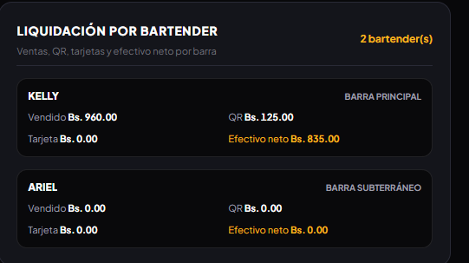
closing displays bartender settlement by bar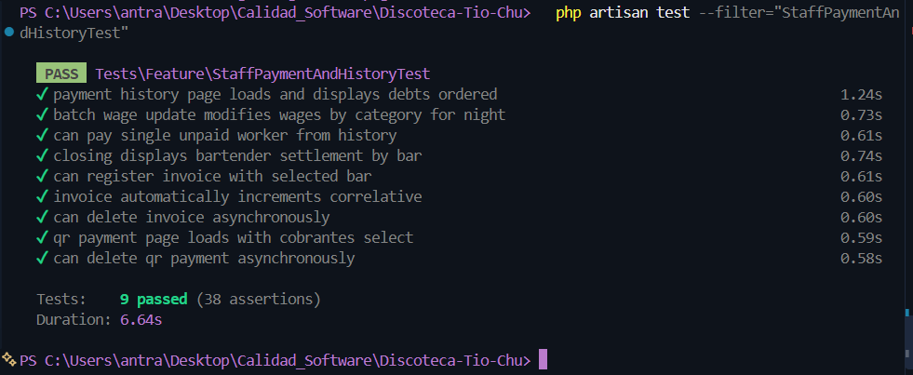
H3
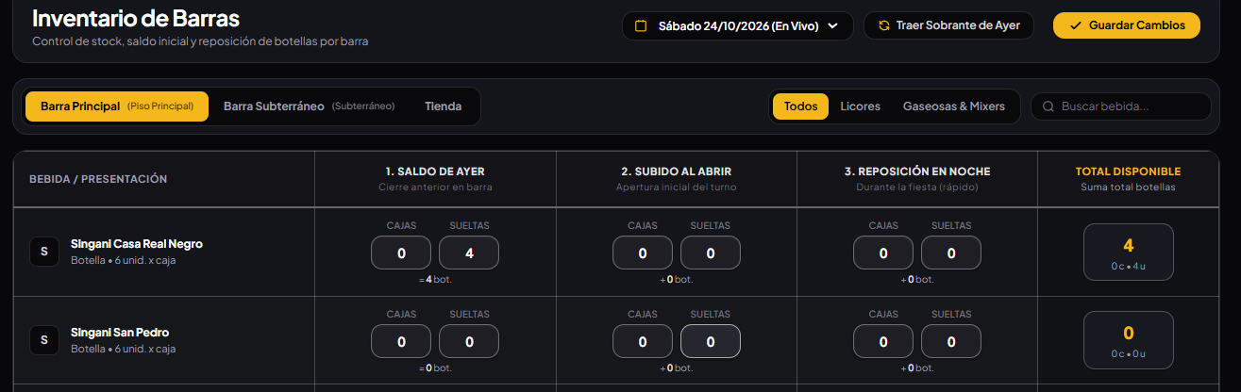
sync previous night carries bar saldo forward without changing warehouse
sync previous night rejects closed session and missing history
inventory index renders and initializes rows for each bar
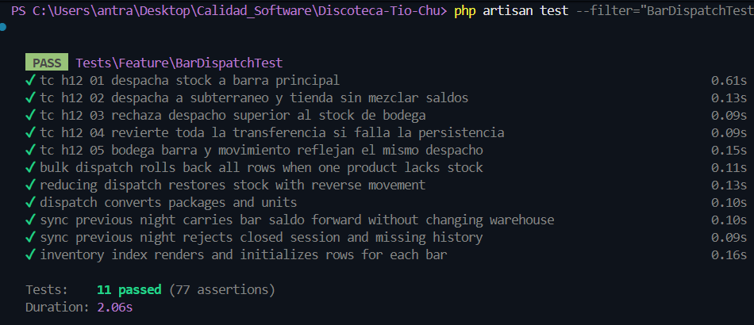
H16
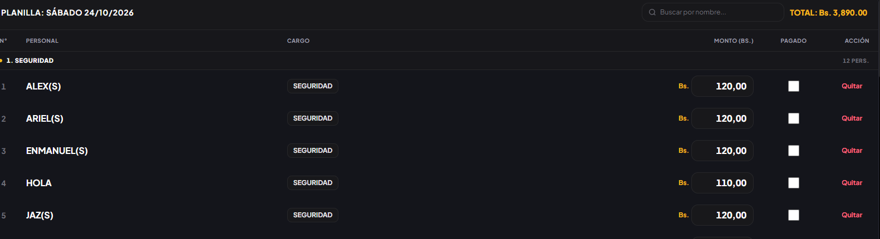
batch wage update modifies wages by category for night
payment history page loads and displays debts ordered
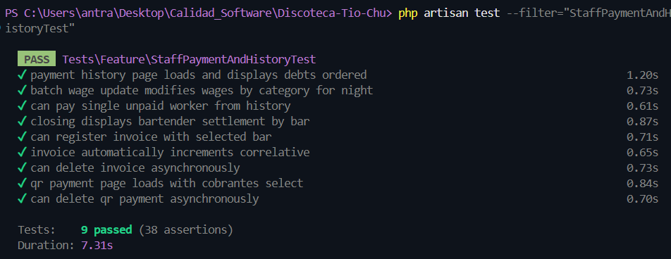
H17
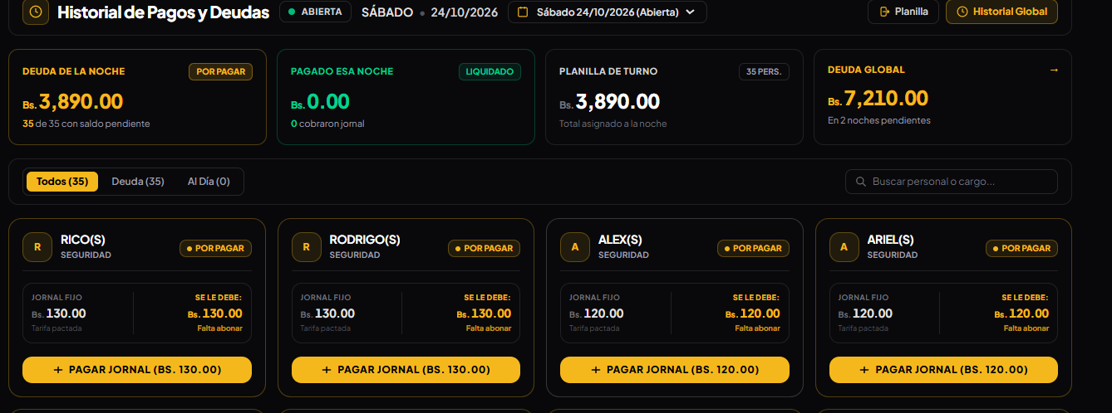
can pay single unpaid worker from history
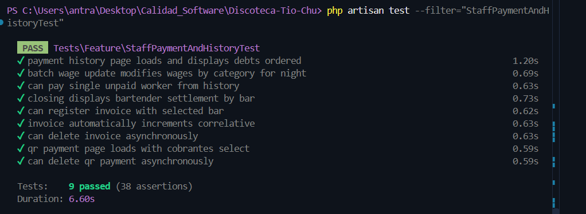

Test General
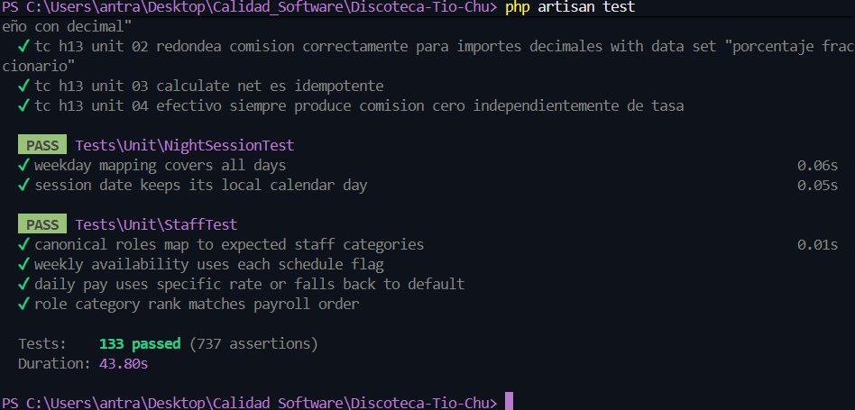
Cobertura
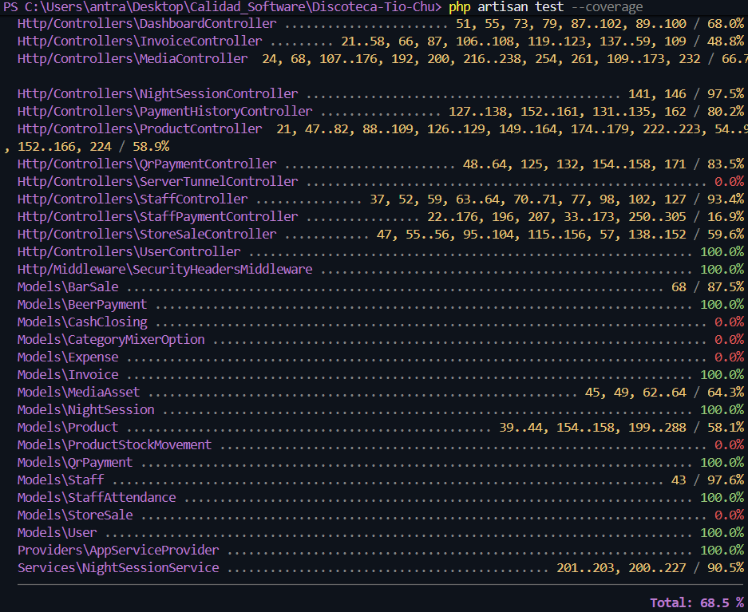

Cypress
