Normal (245 nodes, 707 edges)

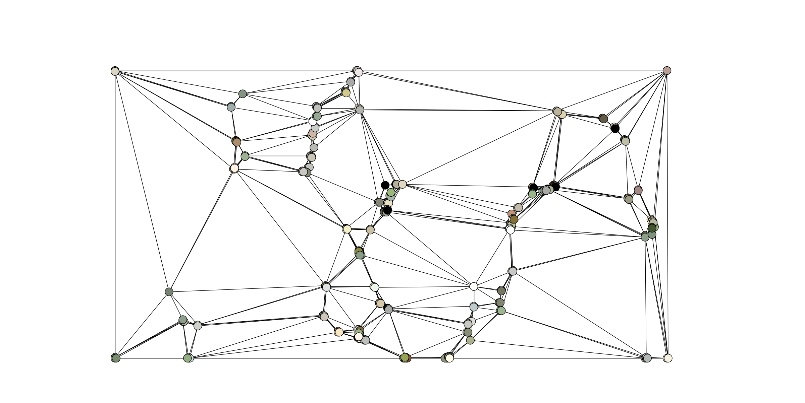

180 Degrees (247 nodes, 705 edges)

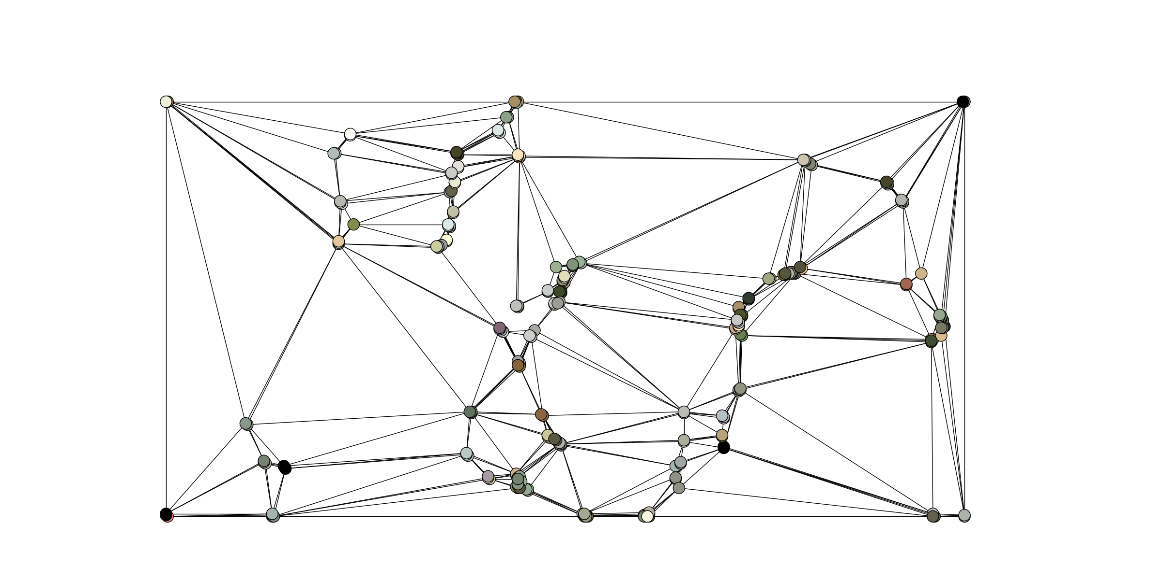

Vertical Flip (254 nodes, 731 edges)

