**Part1:**

1. After you complete Steps 1-1

a) Can h2 ping h3? Briefly explain why or why not.

Yes，單獨一個subnet內的封包傳遞不需透過router，且此時的switch是正常運行的，所以能夠h2與h3之間可以正常傳遞封包。

b) Can h2 ping h4? Briefly explain why or why not.

No，透過router聯接的外網連線規則並未建立，封包無法傳出去。

Complete topology.py so that all hosts, except h1, can ping one another.

Take screenshot to show that your topology configuration is correct.

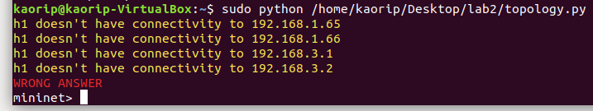

**Part2:**

3. Capture DHCP messages and show the IPs and MACs





4. Can hosts other than h1 acquire IP addresses from DHCP server? Briefly explain your answer.

一般情況下無法，首先在此題目的結構之下，h1以外的hosts，並無法收到DHCP Broadcast，原因是一般router並無法轉送此廣播到其他subnet

**Part3:**

5. What does r1 do on the packets from h1 to h5, and h5 to h1, respectively? Capture packets to explain your answers.

r1-eth0:



r1-eth1:



如圖所示，可以看到h1發出request之後，會由r1-eth1接收封包，再由r1-eth0轉送出去，轉送之後，封包的Source MAC Address會改為r1-eth0。同理，r1-eth0接收reply之後，會將封包的Source MAC Address改為r1-eth1，再送給h1。

6. Capture all ICMP messages received by h1 and explain why h1 can only derive only 1st, 2nd, and 5th hops details.

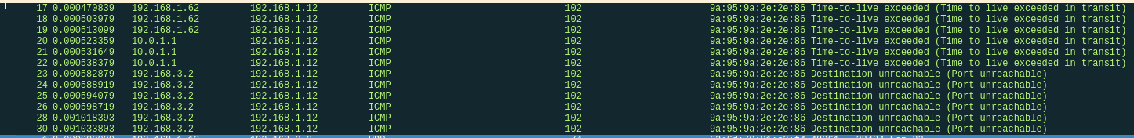

由於h1的封包必須由r1轉送，但r1的規則中並不認識192.168.3.0/24以外的subnet，所以r1送出的封包無法以此subnet和自身gateway以外的網域作為目的地，因此r3與r4無法顯示在table上。

7. H1 uses some ICMP messages to derive 1st and 2nd hop details. What are the type(s) and sender(s) of the ICMP messages?



1st hop:

Type: 11 TTL exceeded

Sender: 192.168.1.62

2nd hop:

Type: 11 TTL exceeded

Sender: 10.0.1.1

8. H1 uses some ICMP messages to derive 5th hop details. What are the type(s) and sender(s) of the ICMP messages?



5th hop:

Type: 3 Destination unreachable

Sender: 192.168.3.2

**Bonus:**

* Ideally, we should have all the hop details as follows.

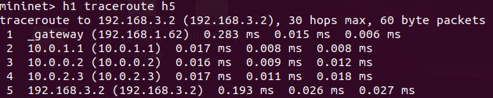

* Try to configure the nodes so that traceroute can output the above hop details.
* Describe the configuration you added
  + Add the configuration commands in your python script

在config()中，新增r1與r2的規則，規則如下:

routers['r1'].cmd('route add -net 10.0.0.0/24 gw 10.0.1.1')

routers['r1'].cmd('route add -net 10.0.2.0/24 gw 10.0.1.1')

routers['r2'].cmd('route add -net 10.0.2.0/24 gw 10.0.0.2')

確保透過r1送出的封包可以將目的位址訂為r3與r4

而封包能正常送達之後，traceroute table便能顯示出來。