**Part1:**

1. Take routing tables screenshot before/after on [r1-r4]

Before:

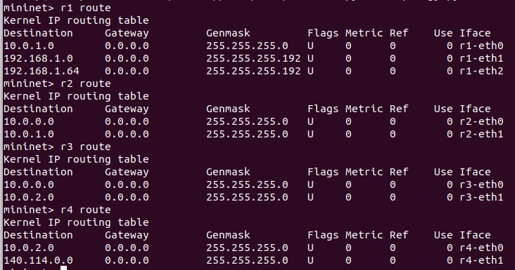

After:

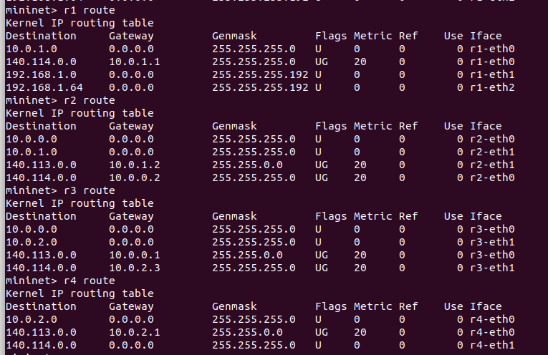

2. Telnet zebra and bgpd daemons of [r1-r4] and take screenshots of routes in zebra and bgpd daemons.

r1:

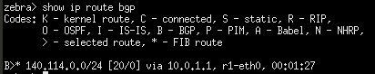

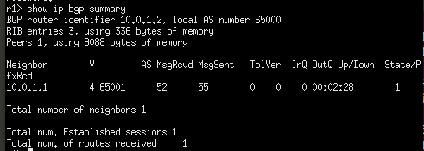

r2:

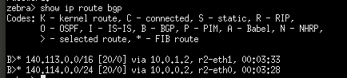

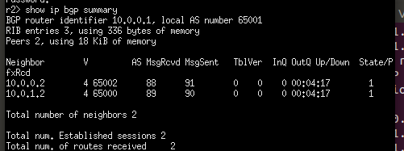

r3:

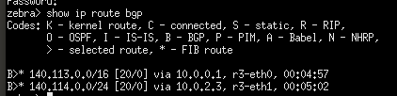

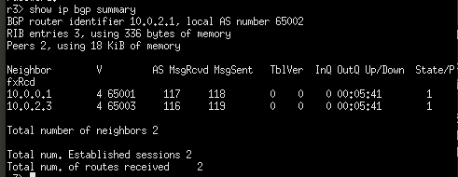

r4:

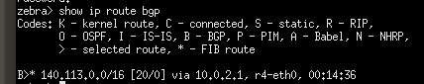

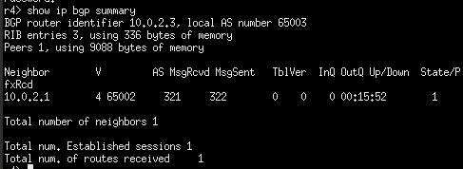

3. Capture BGP packets from wireshark and take screenshot to verify your answer for the following questions

3-1. Show BGP packets (OPEN, UPDATE, KEEP ALIVE) exchanged by r2 and r3

r2-eth0:

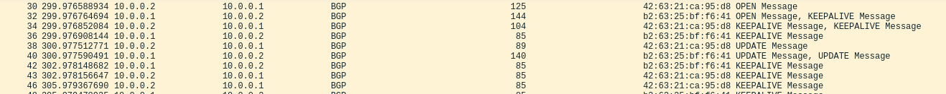

r3-eth0:

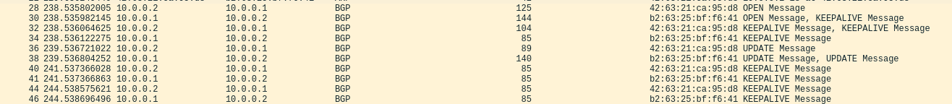

r3-eth1:

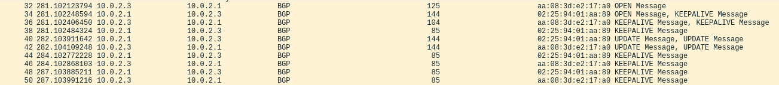

3-2. What will happen to the routing table if you set r4-eth0 down?

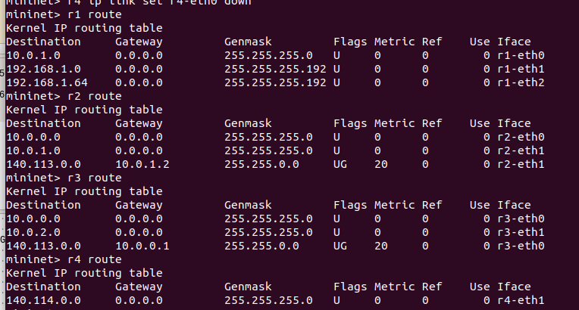

Routing table 會自動移除r4底下的全部subnet

3-3. How does r3 know r4 is unreachable? Explain how



r3-eth1會與r4終止交換訊息，r3-eth0則會與r2交換update message

3-4. How does r2 know r4 is unreachable? Explain how



r2與r3交換update message之後，便可得知r4的狀態

**Part2:**

1. Take screenshot of curl result

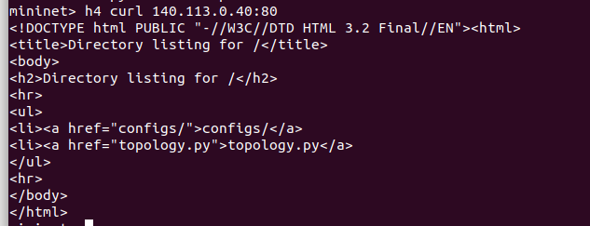

2. Check reachability and take screenshot

h1:

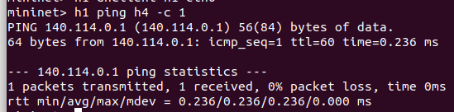

h2:

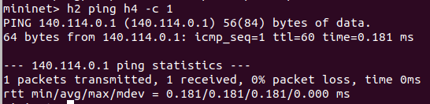

h3:

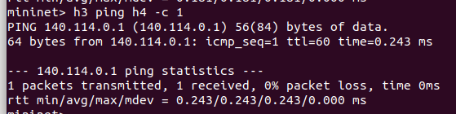

由上面三張圖可觀察到，h1,h2,h3皆可ping到h4，同時表示NAT正常運行

3. Run wireshark on r1 to take screenshot of input/output packet

* Explain the difference of packet headers

h1 ping h4:

r1-eth0:



r1-eth1:



h2 ping h4:

r1-eth0:



r1-eth2:



由h1送出的封包，source IP是192.168.1.14，而經過NAT之後，r1送出到外部網路的封包，source IP會改為140.113.0.30。反之，由外部要送到h1的封包，destination IP會是140.113.0.30，經由r1的NAT處理後，會再改為h1在內網的IP。同樣地，由h2送出或是要送往h2的封包，IP則會以140.113.0.40顯示。