1. Show the ping results to test reachability

a) h1 and h2 ping GWr

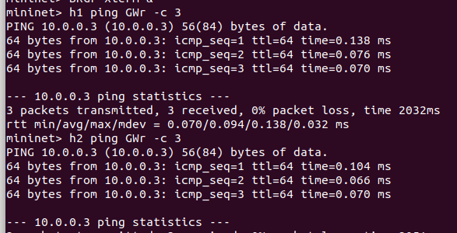

2. Show all interfaces of Node BRGr after h1 and h2 can ping GWr

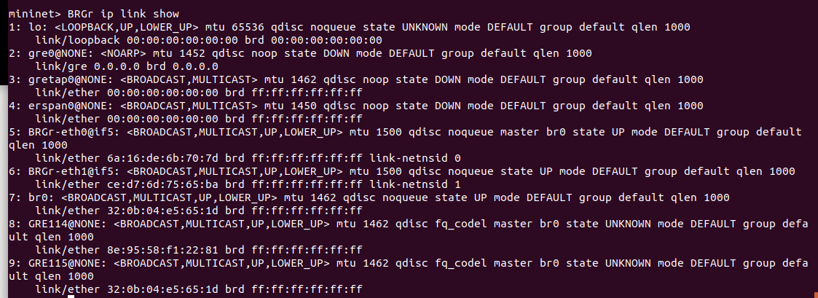

3. Draw the interconnection diagram of interfaces and Linux bridge on BRGr. Explain your diagram with the screenshot of interface list of BRGr.

eth0

e

t

h

1

GRE115

GRE114

BRGr

Linux Bridge



先設立Linux Bridge (br0) 連接eth0，而轉送GRE封包到140.114.0.1與140.115.0.1的GRE114與GRE115再連接上Bridge(br0)，最後由eth1連接外部網域。

4. Explain how Linux kernel of BRGr determines which gretap interface to forward packets from GWr to hosts (h1 or h2)?

Describe your answer with appropriate screenshot.

in eth0:



in br0:



in eth1:



in GRE114:



in GRE115:



由上圖可以發現在GWr發出廣播之後，h1的回傳封包經過eth1後會送往GRE114，GRE115並不會記錄h1的MAC。另外，因為wireshark開啟時，GRE tunnel的相關規則早已建立，無法及時觀察封包傳遞行為，若能接收觀察filter開啟時的封包，應該能更清楚看出BRGr決定封包傳遞的方式。

5. Run tcpdump on h1 to capture packet and take screenshot to explain why or why not h1 is aware of GRE tunneling.

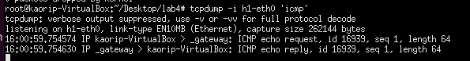

由於GRE tunneling是在BRG1處理，h1本身並不會有處理GRE封包的行為，所以不管是送出封包或接收封包，h1不會收到GRE型態的封包，只會收到已經經過BRG1解析的封包。