Pre_lab7_mod_0710028

Report

IQ_1_0710028.jpg:

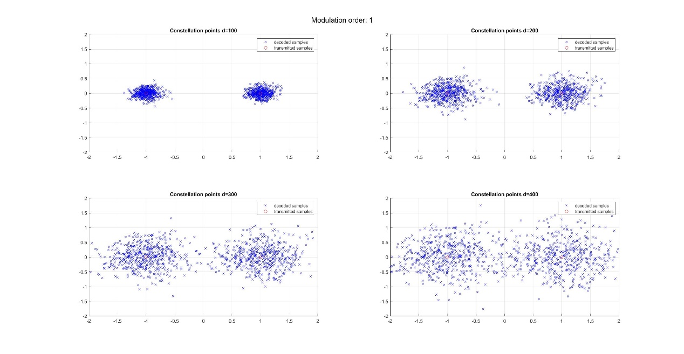

IQ_2_0710028.jpg:

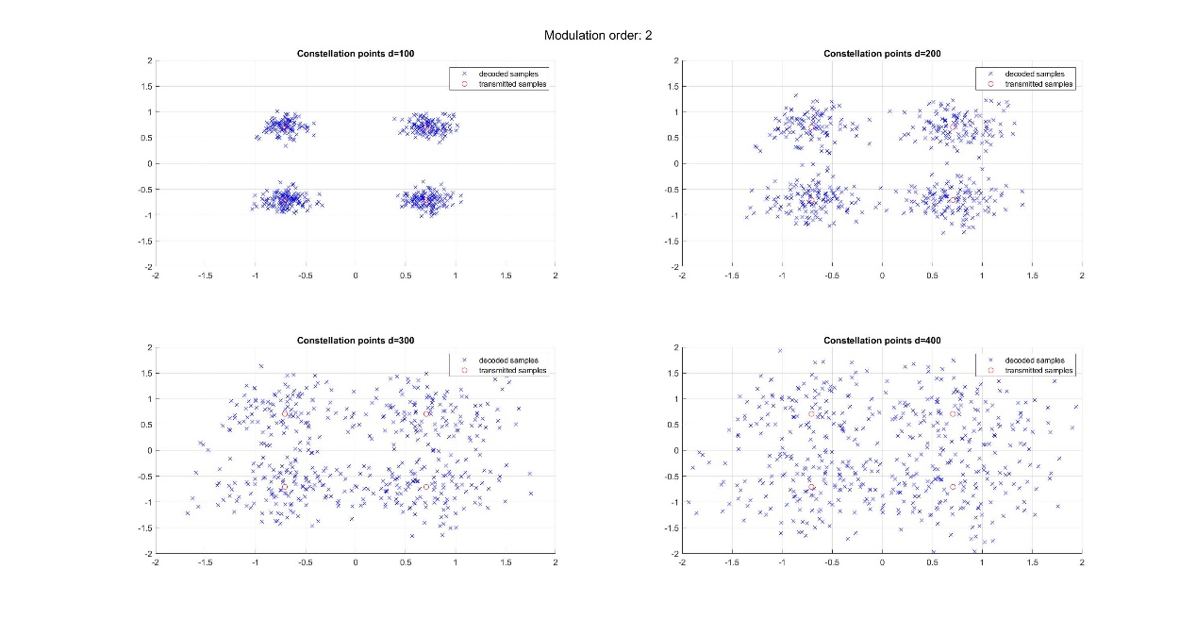

IQ_4_0710028.jpg:

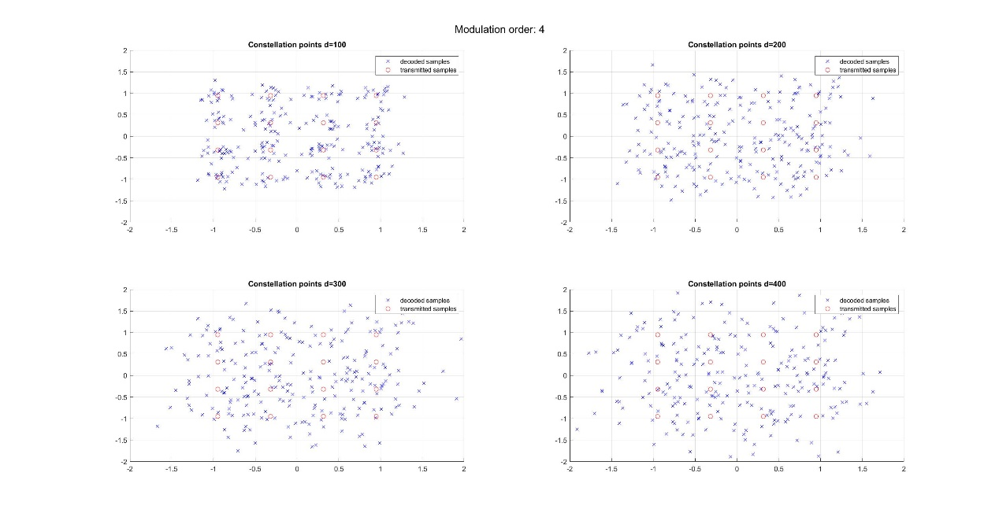

SNR_0710028.jpg:

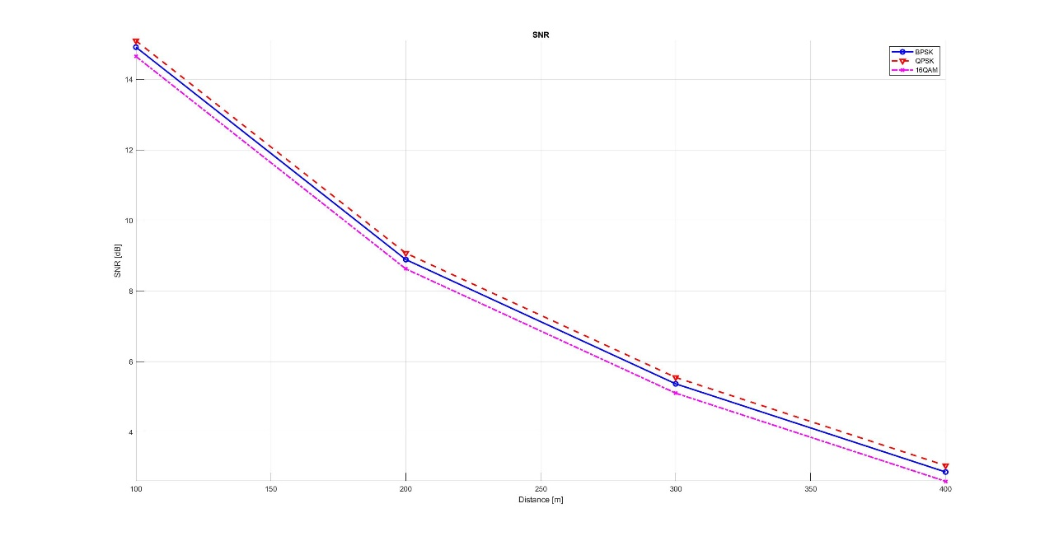

BER_0710028.jpg:

