1. Show the configuration commands you made on each node to provide Internet connectivity for hosts and briefly explain the purpose of the commands

a) BRG1

▪ GRE over UDP (statically)

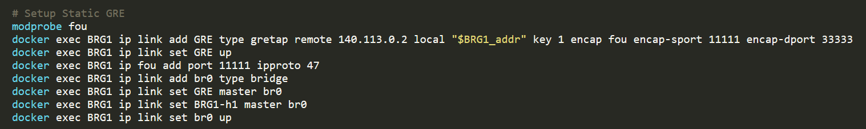

載入fou module，才可以讓ip link設定UDP相關網路通道

b) BRGr

▪ GRE over UDP (dynamically)

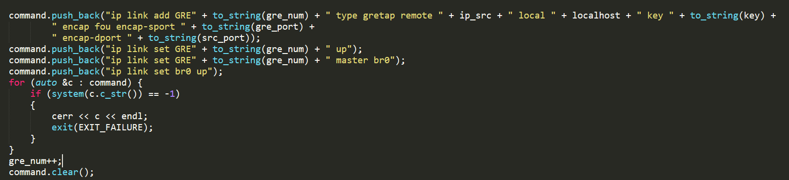

基本上使用的指令同statically，不同的是dinamically的部分需要等待封包解析擷取IP的部分，再做tunnel建立。

c) Edge Router

▪ DHCP for BRG1, BRG2

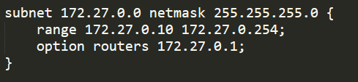



設定好IP位置後就能將dhcpd.conf複製到R1的dhcp資料夾底下運行。另外避免IP範圍過大出錯，所以range設定為10~254…。

▪ NAT rules for BRG1 (show NAT tables to justify your answer)

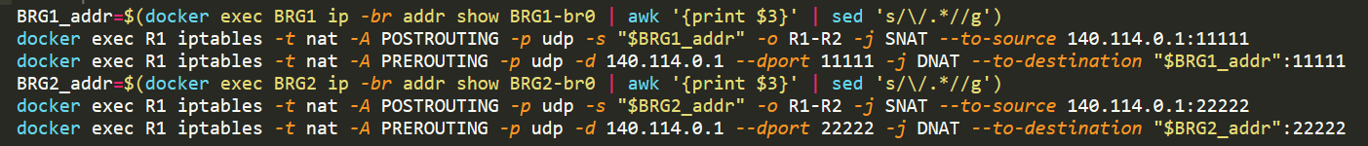

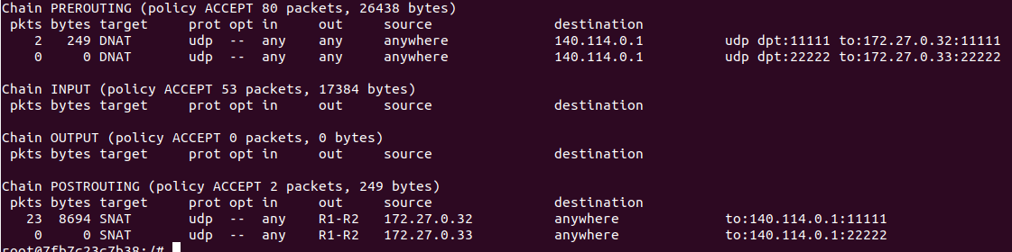

參照lab3的設定將port的部分從tcp改成udp，且source ip與destination ip的port也須分別修改為11111與33333

d) GWr

▪ DHCP for hosts

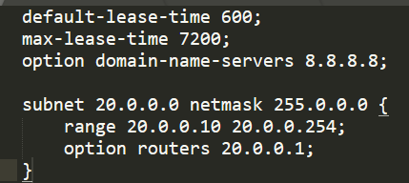



設定好VM內部的DHCP server因為題目要求是20.0.0.0/8，因此netmask是255.0.0.0

▪ NAT rules for hosts (show NAT tables to justify your answer)



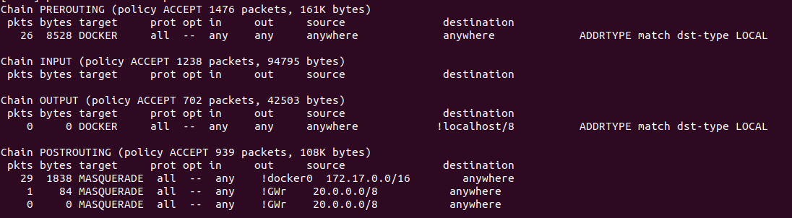

只要source是20.0.0.0/8這個網域且經過GWr的封包都需經過NAT轉換

2. Show interfaces list on node BRGr and BRG1, 2

BRGr:

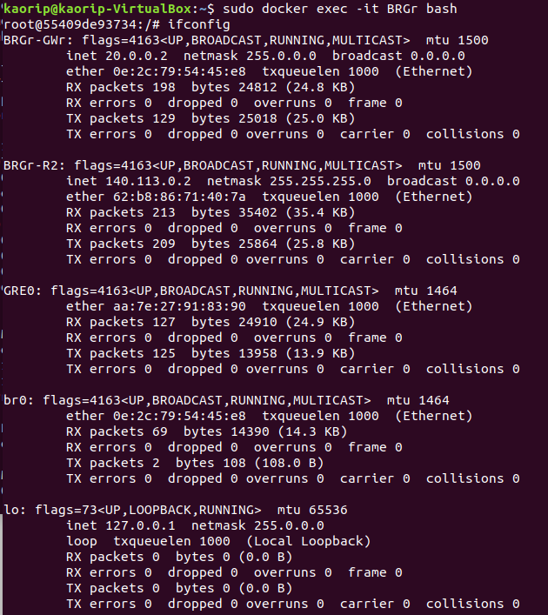

BRG1:

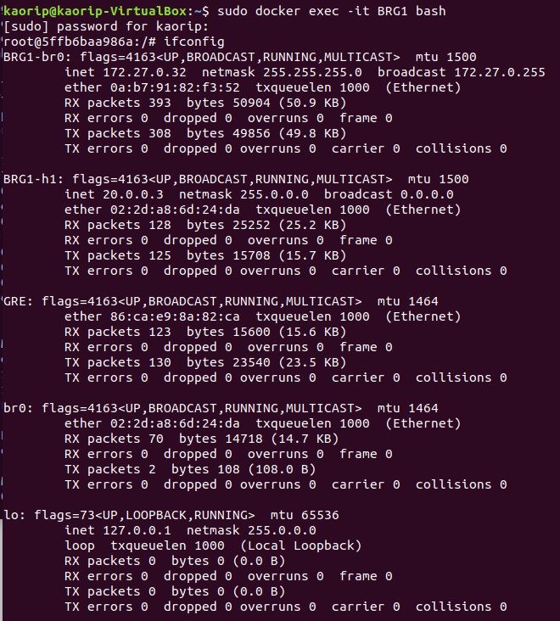

BRG2:

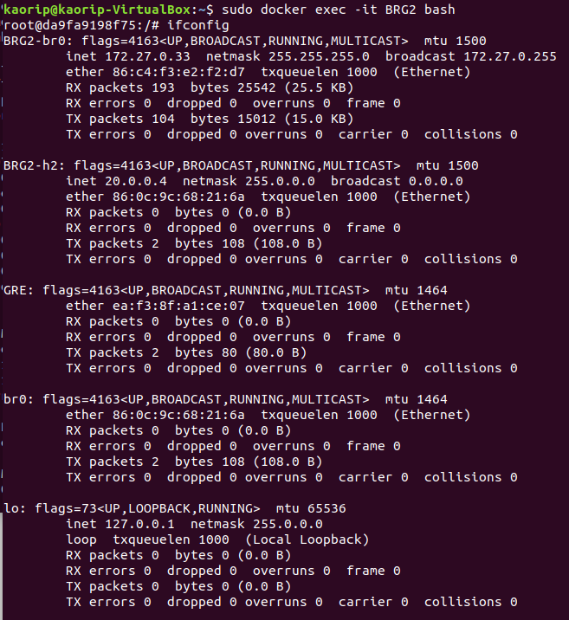

Let h1 ping google DNS server 8.8.8.8.

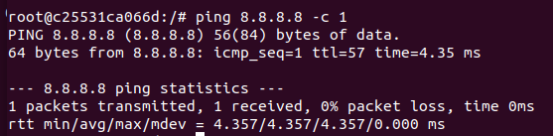

3. Capture packets and take screenshots on node

▪ BRG1 input/output

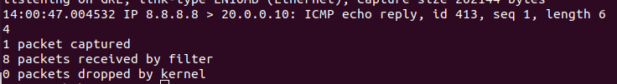

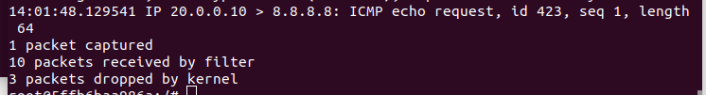

▪ Access Router input/output

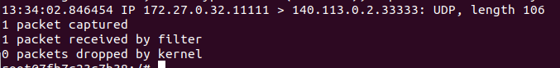

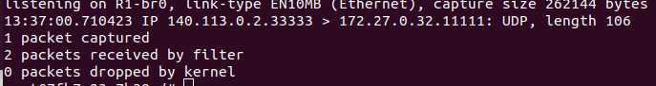

▪ BRGr input/output

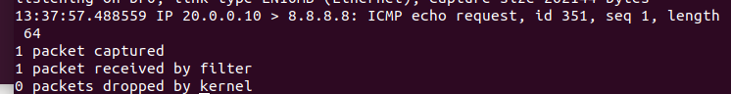

▪ GWr input/output

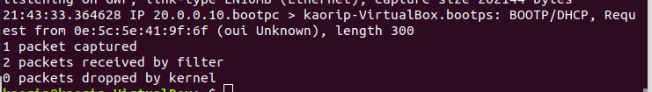

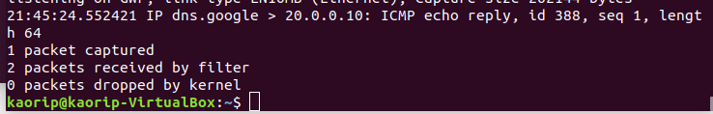

Briefly describe the header changes made by each node, by using the screenshots, to deliver packets from h1 to 8.8.8.8, and from 8.8.8.8 to h1, and briefly explain why such changes are required.

由上圖可見，由h1送出的封包到R1會改變IP header到BRGr改變一次後傳送到外部網路，用以增加內部網路的安全性。

4. BRGr will receive ping responses from Google DNS. Briefly describe how BRGr determines the GRE interface to tunnel the response packets back to BRG1.

確認到傳出對象為已建立好GRE tunnel的網域，BRGr會再封裝封包加上GRE header，BRG1便可以辨識此封包的傳輸來源與目的。