**MULTIMEDIA UNIVERSITY OF KENYA**

P.O. BOX 15653–00503, Mbagathi, Nairobi.

**Tel. +254 (020) 2071391, 254 (0735) 900008,**

**254 (0724) 257083, FAX: 254 (020) 2071247**

Website: [www.mmu.ac.ke](http://www.mmu.ac.ke)

Email: info@mmu.ac.ke

**DEPARTMENT**

INFORMATION COMMUNICATION & TECHNOLOGY

**PROJECT TITLE**

A TECHNICAL FEASIBILITY OF AN ONLINE EXAMINATION PROCESSING PORTAL, A CASE STUDY OF MULTIMEDIA UIVERSITY EXAMINATION MODULE IN THE SCHOOL MANAGEMENT SYSTEM.

**NAME:** WATILAH W FELIX

**ADM NO:** CIT-221-010/2014

**SUPERVISOR:** MS. MULI ELIZABETH

**APRIL 2017**

**TASK**

A PROJECT ON PARTIAL FULFILLMENT OF A DEGREE IN BACHELOR OF SCIENCE IN INFORMATION TECHNOLOGY AT THE MULTIMEDIA UNIVERSITY OF KENYA.

# **DECLARATION**

I declare that this work has not been previously submitted and approved for the award of a degree by this or any other University. To the best of my knowledge and belief, the documentation contains no material previously published or written by another person except where due reference is made in the document itself.

© No part of this documentation may be reproduced without the permission of the author and Multimedia University of Kenya.

Name: Watilah W Felix

Signature …………………………………….

Date………………………………………….

**Approval**

This documentation of Watilah W Felix was reviewed and approved by the following:

Mrs Elizabeth Muli

Lecturer, Faculty of Computing, Information and Technology

Multimedia University of Kenya

Mr Ndegwa

Lecturer, Faculty of Computing, Information and Technology

Multimedia University of Kenya

Mr Ronoh

Lecturer, Computing, Information and Technology

Multimedia University of Kenya

Mr Kinuthia

Lecturer, Computing, Information and Technology

Multimedia University of Kenya

# **ABSTRACT**

The current number of students attending post primary institutions has risen tremendously, as compared to the previous years. This has led to the need for a better way of handling the process of coming up with results at the right time when needed without much use of paper, while at the same time reducing delays. There are numerous systems that have been developed, with some of them having problems of complex nature.

# **DEDICATION**

I dedicate this work to my parents Emmanuel Watilah and Mary Ngina, and my siblings Darren, Joseline, Jephneah, Peter and Reuben.

# **ACKNOWLEDGEMENT**

I would like to express my deepest appreciation to all those who were always there in times of need during the implementation of this project. My kind-hearted gratitude goes to my supervisor Mrs Elizabeth Muli for her continued support and guidance throughout the progress of this project. I would like to thank my colleagues for their unending support, in terms of inputs, peer reviews and criticism during the implementation of the project as well as this documentation. In addition, I would to recognize with much appreciation the vital role of my friends particularly, Zephaniah Odongo, Joshua Ongaga, Stella Nzula and Sarafine Jeptum for their unceasing support and encouragement. I am extremely grateful to my family for their moral support and encouragement duration of this project. Finally, to all and sundry who assisted directly or indirectly in the development of this project, I extend to you my heartfelt gratitude.

**Table of Contents**

DECLARATION ii

ABSTRACT iv

DEDICATION v

ACKNOWLEDGEMENT vi

Chapter 1 : INTRODUCTION AND BACKGROUND STUDY 1

1.0 Introduction 1

1.1 Problem Statement 1

1.2 Overview of the Proposed System 1

1.3 Aim of the Study 2

1.4 Objectives of the Proposed System 3

1.4.1 General Objective 3

1.4.2 Specific Objectives 3

1.5 Justification of the Proposed System 3

1.6 Scope of the Proposed System 4

1.7 Assumptions of the Study 4

1.8 Limitations of the Proposed System 4

Chapter 2 : LITERATURE REVIEW 6

2.0 Introduction 6

2.1 Reviewed Systems 7

2.1.1 Similar Systems 7

2.1.2 Tools and Methodologies used in the Reviewed Systems 9

2.2 The Gap to be bridged by the proposed system 10

Chapter 3 : METHODOLOGY 11

3.0 Introduction 11

3.0.1 RAD Model 11

3.0.2 V- Model 11

3.0.3 Agile Model 12

3.0.4 Incremental Model 12

3.0.5 Waterfall Model 12

3.1 The Methodology - Waterfall Model 13

3.1.1. Feasibility study 13

3.1.2. Requirement analysis and specification 13

3.1.3. Design 13

3.1.4. Implementation and unit testing. 13

3.1.5. Integration and system testing 14

3.1.6. Operation and maintenance. 14

3.1.7 Reasons for using Waterfall Model 16

3.1.8 Programming Tools 16

3.1.3 Proposed System Modules 17

3.2 Data Collection Methods 17

Chapter 4 : FEASIBILITY STUDY 19

4.1 Technical Feasibility. 19

4.2 Economic Feasibility 19

4.3 Operational Feasibility 19

Chapter 5 : SYSTEM REQUIREMENTS ANALYSIS 21

5.1. Functional Requirements 21

5.1.1. Administrator Module 21

5.1.2. Lecturer Module 22

5.1.3. Student Module 22

5.2. Non-Functional Requirements 22

Chapter 6 : SYSTEM DESIGN 23

6.1. Hardware Requirements 23

6.2. Software Requirements 23

6.3. User Interfaces 25

Lecturer Dashboard 26

6.4. Database Designs 34

6.5. Use Case Diagram 35

Chapter 7 : SYSTEM IMPLEMENTATION 36

7.1. Web Clients 36

7.1.1. Development Tools 36

7.1.2. Installation Details 36

7.1.3. Application Components 36

Chapter 8 : SYSTEM TESTING 37

8.1 Introduction 37

8.2 Test Plan 37

8.2.1. Unit Testing 37

8.2.2. User Acceptance Testing 37

8.2.3. Integration Testing 37

Chapter 9 : CONCLUSIONS AND RECOMMENDATIONS 38

9.1. Recommendations 38

REFERENCES 39

# **: INTRODUCTION AND BACKGROUND STUDY**

## **Introduction**

The changing trends in technology has led to the need for dynamic ways of doing things. With an online web-based examination processing portal, a case study of Multimedia University of Kenya, the lecturers can be able to submit the marks for the student on time. They can do it from wherever they are.

The examination processing module in the School Management System for Multimedia University is partially operational, which makes the most lecturers to have a hard time in the compilation of the marks for the students. The students do not get their results on time because the entire process is not done online. The retrieval of the results has been a menace for a long time.

With the growing number of students who join the university every year, it has become necessity to have an online examination processing system which will help in increasing the accessibility of the results by the students via the web.

## **Problem Statement**

In Multimedia University of Kenya, students have to personally go to school for them to access their results. This wastes a lot of time and money for those staying far away from school. The lecturers are also forced to go through some challenges before the compilation of the results is completed. This makes some faculties to delay in the process of releasing of the results.

## **Overview of the Proposed System**

The proposed Examination Processing Portal is expected to be easy to understand and use. It will have a great Graphical User Interface with navigation labels, menus and buttons to enable the users of the system to navigate freely and know where they are and where they want to go without much difficulties. Adding of data in the system will be very simple because the system will make use of labels and placeholders in case of the input fields, to aid the users in guiding them on what to input. The numeric and string data types will be differentiated by the user using the sample data in the text fields. All the errors will be instantly communicated to the user, in case of entry of wrong data. The errors will be shown in dialogue boxes or modals.

The system will allow the lecturer to register new students, add the marks for the CATs, assignments, and the final exam. The system will then calculate the total marks scored by the student, the grade and give remarks/ comments. The students can also be able to know what they scored in the CATs, assignments and the main exam. The portal students can be able to download their results after full compilation, in PDF format, among other benefits. Through these features, the portal will be able increase the efficiency of processing the examination results and solve the problem of delaying in releasing of the results.

The development of the proposed system will be web-based, and therefore the tools used will include some programming languages and the IDE. PHP will be used as backend scripting language to process all the requests issued by the users of the system. JavaScript will be used as frontend scripting language, which will ensure the integrity of data before the data is sent to the server for processing. JavaScript will also be responsible for the animations on the interface. HTML5 and CSS3 will be used as markup and styling languages respectively. The database will be developed using MySQL as the query language that is used for creating and maintaining the database. The IDE that will be used is JetBrains’ PhpStorm, which has the capabilities of editing PHP, HML5 and CSS3, while the database will be edited using MySQL server. The system will be tested on the localhost, with WAMP server as the local server.

## **Aim of the Study**

The overall purpose of the Examination Processing Portal is to increase efficiency in the creating and generation of examination reports for the students.

## **Objectives of the Proposed System**

### ***General Objective***

The main objective of the project will be to design, develop and test the system that will assist both the lecturers and the students in the processing of the examination, and generation of report forms for both of them.

### ***Specific Objectives***

1. To develop a better examination processing portal than the current one.
2. To develop a web-based system that will have the best technical feasibility in the examination management process.
3. To formulate system requirements
4. To design, develop and test the system
5. To evaluate the system

## **Justification of the Proposed System**

The Examination Processing Portal will benefit the University, the lecturers and the student fraternity. The institution will benefit from the system by getting the examination being processed at the right time, so that other activities can be scheduled on time. The lecturers will be able to do their work from wherever they wish, especially when it comes to submit the examination marks for the students for processing. This is because the system will be online and web-based. This means that the results will be submitted on time, to avoid delays as it has be the routine in the past years. The student on the other part will be able to see and download the results in PDF format. The students will also be in a position to see what they scored in every unit, and be able to report to the respective lecturer of the unit, in case of any errors of missing marks for any CAT, assignment or the main exam.

## **Scope of the Proposed System**

The project will be to develop the proposed Examination Processing Portal will be online web-based, and it will help the lecturers to register students prior submitting their (students) marks to an online database, where the processing is done to generate results for the students and reports to the lecturers and the administrators, on the academic performance and the progress of the students. The project is will be completed by the end of the semester (6/7/2017).

## **Assumptions of the Study**

The following are the assumptions of the proposed system;

1. All the lecturers will have an access the internet connection whenever they will want to submit the marks.
2. All the students will have the access to the internet for them to see or download their results from the portal.
3. The examination processing portal will always be online and running.
4. All the users are English literate; this is because the system will be developed in English.
5. Users have basic knowledge and should be comfortable using general purpose applications on computers.

## **Limitations of the Proposed System**

1. An extra security as SSL must be used to secure the marks details and other examination information.
2. The limited period required to develop the system may create limitations to the completion of the project.
3. Lack of full knowledge in the programming languages that will to be used in the development of the system, might hinder the delivery of the system within the required time.
4. The failures of some development tools during the development process might lead to the delay of submission of the project.

**Project Schedule**

The Gantt chart below shows how the activities will take place during the development of the project.

|  |  |  |  |  |  |  |  |  |  |  |  |  |  |  |
| --- | --- | --- | --- | --- | --- | --- | --- | --- | --- | --- | --- | --- | --- | --- |
| **DURATION** | **APRIL**  **2017** | | | | **MAY**  **2017** | | | | **JUNE**  **2017** | | | | **JULY 2017** | |
| **ACTIVITY** | **WEEKS** | | | | **WEEKS** | | | | **WEEKS** | | | |  | |
|  | **1** | **2** | **3** | **4** | **1** | **2** | **3** | **4** | **1** | **2** | **3** | **4** |  |
| FEASIBILTY STUDY |  | |  |  |  |  |  |  |  |  |  |  |  |
| DESIGN |  |  |  | | | |  |  |  |  |  |  |  |
| CODING |  |  |  |  |  |  |  | |  |  |  |  |  |
| TESTING |  |  |  |  |  |  |  |  |  | |  |  |  |
| IMPLEMENTATION |  |  |  |  |  |  |  |  |  |  | |  |  |
| DOCUMENTATION |  | | | | | | | | | | | | | |
| PRESENTATION OF THE PROJECT |

# **: LITERATURE REVIEW**



## **Introduction**

The growing trends in the Information Technology field makes it necessary also to have a digital way of processing and presentation of the results. This is a better way to manage exam processing. Some research is being carried out by a body of researchers on the better ways of managing electronic exam systems.

Web-based Examination System is an effective solution for mass education evaluation (Zhenming et al, 2003). They developed a novel online examination system based on a Browser/Server framework which carries out the examination and auto-grading for objective questions and operating questions, such as programming, operating Microsoft Windows, editing Microsoft Word, Excel and PowerPoint, etc. It has been successfully applied to the distance evaluation of basic operating skills of computer science, such as the course of computer skills in Universities and the nationwide examination for the high school graduates in Zhejiang Province, China. Another paper (He, 2006) presents a web-based educational assessment system by applying Bloom’s taxonomy to evaluate student learning outcomes and teacher instructional practices in real time. The system performance is rather encouraging with experimentation in science and mathematics courses of two local high schools.

Another paper proposed web based online examination system (Rashad et al, 2010). The system carries out the examination and auto-grading for students’ exams. The system facilitates conducting exams, collection of answers, auto marking the submissions and production of reports for the test. It supports many kinds of questions. It was used via Internet and is therefore suitable for both local and remote examination. The system could help lecturers, instructors, teachers and others who are willing to create new exams or edit existing ones as well as students participating in the exams. The system was built using. various open source technologies AJAX, PHP, HTML and MYSQL database are used in this system. An auto-grading module was generalized to enable different exam and question types. The system was tested in the Mansoura university quality assurance center. The test proved the validity of using this kind of web based systems for evaluates students in the institutions with high rate of students.

## **Reviewed Systems**

### ***Similar Systems***

*Analysis of the existing systems used in Kenyan Universities*

In Kenya, very few universities use Examination Processing Systems for the preparation of examinations and allowing the retrieval of the results by the students. Two among the few universities that use Examination Processing System include Multimedia University of Kenya (MMU) and University of Nairobi (UoN). According to the review of these systems, most of the universities use intranet set up within the university environments. With the exception of when the students want to retrieve their results, that’s when they can use the internet.

1. **Examination module used in the ERP of Multimedia University of Kenya**

The ERP procured by Multimedia University of Kenya seems not to be efficiently functioning. This is because some students from the Faculty of Computing, Information & Technology (CIT) have never been able to retrieve and download their results from the portal. This is a great challenge to the institution because there some major issues that have to be sorted out for the system to function according to the requirements.

**Architecture of the existing Examination Module**

Akinsanmi (2010) presented a 3-tier architecture comprising the presentation tier, logic tier and the database tier. The presentation tier offers an interface to the user, the logic tier serves as the middleware that is responsible for processing the user’s requests, while the database tier serves as the repository of a pool of thousands of questions. It also consists of other modules for authentication (using Username/Admission Number/Email and Password) and computing results. This is the architecture used by all the examination processing systems that were reviewed within Kenya and it is also the same architecture that was used even in other countries with just little modifications. This type of architecture did not give security issues too much attention and impersonation is very likely.

**Checking and Presentation of the Results**

In Multimedia University of Kenya, students don’t get to see their results immediately after the exams. In some cases, the results may take weeks or even months before it is made available to the students. This violates one of the main essence of introducing online examination processing system (instant access to results). This may give room for alteration of students’ result. There is also no room for the users to see and launch any complaint to the relevant lecturer in case of any errors in the results. In the university, only the Faculty of Media and Communication presents the students’ results online for retrieving by the students.

1. **Examination module in the Student Portal of the University of Nairobi**

The examination processing system used in The University of Nairobi allows both the lecturers and the students to interact with it efficiently. This is justified by the preparation of results that are always produced and made available on the students’ portal even though the results are always released later than expected by the students. The students don’t have to wait for a very long period of time before their results are out. The system is configured on the intranet set up in the university. This means the lecturer cannot submit the results while using the public internet.

The architecture of the existing module is similar to the one implemented in the system used by MMU. Presentation of the results is not always timely, which makes the system not very efficient for its purpose.

**Challenges of the reviewed systems**

1. **Security**

The existing Examination Processing system was at times a victim of hacking by the IT students, with the aim of changing their results. The security of the system is at risk and there is a need to take care of this by designing intranet and storing the results in encrypting language.

1. **Human interference**

Human can interfere with the delay of the result where students have to wait for more days or months to collect the results. The students should be able to check their result after a specified period of time so as to prevent the human manipulation of result of whatever kind.

1. **Inadequate training for the students and Staff**

Many candidates engaging the examination portal do not understand the proper usage of computer system talk less of the system software. There should be adequate training and awareness for the students prior to the period of releasing of the results. So also, the staff should be well informed the issues concerning the usage of the examination system.

1. **Complexity of Software**

The portals being used in most of Universities are a little bit cumbersome. The interface of the software to be used should be highly friendly to increase the effectiveness of the system.

### ***Tools and Methodologies used in the Reviewed Systems***

It was found out that the methodologies that were used in the development of the Examination Processing Modules of the two Universities, were V-Model, whereby there was verification and validation with every stage in the Software Development Life Cycle (SDLC). This enabled the developers to develop the system respect systems with much ease.

## **The Gap to be bridged by the proposed system**

Security issues will be taken care of by allowing different users to sign in in the portal by use of their predefined usernames and personal passwords. There will be an option to change the login password in case the user forgets his/her own password.

The delay in the presentation of the results will be curbed by the admin setting a deadline to the lecturers. There will be a countdown on each lecturer’s dashboard to let them work within the specified period. Therefore, there will be no human interference in production of the results. The students will also be able to see what they scored in the CATs and assignments, as opposed to the traditional final results.

The effective and efficiency of the Examination Processing Portal will be enhanced by the user-friendly interface that will be used. This will allow for easy navigation around the portal.

# **: METHODOLOGY**



## **Introduction**

The establishment and use of sound engineering principles in order to obtain economically developed software that is reliable and works efficiently on real machines is called *software* *Engineering.*

In this chapter, the software design methodologies and research design that are employed in this project development are discussed here. It gives an overview of Waterfall Model as the chosen software design methodology approach. In this chapter, both object oriented programming and structured programming techniques used in the implementation process of the project. The chapter also describes the client side web programming technologies used. The description of the several JavaScript and CSS3 frameworks such as jQuery and Bootstrap that are used in the creation of the web based Examination Processing System. The adopted research design model for this project is discussed.

The following are the various methodologies that can be employed in the development of the chosen system;



### ***RAD Model***

###### RAD model is Rapid Application Development model.It is a type of [incremental model](http://istqbexamcertification.com/what-is-incremental-model-advantages-disadvantages-and-when-to-use-it/). In RAD model the components or functions are developed in parallel as if they were mini projects. The developments are time boxed, delivered and then assembled into a working prototype.  This can quickly give the customer something to see and use and to provide feedback regarding the delivery and their requirements.

### ***V- Model***

Verification and Validation model. Just like the [waterfall model](http://istqbexamcertification.com/what-is-waterfall-model-advantages-disadvantages-and-when-to-use-it/), the V-Shaped life cycle is a sequential path of execution of processes. Each phase must be completed before the next phase begins.  Testing of the product is planned in parallel with a corresponding phase of development.

V - Model is an extension of the waterfall model and is based on association of a testing phase for each corresponding development stage. This means that for every single phase in the development cycle there is a directly associated testing phase. This is a highly disciplined model and next phase starts only after completion of the previous phase.

### ***Agile Model***

Agile development model is a type of [Incremental model](http://istqbexamcertification.com/what-is-incremental-model-advantages-disadvantages-and-when-to-use-it/). The Software is developed in incremental, rapid cycles. This results in small incremental releases with each release building on previous functionality. Each release is thoroughly [tested](http://istqbexamcertification.com/why-is-testing-necessary/) to ensure [software quality](http://istqbexamcertification.com/what-is-software-quality/) is maintained. It is used for time critical applications.  Extreme Programming (XP) is currently one of the most well-known agile [development life cycle model](http://istqbexamcertification.com/what-are-the-software-development-models/).

### ***Incremental Model***

In incremental model the whole requirement is divided into various builds. Multiple development cycles take place here, making the life cycle a “multi-waterfall” cycle.  Cycles are divided up into smaller, more easily managed modules.  Each module passes through the requirements, design, implementation and [testing](http://istqbexamcertification.com/what-is-a-software-testing/) phases. A working version of software is produced during the first module, so you have working software early on during the [software life cycle](http://istqbexamcertification.com/what-are-the-software-development-life-cycle-phases/). Each subsequent release of the module adds function to the previous release. The process continues till the complete system is achieved.

### ***Waterfall Model***

It is also referred to as a **linear-sequential life cycle model**.  It is very simple to understand and use.  In a waterfall model, each phase must be completed fully before the next phase can begin.   At the end of each phase, a review takes place to determine if the project is on the right path and whether or not to continue or discard the project. In waterfall model phases do not overlap.

Therefore, Waterfall Model is the chosen methodology to be used in the development of this project.

## **The Methodology - Waterfall Model**

The following will be the steps followed during entire period of developing the Online Examination Processing System.

### ***Feasibility study***

The feasibility study activity involves the analysis of the problem and collection of the relevant information relating to the product. The main aim of the feasibility study is to determine whether it would be financially and technically feasible to develop the product.

### ***Requirement analysis and specification***

The goal of this phase is to understand the exact requirements of the customer and to document them properly (SRS).

### ***Design***

The goal of this phase is to transform the requirement specification into a structure that is suitable for implementation in some programming language.

### ***Implementation and unit testing.***

During this phase, the design is implemented. Initially small modules are tested in isolation from rest of the software product.

### ***Integration and system testing***

In this all the modules are integrated and then tested altogether.

### ***Operation and maintenance.***

Release of software inaugurates the operation and life cycle phase of the operation.

There are several advantages associated to Waterfall Model. They include;

1. Simple and easy to understand and use.
2. Using this model makes it easy to manage due to the rigidity of the model – each phase has specific deliverables and a review process.
3. Phases of waterfall model are processed and completed one at a time.
4. The model works well for smaller projects where requirements are very well understood.



**Fig: Waterfall Model**



### ***Reasons for using Waterfall Model***

Waterfall model was best suited for development of Online Examination Processing System because the System is developed by one person within a specified short time. Therefore, the need for coming up with specific requirements for use in the project was a necessity. The requirements used in the Waterfall Model are very well-known, clear and fixed for the development of the project. Definition of the required system is very stable because the requirements are always analyzed and then gathered specifically for the entire project. The technology used with Waterfall Model is well understood and best suits the development of such system which is small and does not require a lot of time. The requirements are always analyzed fully before starting the development of the system, thereby reducing the chances of having ambiguous requirements. The resources with the required expertise are freely available making it easy to gather the requirements. The other reason as to why I chose the use of Waterfall Model is because the project to be developed is not very large.



### ***Programming Tools***

#### **Web Application**

The development of the main Examination Processing System is based on web application, in which PHP 5.6.25 server framework is used. JQuery, a JavaScript framework and Bootstrap a CSS3 frameworks are used on the client side programming. The choice of PHP server framework was necessary because of its flexibility, inbuilt security features, dependency management and Model View controller (MVC) framework that provides easy dependency management.

#### **Database**

The development of the entire Examination Processing System is based on MySQL for data storage. This is because of its nature of being open source, its robustness and its compatibility with PHP 5.6.25 framework.



### ***Proposed System Modules***

The proposed examination system will have the following modules;

1. **Administrator’s Module**

The Administrator will be able to manage all the lecturers and the student details. He/she will be able view all the reports available on the system.

1. **Lecturers’ Module**

The lecturer will be able to log into his dashboard where he/she can be able to register a student, enter marks for the CATs, assignments and marks for the final exam. The lecturer can be able to create personal weekly timetable.

1. **Students’ Module**

The registered students will be able to sign in into their accounts and be able to see the final results, as well as the breakdown of results per subject. The students cannot modify any details on their accounts with exception of changing their passwords.

## **Data Collection Methods**

1. **Interview**

It refers to a way of gathering information in which one person asks another person questions face to face. The interview was conducted for both lecturers and the students. Consideration was based on the experience with the usage of respective systems that were reviewed. The reasons for using interview was that; It gave the facts about the current system. It helped to come up with the details of the current system whose aim is to improve the new system, there was immediate feedback and it helped the interviewer to come up with new and good ideas of developing a new system.

1. **Observation**

Being a student of Multimedia University of Kenya, for a long period of time, I had observed the flaws in the existing system, which called for a new improved system.

# **: FEASIBILITY STUDY**

## **Technical Feasibility.**

The technical feasibility of the proposed system deals with the technology used in the system. It deals with the hardware and software used in the system whether they are of latest technology or not. It happens that after a system is prepared a new technology arises and the user wants the system based on that technology. This system uses jQuery, HTML5 and CSS3 to implement the front-end, while PHP technology and MySQL are used for backend implementation. The system does not require any special type of hardware in order for it to run. The technical feasibility of the system indicates that the system is feasible.

## **Economic Feasibility**

Economic analysis is the most frequently used method for evaluating the effectiveness of a new system. More commonly known as cost/benefit analysis. The use of technology that is freely available to come up with is a system, makes it economically feasible. The costs required to implement the system might not be as high as for other system which are developed on technologies that are purchased. The use of this system will not require the purchase of any special equipment. The only cost that might be incurred during the operation is the hosting charges and the yearly renewal of the domain name, because the system will be accessed through the browser so long as there is internet connection.

## **Operational Feasibility**

The System has been developed in such a way that it becomes very easy even for a person with little computer knowledge to operate it. This Examination Processing System is very user friendly and does not require any technical person to operate. These features make the system to be operationally feasible.

1. **Performance**: The system will provide adequate response time for its input data in forms and periodic generation of reports.
2. **Information:** the system provides and users and managers with accurate and timely information.
3. **Control:** Passwords for the administrator has offered adequate control against fraud and has guaranteed the accuracy and security of data and information.
4. **Efficiency:** The system makes use of resources including time, people, flow of forms without any processing delays.
5. **Services:** The system provides reliable services as a result of its flexibility and expandability

# **: SYSTEM REQUIREMENTS ANALYSIS**

This stage involved sorting and critical judging of the information that was collected. It helped to identify problem areas and inefficiencies and bottlenecks in the current manual system.

The main aim of the system analysis was to:

1. Ensure the information in the existing system to be transferred into the new system.
2. Eliminate most of the errors experienced in current system.
3. Have basic information against which to measure the performance of the current and new system.
4. The functionality of the existing system that will be needed in the new system.

## **Functional Requirements**

Through interviews with some lecturers and some members from the IT department, some important requirements were arrived at, which were utilized in the development of the system. I also held talks and discussions with fellow students, and considered their observations on the existing system.

The following are the functions to be performed by the system in the different modules:

### ***Administrator Module***

In the administrator module, the administrator manages the master data. This data includes Lecturer’s details and student’s details. He/she can be able to view the performance of the students. The Admin is responsible for adding lecturers and assigning them log in details. He can be able to manage all details such as update database, delete some information and insert new information.

### ***Lecturer Module***

In the lecturer’s module of the new system, the lecturer is responsible for adding new students in the database, delete those students who are not supposed to be in the system, enter marks for the students, register units for every student, add classes in the system.

### ***Student Module***

The students can use their Registration numbers to log into their respective accounts. The students can be able to check their results from the system, and they can as well register for units for themselves. If the student has not registered for the units, he cannot be able to view the results, unless they consult with their lecturers.

## **Non-Functional Requirements**

They are the quality requirements that stipulate how well a software does what it has to do.

1. **Performance** - No. of terminals to be supported is dependent on the server that we will use at the time of deployment.

The web application server used should provide good performance and ability to manage performance with techniques such as support for caching. After entering of the exam marks, the entire score of the student will be calculated as per the rules in less than a second.

1. **Availability** – The Examination Processing System has 24*7 availability. It can be accessed for 24 hours a day. For this UPS support must be on the server site with a backup of at least 8 hours in case of power failure.
2. **Reliability** - It means the extent to which the system performs with required precision.

The results produced will be very much reliable since the calculations of the average and grading is properly performed.

1. **Usability** - The Exam System should be user friendly and should require least effort to operate. The web server used should provide services like session management to maintain sessions in the application.
2. **Portability** - The website is made using HTML, JavaScript and PHP, which are platform independent and can be transported to other servers with minimum effort.

# **: SYSTEM DESIGN**

## **Hardware Requirements**

The section of System Requirements is an important task related to the software development insufficient random-access memory may affect adversely on the speed and efficiency of the entire system. The process should be powerful to handle the entire operations. The hard disk should have sufficient capacity to store the file and application.

|  |  |
| --- | --- |
| **Feature** | **Requirements** |
| Processor | Pentium IV and above |
| Processor speed | 1.4 GHz Onwards |
| System memory | 128 Mb minimum 256 Mb recommended |
| Cache size | 512 KB |
| RAM | 512 MB(Minimum) |
| Network card | Any card can provide a 100mbps speed |
| Network connection | UTP or Coaxial cable connection |
| Printer | Inkjet/Laser Color printer provides at least 1000 Dpi |
| Hard disk | 80Gb and more |
| Monitor | SVGA Color 15” |

## **Software Requirements**

This system will require to run on any web server that supports Apache. This is because the system is web based. Considering the technologies used in the development of the system, it is cross platform and it will be able to run on all operating systems, provided that the server is up.

This is not a desktop application, and therefore it can be accessed by the users from anywhere. This can allow the lecturers to submit marks for the students from the comfort of their homes or even while commuting. The users will only require their machine to be installed with a web browser, to access the services.

## **User Interfaces**

***Login Interface*** – This interface allows the different users to login in their respective dashboards. The user must click on the respective tab and then enter the username and password in order to log in.

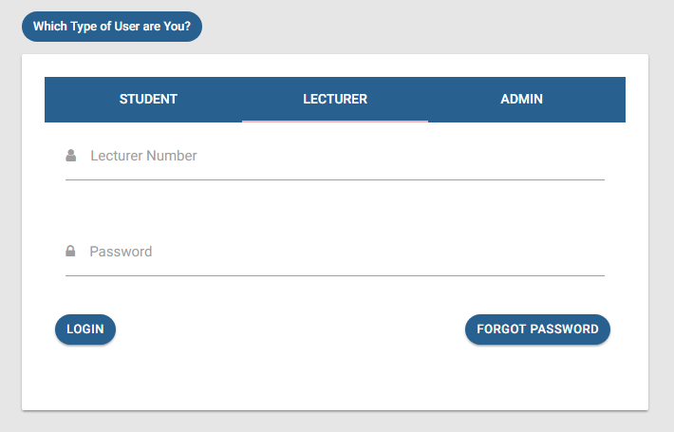

### **Lecturer Dashboard**

***Registered Units*** – Once the lecturer is logged in, he/she can be able to see the students who have registered for the units, as illustrated in the table below.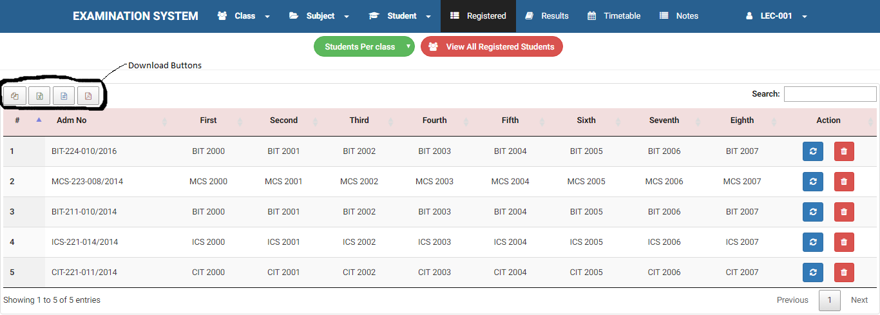

***Add New Student –*** The lecturer is also able to add new students in the system. The screenshot below illustrates the implementation.

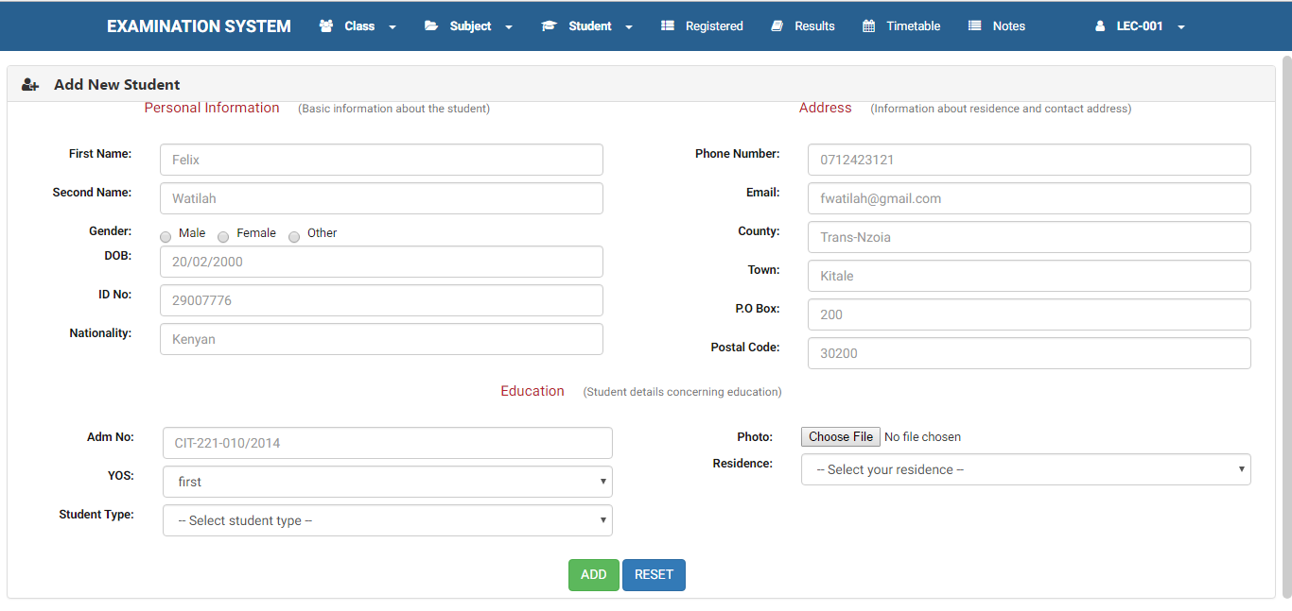

***Registered Students –*** The interface below shows the students who are enrolled in the system. From here, the lecturer can be able to delete the student from the database, as well as update the student details.

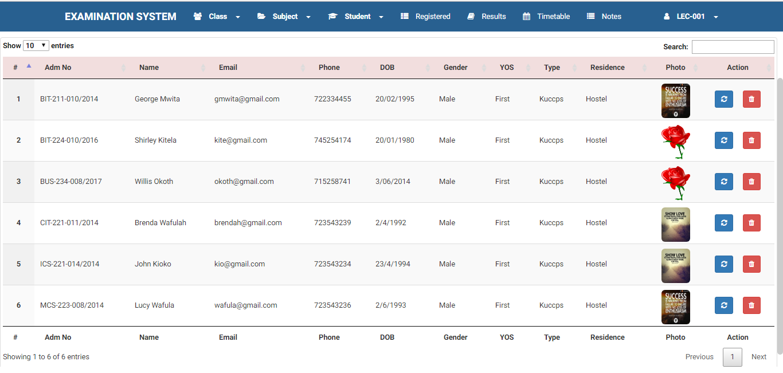

***Update Student –*** Using the interface below, the lecturer can be able to update the student’s details as well as register units for the students. The lecturer cannot edit the student’s registration number and the national ID number.

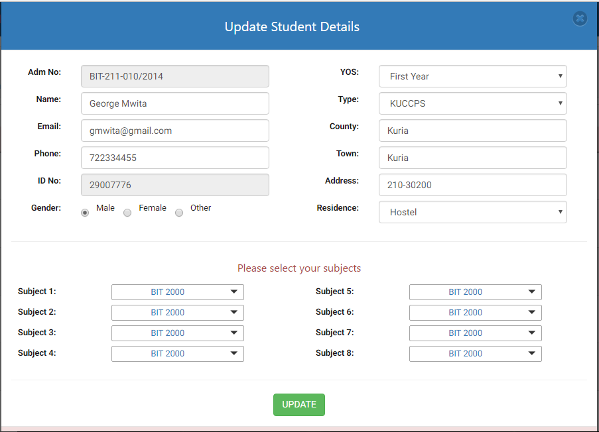

***Students’ result –*** The screenshot below shows the results of all students in the system. On the right-top corner of the table, there is a search field which allows instant search from the table. The download buttons are on the top-left corner of the result table. The lecturer can copy the results, he/she can be able to download the result in csx, xml or pdf formats.

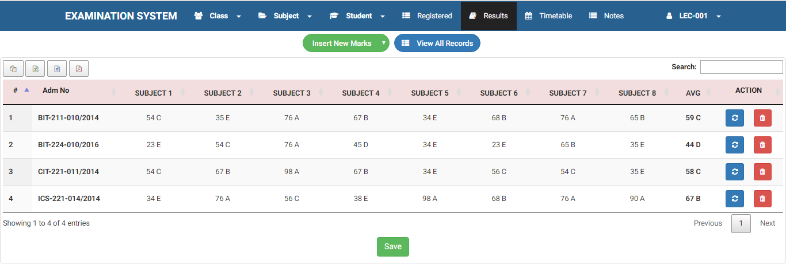

***Enter new marks*** – The lecturer enters the marks of the students directly from the table shown in the screenshot below. 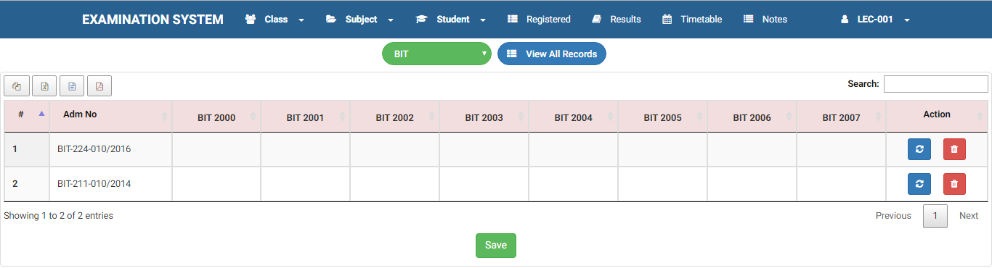

**Student Dashboard**

***Results –*** Once the student has entered the correct login credentials, he/she lands on the student dashboard, where he/she can be able to see the results which indicates the marks attained and the respective grade.

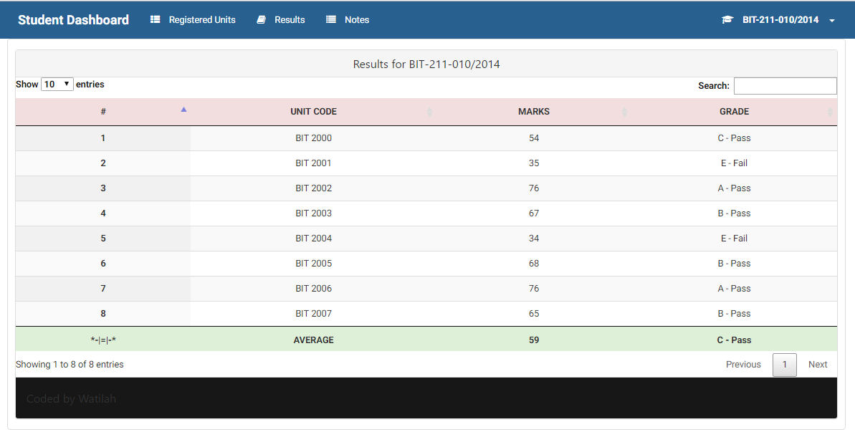

***Register Units –*** The student should register for the units in order for him/her to get the results on the dashboard. On the same page, the registered units can be seen on the lower part. The system cannot allows duplicate registration of the units by the student. 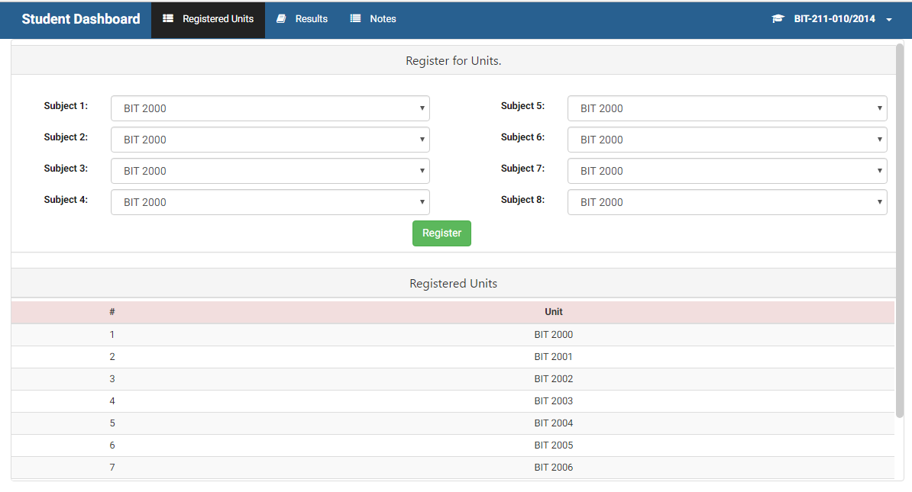

## **Database Designs**

The system uses a database called EXAM with six tables. The relationship among the tables is as shown below.

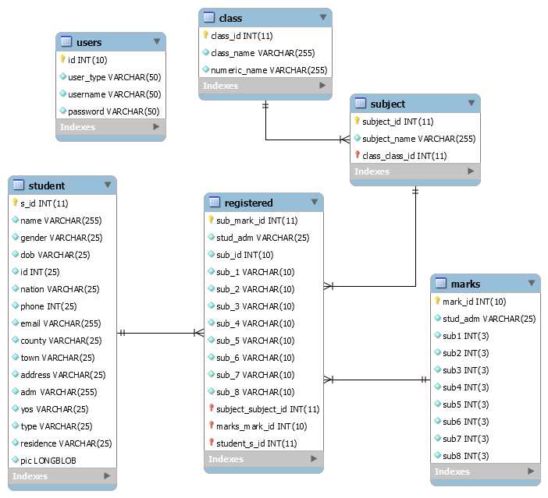

## **Use Case Diagram**



# **: SYSTEM IMPLEMENTATION**

This chapter describes the system development. The backend of the system is developed on PHP5 web server, while the front-end is built using HTM5 and jQuery. The nice interfaces were achieved by the use of Bootstrap, a CSS3 framework, jQuery was of much use in the front-end development, especially for validation purposes.

## **Web Clients**

### ***Development Tools***

The system is developed using the following languages

1. HTML5
2. CSS3
3. JAVASCRIPT
4. PHP5

The design on the exam portal implements Twitter Bootstrap 3.

### ***Installation Details***

The web clients are available on the web browsers, both mobile and desktop. To access the system, the user must have his desktop or device installed with Mozilla Firefox, Microsoft Edge, Internet Explorer, Safari of Chrome web browsers.

### ***Application Components***

This system consists of several web pages, each providing access to a particular interface. The main components of the system include the dashboards for the admin, the lecturer and the student. All activities are carried out within their respective dashboards.

# **: SYSTEM TESTING**

## **Introduction**

This section describes the approach to system testing, which is an important stage of any system development process as it establishes the achievement of functional and non-functional requirements.

## **Test Plan**

To the Examination Processing System, three testing technique were employed, to ensure that all requirements were tested under sound test cases. They included:

### ***Unit Testing***

This method involved testing each component of the system to ensure proper functionality as per system requirements outlined and the use cases defines in the system design phase.

### ***User Acceptance Testing***

In this approach, the system’s readiness to be deployed in a live environment was thoroughly tested. The main objective of this approach was to verify the system’s usability, user experience and its ability to match user requirements and expectations.

### ***Integration Testing***

This systematic technique of constructing the program structure was completed. In this testing, the tested modules were combined into the subsystem which are then tested. The goal here was to see if the modules can be integrated properly.

# **: CONCLUSIONS AND RECOMMENDATIONS**

This project sought to investigate and try to remedy the shortcomings of the existing examination module in the ERP of Multimedia University of Kenya, among other institutions. To achieve this objective, discussions were held with the stakeholders which included fellow students, some lecturers and members of IT department. It helped in coming up with proper requirements for the system.

## **Recommendations**

In order to successfully roll out the proper and efficient use of the Examination Processing System to protect both the students and lecturers from unnecessary delays in the releasing of the exam. The students will have to informed on the timely registration of units in order to avoid the cases of missing marks.

# **REFERENCES**

1. International Journal of Emerging Technology and Advanced Engineering, Website: www.ijetae.com ( ISSN 2250 - 2459, ISO 9001:2008 Certified Journal, Volume 4 , Issue 3 , March 2014 ) 660 Online Descriptive Examination and Assessment System Bhagyashri Kaiche 1, Samiksha Kalan 2, Sneha More 3 , Lekha Shelukar 4 1,2,3,4 KBT College of Engg Nashik, (India)
2. Z. M. Yuan, L. Zhang, G. H. Zhan, A novel web-based online examination system for computer science education, In proceeding of the 33rd Annual Frontiers in Education, 2013, S3F7-10.
3. WebBased online Secured Exam; B.Persis Urbana Ivy,A.shalini, A.Yamuna/International Journal of Engineering Research and Applications (IJERA) ISSN:2248-9622 www.ijera.com Vol. 2, Issue 1,Jan-Feb 2012, pp.943-944943.
4. Online Descriptive Examination and Assessment System.L. Zhang, et al., Development of Standard Examination System of Special Course for Remote Education, Journal of Donghua University (English Edition), 2013, Vol. 19, NO.1, 99-102.

# **APPENDICES**

Sample code

**<?php  
  
include 'db/connect.php'**;  
  
**if** (**isset**($_POST[**'name'**], $_POST[**'adm_no'**], $_POST[**'stud_pass'**])){ *//STUDENT* $name = $_POST[**'name'**];  
 $adm_no = $_POST[**'adm_no'**];  
 $stud_pass = $_POST[**'stud_pass'**];  
  
 **if** ($name != **''**){ *//Check the selected user* **if** ($adm_no != **''**){ *//Check Admission Number* **if** ($stud_pass != **''**){ *//Check Password  
  
 //SELECT THE USER FROM THE DATABASE* $user = *mysqli_query*($conn, **"SELECT** *\** **FROM `student` WHERE `adm`='**$adm_no**'"**);  
  
 **if** ($user == **true**){  
 $row = *mysqli_fetch_array*($user, ***MYSQLI_BOTH***);  
 **if** ($adm_no === $row[**'adm'**]){  
 **if** ($stud_pass === *strtolower*($row[**'adm'**])){  
 **echo "Student"**;  
 *session_start*();  
 $_SESSION[**'student'**] = $row[**'adm'**];  
 }**else**{  
 **echo "Your password should be your admission number in lowercase"**;  
 }  
 }**else**{  
 **echo** *mysqli_error*($conn);  
 }  
 }**else**{  
 **echo "You never did any exam"**;  
 }  
  
 }**else**{  
 **echo 'Please enter your password'**;  
 }  
 }**else**{  
 **echo 'Please enter your admission number'**;  
 }  
 }**else**{  
 **echo 'Please enter the type of user'**;  
 }  
  
}