NASA Harvest/ FAO Malawi Crop Cut Campaign 2023 Sampling Frame & Methodology

Christina Justice¹, Blake Munshell¹, Mike Humber¹, Jonathan Pound², Ritvik Sahajpal¹,Rachel Mkandawire, Grifth Yedwa, Margaret Mugo³, Edna Sibale³, Inbal Becker-Reshef¹

¹ NASA Harvest, University of Maryland, United States
² United Nations Food and Agriculture Organization, Italy
³ United Nations Food and Agriculture Organization Malawi, Malawi

The 2023 FAO/ NASA Harvest Malawi Crop Cut Campaign aimed at collecting sample crop cuts and farmer interviews from selected maize fields across Kasungu district, Malawi that represented yield variability at the district level. This dataset represents an unprecedented public dataset of sample crop cut yields aimed at supporting the advancement of yield forecast models by the broader research community.

A total of 261 fields were sampled across Kasungu district. The crop cut methodology followed the gold standard crop cut methodology taken from the FAO Handbook but slightly updated to include the collection of quantitative and qualitative data through the digital survey tool Survey123 and additional measurements including moisture meter measurements and different sizes of sample crop cuts to test the how crop cut size affected sample crop cut yields.

Sampling Frame

The objective of the sampling frame was to select 100 villages from across Kasungu district, Malawi that represented in season yield variability at the district level. Villages were selected based on proximity to cropland by using a 2-kilometer buffer around each village and sampling the NASA Harvest 2020/2021 Malawi Cropland Mask to identify the villages with at least 75% cropland in the surrounding area, to define ‘rural villages’. From these identified villages NDVI values were calculated at the 95th percentile during the peak vegetative calendar. Within the 2-kilometer buffered villages, the average 95th percentile NDVI was used to classify each village into High, Medium and Low classifications using Natural Breaks (Jenks), relating to High, Medium and Low crop yields/ conditions based on the assumption high NDVI values correlate with higher yields. 100 villages were then randomly selected proportionally from these classifications to represent yield variability at the District level. This final sample was then provided to local partners to identify the final list of 90 villages where sample crop cuts would be taken from selected fields. To identify the selected fields within each selected village, a village representative was tasked with selecting representative fields that met the following criteria: primary crop is maize, field size is larger than .5 hectares, maize crop is at full maturity and no portion of the field has been harvested, selected fields are representative of crop condition variability at the village level. This was a necessary concession to ensure adequate participation in the crop cut exercise. The sampling frame protocol applied under this campaign is one that we expect to evolve in future campaigns to further test the best sampling methods for selecting field locations to represent yield variability in support of validation of training data.
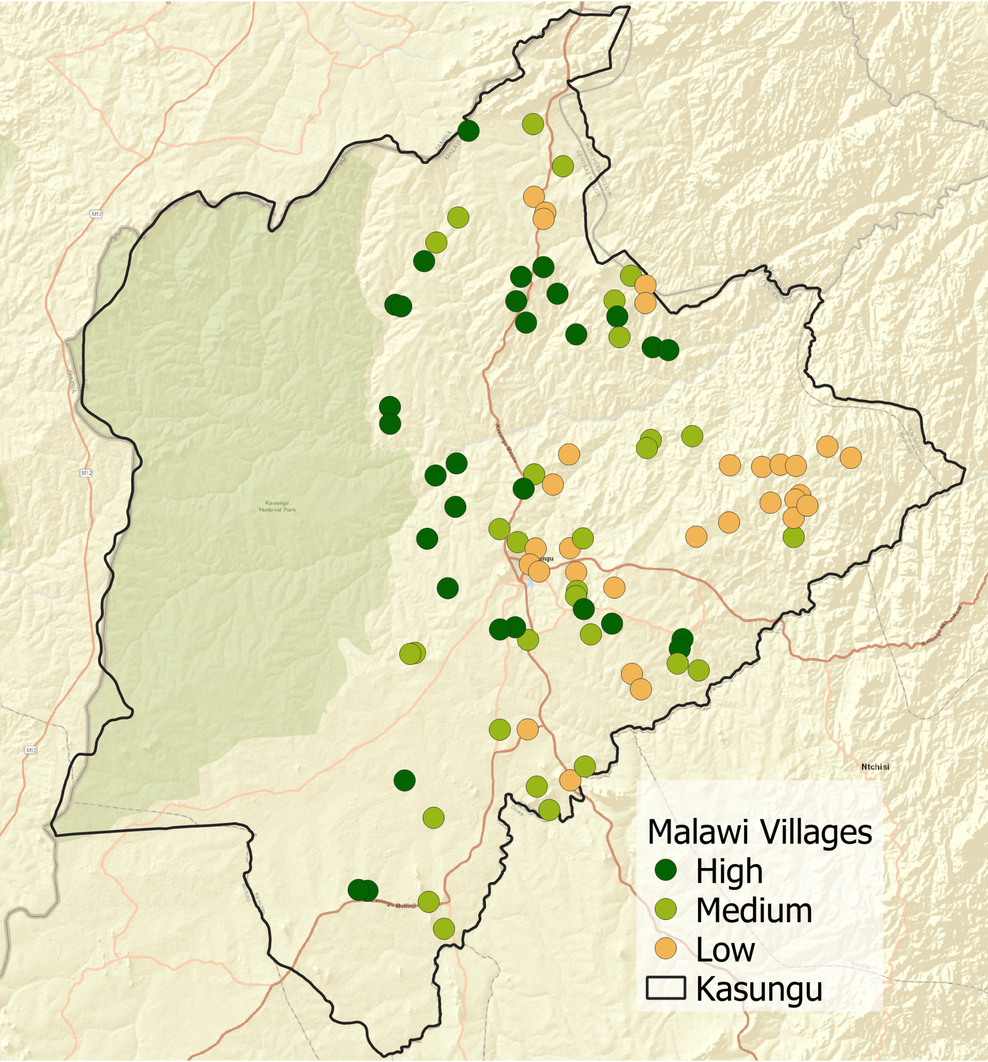
Figure 1

Crop Cut Methodology

The field location and field boundary and area in hectares was collected from every identified field. From each field a 10x10 meter crop cut was taken containing a nested 5x5 meter crop cut sub plot at the southwest corner of the 10x10 meter crop cut (See Figure 1). The location of the sample crop cuts was randomly selected using the length and width measurements of the field and ensuring that the randomly generated coordinates placed the sample crop cuts within the field boundaries and that no portion of the crop cut was within 5 meters of the field edge. At the randomly generated coordinate the 5x5 meter crop cut plot and 10x10 meter crop cut plots were 1. measured out, 2. demarcated, 3. harvested in sequence. The 5x5 meter sub plot was harvested first to ensure that no portion of the 5x5 was measured with the 10x10 plot. The maize cobs harvested from the sample crop cut plots were 1. cleaned, 2. Weighed, 3. counted 4. 20 percent of the cobs were randomly selected and dekerneled to assess the kernel weight and 5. measure the moisture content of the maize kernels to calculate dry weight of the kernels. The measurements were recorded using the Survey123 application and a farmer survey was taken at each sampled field to record qualitative information related to yield including the farmer field practices and crop condition assessment.
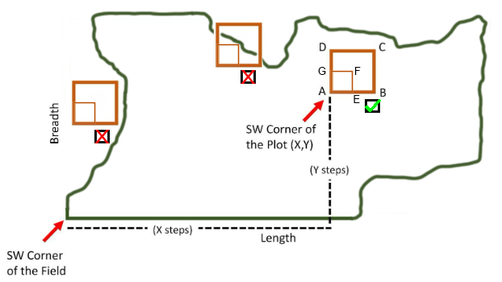
Figure 2. Identification of 10x10 and 5x5 meter sample crop cut locations from the SW corner of a selected field. If a randomly selected location was outside of the field boundary, or any part of the 10x10 meter plot fell outside of the boundary, the location was resampled.

Farmer Interview

A farmer interview was conducted using the Survey123 application relating to the specific field where the crop cut was taken. The main purpose of these questions are to understand seasonal climatic conditions and farming methods, but also took advantage of the opportunity to ask about demographics, food security, and other topics desired by the Ministry and FAO. Below outlines the key questions asked to understand the situations of the fields and the farmer.

User Information:
- Start time
- End time
- Username
- Device ID
- Device Online
- Language used
- Device Model
- Device OS

Demographic:
- General Notes
  - All demographic questions should be named starting with ‘hh’ for ‘household’
- Farmer Name:
- Farmer Phone Number:
- What is the sex of the farmer?
- What is the age of the farmer?
- What is the size of your household?
- How many people are currently living in your household?
- What is the household annual income?
- How many years of education does the farmer have/What is the highest level of education achieved by the farmer?
- For how many years has the farmer been farming?
- For how many generations has this farm been in the family?
- Administrative unit(s)
  - EPA, TA, Village, Village Head, Section, or any other AU where existing data may be lacking
- How many laborers will harvest this field?
- How many laborers would you hire to harvest this field in an average year?

Location:
- Field Boundary
- Field Point Location as backup
  - Can be primary geometry if inside a field in a country with large, commercial agriculture, but photointerpretation is not good enough for countries with smallholder agriculture like Malawi
- Location Accuracy
- Location Latitude
- Location Longitude
  - In S123, cannot have multiple geometries easily, so it is easier to write the properties of a null geometry to a field.
- Calculate area in multiple units
  - Hectares, square kilometers, square miles

Crop Type:
- General Notes:
  - All questions about the current season crops should be named starting with ‘cs’ for ‘current season’. If asking questions about previous seasons, start with ‘ps’.
  - There should also be questions either calculated and hidden, or done in post processing, to adhere to JECAM naming conventions such as “CT_NAME”, “CT_CODE”, “LC_NAME”, and “LC_CODE”.
- Landscape photo of the crops in the field
  - Include soil, crop, and sky
- What is the main crop type in the field?
- Are there multiple crops in the field?
  - If yes, select all other crops in the field.
- What percentage of the field is planted with the main crop?
- What percentage of the field is planted with secondary crops?
  - If possible, for each selected crop.
  - If not possible, for each of the most important crops (ie, in Namibia, ask if the secondary crop is maize/millet/sorghum, but not any other crops)

Crop Condition/ Farmer Practices:
- Was this field tilled before planting?
  - What was the estimated start date of tilling?
- What is the estimated start date of planting?
- Did planting take place early, on time, or late compared to an average year?
  - By how many weeks was planting early or late
    - Can use ${relative planting} to make question more clear
- What was the planting distance between rows, in cm?
- What was the planting distance between plants, in cm?
- What was the planting density, in plants per square meter?
  - Can be calculated from previous two questions
  - Alternatively, Mark out a 1 square meter plot and count the number of plants in the plot.
- Did replanting take place during the season?
  - What type of replanting took place?
    - Ie., full field, partial, gap filling
  - What is the estimated date of replanting?
  - What percentage of the field was replanted?
- What land preparation practices were used for the current season?
- What management practices were used for the current season?
  - Tractors, ox-ploughs, hand-till agriculture, conservation agriculture, etc.
- What agricultural inputs were used for the current season?
  - Organic fertilizers, chemical fertilizers, insecticides, organic pesticides, chemical pesticides, lime, etc.
  - What was the source of the agricultural inputs?
    - Ie., NGOs, government, self
  - Did you have any difficulties in accessing the agricultural inputs?
    - What was the cause of difficulty in accessing the agricultural inputs?
- Did you receive any extension services this cropping season?
  - From whom did you receive extension services?
  - What type of extension services did you receive?
  - Did the extension service you used improve your farming practices?
  - Please provide comments on the extension services used:
- Were government services used for land preparation?
  - What is the reason government services are not being used?
  - Which government services were used for land preparation?
    - Which tractor ploughing services were used?
    - Which tractor ploughing services are preferred?
- Did you have any difficulties accessing ploughing services?
- Were government input subsidies used on this field?
- If fertilizer is selected as an agricultural input…
  - How many times did you apply fertilizer this current season?
  - What types of fertilizer did you use this season?
  - What was the fertilizer rate?
  - Did you have any difficulties acquiring fertilizer for this season?
  - What was the cause of the difficulty in acquiring fertilizer?
- What was the main type of seed used this season?
  - What secondary seed types were used this season?
  - What was the source of the seed?
  - Did you have any difficulties in accessing seed this season?
    - What was the reason for difficulty?
  - How much seed (in kg.) did you apply to your field?
  - How much seed (in kg.) does your field require?
- How many times did you weed the field this season?
- Is this field irrigated?
  - What type of irrigation is used?
- What is the development stage of the main crop in the field?
  - Ie., planting through early vegetative, vegetative through reproductive, ripening through harvest, harvested
- How are germination conditions in this field compared to an average year?
- Is there any crop stress or damage during the season?
  - What percentage of the field was impacted by all damages?
  - Please estimate the percent crop loss due to all damages:
  - What are the causes of the damage/stress?
  - If they select pests, what was the main pest?
  - Photo of damages
- What is the farmer’s assessment of crop condition of the crops?
  - Ie., exceptional, favourable, watch, poor, failure
- What model of combine was used?
  - What is the model year of the combine used?

Crop Cut:
- General Note:
  - Naming depends greatly on your crop cut methodology. We did sub-crop cuts (‘subc’), (‘cc’) crop cuts, and (‘ff’) full field harvests.
- Latitude of crop cut location
- Longitude of crop cut location
- Is this crop cutting location representative of the general field conditions?
  - If not, is it better or worse?
- What is the number of cobs in the crop cut location?
- What is the weight of the dehusked cobs?
- What is the weight of 1/5th of the cobs, where every 5th cob is randomly selected?
- What is the weight of the shelled kernels of the randomly selected cobs?
- What is the moisture content of the shelled kernels?
- Formula to work out the yield estimate in tonnes/hectare (for a 10m crop cut):
  - A: Kernel Weight
  - B: (100 - moisture content) / 100
  - (((((A*B)/0.87)*5)*100)/1000)
    - 0.87 because 13% is the theoretical ideal MC to harvest maize
    - 5 because every 5th cob was randomly selected
    - 100 because there are 100 10m cuts in one hectare
    - 1000 because there are 1000 kilograms in one tonne

Climate Information:
- What is the estimated start date of onset rainfall?
  - Was this rainfall productive?
- How was the rainfall performance this season compared to an average year?
- Were there dryspells that occurred during the season?
  - During which months did the dryspells occur?
  - During which growth stage did the dryspells occur?
  - What was the most impactful dry month?
  - What was the length (in weeks) of the most impactful dryspell?
- Were there floods that occurred during the season?
  - During which months did the flooding occur?
  - During which growth stage did the flooding occur?
  - What was the most impactful flooding month?
  - What was the length (in weeks) of the most impactful flooding?

Livestock:
- Do you have livestock?
  - What is the primary type of livestock you have?
  - How many heads of the primary livestock do you have?
  - What is the status of your livestock?
  - Were the livestock used as draught animals for ploughing this season?
- How are livestock conditions in your area?
- How are grazing conditions in your area?
- Do livestock have enough water in your area?
  - What are the main sources of water for livestock in the area?
- Have you had any livestock mortalities?
  - What was the cause of the livestock mortality?
  - How many of your livestock died?
  - What types of livestock died?
- Is there livestock disease in your area?
  - What types of diseases are present in your area?
  - Are you aware of any Disease Control Interventions your area received following the disease outbreak?
    - What were these Disease Control Interventions?
    - Were you able to administer vaccines to your livestock during or after the outbreak in your area?
    - During which months was the livestock disease present?
    - During the outbreak, were there any control measures implemented to avoid the spread of disease?
      - Which restrictions were applied in your area?
      - Were you able to transfer animals in your area during the outbreak period?
        - What was the reason for transfer?

Food Security:
- What are the household sources of food supply?
  - Ie., purchase, self production, borrow, food aid, gifts
- In the past 7 days, what was the main source of obtaining food for this household?
  - * Sometimes only relevant for an emergency response survey
- Does this household currently have food stocks that were harvested in the previous season?
  - How many months from now will the food stock harvested from the previous season cover household consumption requirements?
  - If less than 12 months, Which of the following coping mechanisms will the household use in order to have enough food until the next harvest?
    - Ie., relying on less preferred and less expensive food, borrowing food including help from relatives or friends, limit food portions, restrict consumption by adults for children to eat, reduce number of meals eaten in a day, purchase food
- Will the current season’s harvest be sufficient for food supply till the next harvest?
  - How many months will self-production this season cover household consumption needs?
  - Which of the following coping mechanisms will the household put in place in order to reach next year's harvest?

Emergency Response :
- Was the household admitted to a refugee camp?
- For how many days was the field impacted by _____?
- What percentage of the crop loss was due to ______?
- Have you recorded any loss and/or damage to livestock following the recent _____?
  - What types of livestock were killed or injured due to the ______?
- Is your usual market (where food can be obtained) still functioning?
- Is your usual market (where food can be obtained) still accessible?
- Were any household food stocks lost due to ______?
  - What percent of your household food stock was lost?
  - Coping mechanisms
- In the past 7 days, was there a time when you did not have enough money or resources to buy food?
- Has your farm experienced disruptions to labor due to the ______?
  - Can be any source of disruption
- Has this field been shelled?
- Have you shifted planting decisions due to war?
  - Can be any source of disruption

Figure 3. A collection of questions that NASA Harvest has asked in the field campaigns.

United Nations Food and Agricultural Organization. Handbook on crop statistics: improving methods for measuring crop area, production, and yield. 2018. https://www.fao.org/3/ca6408en/ca6408en.pdf
Becker-Reshef I, Justice C, Sullivan M, Vermote E, Tucker C, Anyamba A, Small J, Pak E, Masuoka E, Schmaltz J, et al. Monitoring Global Croplands with Coarse Resolution Earth Observations: The Global Agriculture Monitoring (GLAM) Project. Remote Sensing. 2010; 2(6):1589-1609. https://doi.org/10.3390/rs2061589

