Table 1
Means, Standard Deviations, and One-Way Analyses of Variance in psychosocial functioning: Atypical AN (AAN) vs non-AAN participants
Comparison | AAN |  |  | Comparison |  |  | Measure
Group | n | M | SD | n | M | SD | F | p | η² | d
Healthy | 34 | 2.42 | 0.70 | 1800 | 2.22 | 0.51 | 5.019 | 0.025 | 0.003 | 0.388
AN | 34 | 2.42 | 0.70 | 9 | 2.42 | 0.62 | 0.000 | 0.989 | 0.989 | 0.000
BN | 34 | 2.42 | 0.70 | 113 | 2.59 | 0.58 | 2.014 | 0.158 | 0.014 | -0.278
BED | 34 | 2.42 | 0.70 | 66 | 2.33 | 0.51 | 0.578 | 0.449 | 0.006 | 0.160
PD | 34 | 2.42 | 0.70 | 19 | 2.49 | 0.62 | 0.127 | 0.723 | 0.002 | -0.102
WL10 | 34 | 2.42 | 0.70 | 81 | 2.23 | 0.58 | 2.199 | 0.141 | 0.019 | 0.303
Notably, subthreshold and threshold participants were combined for AN, BN, and BED.

Table 2
Logistic regression results: univariate prediction of future AAN onset
Measure | AUROC | OR | 95% CI |  | SE (β) | p
 |  |  | LL | UL
Body dissatisfaction | 0.681 | 2.606 | 1.756 | 3.865 | 0.201 |  | <0.001
Negative affect | 0.703 | 1.818 | 1.458 | 2.267 | 0.113 |  | <0.001
Dieting | 0.677 | 2.045 | 1.490 | 2.808 | 0.162 |  | <0.001
BMI | 0.626 | 1.060 | 1.019 | 1.102 | 0.020 |  | 0.004
Psychosocial functioning | 0.595 | 2.086 | 1.308 | 3.328 | 0.238 |  | 0.002
Thin-ideal internalization | 0.599 | 2.145 | 1.222 | 3.768 | 0.287 |  | 0.008
Binge eating | 0.539 | 1.043 | 0.969 | 1.123 | 0.038 |  | 0.260
Compensatory behaviors | 0.605 | 1.032 | 0.988 | 1.078 | 0.022 |  | 0.160
Feeling fat | 0.698 | 1.390 | 1.224 | 1.578 | 0.065 |  | <0.001
Fear of weight gain | 0.698 | 1.338 | 1.202 | 1.489 | 0.055 |  | <0.001
Lower-than-expected BMI | 0.610 | 0.000 | 0.000 | 0.005 | 10.394 |  | 0.013
Weight/shape overvaluation | 0.700 | 1.814 | 1.433 | 2.296 | 0.120 |  | <0.001
(BP vs Control) | 0.572 | 0.557 | 0.330 | 0.939 | 0.266 |  | 0.028
(Healthy Weight vs Control) | 0.500 | 1.531 | 0.600 | 3.908 | 0.478 |  | 0.373

Table 3
Logistic regression and balanced random forest results: multivariate prediction of future AAN onset
Model | Accuracy | Sensitivity | Specificity | AUROC
Logistic regression | 0.626 | 0.847 | 0.619 | 0.789
Balanced random forest | 0.629 | 0.847 | 0.621 | 0.771

Figure 1. SHAP feature importance values for balanced random forest and logistic regression in the multivariate future onset predictions
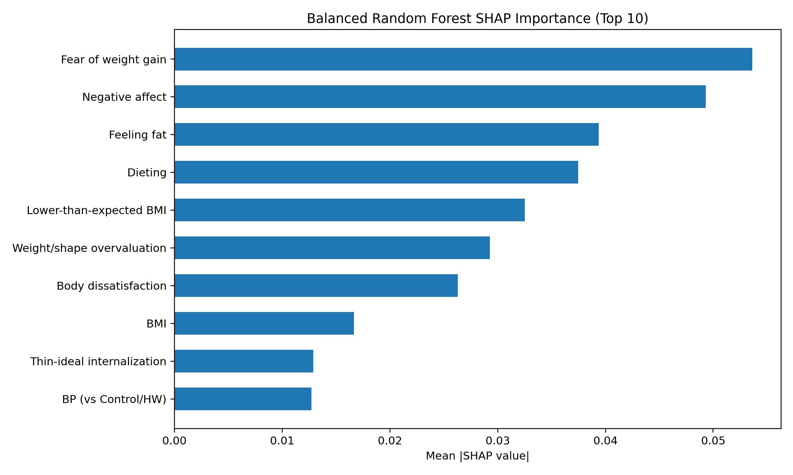
Mean absolute SHAP values (higher = greater average contribution to model output) for the balanced random forest (left) and class-weighted logistic regression (right). Features are ordered by importance within each model. Predictors include baseline risk factors, prodromal symptoms, and study-condition indicators.
Figure 2. Balanced random forest SHAP beeswarm plot for incident AAN onset prediction.
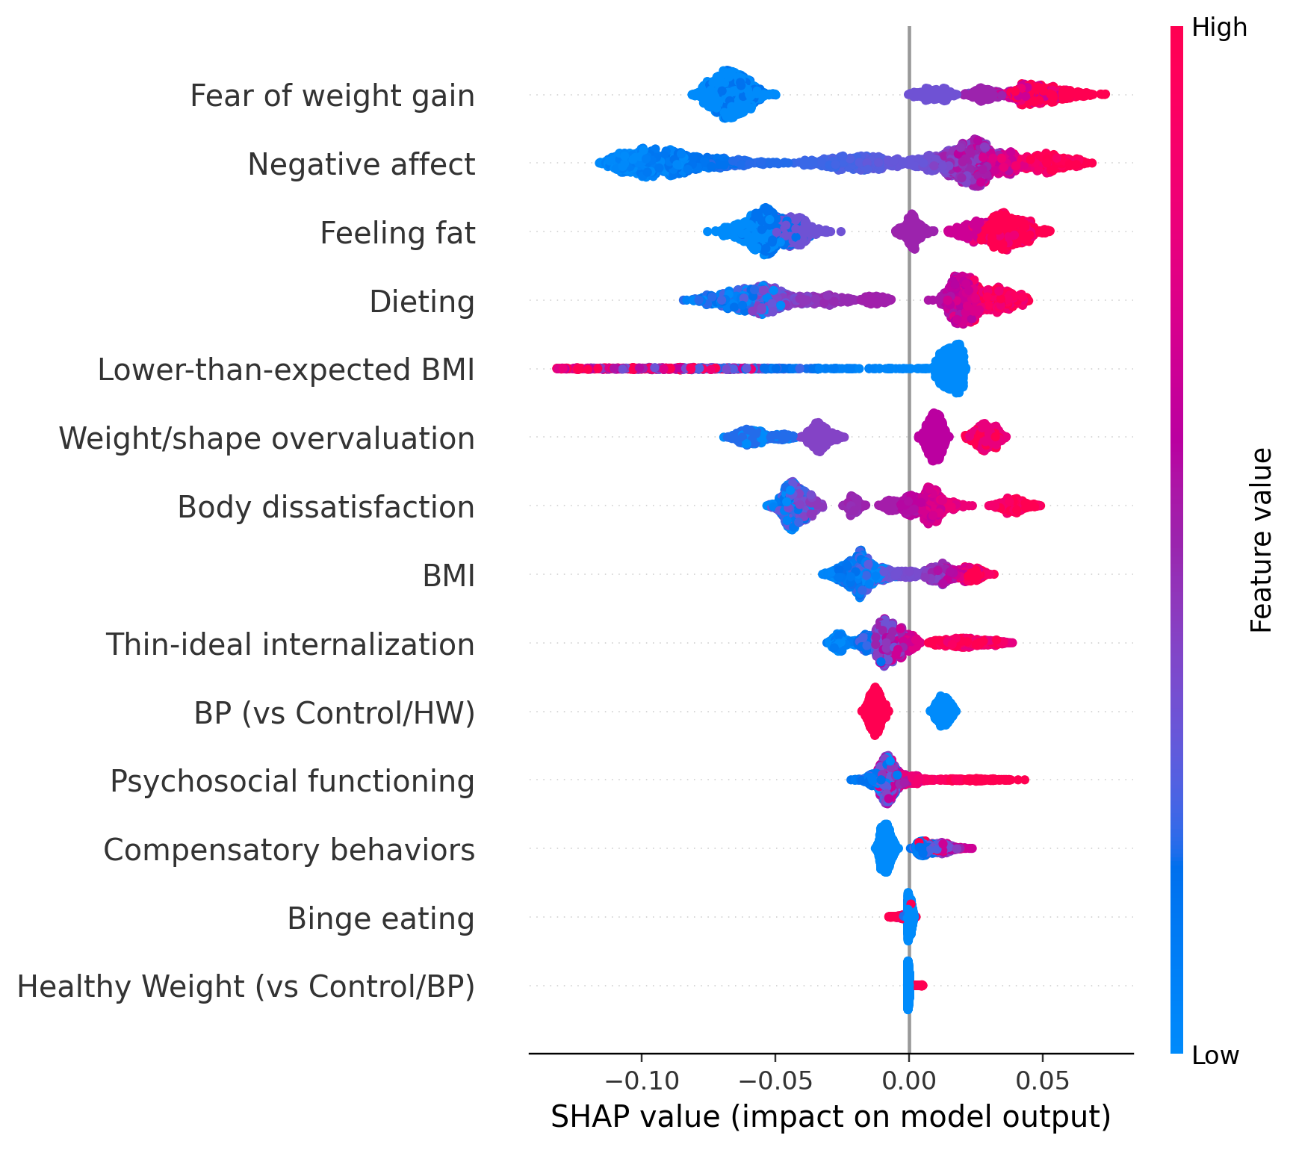
Beeswarm distribution of SHAP values for each baseline predictor in the class-weighted logistic regression model. Each point represents one participant; color indicates the observed feature value (low to high). Positive SHAP values shift predictions toward higher probability of AAN onset; negative SHAP values shift predictions toward lower probability.

Figure 3. Logistic regression SHAP beeswarm plot for incident AAN onset prediction. 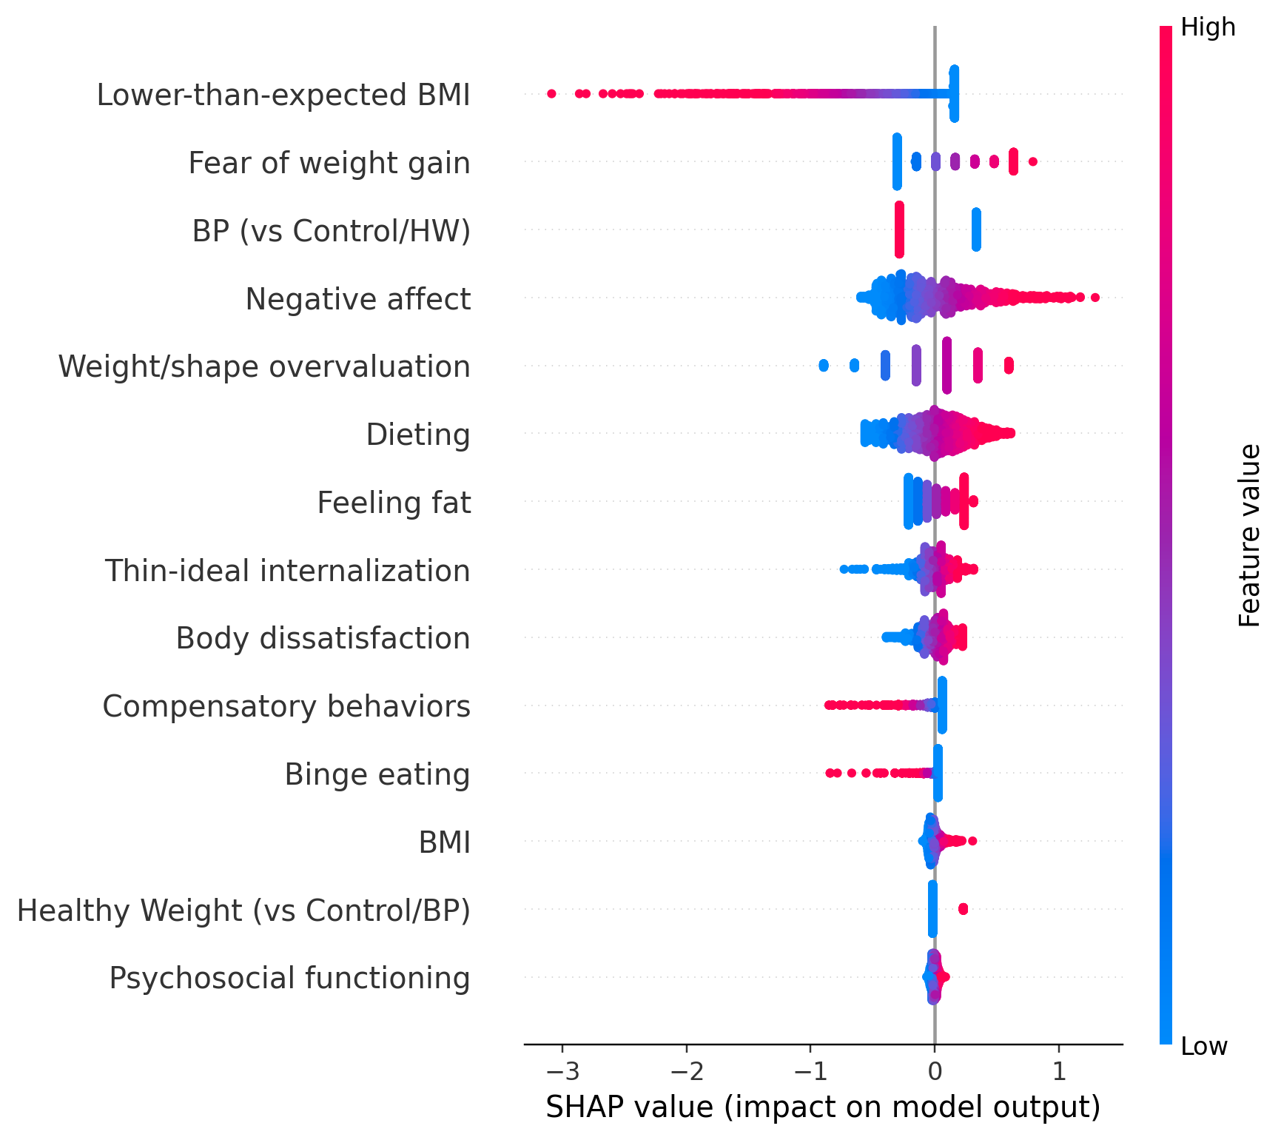
Beeswarm distribution of SHAP values for each baseline predictor in the balanced random forest. Each point represents one participant; color indicates the observed feature value (low to high). Positive SHAP values shift predictions toward higher probability of AAN onset; negative SHAP values shift predictions toward lower probability.

Table 5
Logistic regression results: univariate prediction of remission vs. persistence. Rows with p<0.05 are highlighted along with the 4 largest Cohen’s d-values.
Measure | Accuracy |  | OR |  | 95% CI |  | SE (β) |  | p |  | d
 |  |  |  | LL |  | UL
Body dissatisfaction | 0.500 | 1.322 |  | 0.687 |  | 2.542 |  | 0.334 |  | 0.403 | 0.154
Negative affect | 0.500 | 1.271 |  | 0.713 |  | 2.266 |  | 0.295 |  | 0.416 | 0.132
Dieting | 0.429 | 1.239 |  | 0.613 |  | 2.504 |  | 0.359 |  | 0.550 | 0.118
BMI | 0.514 | 1.074 |  | 0.967 |  | 1.194 |  | 0.054 |  | 0.184 | 0.039
Psychosocial functioning | 0.514 | 1.689 |  | 0.620 |  | 4.599 |  | 0.511 |  | 0.305 | 0.289
Thin-ideal internalization | 0.429 | 1.881 |  | 0.470 |  | 7.526 |  | 0.707 |  | 0.372 | 0.348
Binge eating | 0.543 | 1.071 |  | 0.863 |  | 1.329 |  | 0.110 |  | 0.536 | 0.038
Compensatory behaviors | 0.486 | 1.041 |  | 0.969 |  | 1.118 |  | 0.037 |  | 0.275 | 0.022
Feeling fat | 0.557 | 1.018 |  | 0.789 |  | 1.314 |  | 0.130 |  | 0.892 | 0.010
Fear of weight gain | 0.514 | 2.564 |  | 1.128 |  | 5.826 |  | 0.419 |  | 0.025 | 0.519
Lower-than-expected BMI | 0.600 | 0.040 |  | 0.000 |  | 934.650 |  | 5.135 |  | 0.530 | -1.778
Weight/shape overvaluation | 0.571 | 2.567 |  | 1.071 |  | 6.152 |  | 0.446 |  | 0.034 | 0.520
(BP vs Control) | 0.571 | 1.517 |  | 0.459 |  | 5.014 |  | 0.610 |  | 0.494 | 0.230
(Healthy Weight vs Control) | 0.571 | 1.643 |  | 0.235 |  | 11.496 |  | 0.993 |  | 0.617 | 0.274

