**Problem 1:**

When hitting 1 of these buttons nothig happens and the CPU consumption shoots up to maximum.

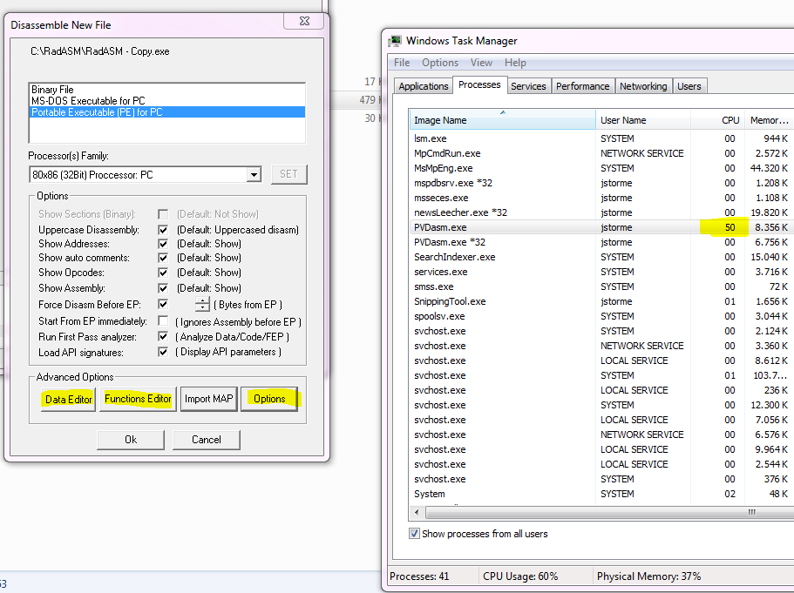

**Problem 2:**

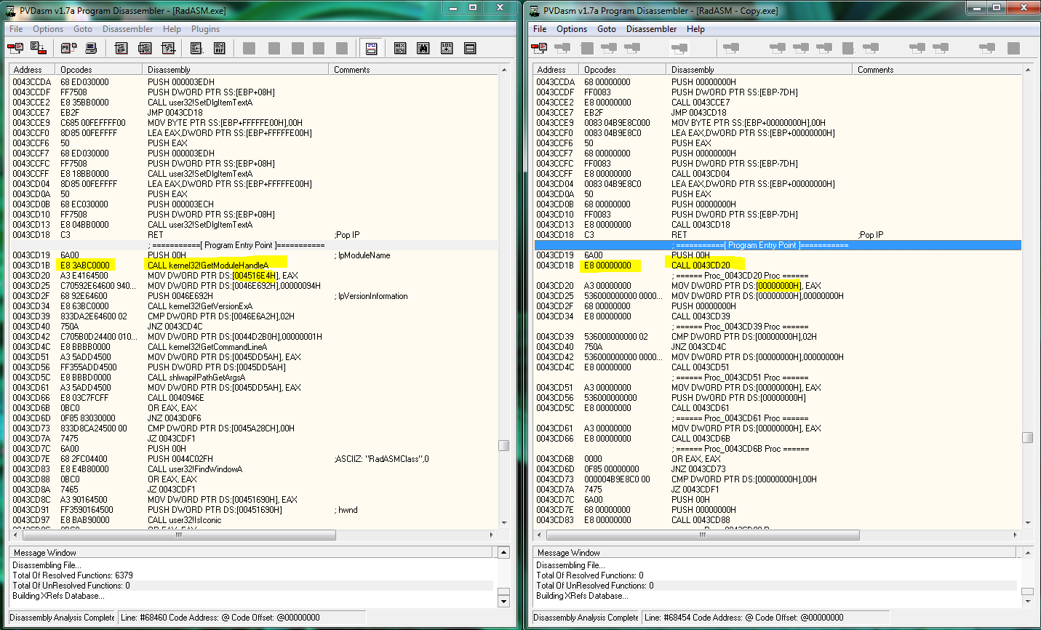

Disassembly is not the same on x64 as on x86. But also both of them use high amount of CPU power.

After I select File -> Close file. Both crash on my machine.

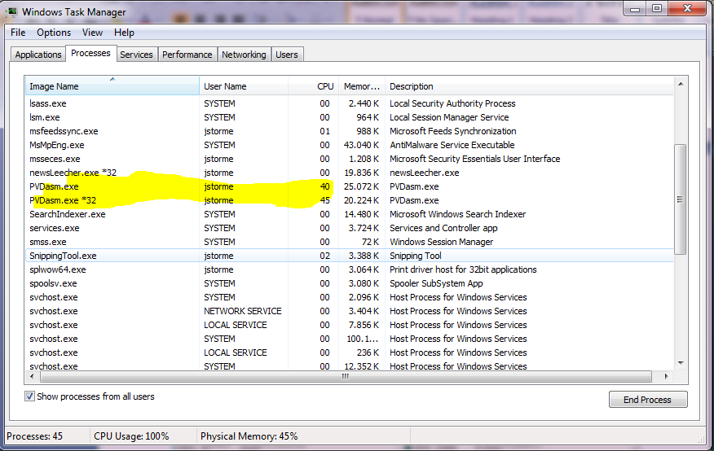

**Problem 3**

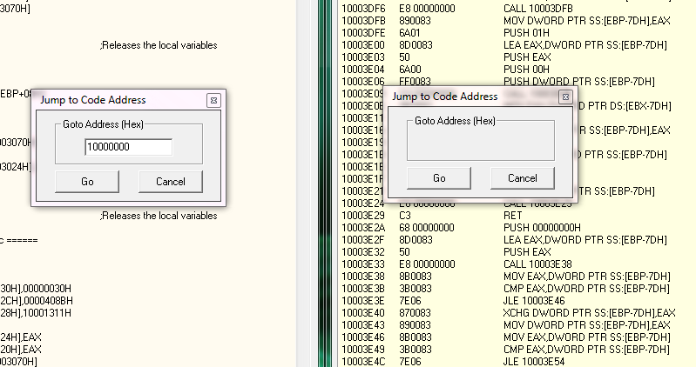

No textbox in x64 PVDasm ☹. If I hit Go CPU rockets to the sky again.

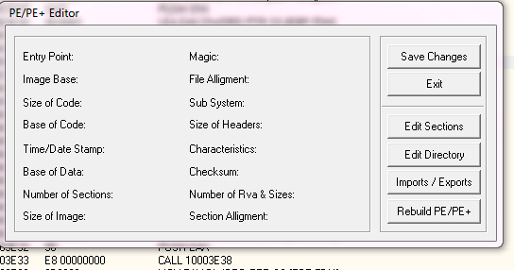

Same for the PE/PE+ editor.

Problem 4

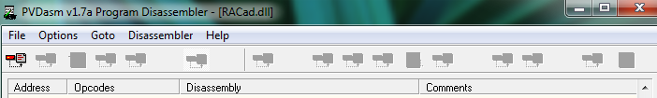

Toolbar items aren’t available.