ESPINA (ESPina Interactive Neuron Analyzer)

- Introduction
- Basic Concepts
- Menu Commands

1. Introduction

Since synapses are key elements in the structure of nervous circuits, understanding their location, size and proportion between the two different types is extraordinarily important in terms of function.

This tool automatically performs segmentation and 3D volume reconstruction of synapses in the cerebral cortex, helping the user to examine large tissue volumes and interactively validate the results provided by the software.

2. Basic Concepts

ESPINA can display multiple spatially or temporally related images. These image sets are called stacks. The images that make up a stack are called sections. All the sections in a stack must be the same size and bit depth. ESPINA supports 8-bit grey scale images.

The ESPINA main window contains a "Menu bar", a "Tool bar", and the main view (X-Y) of a stack of images. Three secondary docked windows are automatically displayed, showing different views of the stack: “3D”, "Y-Z" and "X-Z". The "3D" window shows simultaneously the three planes X, Y, Z, and the rendered volume of the segmented objects. Three docked windows more, related with the semantic information of the segmented objects and the current stack are shown: "Samples", "Taxonomies" and "Segmentations"

All Windows can be dragged around the screen and re-sized. In the views of the stack the right button of the mouse can be used to zoom in/out. A scroll bar, and the mouse scroll, provides the ability to move through the sections. The displacement action is triggered by pressing the third button (or mouse wheel).

3. Menu Commands

Menu bar

File:
\Open – ParaView Mode: opens a stack of images (the current supported formats are .mha, .mhd, .pvd, .seg). This command also opens previously segmented files (which are saved with the file extension .seg)
\Save – ParaView Mode: save the segmentations performed and the reference to the stack of images.

View:
This menu contains a list with all the widgets available. They could be set as activate or not by selecting an item.

Tools (for a detailed description see point 4):
\ManagePlugins: opens a window with the local plugins loaded in the application. It permits also to load new ParaView plugins or remove them.

Toolbar

The toolbar of the main window contains tools for:
- Show/Hide the objects
- Select the label of the objects
- Export to a CSV file the selected pixels of the stack
- Select the threshold for the automatic selection of the borders of the objects
- Add a new object. This has two kind of selectors: Exact Pixel and Best Pixel. The first uses the selected pixel as seed. The last, takes as seed the darker pixel around the selection.
- Region of interest: defines a region of interest in 3D

The 3D window contains some action buttons (at the bottom) to render the volume of the segmented objects in different modes and view the planes.


- volume: shows a 3D volume reconstruction of the objects and it is automatically refreshed when an object is added/deleted.
- maya: shows an accurate 3D volume reconstruction of the objects.
- planes: shows the planes of the current slices of the views.

To facilitate visualization and identification, images and 3D reconstructed objects can be show/hide.

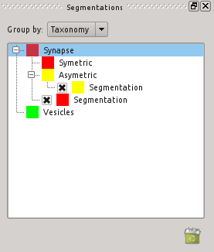
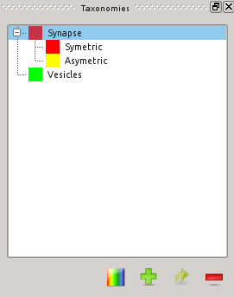
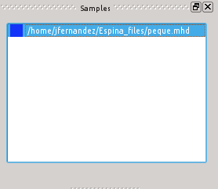

Taxonomy Widget
To categorize the objects there is a default taxonomy to give them a semantic meaning. It shows a tree with the relations between the taxonomy nodes.


This widget allows to change the color of a taxonomy item and all its segmented objects, add a new one, add a sub-taxonomy element for a selected one and remove a taxonomy node.

Segmentation Widget
Shows the tree of the Taxonomy Widget with the segmented objects. The segmented objects item has a cross mark which shows or hide the object in the views. A double click upon a segmentation item pops up a window with the 3D representation of the object. Also an object can be removed by selecting one and pressing the trash button.
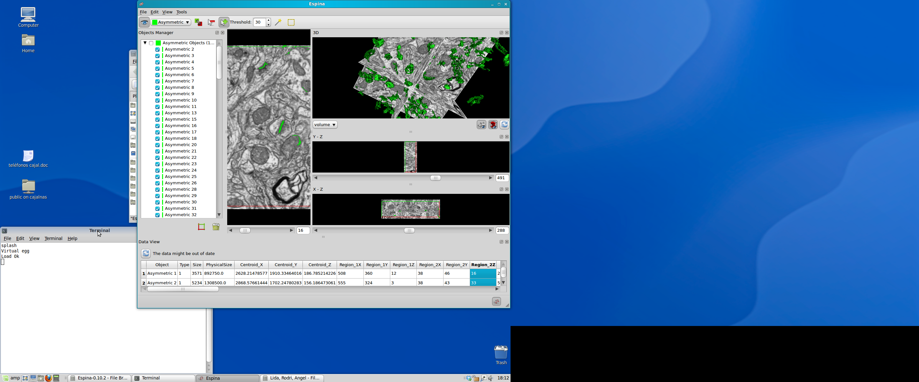

Sample Widget
Contains all the stacks loaded by ESPINA. At the moment the applications works with the last stack loaded. In the future it will work with multiple stacks at the same time. The scale could be changed or view by pressing upon the stack item. A dialog box appears with the current values of the stack's scale. They could be changed modifying and applying the parameters.

