3. 1b:

* informal feedback: It's feedback that’s given on a day to day basis and is given on any aspect of a doctor’s professional performance and conduct, by any member of a multidisciplinary team.
* formal feedback: it’s feedback in a written form that comes as a part of structured assessments that is offered by any member of a multidisciplinary team.
* formative feedback: it’s feedback ‘’for learning’’ and provides the opportunity to reflect and redirect effort before completing a final assessment.
* summative feedback: it’s feedback that measures a performance and comes with a mark/grade and feedback to explain your mark/grade.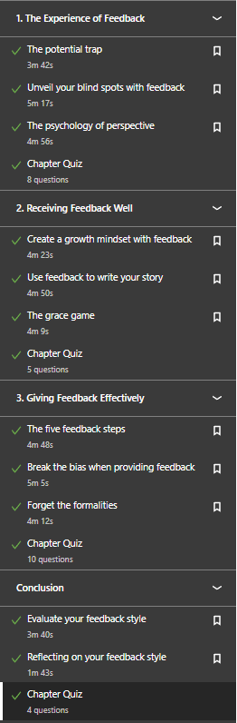

3. 1c: 

3. 1d:

What went well:

You set up a good presentation with information and you used a lot of

pictures and images which made the presentation not look boring, you

talked in the microphone well which made the crowd hear what you said

you showed on the images to the crowd what you were talking about and

that made it the information clearer

What could’ve been done better:

Try to stay in one place when you’re talking, try to say less ‘’eh’’ and

look more into the crowd, try to explain difficult things to the crowd, put

less text in your presentation and talk slower,

Positive summary:

You had a good presentation, try to put less information in the

presentation and talk a bit slower. You did talk in the microphone a lot which was good and the students could hear what you said, you showed the students on the images what you were talking about but try to be more clearer and answer questions precisely so that the students know what you are talking about rather than being confused. Try to keep your phone on silent during the presentation so there would be no distraction and look a bit more in the crowd.

3. 1e: I can’t do that one because I’m home due to the strike.

3. 1f: Feedback is like a conversation that involves listening as well as talking. A smart art teacher once said swallow, breathe and say thank you. work to find value. feedback starts with being open to change, are you interested in improvement? improvement -> better relationships. People will give us feedback when we don’t ask. Are we willing to take feedback like this and incorporate it into how we make decisions? Your questions matter, even if they’re inconvenient, even if I disagree with them, even if I think they’re irrelevant, even if you’re telling me that if I want to stay relevant I need to adapt. Feedback begins with being open to change.