OT Server - WEB Deployment on Windows

Install the following:

- OT for Windows
- PHP from http://www.php.net
- Apache from http://httpd.apache.org/
- OpenSSL from http://slproweb.com/products/Win32OpenSSL.html

Php

- Copy otapi-php.dll, otapi.dll and otlib.dll to root folder of PHP

- Copy otapi-php.dll to PHP\ext folder

- From root folder of PHP, open PHP.ini with notepad.

- Search for block of code where you have
extension = .......

- include this line

- extension=otapi-php.dll

- Also, ensure that the line:

- "extension=php_openssl.dll"

- is not commented out - i.e. there is no semi-colon in front.

- When ready, copy php.ini to c:\Windows

Apache:

Typical install path :
C:\Program Files\Apache Group\Apache2\conf\httpd.conf

Apache is normally installed as a windows service.

If already running, stop it.

Jump to root folder of Apache (default: C:\Program Files\Apache Group\Apache2)

Click on "conf" folder

Open httpd.conf with notepad

Search for these lines and make that paths ae correct

extension_dir = "c:\PHP\ext"

Locate the string “cgi.force_redirect = 1” which should be on a line that is
commented out (it begins with a semi colon). Remove the semi colon and the
space after it, leaving only the string.
Example:
cgi.force_redirect = 1

At bottom of script include the following:

ScriptAlias /php/ "/php/"
AddType application/x-httpd-php .php
Action application/x-httpd-php "/php/php.exe"

ScriptAlias /php/ "c:/php/"
AddType application/x-httpd-php .php
Action application/x-httpd-php "/php/php-cgi.exe"

LoadModule php5_module "c:/php/php5apache2.dll"
AddType application/x-httpd-php .php

# configure the path to php.ini
PHPIniDir "C:/php"

# Add to the end of the LoadModule section
LoadModule php5_module "c:/php/php5apache.dll"
# Add to the end of the AddModule section
AddModule mod_php5.c

AddType application/x-httpd-php .php
# For syntax highlighted .phps files, also add
AddType application/x-httpd-php-source .phps

Also search for line “Listen 8080”

Change to 80 if you installed Apache on port 80.

Save changes, and re-start Apache server.

From Windows, go to

Control Panel\System and Security\Administrative Tools

Click on Services and click on Apache Server
Go to the log-on tab
Make sure that This Account is selected with the necessary credentials
This ensure that files are accessed in
C:\Users\JSpit-PC\AppData\Roaming

Testing Apache installation:

Open web-browser and go to http://localhost

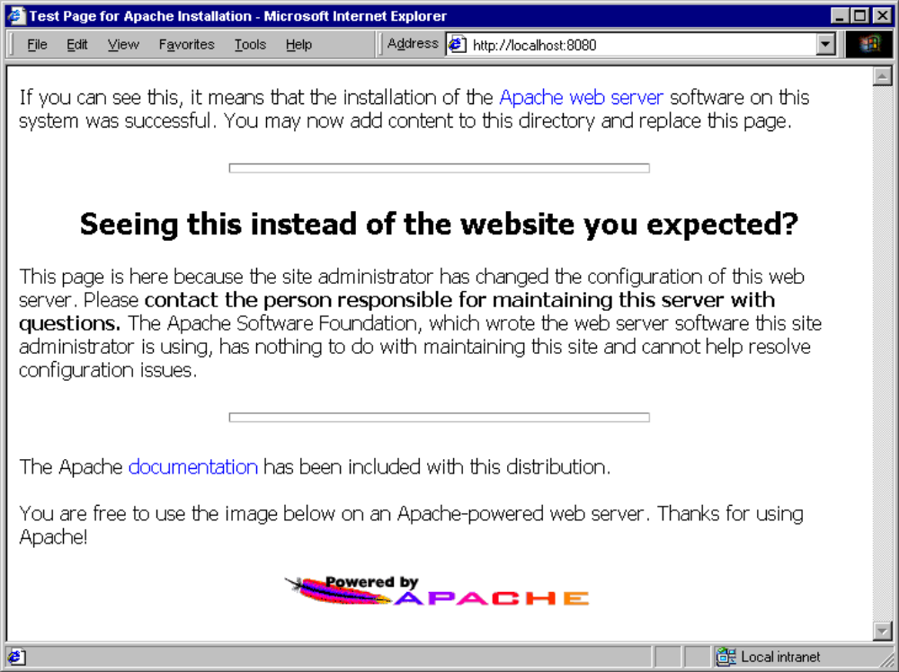

If you see this, then apache is installed correctly.

Testing apache and Php

Copy “test.php” to C:\Program Files\Apache Group\Apache2\htdocs (assuming that apache was installed there)

Open browser and go to:
http://localhost:8080/test.php

The result should be a page showing Php configuration and setup on your machine:

Open Transactions

- Create folder opentrans under
C:\Program Files\Apache Group\Apache2\htdocs
- Install php_ot_test.php and otapi.php
- Go to C:\Users\<your computer name>\AppData\Roaming and create <OpenTransactions> folder
- Copy sample data of opentransactions to this folder
- Open web-browser
- Go to http://localhost/opentrans/php_ot_test.php

You should end up with something like this:
1356849342 = 30/12/2012 06:35:42
wallet exists.
SUCCESS setting the password callback.
Server count: 1
Server Id : tBy5mL14qSQXCJK7Uz3WlTOKRP9M0JZksA3Eg7EnnQ1 Localhost Server Contract
nym count = 2
Nym Id : SP8rPHc6GMRPL517UL5J8RK2yOiToyVqMaj3PUHvLzM Trader Bob
Nym Id : T1Q3wZWgeTUoaUvn9m1lzIK5tn5wITlzxzrGNI8qtaV FT's Test Nym
Success in check nym.
Error in withdraw cash. Is the server running? Is the test data in ~/.ot ?

