**GLUT Installation for VS 2019**

**GLUT overview**

GLUT (Graphics Library Utility Toolkit) must be properly installed before using the C++ Graphics Library (**graphXXXX.lib – XXXX is 2013, 2015, 2017, or 2019**) used in this course. GLUT is responsible for displaying the core graphics used by **graphXXXX.lib. GLUT is already installed on the UCA computers - you only need to perform this installation on the PCs that you own.**

**Note:** GLUT and the C++ Graphics Library can only be installed on computers running the Windows OS.

**GLUT Installation**

Perform the following steps to install GLUT on you PCs.

1. Download *glut.zip* from blackboard. This is available under *Graphics Drivers*

2. Extract all files from glut.zip. You should see the following files:

*glut.def* Export Definition File (informational file)

*glut.h* Header file

*glut.dll* Dynamic Library file

*glut32.lib* Static Library file

*README-win32.txt* Version/Compilation File (informational file)

3. Locate the *top* level directory where VS 2019 is installed. For a typical installation this top level path would be located at either:

C:\Program Files\Microsoft Visual Studio\2019\Community\VC\Tools\MSVC\14.21.27702

Or

C:\Program Files (x86)\Microsoft Visual Studio\2019\Community\VC\Tools\MSVC\14.21.27702

**The very last folder (for this example *14.10.25017*) will be dependent on the version of VS 2019 that you have installed.** It will still consist of a set of 3 numbers delimited by dots.

Locate the *include* folder beneath this top level path. For a typical installation, this folder would appear as shown below:

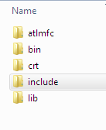

5. Create a new folder **inside** of the *include* folder. Name this new folder *gl*. Your *include* folder should now appear as shown below:

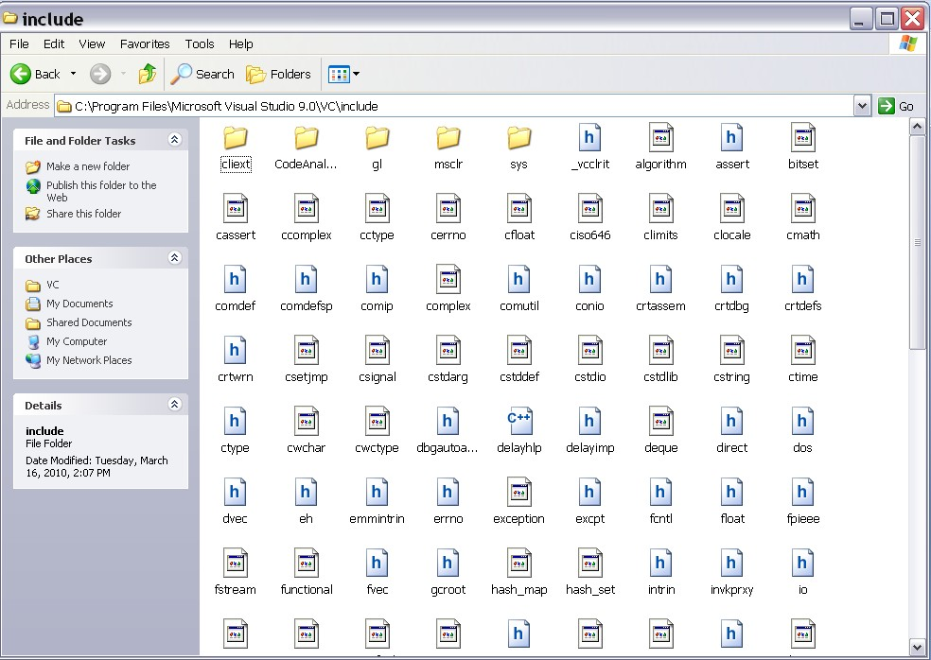

**Fig. 1. Creation of *gl* folder**

6. Copy the following file **into** the *gl* folder:

*glut.h*

7. Locate the *lib* folder beneath the top level path. For a typical installation, this folder is located at either:

C:\Program Files\Microsoft Visual Studio\2019\Community\VC\Tools\MSVC\14.21.27702\lib

Or

C:\Program Files (x86)\Microsoft Visual Studio\2019\Community\VC\Tools\MSVC\14.21.27702\lib

8. Under this lib folder contains two folders – one for 32 bit and one for 64 bit as shown below:



9. Copy the following file **into** ***both the x64 and x86* folders**:

*glut32.lib*

10. Locate the *system* folders for Windows. For a typical installation under Windows 10 and Windows 7, these folder are located at:

C:\Windows\system

C:\Windows\System32

**(These folders may be named differently or located in a slightly different location for other versions of Windows)**

11. Copy the following file **into** both *system and system32* folders:

*glut32.dll*

12. Reboot your computer

13. Create MSVC++ projects as outlined in **VisualStudioTutorial.pdf.**