Project

2023-03-30

#loading the data  
setwd("C:/Users/Icy/Documents/School-GMU/BINF 702/Project files")  
Ach_data <- read.csv("acetylcholinesterase_05_bioactivity_data_2class_pIC50.csv")  
  
head(Ach_data)

## X molecule_chembl_id canonical_smiles  
## 1 0 CHEMBL133897 CCOc1nn(-c2cccc(OCc3ccccc3)c2)c(=O)o1  
## 2 1 CHEMBL336398 O=C(N1CCCCC1)n1nc(-c2ccc(Cl)cc2)nc1SCC1CC1  
## 3 2 CHEMBL131588 CN(C(=O)n1nc(-c2ccc(Cl)cc2)nc1SCC(F)(F)F)c1ccccc1  
## 4 3 CHEMBL130628 O=C(N1CCCCC1)n1nc(-c2ccc(Cl)cc2)nc1SCC(F)(F)F  
## 5 4 CHEMBL130478 CSc1nc(-c2ccc(OC(F)(F)F)cc2)nn1C(=O)N(C)C  
## 6 6 CHEMBL130098 CSc1nc(-c2ccc(Cl)cc2)nn1C(=O)N(C)C  
## class MW LogP NumHDonors NumHAcceptors pIC50  
## 1 active 312.325 2.8032 0 6 6.124939  
## 2 active 376.913 4.5546 0 5 7.000000  
## 3 inactive 426.851 5.3574 0 5 4.301030  
## 4 active 404.845 4.7069 0 5 6.522879  
## 5 active 346.334 3.0953 0 6 6.096910  
## 6 active 296.783 2.8501 0 5 7.000000

#test data for normality  
Ach_norm<-rnorm(100)  
shapiro.test(Ach_norm) # we cannot reject the hypothesis that the data is normally distributed

##   
## Shapiro-Wilk normality test  
##   
## data: Ach_norm  
## W = 0.98641, p-value = 0.3993

#Create a frequency plot of the 2 bioactivity classes  
library(rlang)

## Warning: package 'rlang' was built under R version 4.2.3

library(ggplot2)

## Warning: package 'ggplot2' was built under R version 4.2.3

ggplot(Ach_data, aes(x = class)) +  
 geom_bar(color = "black", fill = "lightblue") +  
 labs(x = "Bioactivity class", y = "Frequency") +  
 theme_classic() +  
 theme(axis.text = element_text(size = 14, face = "bold"),  
 axis.title = element_text(size = 14, face = "bold"),  
 panel.grid.major = element_blank(),  
 panel.grid.minor = element_blank(),  
 panel.border = element_blank(),  
 legend.position = "none")

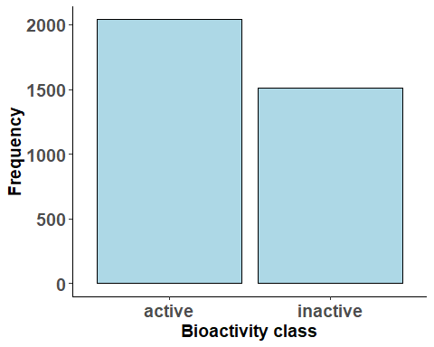

#scatterplot of MW versus logP  
  
ggplot(Ach_data, aes(x=MW, y=LogP, color=class, size=0.5)) +   
 geom_point(alpha=0.7, shape=1, aes(fill=class), show.legend=TRUE, stroke=0.5) +   
 scale_size_continuous(range = c(2,10)) +  
 labs(x = "MW", y = "LogP") +  
 theme_bw() +  
 theme(legend.position = c(0.02,0.98), legend.justification = c(0, 1), legend.background = element_blank(), legend.key.width = unit(0.8,"cm"))

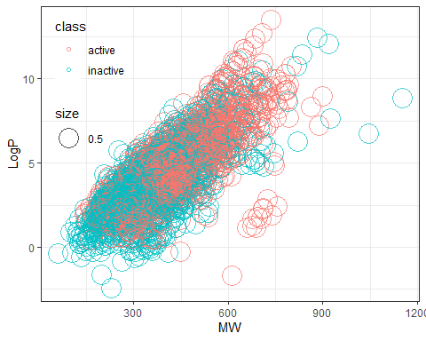

#box plots of pIC50 values versus bioactivity class  
  
ggplot(data=Ach_data, aes(x=class, y=pIC50,fill=class)) +  
 geom_boxplot() +  
 scale_fill_manual(values=c("blue", "red")) +  
 labs(x="Bioactivity class", y="pIC50 value") +  
 theme_classic() +  
 theme(axis.text.x = element_text(angle=90, vjust=0.5, hjust=1),   
 legend.position="none")

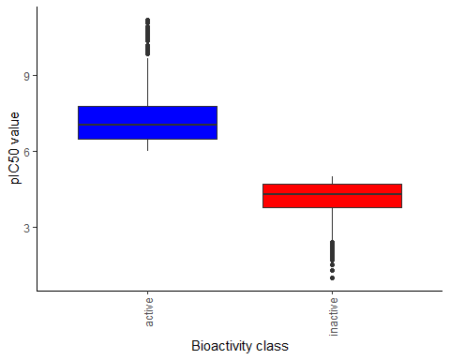

#mannwhitney U test. Non parametric stat significant tests  
  
mannwhitney <- function(descriptor, verbose=FALSE) {  
 # actives and inactives  
 active <- Ach_data[Ach_data$class == "active", descriptor]  
 inactive <- Ach_data[Ach_data$class == "inactive", descriptor]  
  
 # compare samples  
 res <- wilcox.test(active, inactive)  
  
 # interpret  
 alpha <- 0.05  
 if (res$p.value > alpha) {  
 interpretation <- "Same distribution (fail to reject H0)"  
 } else {  
 interpretation <- "Different distribution (reject H0)"  
 }  
  
 # print results  
 if (verbose) {  
 cat(paste("Descriptor:", descriptor, "\n"))  
 cat(paste("Statistics:", res$statistic, "\n"))  
 cat(paste("p-value:", res$p.value, "\n"))  
 cat(paste("alpha:", alpha, "\n"))  
 cat(paste("Interpretation:", interpretation, "\n"))  
 }  
  
  
 # return results  
 return(data.frame(Descriptor=descriptor, Statistics=res$statistic,  
 p=res$p.value, alpha=alpha,  
 Interpretation=interpretation))  
}  
  
  
mannwhitney("pIC50")

## Descriptor Statistics p alpha Interpretation  
## W pIC50 3078890 0 0.05 Different distribution (reject H0)

#MW boxplot versus bioactivity class  
ggplot(data=Ach_data, aes(x=class, y=MW,fill=class)) +  
 geom_boxplot() +  
 scale_fill_manual(values=c("blue", "red")) +  
 labs(x="Bioactivity class", y="MW value") +  
 theme_classic() +  
 theme(axis.text.x = element_text(angle=90, vjust=0.5, hjust=1),   
 legend.position="none")

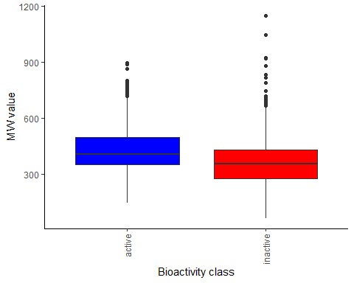

#mannwhitney test in MW  
  
mannwhitney("MW")

## Descriptor Statistics p alpha Interpretation  
## W MW 2020111 4.144511e-57 0.05 Different distribution (reject H0)

#boxplot of logP versus bioactivity class  
ggplot(data=Ach_data, aes(x=class, y=LogP,fill=class)) +  
 geom_boxplot() +  
 scale_fill_manual(values=c("blue", "red")) +  
 labs(x="Bioactivity class", y="LogP value") +  
 theme_classic() +  
 theme(axis.text.x = element_text(angle=90, vjust=0.5, hjust=1),   
 legend.position="none")

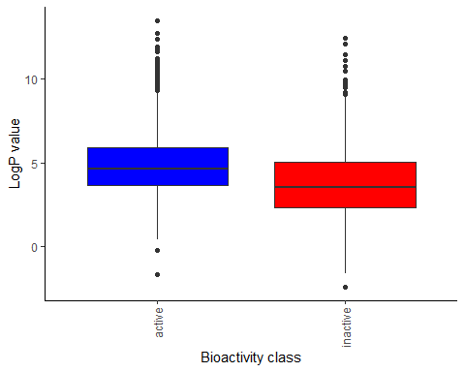

#mannwhitney test in LogP  
  
mannwhitney("LogP")

## Descriptor Statistics p alpha Interpretation  
## W LogP 2036990 4.637335e-61 0.05 Different distribution (reject H0)

#Now looking at NumH donors versus bioactivity class  
ggplot(data=Ach_data, aes(x=class, y=NumHDonors,fill=class)) +  
 geom_boxplot() +  
 scale_fill_manual(values=c("blue", "red")) +  
 labs(x="Bioactivity class", y="NumHDonors value") +  
 theme_classic() +  
 theme(axis.text.x = element_text(angle=90, vjust=0.5, hjust=1),   
 legend.position="none")

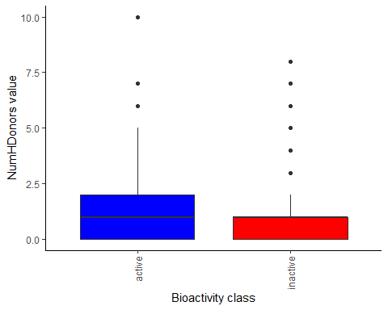

#mannwhitney test on NumHdonors   
  
mannwhitney("NumHDonors")

## Descriptor Statistics p alpha Interpretation  
## W NumHDonors 1717885 5.040191e-10 0.05 Different distribution (reject H0)

#NumHAcceptors  
ggplot(data=Ach_data, aes(x=class, y=NumHAcceptors,fill=class)) +  
 geom_boxplot() +  
 scale_fill_manual(values=c("blue", "red")) +  
 labs(x="Bioactivity class", y="NumHAcceptors value") +  
 theme_classic() +  
 theme(axis.text.x = element_text(angle=90, vjust=0.5, hjust=1),   
 legend.position="none")

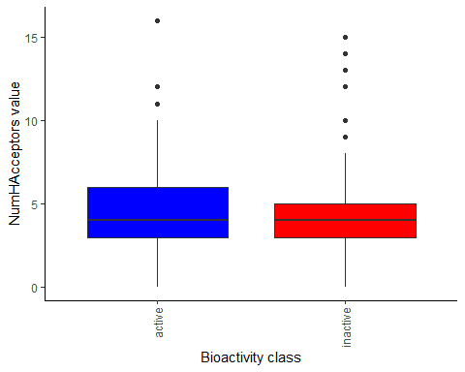

#mannwhitney test on NumHAcceptors  
mannwhitney("NumHAcceptors")

## Descriptor Statistics p alpha  
## W NumHAcceptors 1671318 8.850162e-06 0.05  
## Interpretation  
## W Different distribution (reject H0)