**DAILY ONLINE ACTIVITIES SUMMARY**

|  |  |  |  |  |  |  |  |  |
| --- | --- | --- | --- | --- | --- | --- | --- | --- |
| **Date:** | **02/07/2020** | | | | | **Name:** | **Felomina Jancy** | |
| **Sem & Sec** | **4th SEM 'A' Section** | | | | | **USN:** | **4AL18CS022** | |
| **Online Test Summary** | | | | | | | | |
| **Subject** | | - | | | | | | |
| **Max. Marks** | | **-** | | **Score** | | | **-** | |
| **Certification Course Summary** | | | | | | | | |
| **Course** | **Automation Anywhere** | | | | | | | |
| **Certificate Provider** | | | **ICT Academy** | | **Duration** | | | **3 hours** |
| **Coding Challenges** | | | | | | | | |
| **Problem Statement:** Given an array of **N** elements, the task is to minimize the maximum difference of adjacent elements by inserting at most **K** elements in the array. | | | | | | | | |
| **Status: completed** | | | | | | | | |
| **Uploaded the report in Github** | | | | | **yes** | | | |
| **If yes Repository name** | | | | | **https://github.com/Felomina75/lockdown-coding.git** | | | |
| **Uploaded the report in slack** | | | | | **yes** | | | |

Online Test Details: (Attach the snapshot and briefly write the report for the same)

Certification Course Details: (Attach the snapshot and briefly write the report for the same)

Coding Challenges Details: (Attach the snapshot and briefly write the report for the same)

ONLINE TEST DETAILS:

No test.

CERTIFICATION COURSE DETAILS:

* I was able to do module 9 of the "Automation Anywhere" course.
* The topics covered were :
* Unleash your intelligence bots
* Introduction to Bot insight
* Business analytics
* Operational analytics

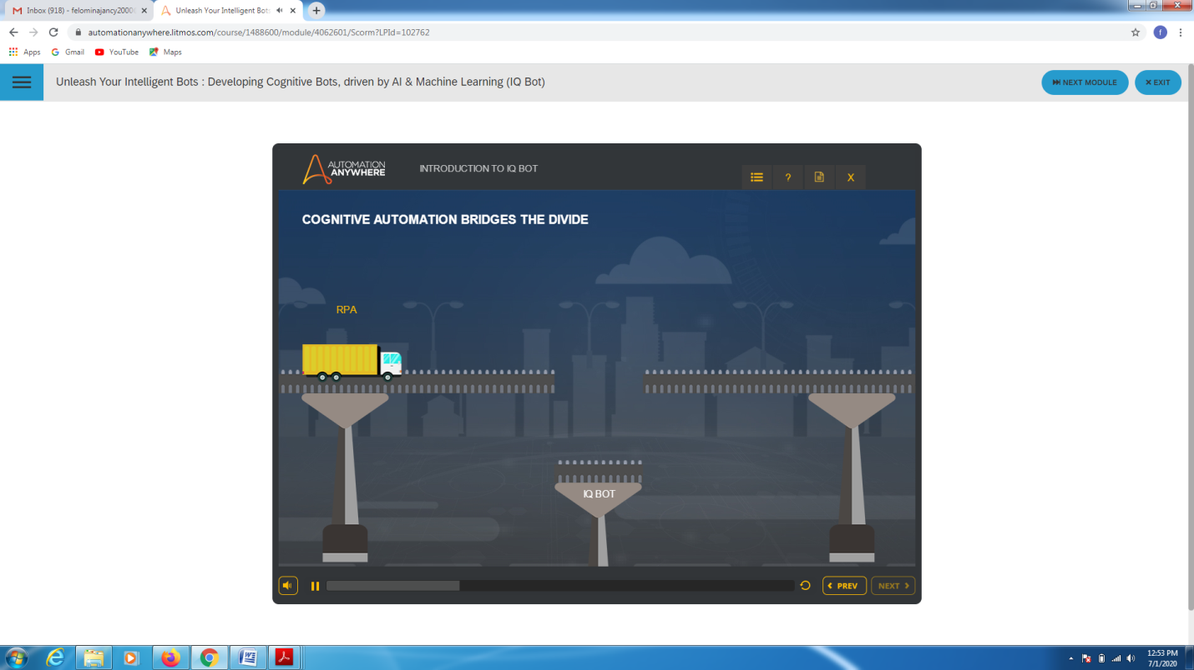

* Also completed two bot assessment.

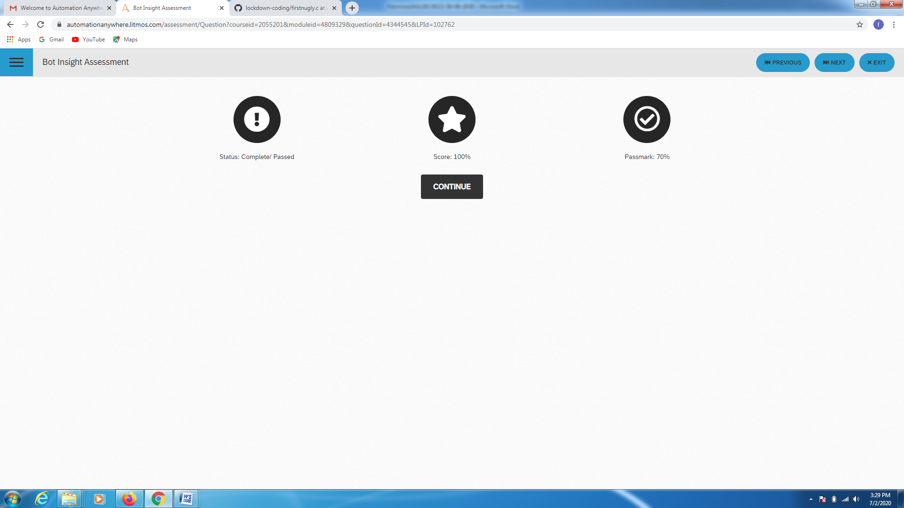 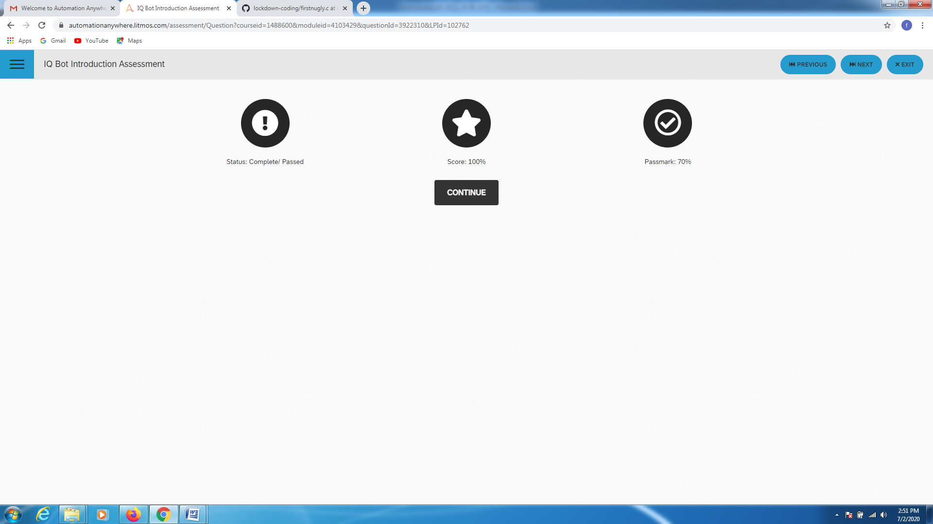

* Finally completed the course.

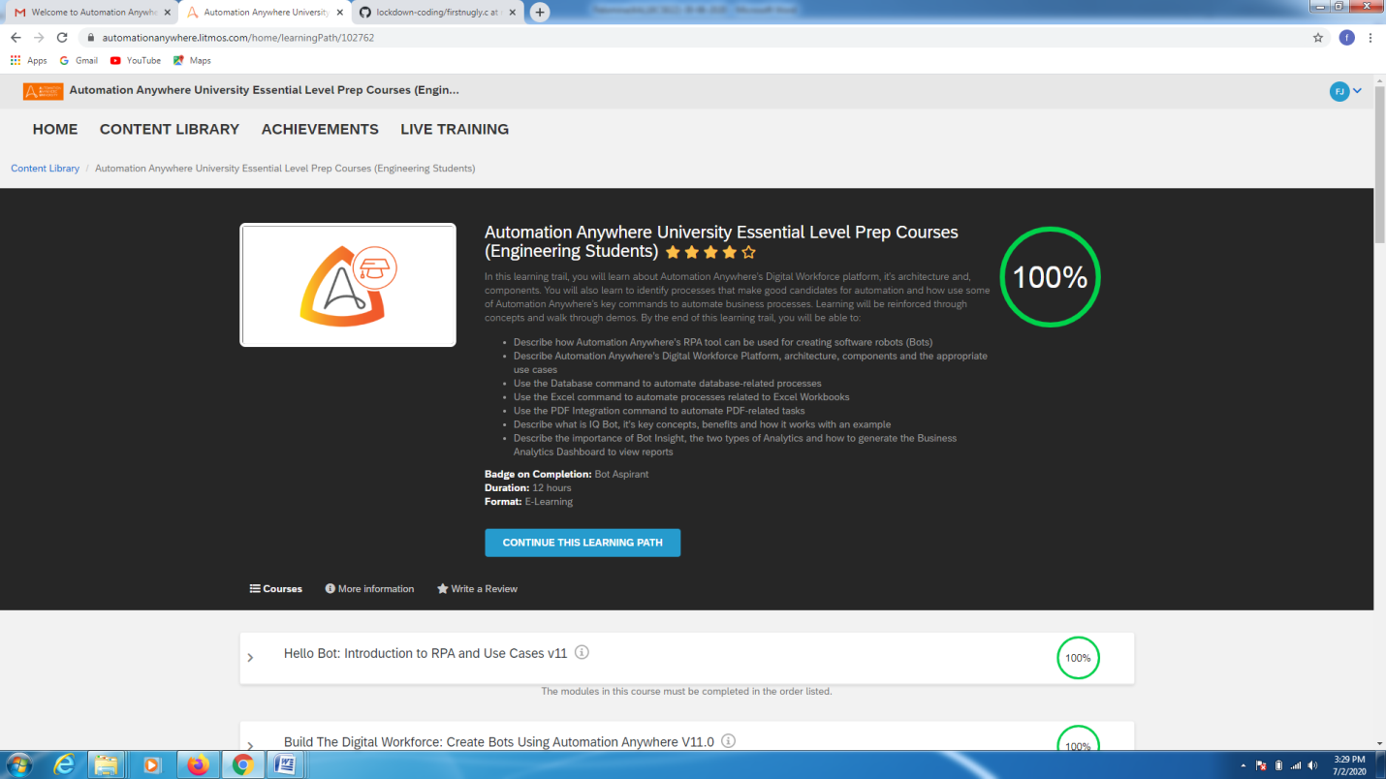 CODING CHALLENGES DETAILS:

Problem statement:

Given an array of **N** elements, the task is to minimize the maximum difference of adjacent elements by inserting at most **K** elements in the array.

Solution : Uploaded it in github

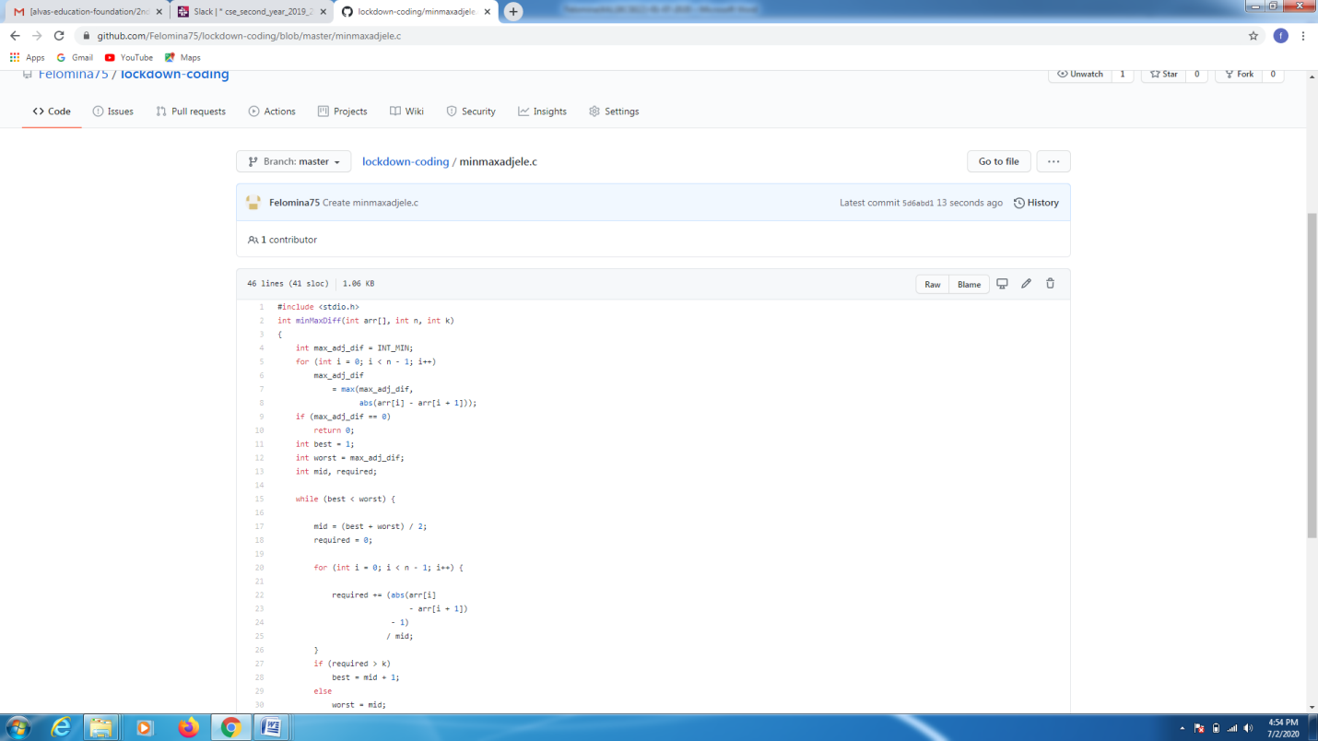

EXTRA ACTIVITIES:

I attended a webinar on "Constructor , destructor and Inheritance" by Ms. Shruthi Shetty J . At the end of the session there was a quiz . I was able to score 30/30 in the quiz.

