**DAILY ONLINE ACTIVITIES SUMMARY**

|  |  |  |  |  |  |  |  |  |
| --- | --- | --- | --- | --- | --- | --- | --- | --- |
| **Date:** | **01/06/2020** | | | | | **Name:** | **Felomina Jancy** | |
| **Sem & Sec** | **4th SEM 'A' Section** | | | | | **USN:** | **4AL18CS022** | |
| **Online Test Summary** | | | | | | | | |
| **Subject** | | Object Oriented Concepts | | | | | | |
| **Max. Marks** | | **30** | | **Score** | | | **26** | |
| **Certification Course Summary** | | | | | | | | |
| **Course** | **IoT Wireless and Cloud Computing Emerging Technologies** | | | | | | | |
| **Certificate Provider** | | | **Coursera** | | **Duration** | | | **3 hours** |
| **Coding Challenges** | | | | | | | | |
| **Problem Statement:** 1.Write a program to find if it's largest of two possible digit swaps.  2.Write a program to find Last Digit of a^b. | | | | | | | | |
| **Status: completed** | | | | | | | | |
| **Uploaded the report in Github** | | | | | **yes** | | | |
| **If yes Repository name** | | | | | **https://github.com/Felomina75/lockdown-coding.git** | | | |
| **Uploaded the report in slack** | | | | | **yes** | | | |

Online Test Details: (Attach the snapshot and briefly write the report for the same)

Certification Course Details: (Attach the snapshot and briefly write the report for the same)

Coding Challenges Details: (Attach the snapshot and briefly write the report for the same)

ONLINE TEST DETAILS:

The portion for online test was from module 2 and 3 which was about introduction to java, classes, inheritance and exception handling. There were 30 questions and the duration was 45 minutes. The questions were optimal and were easy. The score that I got in the test is 26/30.

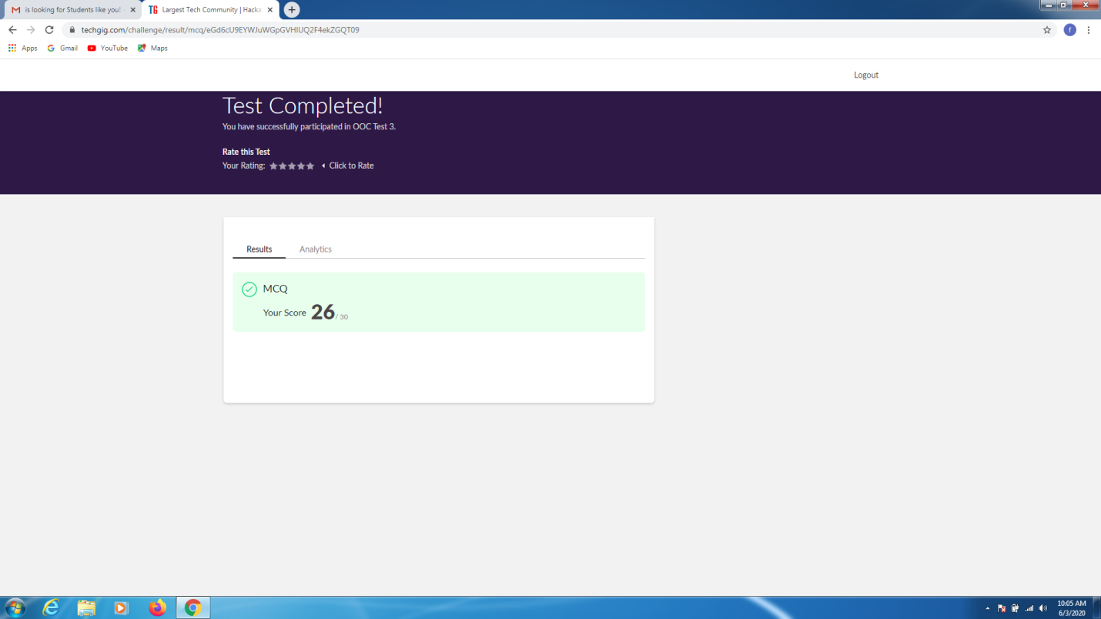

CERTIFICATION COURSE DETAILS:

* As continuation of the online course, I was able to do the week 4.
* The concepts covered were
* **Wi-Fi operations**
* **CSMA/CA**
* **IFS priority**
* **DCF**

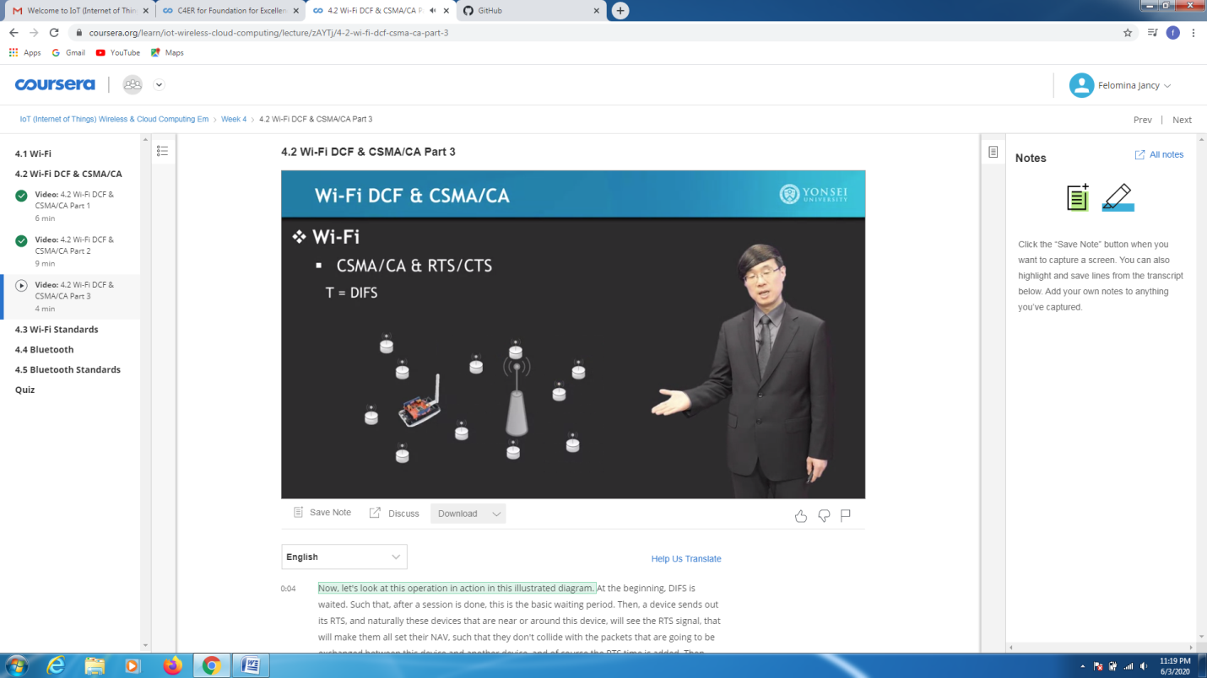CODING CHALLENGES DETAILS:

Problem statement 1:

Write a program to find if it's largest of two possible digit swaps.

Solution : Uploaded it in github

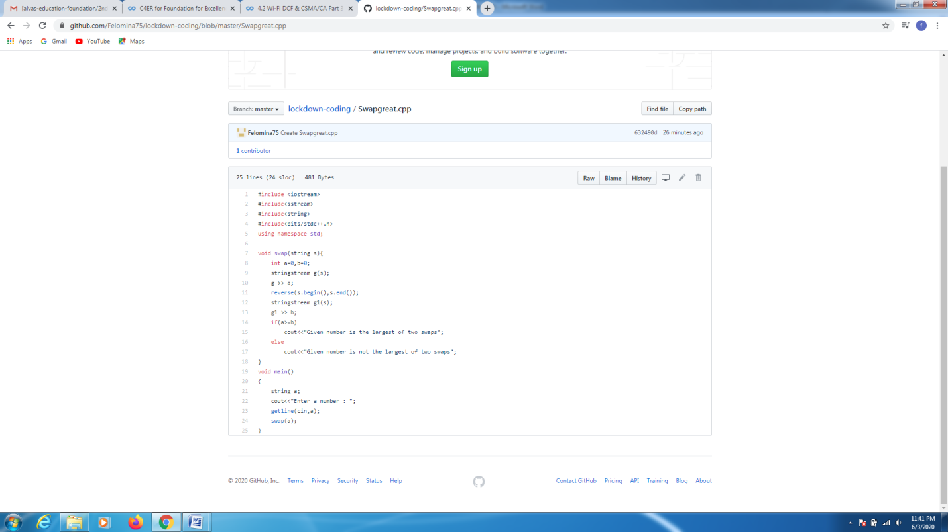

Problem statement 2:

Write a program to find Last Digit of a^b.

Solution : Uploaded it in github

