**DAILY ONLINE ACTIVITIES SUMMARY**

|  |  |  |  |  |  |  |  |  |
| --- | --- | --- | --- | --- | --- | --- | --- | --- |
| **Date:** | **03/07/2020** | | | | | **Name:** | **Felomina Jancy** | |
| **Sem & Sec** | **4th SEM 'A' Section** | | | | | **USN:** | **4AL18CS022** | |
| **Online Test Summary** | | | | | | | | |
| **Subject** | | - | | | | | | |
| **Max. Marks** | | **-** | | **Score** | | | **-** | |
| **Certification Course Summary** | | | | | | | | |
| **Course** | **Cloud and Virtualization concepts** | | | | | | | |
| **Certificate Provider** | | | **VMware** | | **Duration** | | | **3 hours** |
| **Coding Challenges** | | | | | | | | |
| **Problem Statement:** Write a C Program to Move all zeroes to end of array. | | | | | | | | |
| **Status: completed** | | | | | | | | |
| **Uploaded the report in Github** | | | | | **yes** | | | |
| **If yes Repository name** | | | | | **https://github.com/Felomina75/lockdown-coding.git** | | | |
| **Uploaded the report in slack** | | | | | **yes** | | | |

Online Test Details: (Attach the snapshot and briefly write the report for the same)

Certification Course Details: (Attach the snapshot and briefly write the report for the same)

Coding Challenges Details: (Attach the snapshot and briefly write the report for the same)

ONLINE TEST DETAILS:

No test.

CERTIFICATION COURSE DETAILS:

* I started with a new course "Cloud and Virtualization concepts" organized by VMware.
* It consists of 8 modules and I completed first and second modules.
* The concepts covered are:
* Access to an NDG NETLAB
* Cloud and virtualization concept
* Hardware and software
* before virtualization and after virtualization
* The hypervisor

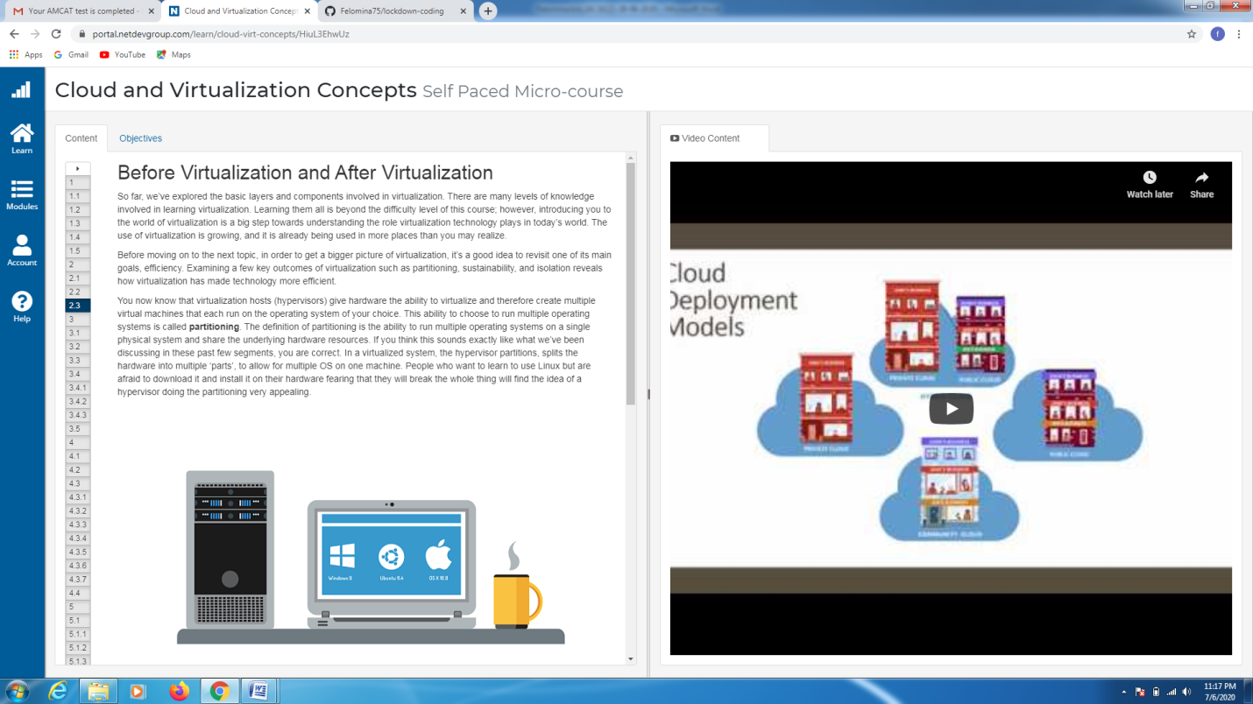CODING CHALLENGES DETAILS:

Problem statement:

Write a C Program to Move all zeroes to end of array.

Solution : Uploaded it in github

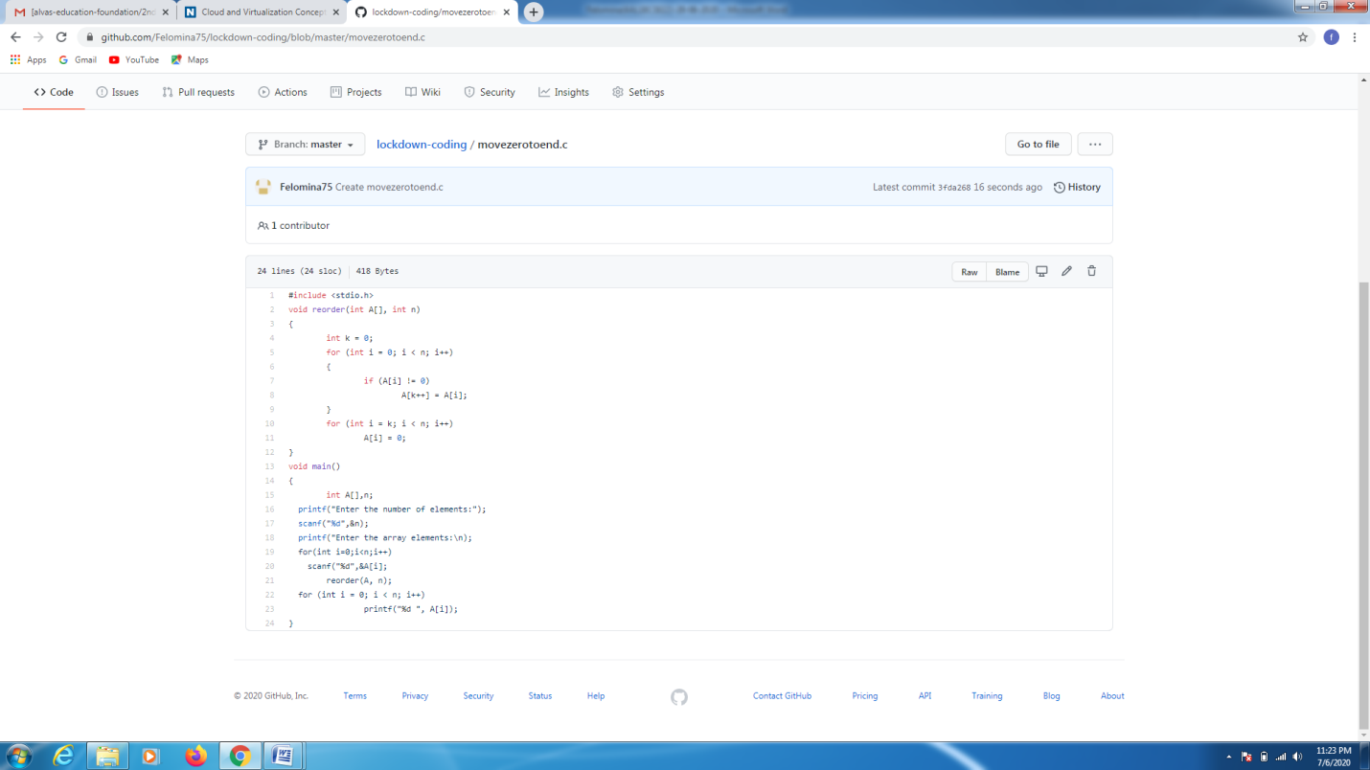

EXTRA ACTIVITIES:

I attended a webinar on "Functions , pointers , string and operations on functions" by Ms. Megha D. Hegde . It also considered an quiz . I was able to score 25/30 in the quiz.

