**DAILY ONLINE ACTIVITIES SUMMARY**

|  |  |  |  |  |  |  |  |  |
| --- | --- | --- | --- | --- | --- | --- | --- | --- |
| **Date:** | **04/06/2020** | | | | | **Name:** | **Felomina Jancy** | |
| **Sem & Sec** | **4th SEM 'A' Section** | | | | | **USN:** | **4AL18CS022** | |
| **Online Test Summary** | | | | | | | | |
| **Subject** | | Microcontroller and embedded system | | | | | | |
| **Max. Marks** | | **20** | | **Score** | | | **17** | |
| **Certification Course Summary** | | | | | | | | |
| **Course** | **Automation Anywhere** | | | | | | | |
| **Certificate Provider** | | | **ICT Academy** | | **Duration** | | | **3 hours** |
| **Coding Challenges** | | | | | | | | |
| **Problem Statement:** 1. Write a C++ program to find the missing number in array  2. Write a java program to read three integer values from the keyboard. | | | | | | | | |
| **Status: Completed** | | | | | | | | |
| **Uploaded the report in Github** | | | | | **yes** | | | |
| **If yes Repository name** | | | | | **https://github.com/Felomina75/lockdown-coding.git** | | | |
| **Uploaded the report in slack** | | | | | **yes** | | | |

Online Test Details: (Attach the snapshot and briefly write the report for the same)

Certification Course Details: (Attach the snapshot and briefly write the report for the same)

Coding Challenges Details: (Attach the snapshot and briefly write the report for the same)

ONLINE TEST DETAILS:

The portion for the online test was 3rd module which includes introduction to the embedded system , it's classification applications and purpose. The test was conducted in the afternoon from 2pm to 2:30pm. There were 20 questions and the time limit was 30 minutes . The questions were easy . The marks which I scored was 17/20.

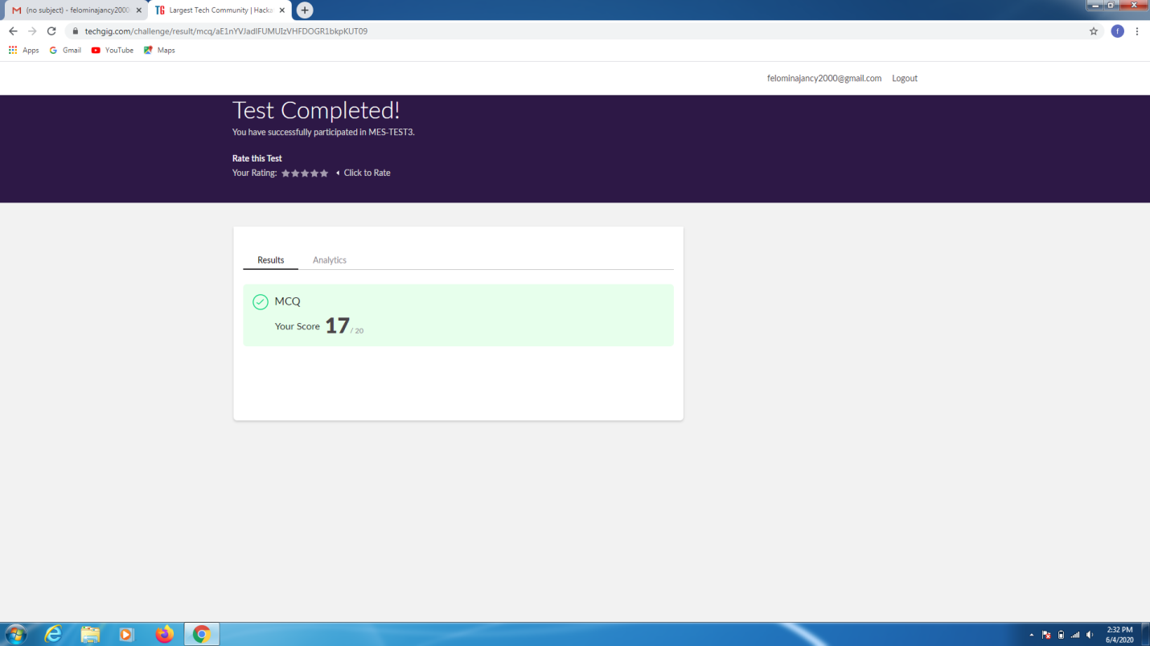CERTIFICATION COURSE DETAILS:

* As a continuation of "Automation Anywhere" course , I was able to take Bot assessment in which I scored the passing marks of 100 .

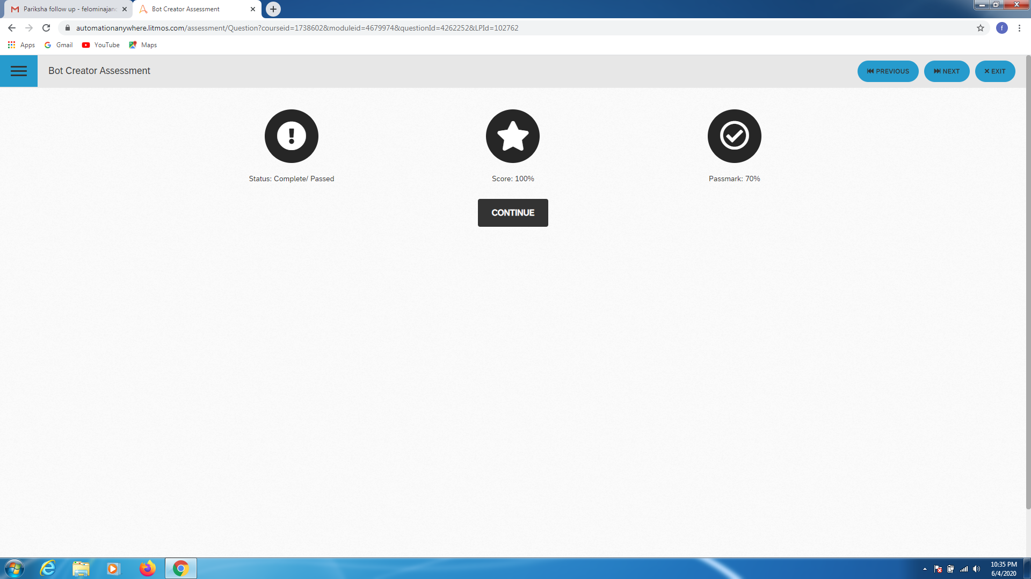

* Then continued the module, the topics covered were:
* Introduction to metabot
* Metabot designer
* Two types
* Assests
* Logic
* Demonstration
* Summary

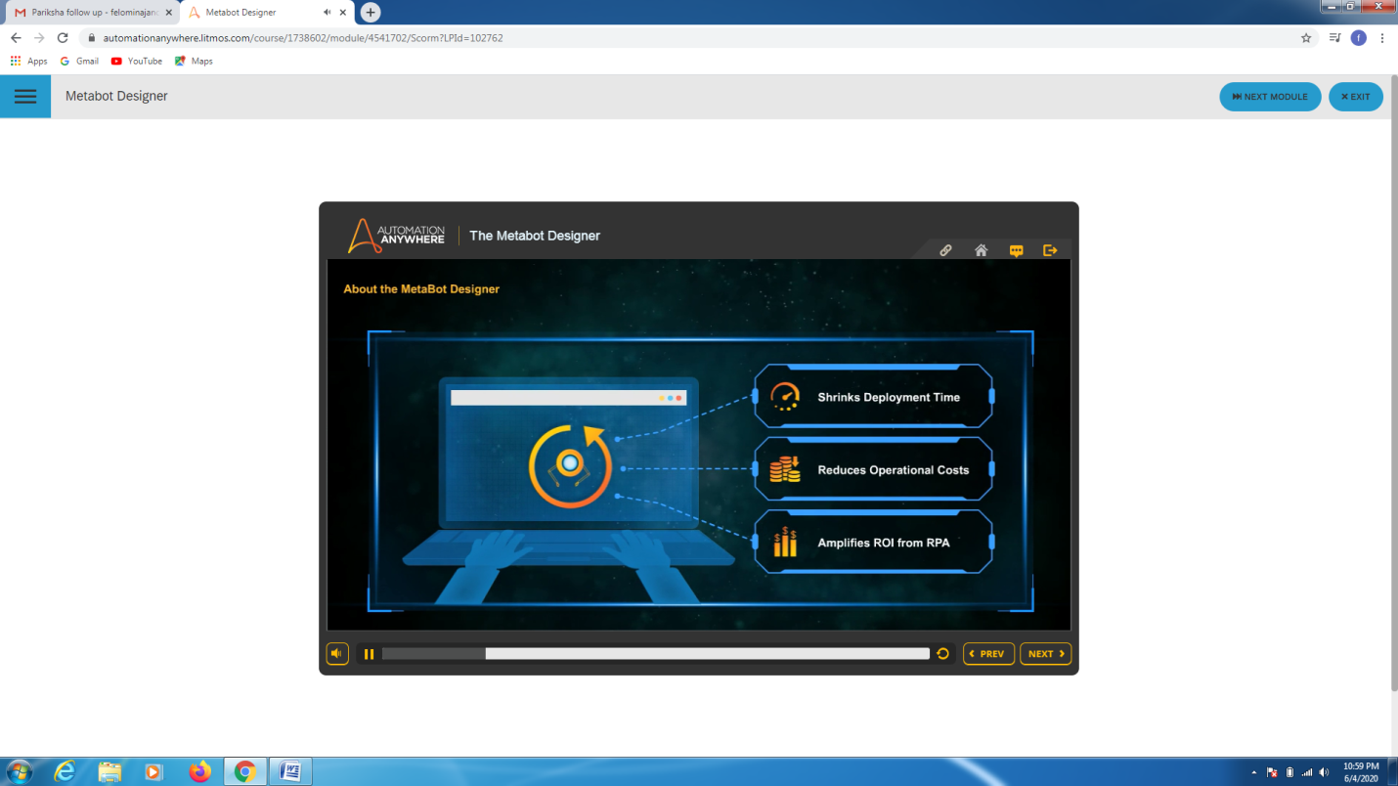

CODING CHALLENGES DETAILS:

Problem statement 1:

Write a C++ program to find the missing number in array

**Solution: Uploaded in github.**

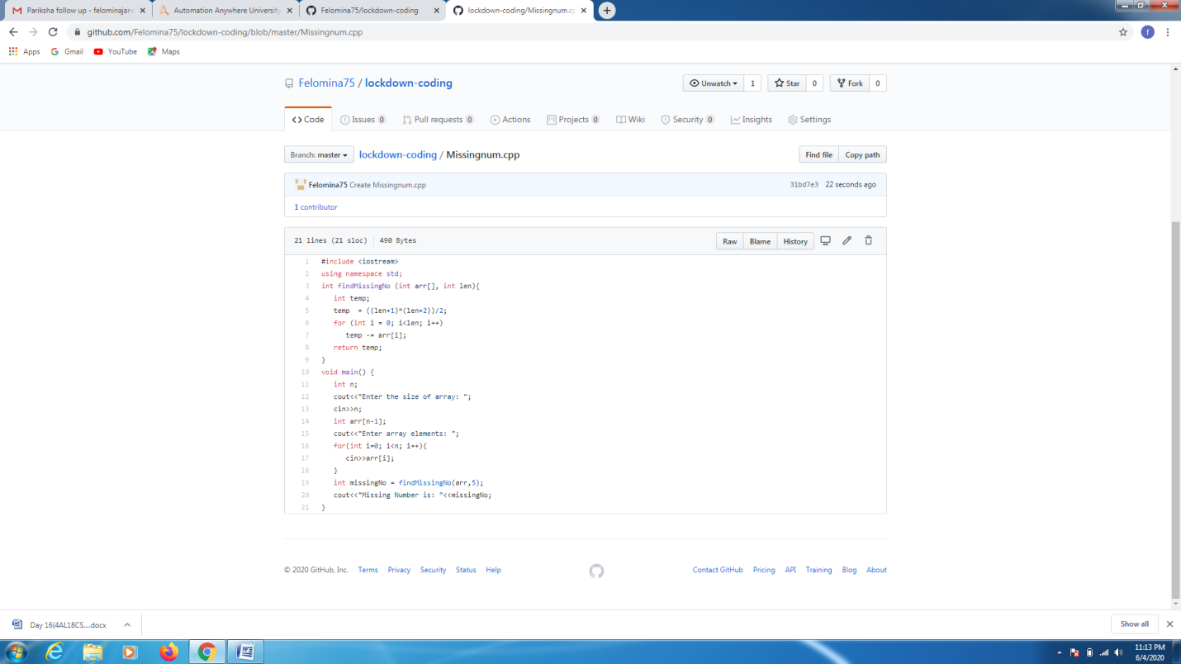

**Problem statement 2:**

Write a java program to read three integer values from the keyboard and find the sum of the values. Declare a variable "sum" of type int and store the result in it.

Solution : Uploaded in github.

