**DAILY ONLINE ACTIVITIES SUMMARY**

|  |  |  |  |  |  |  |  |  |
| --- | --- | --- | --- | --- | --- | --- | --- | --- |
| **Date:** | **05/06/2020** | | | | | **Name:** | **Felomina Jancy** | |
| **Sem & Sec** | **4th SEM 'A' Section** | | | | | **USN:** | **4AL18CS022** | |
| **Online Test Summary** | | | | | | | | |
| **Subject** | | - | | | | | | |
| **Max. Marks** | | **-** | | **Score** | | | **-** | |
| **Certification Course Summary** | | | | | | | | |
| **Course** | **1. IoT Wireless and Cloud Computing Emerging Technologies**  **2. STEPATHON** | | | | | | | |
| **Certificate Provider** | | | **1. Coursera**  **2. ICT Academy** | | **Duration** | | | **1. 2 hours**  **2. 1 hour** |
| **Coding Challenges** | | | | | | | | |
| **Problem Statement:** Write a Java Program to find the duplicate characters in a string. | | | | | | | | |
| **Status: completed** | | | | | | | | |
| **Uploaded the report in Github** | | | | | **yes** | | | |
| **If yes Repository name** | | | | | **https://github.com/Felomina75/lockdown-coding.git** | | | |
| **Uploaded the report in slack** | | | | | **yes** | | | |

Online Test Details: (Attach the snapshot and briefly write the report for the same)

Certification Course Details: (Attach the snapshot and briefly write the report for the same)

Coding Challenges Details: (Attach the snapshot and briefly write the report for the same)

ONLINE TEST DETAILS:

No test.

CERTIFICATION COURSE DETAILS:

* As continuation of the online course, I was able to do the week 4.
* The concepts covered are :
* **Wi-Fi Standards**
* **IEEE 802.11**
* **IEEE 802.11e EDCA**
* **IEEE 802.11 ad**
* **IEEE 802.11ah**

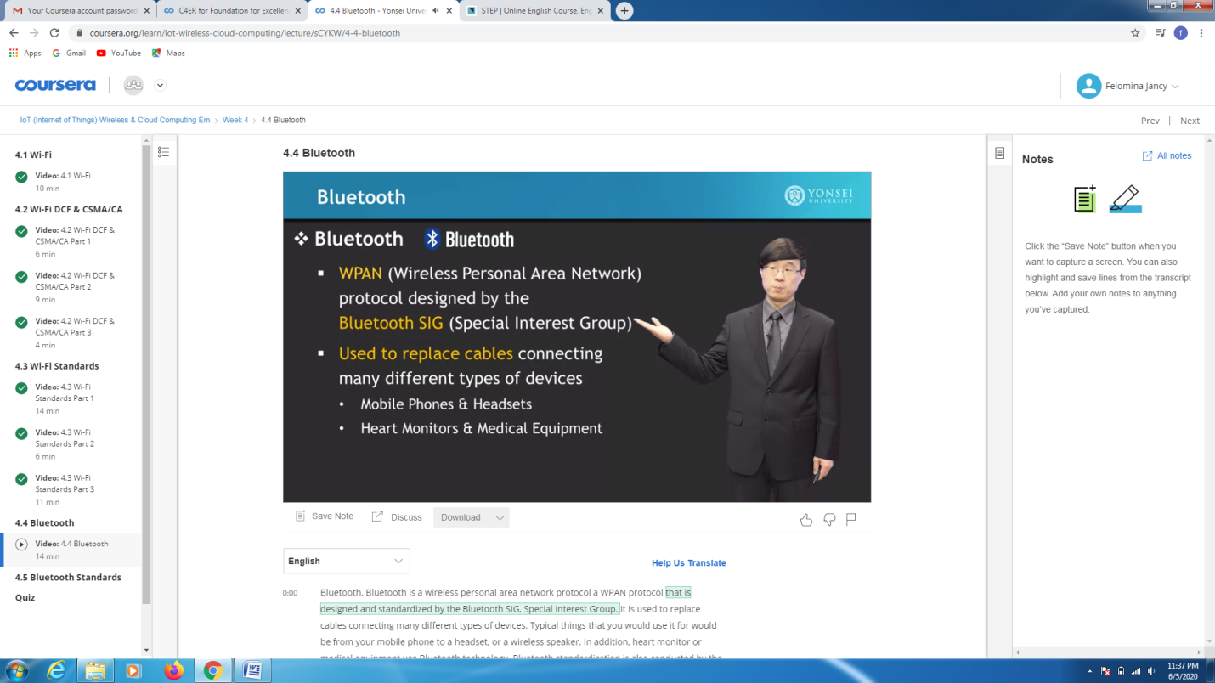

* Then I was able to do 5 activities of "STEPATHON" of week 2.

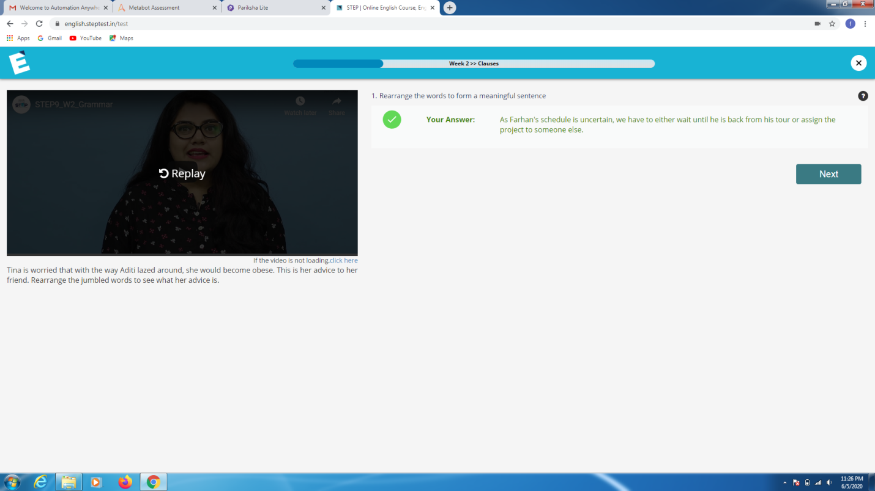

CODING CHALLENGES DETAILS:

Problem statement 1:

Write a Java Program to find the duplicate characters in a string.

Solution : Uploaded it in github

