**DAILY ONLINE ACTIVITIES SUMMARY**

|  |  |  |  |  |  |  |  |  |
| --- | --- | --- | --- | --- | --- | --- | --- | --- |
| **Date:** | **06/06/2020** | | | | | **Name:** | **Felomina Jancy** | |
| **Sem & Sec** | **4th SEM 'A' Section** | | | | | **USN:** | **4AL18CS022** | |
| **Online Test Summary** | | | | | | | | |
| **Subject** | | Data Communication | | | | | | |
| **Max. Marks** | | **30** | | **Score** | | | **30** | |
| **Certification Course Summary** | | | | | | | | |
| **Course** | **1. IoT Wireless and Cloud Computing Emerging Technologies**  **2. Pariksha(aptitude training)** | | | | | | | |
| **Certificate Provider** | | | **1. Coursera**  **2. Foundation for excellence** | | **Duration** | | | **1.2 hours**  **2. 1 hour** |
| **Coding Challenges** | | | | | | | | |
| **Problem Statement:** 1. Write a program to rotate an array by N positions.**2.** Write a java program to find second largest number. | | | | | | | | |
| **Status: completed** | | | | | | | | |
| **Uploaded the report in Github** | | | | | **yes** | | | |
| **If yes Repository name** | | | | | **https://github.com/Felomina75/lockdown-coding.git** | | | |
| **Uploaded the report in slack** | | | | | **yes** | | | |

Online Test Details: (Attach the snapshot and briefly write the report for the same)

Certification Course Details: (Attach the snapshot and briefly write the report for the same)

Coding Challenges Details: (Attach the snapshot and briefly write the report for the same)

ONLINE TEST DETAILS:

The portion for the online test was 5th module which was about wired LAN Ethernet, wireless LAN and other wireless networks. There were 30 questions and the time limit was 454 minutes . The questions were easy . The marks which I scored was 30/30.

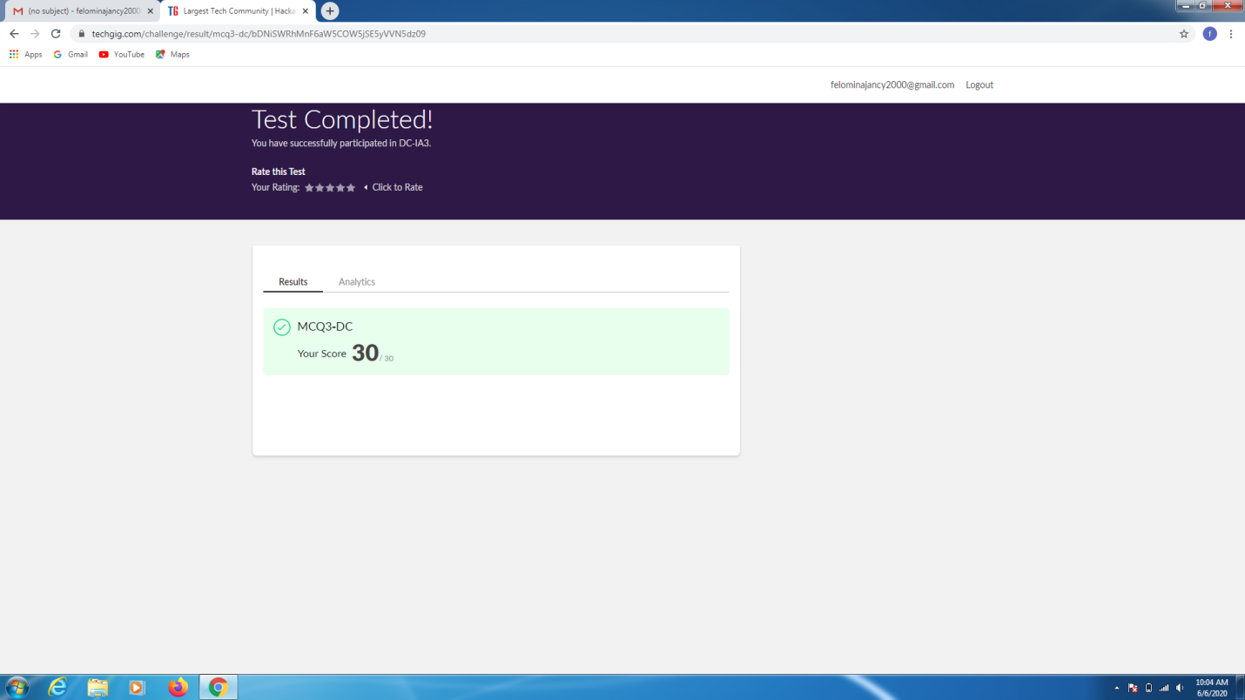

CERTIFICATION COURSE DETAILS:

* **As continuation of the online course, I was able to do the week 4 of the IoT Wireless and Cloud Computing Emerging Technologies .**
* **The topics covered are :**
* **Bluetooth**
* **Bluetooth standards**
* **Bluetooth features evolution**

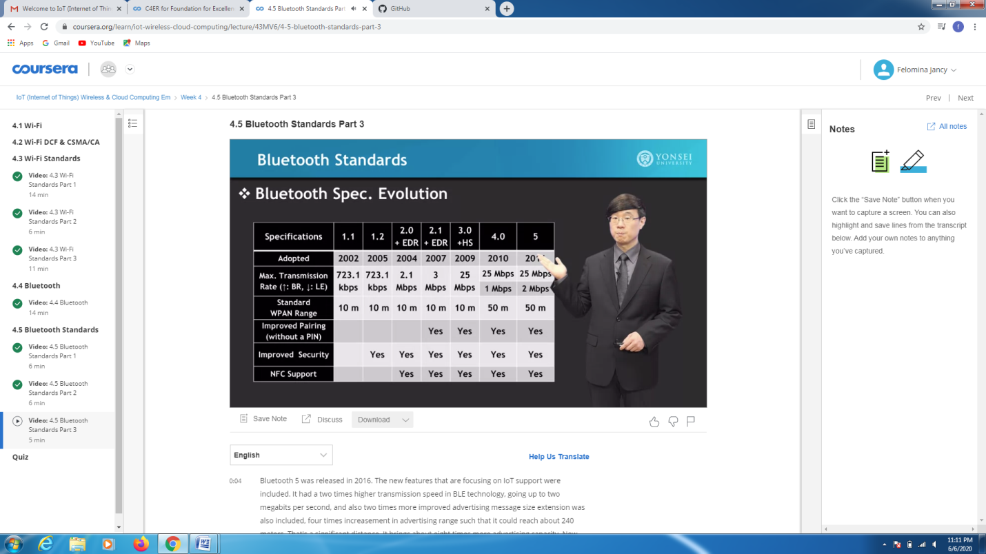

* **Foundation for Excellence provided me a platform to improve my aptitude skills . As a part of the program I completed a post assessment test of 1 hour.**

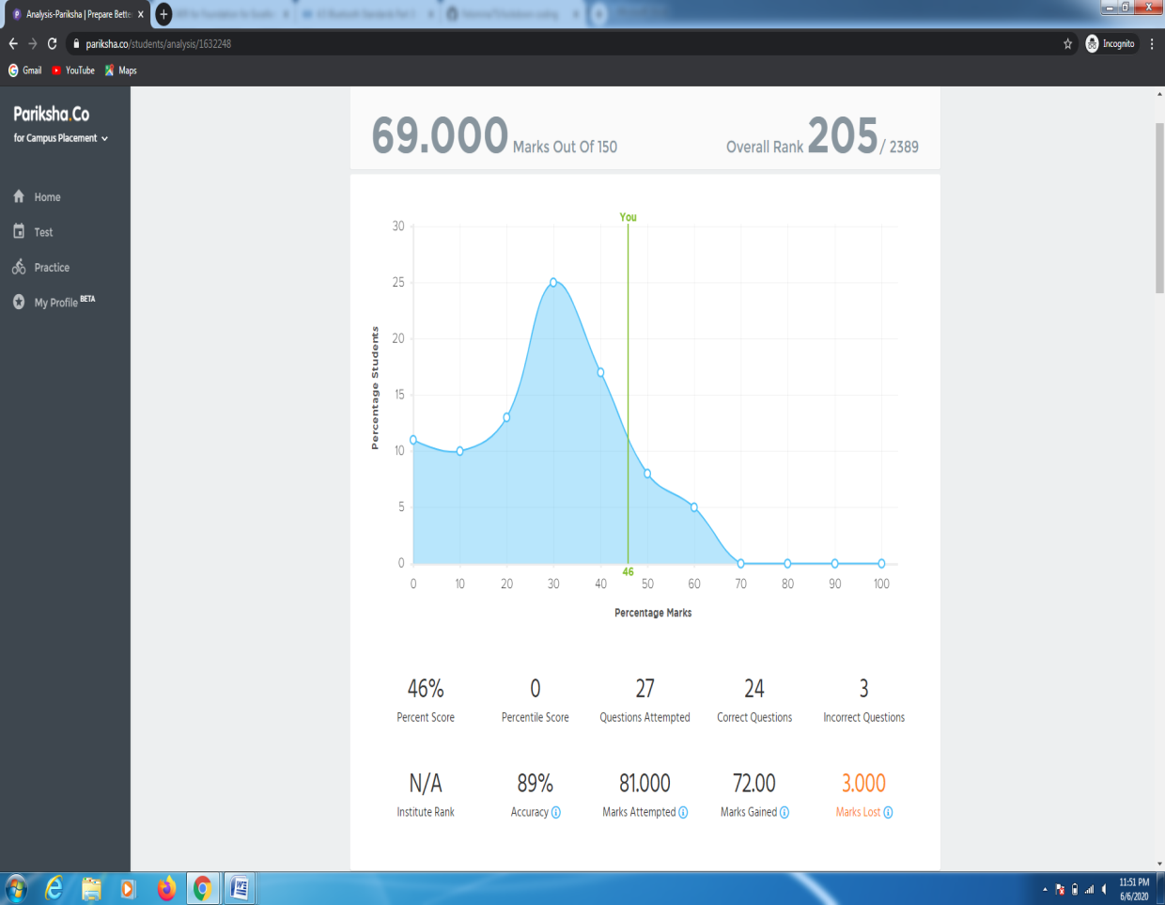

CODING CHALLENGES DETAILS:

Problem statement 1:

Write a program to rotate an array by N positions.

Solution : Uploaded it in github

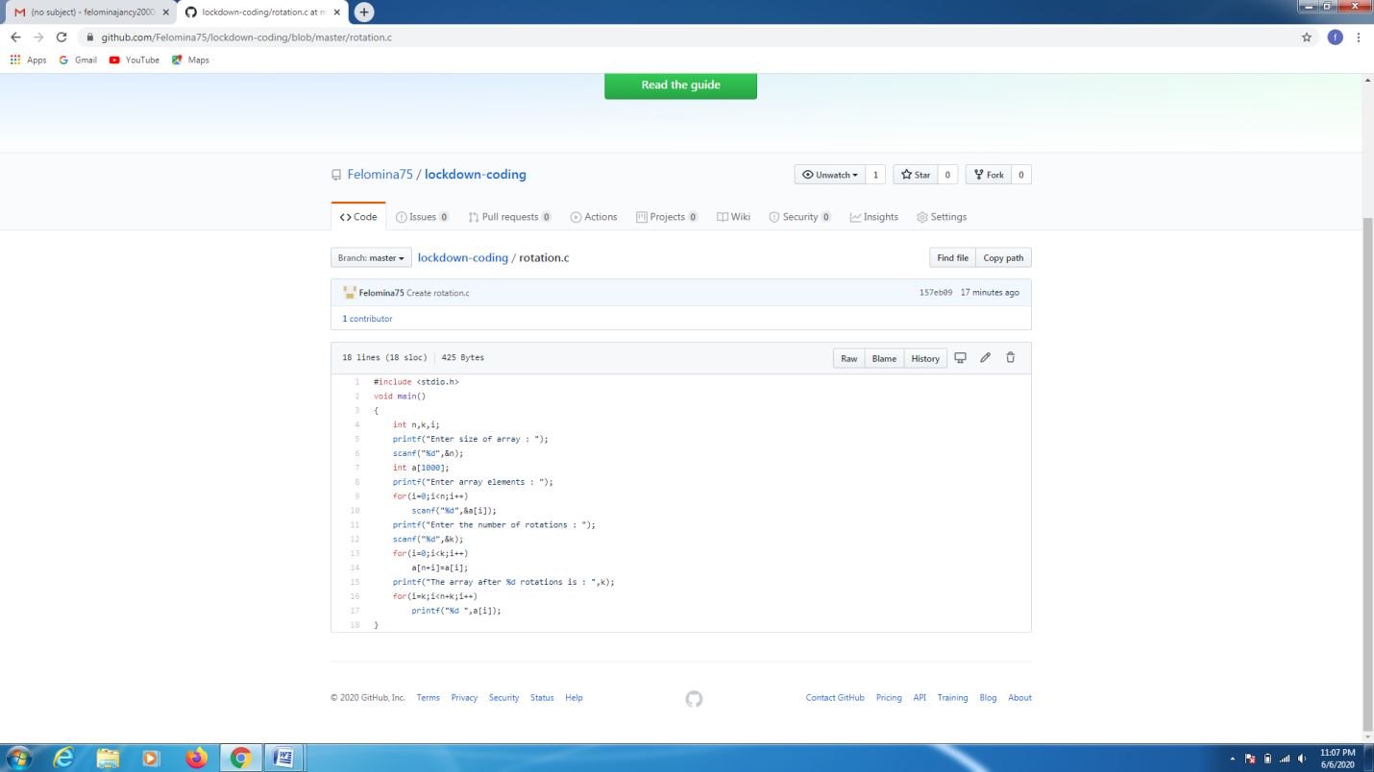

Problem statement 2:

Write a java program to find second largest number.

Solution : Uploaded it in github

