**DAILY ONLINE ACTIVITIES SUMMARY**

|  |  |  |  |  |  |  |  |  |
| --- | --- | --- | --- | --- | --- | --- | --- | --- |
| **Date:** | **06/07/2020** | | | | | **Name:** | **Felomina Jancy** | |
| **Sem & Sec** | **4th SEM 'A' Section** | | | | | **USN:** | **4AL18CS022** | |
| **Online Test Summary** | | | | | | | | |
| **Subject** | | **Complex analysis, probability and statistical methods** | | | | | | |
| **Max. Marks** | | **30** | | **Score** | | | **Not yet declared** | |
| **Certification Course Summary** | | | | | | | | |
| **Course** | **Cloud and Virtualization concepts** | | | | | | | |
| **Certificate Provider** | | | **VMware** | | **Duration** | | | **3 hours** |
| **Coding Challenges** | | | | | | | | |
| **Problem Statement:** Write a Java program to find the Nth natural number with exactly two bits set. | | | | | | | | |
| **Status: completed** | | | | | | | | |
| **Uploaded the report in Github** | | | | | **yes** | | | |
| **If yes Repository name** | | | | | **https://github.com/Felomina75/lockdown-coding.git** | | | |
| **Uploaded the report in slack** | | | | | **yes** | | | |

Online Test Details: (Attach the snapshot and briefly write the report for the same)

Certification Course Details: (Attach the snapshot and briefly write the report for the same)

Coding Challenges Details: (Attach the snapshot and briefly write the report for the same)

ONLINE TEST DETAILS:

**Complex analysis, probability and statistical methods:** The portion for the test was from module 1 which was about Calculus of complex function and construction of analytic function . There were 3 questions which was for 10 mark each and it was descriptive test . We had to write and scan and upload in the Google classroom. Total duration was 45 minutes. The questions were optimal and were easy.



CERTIFICATION COURSE DETAILS:

* As a continuation of the course "Cloud and Virtualization concepts" organized by VMware, I was able to complete seventh and eighth modules.
* Thus , I was able to complete the course and earn a badge.
* The concepts covered are:
* VMware virtualization solutions
* vMotion
* Storage vMotion
* vSphere high availability
* vSphere DRS
* vSphere storage DRS
* vSphere FT
* vSphere replication
* VMware VSANE
* VMware NSX
* VMware cloud foundation
* vCloud automation center
* Cloud health

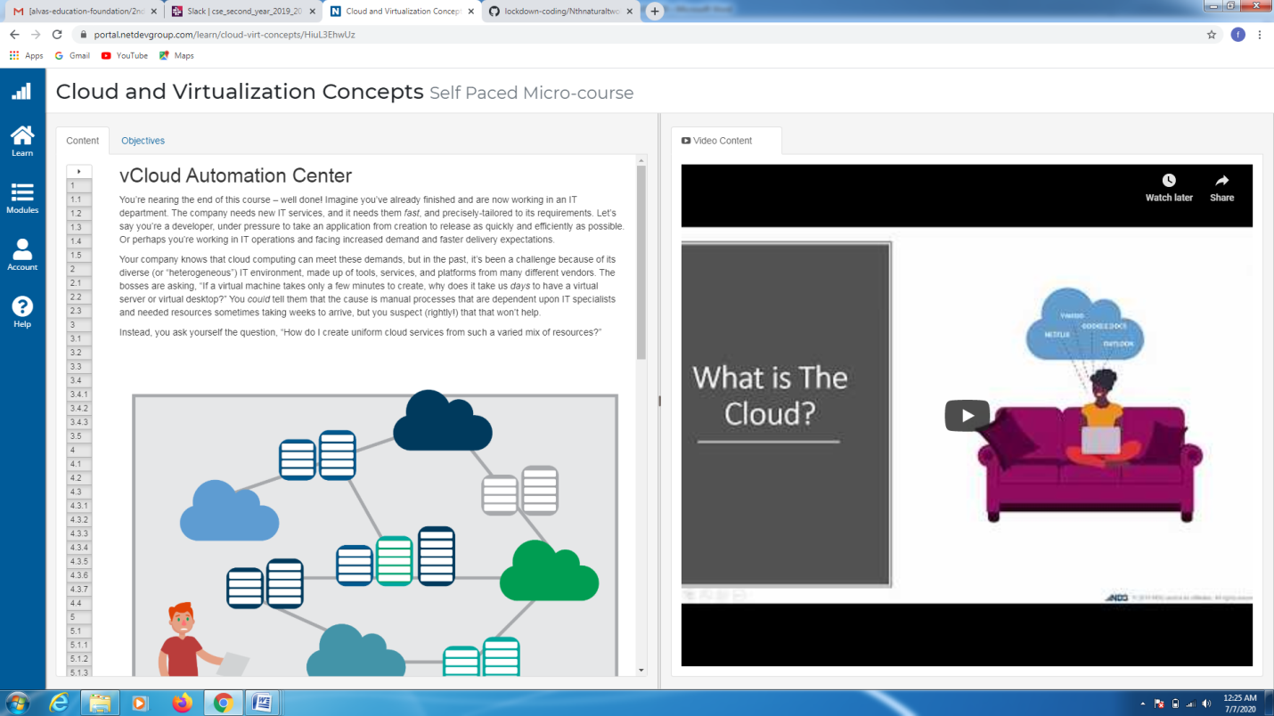

CODING CHALLENGES DETAILS:

Problem statement:

Write a Java program to find the Nth natural number with exactly two bits set.

Solution : Uploaded it in github

