**DAILY ONLINE ACTIVITIES SUMMARY**

|  |  |  |  |  |  |  |  |  |
| --- | --- | --- | --- | --- | --- | --- | --- | --- |
| **Date:** | **07/06/2020** | | | | | **Name:** | **Felomina Jancy** | |
| **Sem & Sec** | **4th SEM 'A' Section** | | | | | **USN:** | **4AL18CS022** | |
| **Online Test Summary** | | | | | | | | |
| **Subject** | | - | | | | | | |
| **Max. Marks** | | **-** | | **Score** | | | **-** | |
| **Certification Course Summary** | | | | | | | | |
| **Course** | **Automation Anywhere** | | | | | | | |
| **Certificate Provider** | | | **Coursera** | | **Duration** | | | **3 hours** |
| **Coding Challenges** | | | | | | | | |
| **Problem Statement:** Write a C++ Program to swap two numbers using friend as a bridge concept. . | | | | | | | | |
| **Status: completed** | | | | | | | | |
| **Uploaded the report in Github** | | | | | **yes** | | | |
| **If yes Repository name** | | | | | **https://github.com/Felomina75/lockdown-coding.git** | | | |
| **Uploaded the report in slack** | | | | | **yes** | | | |

Online Test Details: (Attach the snapshot and briefly write the report for the same)

Certification Course Details: (Attach the snapshot and briefly write the report for the same)

Coding Challenges Details: (Attach the snapshot and briefly write the report for the same)

ONLINE TEST DETAILS:

No test as it was Sunday.

CERTIFICATION COURSE DETAILS:

* I was able to do metabot assessment and bot insight assessment of the "Automation Anywhere" course.
* The assessment had 15 questions and 70% was passing mark.

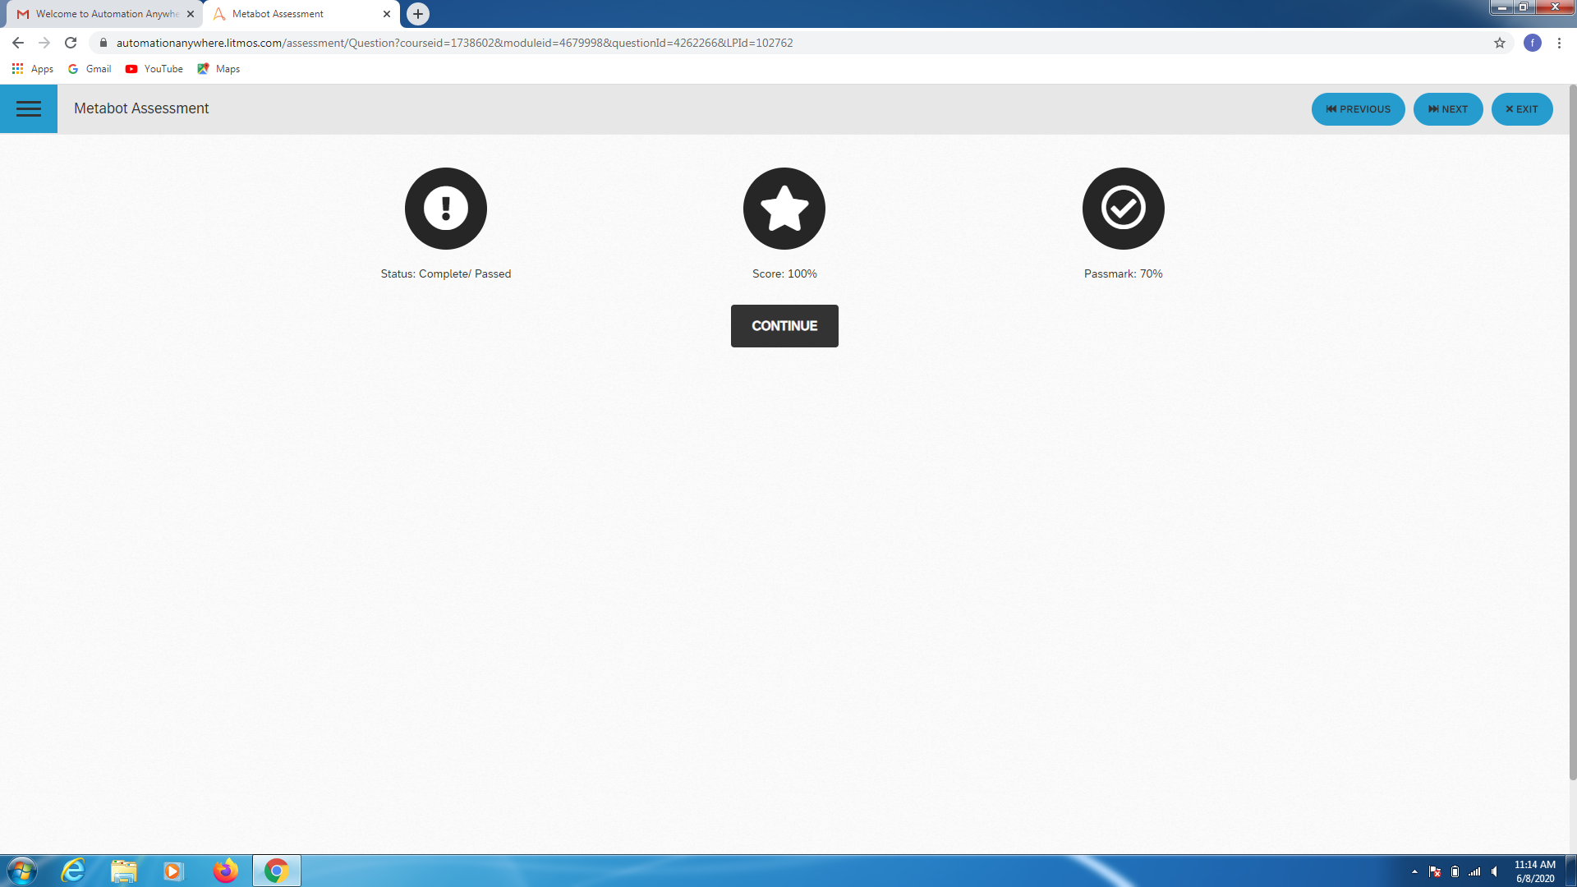

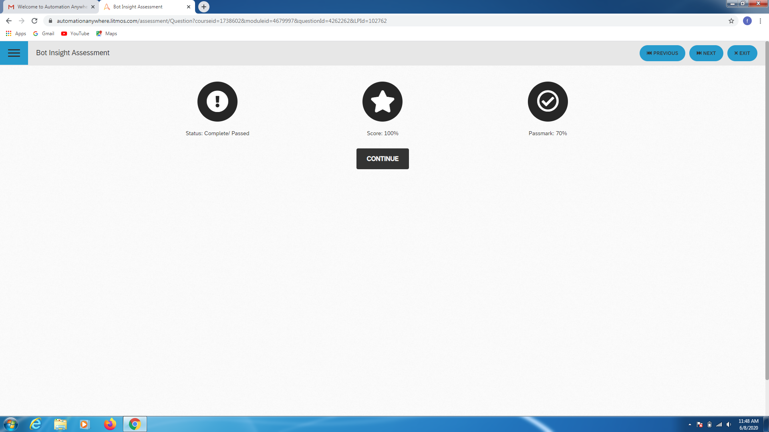

* Then I continued the module and completed it.

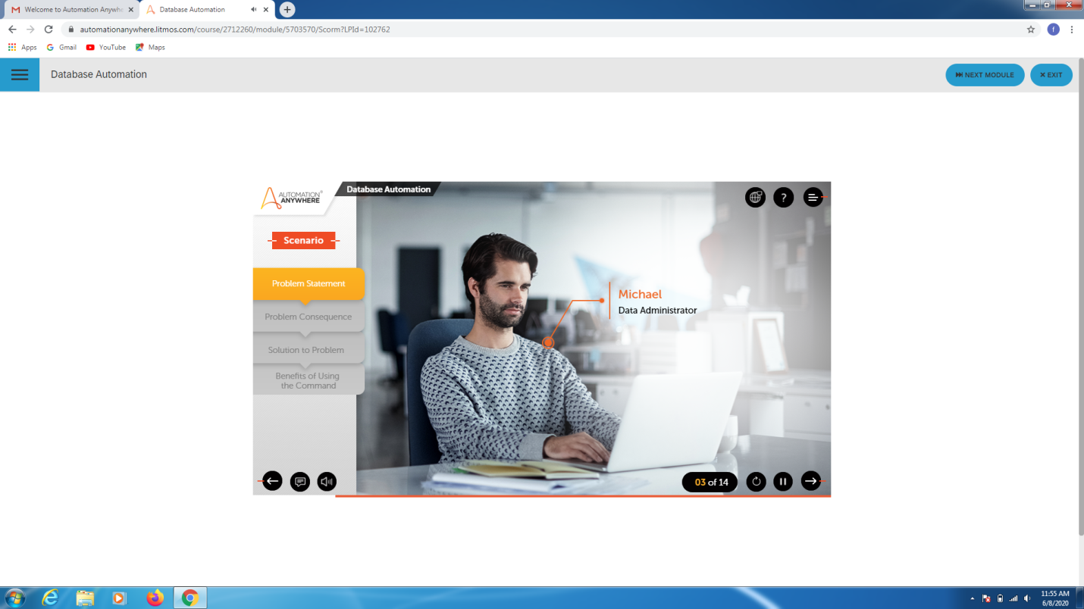CODING CHALLENGES DETAILS:

Problem statement:

Write a C++ Program to swap two numbers using friend as a bridge concept. .

Solution : Uploaded it in github

