**DAILY ONLINE ACTIVITIES SUMMARY**

|  |  |  |  |  |  |  |  |  |
| --- | --- | --- | --- | --- | --- | --- | --- | --- |
| **Date:** | **08/06/2020** | | | | | **Name:** | **Felomina Jancy** | |
| **Sem & Sec** | **4th SEM 'A' Section** | | | | | **USN:** | **4AL18CS022** | |
| **Online Test Summary** | | | | | | | | |
| **Subject** | | **Complex analysis, probability and statistical methods** | | | | | | |
| **Max. Marks** | | **30** | | **Score** | | | **22** | |
| **Certification Course Summary** | | | | | | | | |
| **Course** | **Automation Anywhere** | | | | | | | |
| **Certificate Provider** | | | **Coursera** | | **Duration** | | | **3 hours** |
| **Coding Challenges** | | | | | | | | |
| **Problem Statement:** Write a program to generate all set the partitions of n numbers starting from 1 and so on. | | | | | | | | |
| **Status: completed** | | | | | | | | |
| **Uploaded the report in Github** | | | | | **yes** | | | |
| **If yes Repository name** | | | | | **https://github.com/Felomina75/lockdown-coding.git** | | | |
| **Uploaded the report in slack** | | | | | **yes** | | | |

Online Test Details: (Attach the snapshot and briefly write the report for the same)

Certification Course Details: (Attach the snapshot and briefly write the report for the same)

Coding Challenges Details: (Attach the snapshot and briefly write the report for the same)

ONLINE TEST DETAILS:

**Complex analysis, probability and statistical methods:** The portion for the online test was from module 2 which was about confirmal transformations, bilinear transformation and Cauchy's integral formula . There were 15 questions which was for 2 mark each . Total duration was 40 minutes. The questions were optimal and were easy. The score that I got in the test is 22/30.

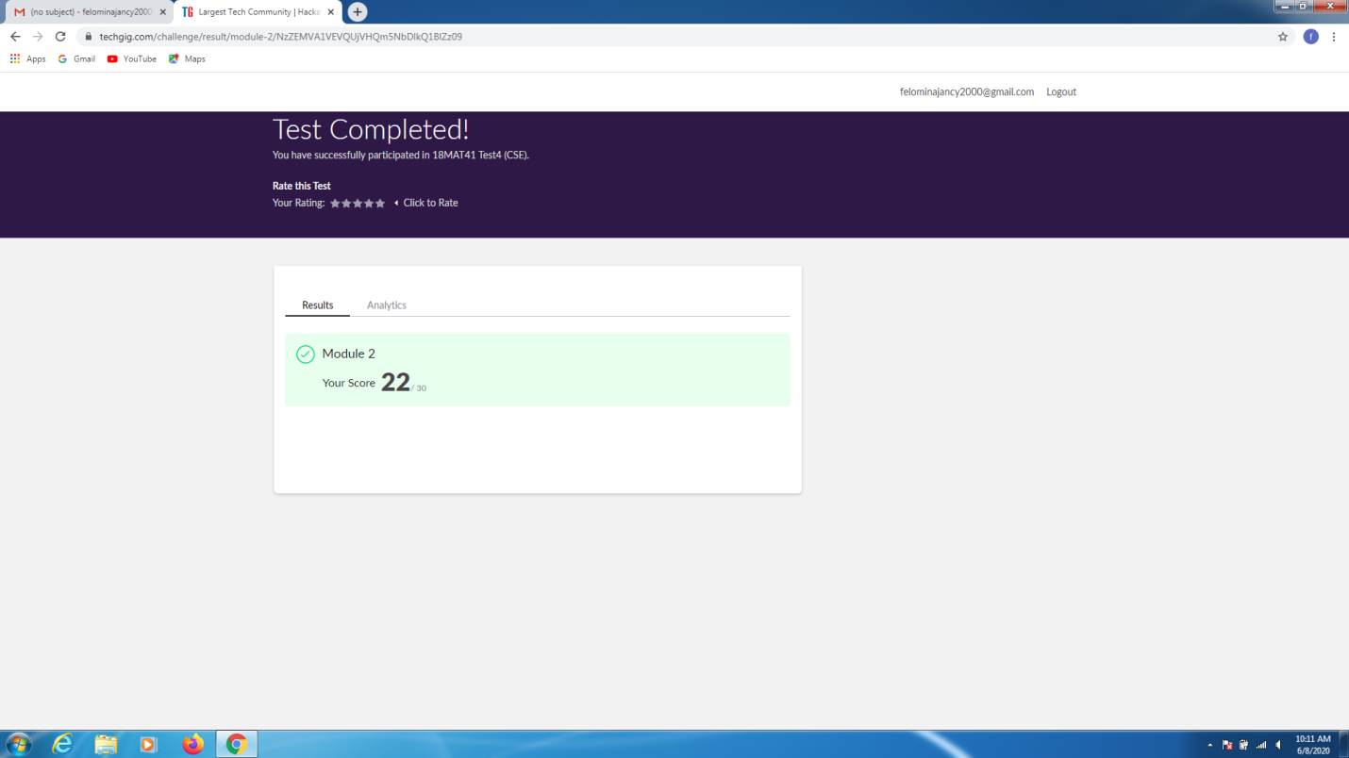CERTIFICATION COURSE DETAILS:

* I was able to do module 3 and module 4 of the "Automation Anywhere" course.
* The topics covered were of PDF automation and the Excel Automation.

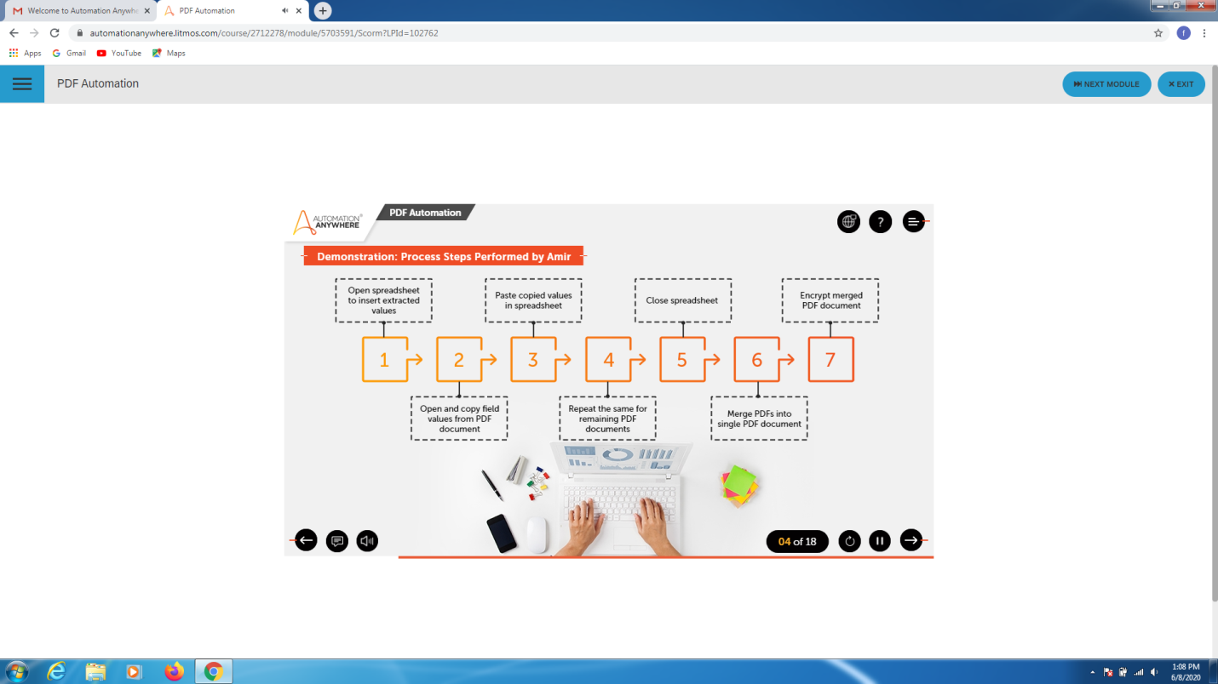 

CODING CHALLENGES DETAILS:

Problem statement:

Write a program to generate all set the partitions of n numbers starting from 1 and so on.

Solution : Uploaded it in github

