**DAILY ONLINE ACTIVITIES SUMMARY**

|  |  |  |  |  |  |  |  |  |
| --- | --- | --- | --- | --- | --- | --- | --- | --- |
| **Date:** | **08/07/2020** | | | | | **Name:** | **Felomina Jancy** | |
| **Sem & Sec** | **4th SEM 'A' Section** | | | | | **USN:** | **4AL18CS022** | |
| **Descriptive Test Summary** | | | | | | | | |
| **Subject** | | Design and Analysis of algorithms | | | | | | |
| **Max. Marks** | | **-** | | **Score** | | | **-** | |
| **Certification Course Summary** | | | | | | | | |
| **Course** | **Become Job Ready for Developer Trailmix1** | | | | | | | |
| **Certificate Provider** | | | **Salesforce** | | **Duration** | | | **3 hours** |
| **Coding Challenges** | | | | | | | | |
| **Problem Statement:** Write a java program to find whether the given strings are anagram. | | | | | | | | |
| **Status: completed** | | | | | | | | |
| **Uploaded the report in Github** | | | | | **yes** | | | |
| **If yes Repository name** | | | | | **https://github.com/Felomina75/lockdown-coding.git** | | | |
| **Uploaded the report in slack** | | | | | **yes** | | | |

Online Test Details: (Attach the snapshot and briefly write the report for the same)

Certification Course Details: (Attach the snapshot and briefly write the report for the same)

Coding Challenges Details: (Attach the snapshot and briefly write the report for the same)

DESCRIPTIVE TEST DETAILS:

The test was from module 1. There were 3 questions and the duration was 45 minutes. The questions were difficult . We had to scan and upload the answers in Google classroom.



CERTIFICATION COURSE DETAILS:

* I started with a new course " **Become Job Ready for Developer Trailmix1" organized by Salesforce.**
* **I was able to complete the module 1 which was of Trailhead Basics.**

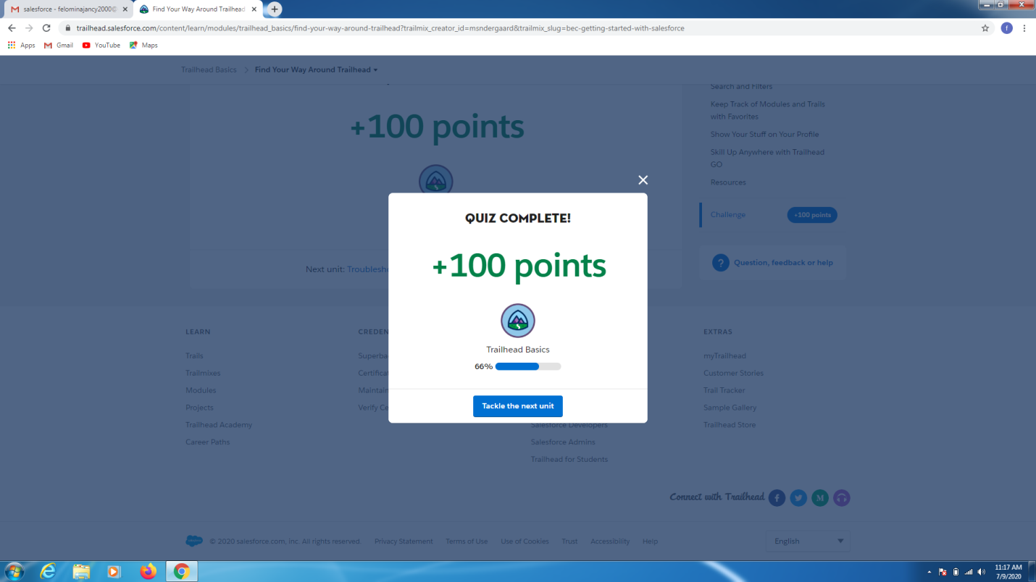CODING CHALLENGES DETAILS:

Problem statement:

Write a java program to find whether the given strings are anagram.

Solution : Uploaded it in github

