**DAILY ONLINE ACTIVITIES SUMMARY**

|  |  |  |  |  |  |  |  |  |
| --- | --- | --- | --- | --- | --- | --- | --- | --- |
| **Date:** | **01/06/2020** | | | | | **Name:** | **Felomina Jancy** | |
| **Sem & Sec** | **4th SEM 'A' Section** | | | | | **USN:** | **4AL18CS022** | |
| **Online Test Summary** | | | | | | | | |
| **Subject** | | **Complex analysis, probability and statistical methods** | | | | | | |
| **Max. Marks** | | **30** | | **Score** | | | **27** | |
| **Certification Course Summary** | | | | | | | | |
| **Course** | **IoT Wireless and Cloud Computing Emerging Technologies** | | | | | | | |
| **Certificate Provider** | | | **Coursera** | | **Duration** | | | **3 hours** |
| **Coding Challenges** | | | | | | | | |
| **Problem Statement:** 1.Write a program to find sub arrays.  2.Write a C program to find the leaders in the array. | | | | | | | | |
| **Status: completed** | | | | | | | | |
| **Uploaded the report in Github** | | | | | **yes** | | | |
| **If yes Repository name** | | | | | **https://github.com/Felomina75/lockdown-coding.git** | | | |
| **Uploaded the report in slack** | | | | | **yes** | | | |

Online Test Details: (Attach the snapshot and briefly write the report for the same)

Certification Course Details: (Attach the snapshot and briefly write the report for the same)

Coding Challenges Details: (Attach the snapshot and briefly write the report for the same)

ONLINE TEST DETAILS:

**Complex analysis, probability and statistical methods:** The portion for the online test was from module 5 which was about joint probability distribution and sampling theory. There were two rounds. The first round had 10 questions which was for 1 mark each and the second round had 10 questions for 2 marks each . Total duration was 45 minutes. The questions were optimal and were easy. The score that I got in the test is 27/30.

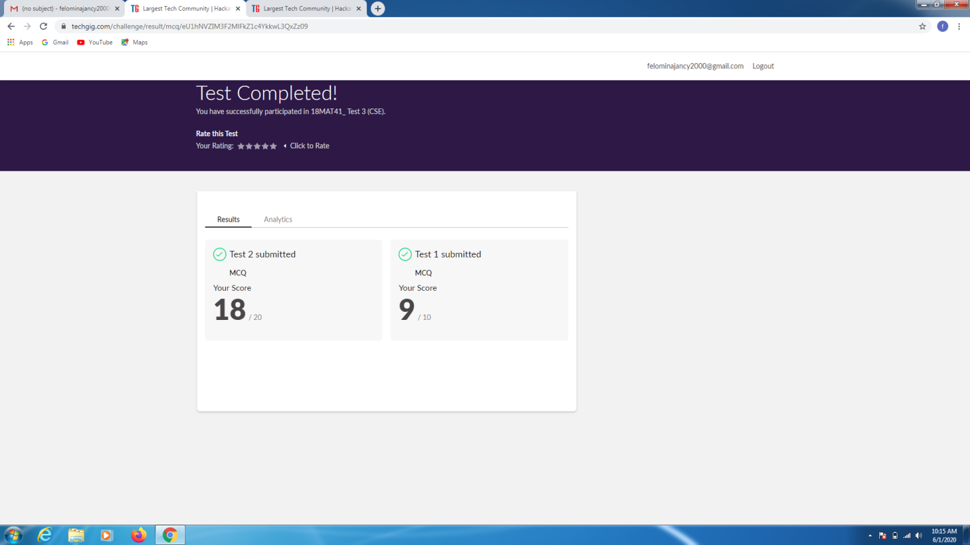

CERTIFICATION COURSE DETAILS:

* As continuation of the online course, I was able to do the week 3 quiz. A ungraded quiz of 6 questions and a ungraded quiz for 20 minutes.

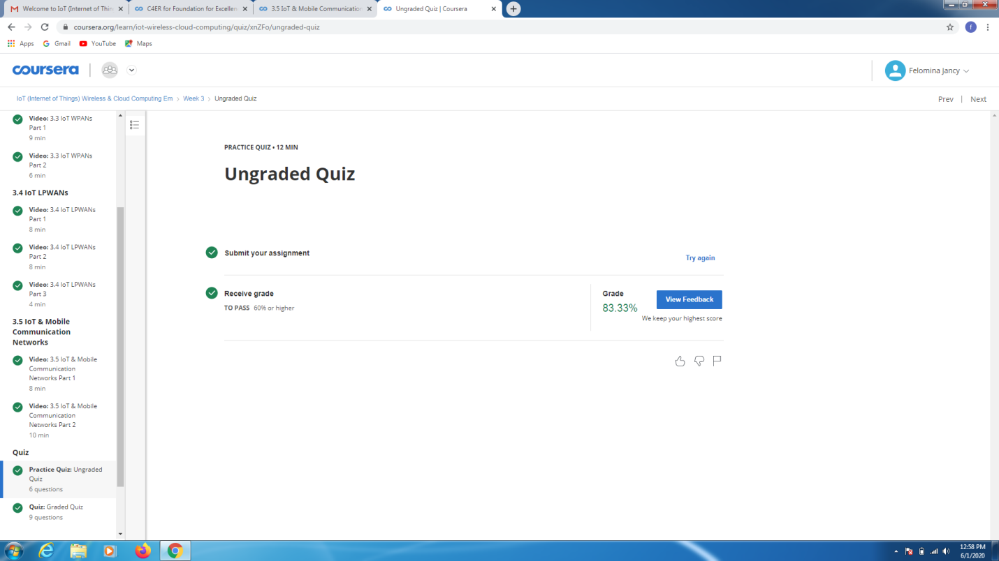

* Now, started with week 4 of this course.
* **The concepts covered in week 4 were related Wi-Fi and Bluetooth.**

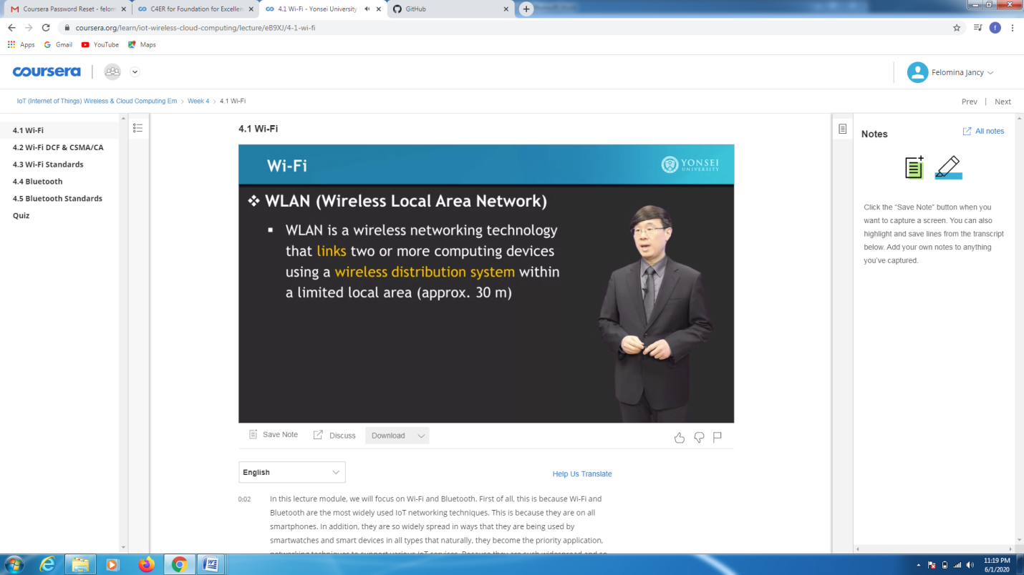

CODING CHALLENGES DETAILS:

Problem statement 1:

Write a program to implement were [Given an array arr[] of size N and an integer K. The task is to find the count of sub arrays such that each sub array has exactly K distinct elements.](https://github.com/orgs/alvas-education-foundation/teams/2nd-year/discussions/90)

Solution : Uploaded it in github

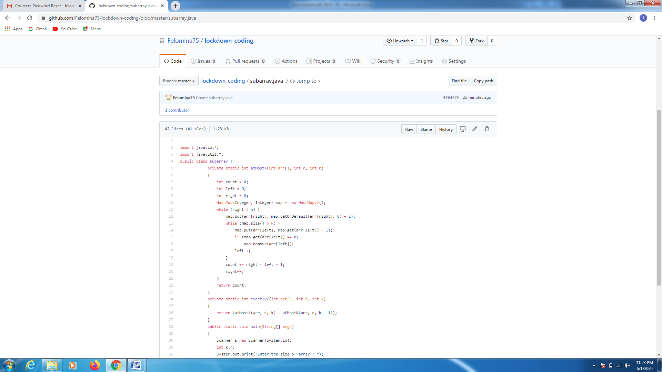

Problem statement 2:

Given an array of positive integers. Write a C Program to find the leaders in the array.

**Note:** An element of array is leader if it is greater than or equal to all the elements to its right side. Also, the rightmost element is always a leader.

**Input:**  
The first line of input contains an integer T denoting the number of test cases. The description of T test cases follows.  
The first line of each test case contains a single integer N denoting the size of array.  
The second line contains N space-separated integers A1, A2, ..., AN denoting the elements of the array.

**Output:**  
Print all the leaders.

**Constraints:**  
1 <= T <= 100  
1 <= N <= 107  
0 <= Ai <= 107

**Example:**

**Input:**  
3  
6  
16 17 4 3 5 2  
5  
1 2 3 4 0  
5  
7 4 5 7 3

**Output:**  
17 5 2  
4 0  
7 7 3  
**Explanation:  
Test case 3:** All elements on the right of 7 (at index 0) are smaller than or equal to 7. Also, all the elements of right side of 7 (at index 3) are smaller than 7. And, the last element 3 is itself a leader since no elements are on its right.

Solution : Uploaded it in github

