**DAILY ONLINE ACTIVITIES SUMMARY**

|  |  |  |  |  |  |  |  |  |
| --- | --- | --- | --- | --- | --- | --- | --- | --- |
| **Date:** | **10/06/2020** | | | | | **Name:** | **Felomina Jancy** | |
| **Sem & Sec** | **4th SEM 'A' Section** | | | | | **USN:** | **4AL18CS022** | |
| **Online Test Summary** | | | | | | | | |
| **Subject** | | Object Oriented Concepts | | | | | | |
| **Max. Marks** | | **30** | | **Score** | | | **28** | |
| **Certification Course Summary** | | | | | | | | |
| **Course** | **Automation Anywhere** | | | | | | | |
| **Certificate Provider** | | | **ICT Academy** | | **Duration** | | | **3 hours** |
| **Coding Challenges** | | | | | | | | |
| **Problem Statement:** Write a C Program to print the sum of boundary elements of a matrix. | | | | | | | | |
| **Status: completed** | | | | | | | | |
| **Uploaded the report in Github** | | | | | **yes** | | | |
| **If yes Repository name** | | | | | **https://github.com/Felomina75/lockdown-coding.git** | | | |
| **Uploaded the report in slack** | | | | | **yes** | | | |

Online Test Details: (Attach the snapshot and briefly write the report for the same)

Certification Course Details: (Attach the snapshot and briefly write the report for the same)

Coding Challenges Details: (Attach the snapshot and briefly write the report for the same)

ONLINE TEST DETAILS:

The online test was from module 3 and 4 which was about introduction classes, inheritance, exception handling, packages, interfaces and multithreading.. There were 30 questions and the duration was 30 minutes. The questions were optimal and were easy. The score that I got in the test is 28/30.

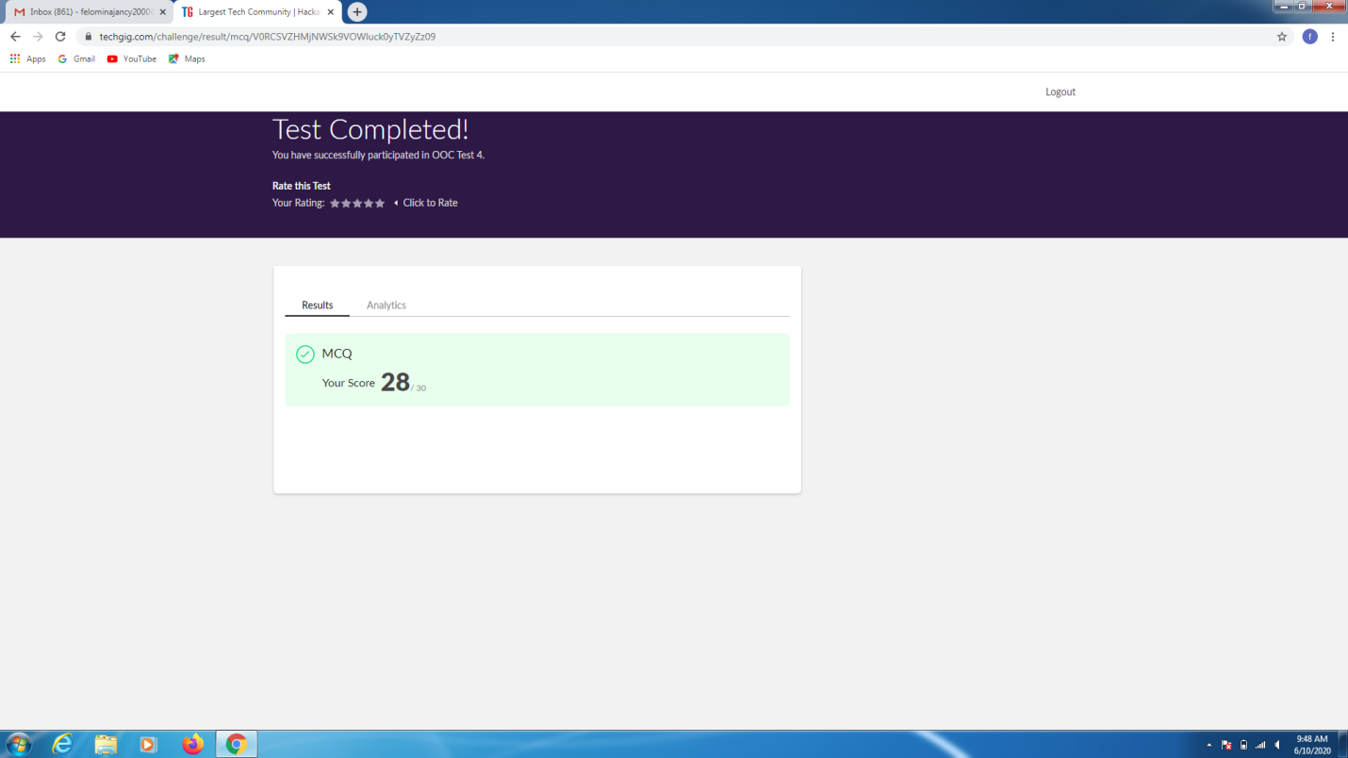

CERTIFICATION COURSE DETAILS:

* I was able to do module 7 and module 8 of the "Automation Anywhere" course.
* The topics covered were of Terminal Emulation and IQ bots.

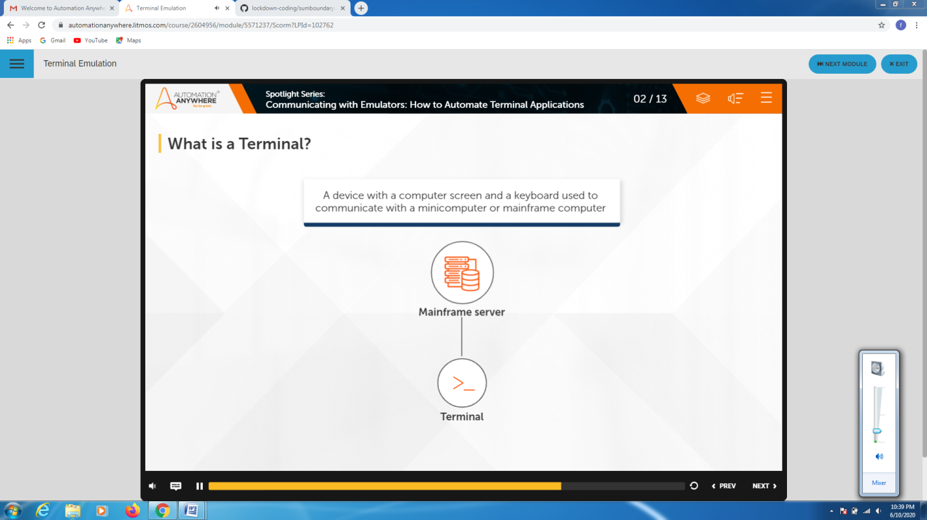CODING CHALLENGES DETAILS:

Problem statement:

Write a C Program to print the sum of boundary elements of a matrix.

Solution : Uploaded it in github

