**DAILY ONLINE ACTIVITIES SUMMARY**

|  |  |  |  |  |  |  |  |  |
| --- | --- | --- | --- | --- | --- | --- | --- | --- |
| **Date:** | **10/07/2020** | | | | | **Name:** | **Felomina Jancy** | |
| **Sem & Sec** | **4th SEM 'A' Section** | | | | | **USN:** | **4AL18CS022** | |
| **Descriptive Test Summary** | | | | | | | | |
| **Subject** | | Object Oriented Concepts | | | | | | |
| **Max. Marks** | | **-** | | **Score** | | | **-** | |
| **Certification Course Summary** | | | | | | | | |
| **Course** | **Programming for everybody(Getting started with Python)** | | | | | | | |
| **Certificate Provider** | | | **Coursera** | | **Duration** | | | **3 hours** |
| **Coding Challenges** | | | | | | | | |
| **Problem Statement:** Write a c program to print alphabet triangle. | | | | | | | | |
| **Status: completed** | | | | | | | | |
| **Uploaded the report in Github** | | | | | **yes** | | | |
| **If yes Repository name** | | | | | **https://github.com/Felomina75/lockdown-coding.git** | | | |
| **Uploaded the report in slack** | | | | | **yes** | | | |

Online Test Details: (Attach the snapshot and briefly write the report for the same)

Certification Course Details: (Attach the snapshot and briefly write the report for the same)

Coding Challenges Details: (Attach the snapshot and briefly write the report for the same)

DSCRIPTIVE TEST DETAILS:

The test was from module 1 which was about overview of object oriented programming. There were 4 questions and the time limit was 45 minutes. The questions were optimal and easy.

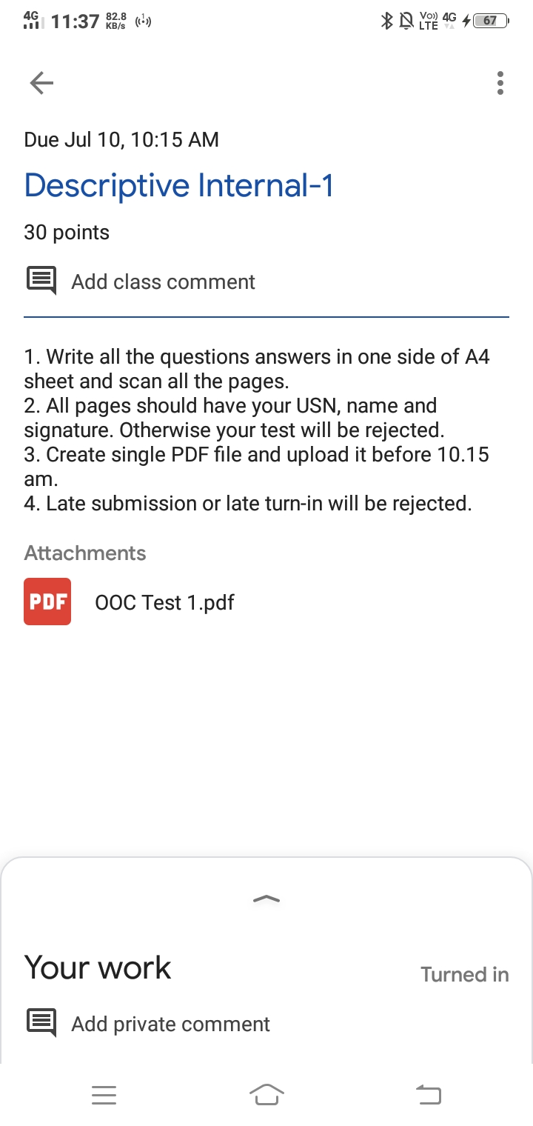

CERTIFICATION COURSE DETAILS:

* I started with a new course " **Programming for everybody(Getting started with Python)" by Coursera , I was able to do week 1.**
* **It was an introduction to python.**

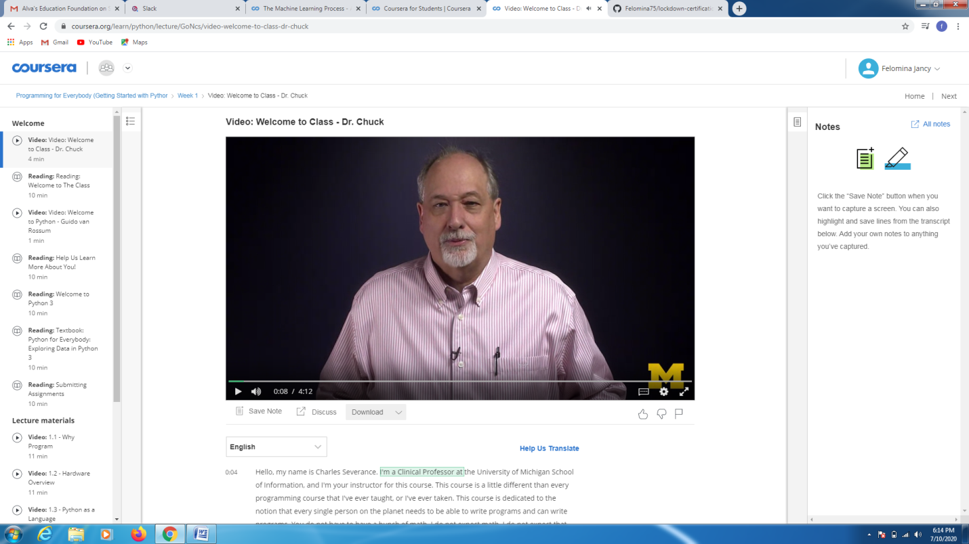

CODING CHALLENGES DETAILS:

Problem statement:

Write a c program to print alphabet triangle.

Solution : Uploaded it in github

