**DAILY ONLINE ACTIVITIES SUMMARY**

|  |  |  |  |  |  |  |  |  |
| --- | --- | --- | --- | --- | --- | --- | --- | --- |
| **Date:** | **11/06/2020** | | | | | **Name:** | **Felomina Jancy** | |
| **Sem & Sec** | **4th SEM 'A' Section** | | | | | **USN:** | **4AL18CS022** | |
| **Online Test Summary** | | | | | | | | |
| **Subject** | | -- | | | | | | |
| **Max. Marks** | | **--** | | **Score** | | | **--** | |
| **Certification Course Summary** | | | | | | | | |
| **Course** | **1. Webinar on skill development**  **2. Stepathon** | | | | | | | |
| **Certificate Provider** | | | **1. Brainovision**  **2. ICT Academy** | | **Duration** | | | **1. 2 hours**  **2. 1 hour** |
| **Coding Challenges** | | | | | | | | |
| **Problem Statement:** Write a Java Program to Segregate Even and Odd numbers. | | | | | | | | |
| **Status: completed** | | | | | | | | |
| **Uploaded the report in Github** | | | | | **yes** | | | |
| **If yes Repository name** | | | | | **https://github.com/Felomina75/lockdown-coding.git** | | | |
| **Uploaded the report in slack** | | | | | **yes** | | | |

Online Test Details: (Attach the snapshot and briefly write the report for the same)

Certification Course Details: (Attach the snapshot and briefly write the report for the same)

Coding Challenges Details: (Attach the snapshot and briefly write the report for the same)

ONLINE TEST DETAILS:

No test.

CERTIFICATION COURSE DETAILS:

* I attended a webinar on "Skill development" organized by Brainovision.
* The session was for 2 hours from 10:30a.m to 12:30a.m .
* Many kinds of problems were solved and it was very useful

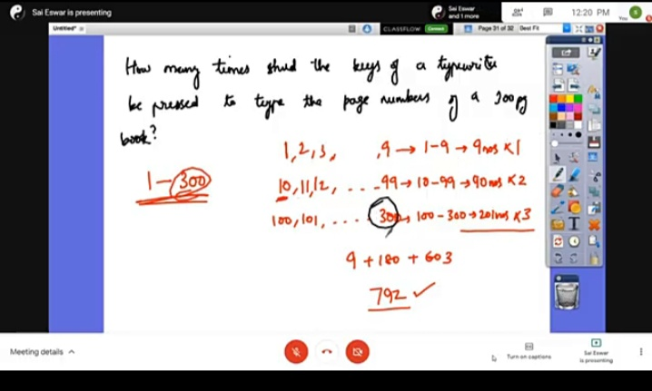

* I received the certificate for attending the webinar and it's in pdf format. So I just took the snapshot of the certificate.

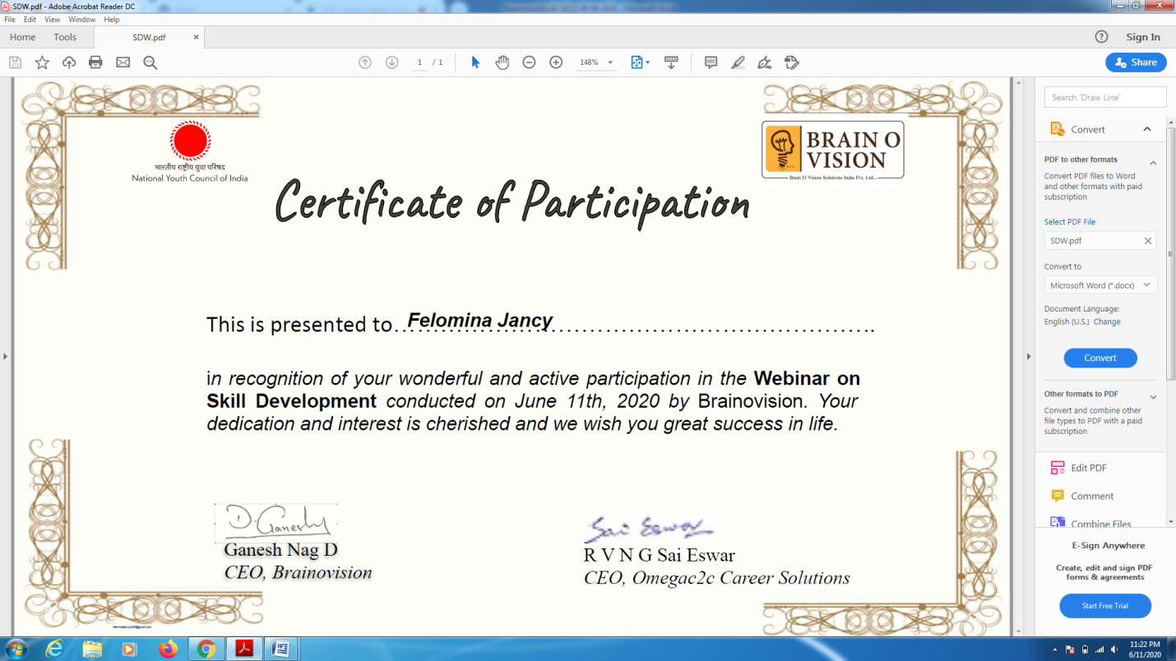

* Then I was able to continue the STEPATHON course organized by ICT Academy.

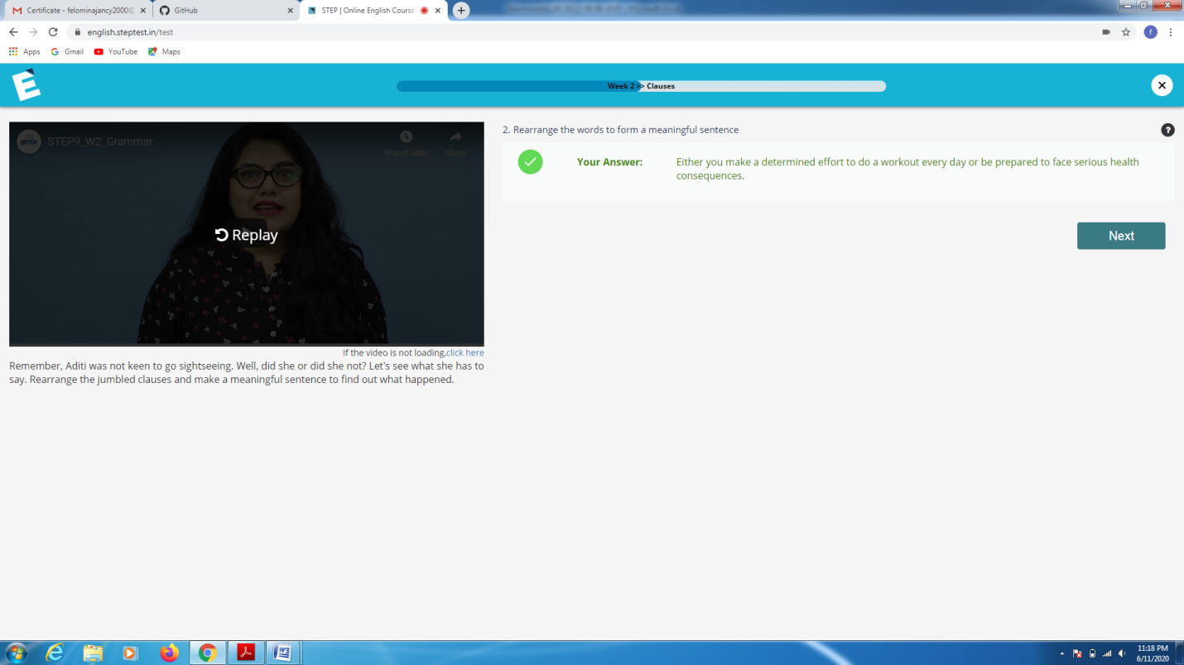CODING CHALLENGES DETAILS:

Problem statement:

Write a Java Program to Segregate Even and Odd numbers.

Solution : Uploaded it in github

