**DAILY ONLINE ACTIVITIES SUMMARY**

|  |  |  |  |  |  |  |  |  |
| --- | --- | --- | --- | --- | --- | --- | --- | --- |
| **Date:** | **11/07/2020** | | | | | **Name:** | **Felomina Jancy** | |
| **Sem & Sec** | **4th SEM 'A' Section** | | | | | **USN:** | **4AL18CS022** | |
| **Descriptive Test Summary** | | | | | | | | |
| **Subject** | | - | | | | | | |
| **Max. Marks** | | **-** | | **Score** | | | **-** | |
| **Certification Course Summary** | | | | | | | | |
| **Course** | **Become Job Ready for Developer Trailmix1** | | | | | | | |
| **Certificate Provider** | | | **Salesforce** | | **Duration** | | | **3 hours** |
| **Coding Challenges** | | | | | | | | |
| **Problem Statement:** Write a C program to convert numbers to characters. | | | | | | | | |
| **Status: completed** | | | | | | | | |
| **Uploaded the report in Github** | | | | | **yes** | | | |
| **If yes Repository name** | | | | | **https://github.com/Felomina75/lockdown-coding.git** | | | |
| **Uploaded the report in slack** | | | | | **yes** | | | |

Online Test Details: (Attach the snapshot and briefly write the report for the same)

Certification Course Details: (Attach the snapshot and briefly write the report for the same)

Coding Challenges Details: (Attach the snapshot and briefly write the report for the same)

DESCRIPTIVE TEST DETAILS:

No test.

CERTIFICATION COURSE DETAILS:

* As a continuation of the course " **Become Job Ready for Developer Trailmix1" organized by Salesforce, I was able to complete module 3,4,5 and 6.**
* **I earned many badges for earning the points.**
* **The modules are:**
* Salesforce platform basics
* CRM for lightning experience
* Data modeling
* Build a lemonade stand app

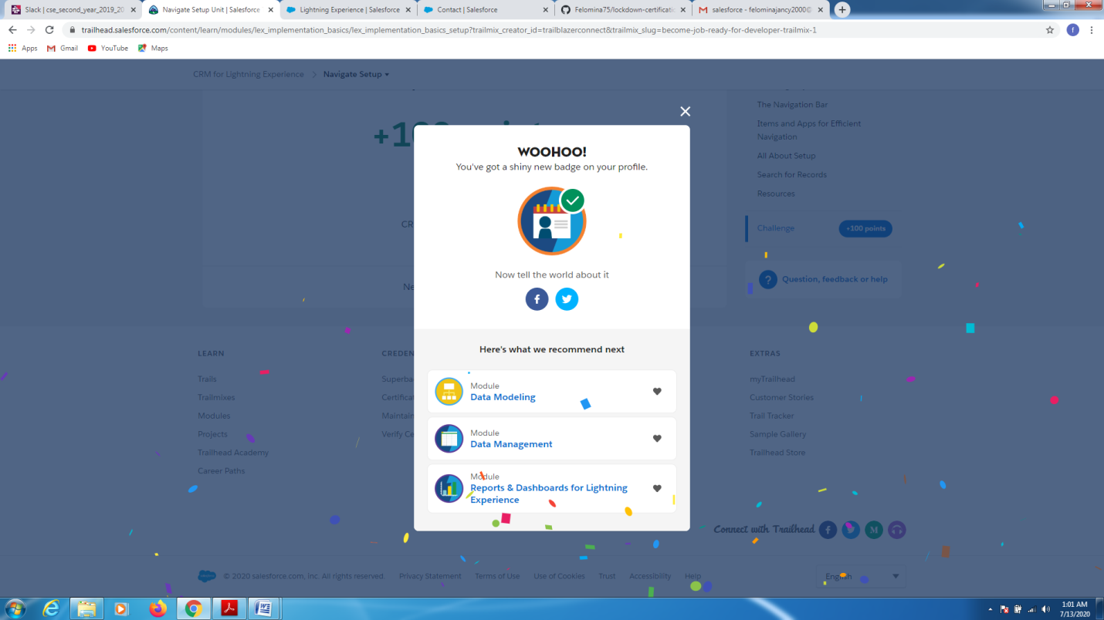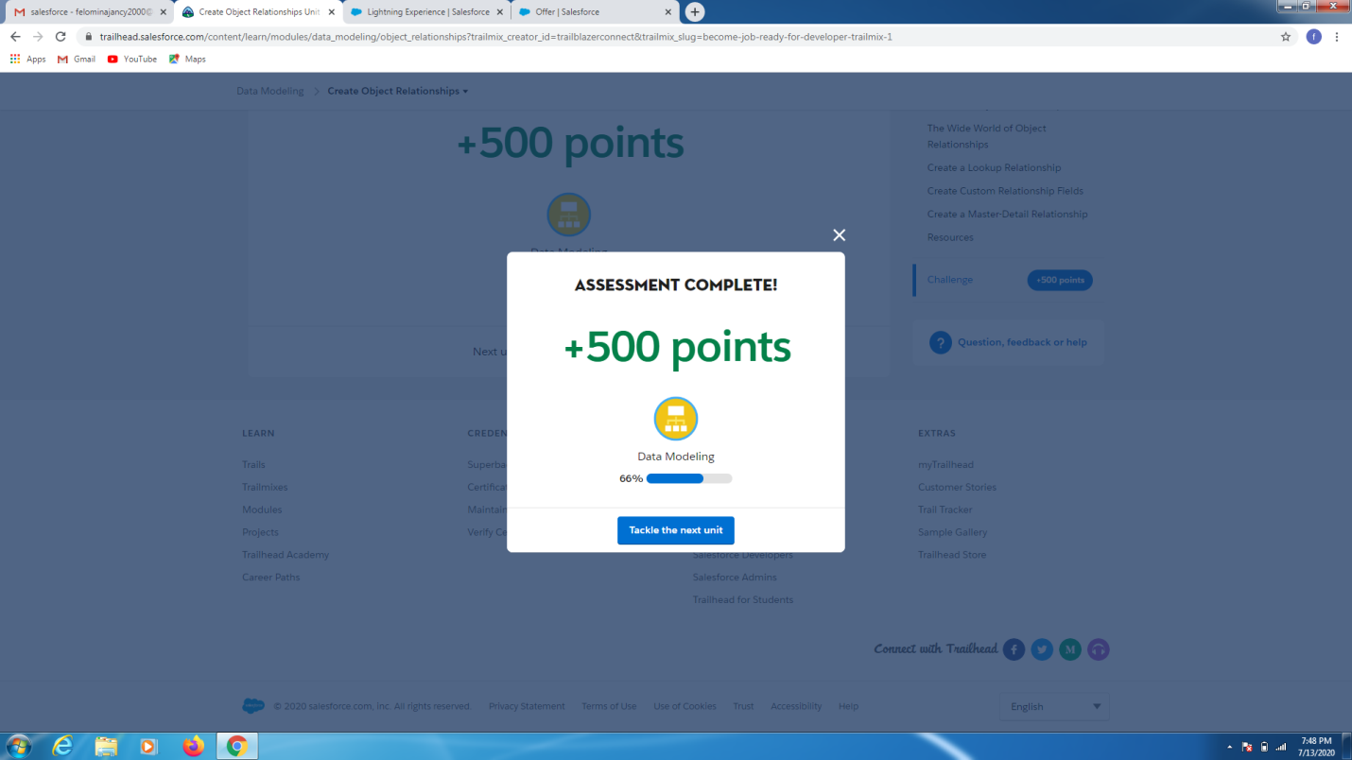

BADGES:









CODING CHALLENGES DETAILS:

Problem statement:

Write a C program to convert numbers to characters.

**Input:** 5

**Output:** five

**Input:** 203

**Output:** two zero three

Solution : Uploaded it in github

