**DAILY ONLINE ACTIVITIES SUMMARY**

|  |  |  |  |  |  |  |  |  |
| --- | --- | --- | --- | --- | --- | --- | --- | --- |
| **Date:** | **12/06/2020** | | | | | **Name:** | **Felomina Jancy** | |
| **Sem & Sec** | **4th SEM 'A' Section** | | | | | **USN:** | **4AL18CS022** | |
| **Online Test Summary** | | | | | | | | |
| **Subject** | | Aadalitha kannada | | | | | | |
| **Max. Marks** | | **25** | | **Score** | | | **24** | |
| **Certification Course Summary** | | | | | | | | |
| **Course** | **IoT Wireless and Cloud Computing Emerging Technologies** | | | | | | | |
| **Certificate Provider** | | | **Coursera** | | **Duration** | | | **3 hours** |
| **Coding Challenges** | | | | | | | | |
| **Problem Statement:** Write a program to find the long repeating sequence in a string. | | | | | | | | |
| **Status: completed** | | | | | | | | |
| **Uploaded the report in Github** | | | | | **yes** | | | |
| **If yes Repository name** | | | | | **https://github.com/Felomina75/lockdown-coding.git** | | | |
| **Uploaded the report in slack** | | | | | **yes** | | | |

Online Test Details: (Attach the snapshot and briefly write the report for the same)

Certification Course Details: (Attach the snapshot and briefly write the report for the same)

Coding Challenges Details: (Attach the snapshot and briefly write the report for the same)

ONLINE TEST DETAILS:

**Aadalitha kannada:** The portion for the online test was from all the 10 chapters . There were 25 questions and the total duration was 25 minutes. The questions were optimal and were easy. The score that I got in the test is 24/25.

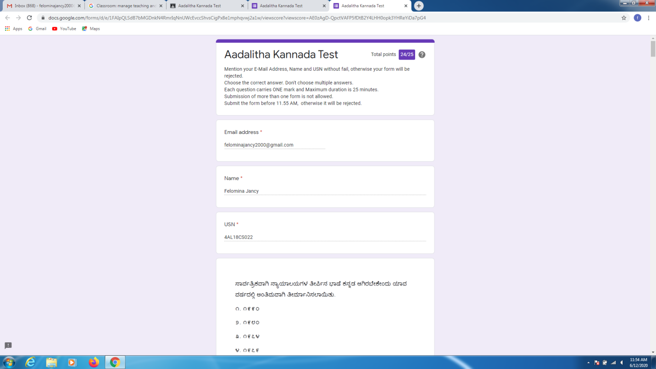CERTIFICATION COURSE DETAILS:

* As continuation of the online course, I was able to do the week 5 of  **"IoT Wireless and Cloud Computing Emerging Technologies " course.**
* **The concepts covered in week 5 were related cloud market analysis , top cloud companies and services and Amazon web services.**

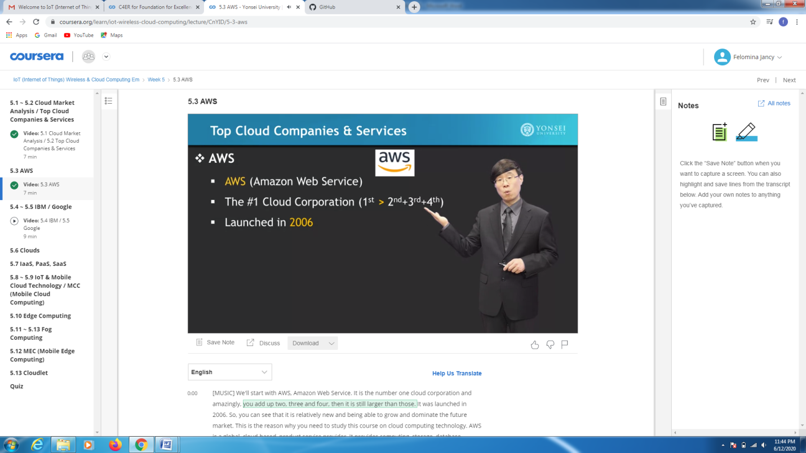CODING CHALLENGES DETAILS:

Problem statement 1:

Write a program to find the long repeating sequence in a string.

Solution : Uploaded it in github

